UNITED STATES
SECURITIES AND EXCHANGE COMMISSION
Washington, D.C. 20549
FORM 10-K
(Mark One)
☒ |  |  | ANNUAL REPORT PURSUANT TO SECTION 13 OR 15(d) OF THE SECURITIES EXCHANGE ACT OF 1934
For the fiscal year ended December 31, 2025
or
☐ |  |  | TRANSITION REPORT PURSUANT TO SECTION 13 OR 15(d) OF THE SECURITIES EXCHANGE ACT OF 1934
For the transition period from _______ to _______
Commission file number: 001-40880
XERIS BIOPHARMA HOLDINGS, INC.
(Exact name of the registrant as specified in its charter)
 |  |  | Delaware |  |  |  |  |  |  |  |  | 87-1082097
 |  |  | (State or other jurisdiction of  incorporation or organization) |  |  |  |  |  |  |  |  | (I.R.S. Employer Identification No.)
 |  |  | 1375 West Fulton Street, Suite 1300  Chicago, Illinois |  |  |  |  |  |  |  |  | 60607
 |  |  | (Address of principal executive offices) |  |  |  |  |  |  |  |  | (Zip Code)
(844) 445-5704
(Registrant's telephone number, including area code)
Securities registered pursuant to Section 12(b) of the Act:
Title of each class |  |  |  |  |  |  |  |  | Trading Symbol(s) |  |  | Name of each exchange on which registered
Common Stock, $0.0001 par value per share |  |  |  |  |  |  |  |  | XERS |  |  | The Nasdaq Global Select Market
Securities registered pursuant to Section 12(g) of the Act: None
Indicate by check mark if the registrant is a well-known seasoned issuer, as defined by Rule 405 of the Securities Act. Yes ☐ No ☒
Indicate by check mark if the registrant is not required to file reports pursuant to Section 13 or 15(d) of the Act. Yes ☐ No ☒
Indicate by check mark whether the registrant (1) has filed all reports required to be filed by Section 13 or 15(d) of the Securities Exchange Act of 1934 during the preceding 12 months (or for such shorter period that the registrant was required to file such reports), and (2) has been subject to such filing requirements for the past 90 days. Yes ☒ No ☐
Indicate by check mark whether the registrant has submitted electronically every Interactive Data File required to be submitted pursuant to Rule 405 of Regulation S-T (§232.405 of this chapter) during the preceding 12 months (or for such shorter period that the registrant was required to submit such files). Yes ☒ No ☐
Indicate by check mark whether the registrant is a large accelerated filer, an accelerated filer, a non-accelerated filer, a smaller reporting company, or an emerging growth company. See the definitions of "large accelerated filer," "accelerated filer," "smaller reporting company," and "emerging growth company" in Rule 12b-2 of the Exchange Act.
 |  |  | Large Accelerated filer |  |  |  |  |  | ☒ |  |  | Accelerated filer |  |  |  |  |  | ☐
 |  |  | Non-accelerated filer |  |  |  |  |  | ☐ |  |  | Smaller reporting company |  |  |  |  |  | ☐
 |  |  |  |  |  |  |  |  |  |  |  | Emerging growth company |  |  |  |  |  | ☐
If an emerging growth company, indicate by check mark if the registrant has elected not to use the extended transition period for complying with any new or revised financial accounting standards provided pursuant to Section 13(a) of the Exchange Act. ☐
Indicate by check mark whether the registrant has filed a report on and attestation to its management’s assessment of the effectiveness of its internal control over financial reporting under Section 404(b) of the Sarbanes-Oxley Act (15 U.S.C. 7262(b)) by the registered public accounting firm that prepared or issued its audit report. ☒
If securities are registered pursuant to Section 12(b) of the Act, indicate by check mark whether the financial statements of the registrant included in the filing reflect the correction of an error to previously issued financial statements. ☐
Indicate by check mark whether any of those error corrections are restatements that required a recovery analysis of incentive-based compensation received by any of the registrant’s executive officers during the relevant recovery period pursuant to §240.10D-1(b). ☐
Indicate by check mark whether the registrant is a shell company (as defined in Rule 12b-2 of the Act). Yes ☐ No ☒
As of June 30, 2025, the aggregate market value of the Registrant's common stock held by non-affiliates of the Registrant was approximately $731.1 million based on the closing sales price as reported on the Nasdaq Stock Market.
As of February 27, 2026, 172,431,290 shares, par value $0.0001 per share, of common stock were outstanding.
DOCUMENTS INCORPORATED BY REFERENCE
Part III incorporates certain information by reference from the Registrant's Definitive Proxy Statement to be filed with the Commission in connection with the Registrant's 2026 Annual Meeting of Stockholders. Such Definitive Proxy Statement will be filed not later than 120 days after the conclusion of the Registrant’s fiscal year ended December 31, 2025.

Table of Contents

Summary of the Material Risks Associated with Our Business
Our business is subject to numerous risks and uncertainties that you should be aware of in evaluating our business. These risks include, but are not limited to, the following:
 |  |  | < |  |  |  |  |  | We have a limited operating history and limited experience commercializing pharmaceutical products and have incurred significant losses since inception.
 |  |  | < |  |  |  |  |  | We have a history of operating losses and may not be able to achieve or sustain profitability in the future, and we may not be able to continue operations without additional fundings.
 |  |  | < |  |  |  |  |  | We may require additional capital to sustain our business, and this capital may cause dilution to our stockholders and might not be available on terms favorable to us, or at all, which could force us to delay, reduce or eliminate our product development programs or commercialization efforts.
 |  |  | < |  |  |  |  |  | Our business depends entirely on the commercial success of our products and product candidates. Even if approved, our product candidates may not be accepted in the marketplace and our business may be materially harmed.
 |  |  | < |  |  |  |  |  | We operate in a competitive business environment, which may have an adverse impact on our revenue. If we are unable to compete successfully against our existing or future competitors, our sales and operating results may be negatively affected and we may not successfully commercialize our products or product candidates, even if approved.
 |  |  | < |  |  |  |  |  | If we are unable to establish or do not maintain sufficient marketing, sales and distribution capabilities or enter into agreements with third parties to market, sell and distribute our products on terms acceptable to us, we may not be able to generate product revenue and our business, results of operations, and financial condition will be materially adversely affected.
 |  |  | < |  |  |  |  |  | Our reliance on third-party suppliers, including single-source suppliers, together with a limited number of possible suppliers and long development lead times to establish alternative sources for our products, product candidates, components and other key materials has in the past and may in the future impact our ability to develop our product candidates or to continue to commercialize Recorlev, Gvoke, Keveyis, or any product candidates that are approved.
 |  |  | < |  |  |  |  |  | Reimbursement decisions by third-party payors and consolidation within the healthcare industry and among competitors may have an adverse effect on pricing and market acceptance. If there is not sufficient reimbursement for our products, it is less likely that they will be widely used and pricing pressure may impact our ability to sell our products at prices necessary to support our current business strategies.
 |  |  | < |  |  |  |  |  | Clinical failure may occur at any stage of clinical development, and the results of our clinical trials may not support our proposed indications for our product candidates. If our clinical trials fail to demonstrate efficacy and safety to the satisfaction of the Food and Drug Administration ("FDA") or other regulatory authorities, we may incur additional costs or experience delays in completing, or ultimately be unable to complete, the development of such product candidates.
 |  |  | < |  |  |  |  |  | Recorlev, Gvoke, Keveyis and our product candidates may have undesirable side effects which may delay or prevent marketing approval, or, if approval is received, require them to include safety warnings, require them to be taken off the market or otherwise limit their sales.
 |  |  | < |  |  |  |  |  | Our failure to successfully identify, develop and market additional product candidates, or acquire additional product candidates or enter into collaborations or other commercial agreements could impair our ability to grow.
 |  |  | < |  |  |  |  |  | Our success depends on our ability to protect our intellectual property and proprietary formulation science, as well as the ability of our collaborators to protect their intellectual property and proprietary formulation science.
 |  |  | < |  |  |  |  |  | Our stock price has been and will likely continue to be volatile, and you may lose part or all of your investment.
 |  |  | < |  |  |  |  |  | Our data collection and processing activities are governed by restrictive regulations governing the use, processing and, in certain jurisdictions, cross-border transfer of personal information.
The summary risk factors described above should be read together with the text of the full risk factors discussed below in the section entitled "Risk Factors" and the other information set forth in this Annual Report on Form 10-K, including our consolidated financial statements and the related notes, as well as in other documents that we file with the United States Securities and Exchange Commission. The risks summarized above or described in full below are not the only risks that we face. Additional risks and uncertainties not precisely known to us or that we currently deem to be immaterial may also materially adversely affect our business, financial condition, results of operations and future growth prospects.

Table of Contents
XERIS BIOPHARMA HOLDINGS, INC.
Index to Annual Report on Form 10-K
Year Ended December 31, 2025

 |  |  |  |  |  |  |  |  |  |  |  | Page
 |  |  | Cautionary Statements for Forward-Looking Information |  |  |  |  |  |  |  |  | 4
 |  |  | Part I.
 |  |  |  |  |  | Item 1. Business |  |  |  |  |  | 6
 |  |  |  |  |  | Item 1A. Risk Factors |  |  |  |  |  | 29
 |  |  |  |  |  | Item 1B. Unresolved Staff Comments |  |  |  |  |  | 71
 |  |  |  |  |  | Item 1C. Cybersecurity |  |  |  |  |  | 71
 |  |  |  |  |  | Item 2. Properties |  |  |  |  |  | 72
 |  |  |  |  |  | Item 3. Legal Proceedings |  |  |  |  |  | 72
 |  |  |  |  |  | Item 4. Mine Safety Disclosures |  |  |  |  |  | 72
 |  |  | Part II.
 |  |  |  |  |  | Item 5. Market for Registrant’s Common Equity, Related Stockholder Matters and Issuer Purchases of Equity Securities |  |  |  |  |  | 73
 |  |  |  |  |  | Item 6. [Reserved] |  |  |  |  |  | 74
 |  |  |  |  |  | Item 7. Management's Discussion and Analysis of Financial Condition and Results of Operations |  |  |  |  |  | 75
 |  |  |  |  |  | Item 7A. Quantitative and Qualitative Disclosures About Market Risk |  |  |  |  |  | 81
 |  |  |  |  |  | Item 8. Financial Statements and Supplementary Data |  |  |  |  |  | 82
 |  |  |  |  |  | Item 9. Changes in and Disagreements with Accountants on Accounting and Financial Disclosure |  |  |  |  |  | 113
 |  |  |  |  |  | Item 9A. Controls and Procedures |  |  |  |  |  | 113
 |  |  |  |  |  | Item 9B. Other Information |  |  |  |  |  | 113
 |  |  |  |  |  | Item 9C. Disclosure Regarding Foreign Jurisdictions that Prevent Inspections |  |  |  |  |  | 113
 |  |  | Part III.
 |  |  |  |  |  | Item 10. Directors, Executive Officers and Corporate Governance |  |  |  |  |  | 114
 |  |  |  |  |  | Item 11. Executive Compensation |  |  |  |  |  | 114
 |  |  |  |  |  | Item 12. Security Ownership of Certain Beneficial Owners and Management and Related Stockholder Matters |  |  |  |  |  | 114
 |  |  |  |  |  | Item 13. Certain Relationships and Related Transactions, and Director Independence |  |  |  |  |  | 114
 |  |  |  |  |  | Item 14. Principal Accountant Fees and Services |  |  |  |  |  | 114
 |  |  | Part IV.
 |  |  |  |  |  | Item 15. Exhibits and Financial Statement Schedules |  |  |  |  |  | 115
 |  |  |  |  |  | Item 16. Form 10-K Summary |  |  |  |  |  | 115
 |  |  |  |  |  | Index to Exhibits |  |  |  |  |  | 116
 |  |  |  |  |  | Signatures |  |  |  |  |  | 121
Solely for convenience, the trademarks and trade names in this Annual Report on Form 10-K (this "Annual Report") are referred to without the ® and ™ symbols, but absence of such references should not be construed as any indicator that their respective owners will not assert, to the fullest extent under applicable law, their rights thereto. The trademarks, trade names, and service marks appearing in this Annual Report are the property of their respective owners.

3
Table of Contents
Cautionary Statements for Forward-Looking Information
This Annual Report contains express or implied forward-looking statements that are based on our management’s belief and assumptions and on information currently available to our management. Although we believe that the expectations reflected in these forward-looking statements are reasonable, these statements relate to future events or our future operational or financial performance and involve known and unknown risks, uncertainties and other factors that may cause our actual results, performance or achievements to be materially different from any future results, performance or achievements expressed or implied by these forward-looking statements. Forward-looking statements in this Annual Report include, but are not limited to, statements about:
•the rate and degree of market acceptance and clinical utility of Recorlev, Gvoke and Keveyis;
•the pricing and reimbursement of Recorlev, Gvoke and Keveyis or any of our product candidates, if approved;
•our estimates regarding the market opportunities for Recorlev, Gvoke and Keveyis and our product candidates;
•the commercialization, marketing and manufacturing of Recorlev, Gvoke and Keveyis and our product candidates, if approved;
•our ability to manufacture, or the ability of third parties to deliver, sufficient quantities of components and drug product for commercialization of Recorlev, Gvoke and Keveyis or any of our product candidates, if approved;
•our expectations related to the collaboration and partnerships with other pharmaceutical companies regarding the development of formulations of their proprietary therapeutics using our formulation science;
•the rate and degree of market acceptance and clinical utility of any of our product candidates for which we receive marketing approval in the future;
•the initiation, timing, progress and results of our research and development programs and future preclinical and clinical studies;
•our ability to advance any other product candidates into, and successfully complete, clinical studies and obtain regulatory approval for them, including potential impacts of regulatory agency staffing cuts and reduced resources as well as shifting policy priorities and the impact on regulatory feedback and timing thereof;
•our ability to identify additional product candidates;
•the implementation of our strategic plans for our business, product candidates and technology;
•the scope of protection we are able to establish and maintain for intellectual property rights covering our product candidates and technology;
•our ability to use the proceeds of our public offerings and borrowings in ways that increase the value of your investment;
•our expectations related to the use of proceeds from our public offerings and borrowings and estimates of our expenses, future revenues, capital requirements and our needs for additional financing;
•our ability to maintain and establish collaborations;
•our financial performance;
•our ability to effectively manage our anticipated growth;
•developments relating to our competitors and our industry, including the impact of government regulations;
•changes in macroeconomic conditions such as the possibility of an economic downturn or general economic uncertainty; and
•other risks and uncertainties, including those listed under the section entitled "Risk Factors" (refer to Part 1, Item 1A, of this Annual Report).
In some cases, forward-looking statements can be identified by terminology such as "could," "will," "would," "may," "should," "expects," "intends," "likely," "plans," "anticipates," "believes," "estimates," "predicts," "potential," "continue" and terms of similar meaning. These statements are only predictions. You should not place undue reliance on forward-looking statements because they involve known and unknown risks, uncertainties and other factors, which are, in some cases, beyond our control and which could materially affect results. Factors that may cause actual results to differ materially from current expectations include, among other things, those listed under the section entitled "Risk Factors" and others discussed in this Annual Report and subsequent documents we periodically file with the Securities and Exchange Commission (the “SEC”). If one or more of these risks or uncertainties occur, or if our underlying assumptions prove to be incorrect, actual events or results may vary significantly from those implied or projected by the forward-looking statements. No forward-looking statement is a guarantee of future performance.
Forward-looking statements in this Annual Report are made only as of the date hereof and while we may elect to update these forward-looking statements at some point in the future, we have no current intention of doing so except to the extent required by
4
Table of Contents
applicable law. You should therefore not rely on these forward-looking statements as representing our views as of any date subsequent to the date of this Annual Report.
This Annual Report also contains estimates, projections and other information concerning our industry, our business and the markets for Recorlev, Gvoke and Keveyis and our product candidates. Information that is based on estimates, forecasts, projections, market research or similar methodologies is inherently subject to uncertainties, and actual events or circumstances may differ materially from events and circumstances that are assumed in this information. Unless otherwise expressly stated, we obtained this industry, business, market and other data from our own internal estimates and research as well as from reports, research surveys, studies and similar data prepared by market research firms and other third parties, industry, medical and general publications, government data and similar sources.

5
Table of Contents
PART I. FINANCIAL INFORMATION

ITEM 1. BUSINESS
Xeris Biopharma Holdings, Inc. along with its subsidiaries, is referenced herein as the "Company", "Xeris", "Xeris Biopharma", "we" or "our". Throughout this document, unless otherwise noted, references to Gvoke include Gvoke PFS, Gvoke HypoPen, and Gvoke Kit.
Overview
We are a commercial-stage biopharmaceutical company focused on developing and commercializing therapies for people with chronic endocrine and neurological diseases in the United States. We offer Recorlev for the treatment of endogenous hypercortisolemia in patients with Cushing’s syndrome, Gvoke for the treatment of severe hypoglycemia, and Keveyis for the treatment of Primary Periodic Paralysis ("PPP"). We are advancing our Phase 3-ready pipeline product, XP-8121, once-weekly subcutaneous ("SC") levothyroxine, which leverages our proprietary technology XeriSol.
Commercial Products
Our top priority is maximizing the potential of our three commercial products:
•Recorlev is a cortisol synthesis inhibitor approved for the treatment of endogenous hypercortisolemia in adults with Cushing's syndrome for whom surgery is not an option or has not been curative. Endogenous Cushing’s syndrome is a rare but serious and potentially fatal endocrine disease caused by chronic elevated cortisol exposure. Recently published data has shown that hypercortisolemia may be a contributor to several widespread and chronic medical conditions suggesting that the prevalence of the condition may be significantly higher than previously believed. We believe this therapy represents a significant commercial opportunity in the United States, with the potential to generate approximately $1 billion in annual net revenue at peak penetration.
•Gvoke is a ready-to-use, liquid-stable glucagon for the treatment of severe hypoglycemia. The product is indicated for use in pediatric and adult patients with diabetes age two years and above and can be administered in two simple steps. We estimate that more than 14 million people in the United States are at heightened risk of severe hypoglycemia and, per guidelines issued by the American Diabetes Association and others, should have a ready-to-use glucagon product like the Gvoke HypoPen with them at all times. The estimated total addressable market for this drug is approximately $5.0 billion in the United States.
•Keveyis is the first therapy approved in the United States to treat hyperkalemic, hypokalemic, and related variants of PPP. PPP is a rare genetic, neuromuscular disorder that can cause extreme muscle weakness and/or paralysis; some forms are also commonly associated with myotonia or muscle stiffness. The estimated total addressable market for this therapy is greater than $0.5 billion in the United States.
Our Pipeline
We prioritize our development efforts on programs that leverage our commercial capabilities or our proprietary formulation technologies, principally our lead pipeline program, XP-8121. Our company name, Xeris, is derived from the ancient Greek word xērós meaning 'dry' or 'without water/non-aqueous'. Our proprietary, non-aqueous formulations are designed to enable the convenient injection of medicines previously uninjectable or poorly injectable when utilizing aqueous approaches. XeriSol and XeriJect offer the opportunity to create ready-to-use, room-temperature stable, highly concentrated, injectable formulations of both small and large molecules.
•XP-8121: We are in the process of developing the first and only, once-weekly, subcutaneous injection of levothyroxine for the treatment of hypothyroidism. We plan to initiate a Phase 3 clinical trial of XP-8121 in 2026. The estimated total addressable market for this therapy is 3-5 million patients or more in the United States which we estimate is a $1.0 to $3.0 billion peak net sales opportunity.
•Partnerships: We are pursuing formulation and development partnerships to apply our XeriSol and XeriJect formulation technologies to enhance the drug delivery and clinical profile of other companies’ proprietary drugs and biologics. Currently, Xeris is working on a number of formulation feasibility programs in the areas of small molecules, peptides, biologics and monoclonal antibodies.
6
Table of Contents
Our Strategy
Our strategy is to build a profitable biopharmaceutical company focused on developing and commercializing therapies for people with chronic endocrine and neurological diseases. Xeris is uniquely positioned to execute on this strategy through the continued growth of our three commercial products, which enables us to invest in and develop therapies for unmet medical needs. We believe this will generate value for all of our stakeholders.
Our Products
Recorlev
Recorlev, approved in 2022, is our therapy for the treatment of Cushing’s syndrome, a rare condition which is the result of sustained, elevated levels of cortisol in the body (hypercortisolism). Cushing’s syndrome affects approximately 25,000 people in the United States of which approximately two-thirds are cured by surgery. Pharmacologic products like Recorlev are used for the balance of patients for whom surgery was not curative or was not an option. Recorlev has received orphan drug exclusivity status in the United States through December 30, 2028 and patent protection through 2040.
We believe this therapy represents a significant commercial opportunity within the United States, having the potential to generate approximately $1 billion in annual net revenue at peak penetration. Recorlev competes primarily with other established medications and therapies, including older generic drugs that are used off-label for Recorlev's approved indication. Because of the complex nature of Cushing’s syndrome, many patients are inadequately treated with currently available medicines.
Our experienced commercial organization focuses on educating prescribing clinicians and patients to raise awareness of the benefits of normalizing cortisol with Recorlev. Our Xeris’ CareConnection program provides direct, dedicated support to treating clinicians and patients throughout their Recorlev journey. In addition, our efforts include the support of a single, highly experienced specialty pharmacy that provides logistical assistance in the securing of coverage from third-party payors and then subsequent distribution of Recorlev to patients.
Gvoke
Gvoke is our ready-to-use, room-temperature stable, liquid glucagon product. Available since late 2019, Gvoke is a potentially life-saving rescue product that is designated to be reliably administrated by the individual with diabetes or their caregivers during low blood sugar emergencies (e.g., a severe hypoglycemic episode). Gvoke is available in three presentation types: Gvoke HypoPen (auto-injector), Gvoke PFS (pre-filled syringe), and Gvoke Kit (pre-filled vial and administration syringe). Our most widely prescribed presentation, Gvoke HypoPen, is designed to be administered subcutaneously in a simple two-step process requiring no dose calibration. Gvoke has patent protection through 2036.
The marketplace for Gvoke and other ready-to-use glucagon products is significant, owing to the widespread and growing prevalence of diabetes, the large proportion of people with diabetes at risk of experiencing a severe hypoglycemic event, and the still limited awareness of the availability of innovative, ready-to-use glucagon.
The current Standards of Care established by the American Diabetes Association, the American Academy of Clinical Endocrinologists, and the Endocrine Society, all advise that patients at increased risk of dangerously low blood sugar should be prescribed a ready-to-use glucagon. There are more than 14 million people with diabetes taking insulin or insulin secretagogues in the United States, and as such, are at-risk and should be prescribed and have handy, a ready-to-use rescue glucagon, like the Gvoke HypoPen for use during a potential severe hypoglycemic episode. Current prescription volumes suggest that approximately 1 million people with diabetes are adequately protected today, leaving a significant number of people without protection as recommended by the latest guidelines. If all at risk persons were adequately protected, the market potential is estimated to be nearly $5 billion annually.
Keveyis
Keveyis (dichlorphenamide) is the first FDA-approved therapy for the treatment of the ultra-rare condition of PPP. PPP is an inherited group of neuromuscular conditions that are characterized by interference with the electrical-chemical communications between nerve cells and skeletal muscles that can cause paralytic attacks.
PPP is estimated to affect approximately 4,000 to 5,000 people in the United States. Our promotional efforts are aimed at bringing awareness of this condition to both the healthcare professionals and patient communities.
Patient identification, capture, and retention in ultra-rare markets is extremely difficult and time-consuming. To address this, we have built an extensive set of patient support processes and proprietary analytics to identify patients affected by PPP and suitable for Keveyis therapy treatment. We also employ a specialty pharmacy to assist with the navigation of complex payer, healthcare professionals and patient support requirements for this ultra-rare disease.
Since our purchase of Keveyis through the acquisition of Strongbridge Biopharma plc ("Strongbridge"), we have been planning and projecting for the loss of orphan drug exclusivity status, which occurred in August 2022. We also continue to seek patents to restore our exclusive rights. We currently have two United States patent applications pending with claims protecting therapeutic uses of Keveyis. Both of these patent applications are on appeal at the United States Court of Appeals for the Federal Circuit. In 2022 and 2025, the FDA approved generic versions of our Keveyis product.
7
Table of Contents
Our Product Candidates
Once Weekly Subcutaneous Injection of Levothyroxine (XP-8121)
XP-8121 is a novel hypothyroidism product candidate, a once weekly subcutaneous levothyroxine formulated with XeriSol. It could potentially mitigate challenges associated with daily oral levothyroxine, the current standard of care for treating hypothyroidism, consistently achieving normal levels of thyroid stimulating hormone ("TSH") due to the many barriers to absorbing oral levothyroxine. Preclinical studies of XP-8121 showed a sustained plasma exposure profile and similar highest concentration of a drug in the blood, or Cmax, when compared with equivalent doses of the oral formulation. We have completed a Phase 1 study of XP-8121 to evaluate the pharmacokinetics, safety and tolerability, and potential for weekly dosing in the treatment of hypothyroidism and a Phase 2 study of XP-8121 to evaluate the dose conversion of oral levothyroxine to XP-8121.
Levothyroxine and Hypothyroidism
The thyroid gland is responsible for the synthesis, storage, and release of metabolic hormones including thyroxine (T4) and triiodothyronine (T3). These hormones are crucial in the regulation of critical metabolic processes and are vital for normal growth and development during fetal life, infancy, and childhood.
Therapeutically, levothyroxine is administered as a replacement for deficient thyroid hormones. The goal of the therapy is restoration of the euthyroid state which can reverse the clinical manifestations of hypothyroidism and significantly improve quality of life. The treatment of choice for correction of hypothyroidism is currently continuous daily oral administration of levothyroxine. It is one of the most widely prescribed drug products in the United States, but the complexity of maintaining biochemical and clinical euthyroidism in people undergoing treatment with oral levothyroxine is challenging. It has been reported that 20% of people undergoing treatment with oral levothyroxine have TSH outside the normal range at any point of time and 30% to 70% do not maintain normal TSH over time. This is due to factors that include, but are not limited to, medical conditions that impact gastrointestinal absorption of levothyroxine; concomitant medications that similarly impact gastrointestinal absorption, and poor compliance with the requirement to avoid taking levothyroxine with food, coffee, and many commonly-used supplements. Many people failing to reach target TSH levels are managed by increasing their levothyroxine daily dose. However, levothyroxine is a drug with a narrow therapeutic index, meaning that relatively small deviations from the proper dose can cause a clinically meaningful shift in pharmacological effects when administered; thus, the titration of levothyroxine oral drug may be a tailored and incremental process.
The Phase 1 clinical study was a single ascending dose crossover design in 30 healthy participants to compare matching doses of oral levothyroxine (Synthroid) and subcutaneous XP-8121. The primary endpoints of the study were to characterize the absorption and elimination kinetics of XP-8121 and compare bioavailability of XP-8121 to oral levothyroxine. Secondary endpoints were safety and tolerability of XP-8121.
In October 2022, we reported positive topline Phase 1 data of XP-8121. The data showed that subjects receiving XP-8121 subcutaneous had slower absorption, lower peak plasma, and higher extended exposure compared to Synthroid PO at the comparable dose of 600 μg. In addition, exposure was proportional over the range of ascending XP-8121 doses studied. Simulations based on a population pharmacokinetic model indicated that exposure from weekly XP-8121 1200 μg SC doses overlapped daily Synthroid PO 300 μg suggesting a dose conversion factor of 4x. Importantly, single SC doses of XP-8121 at all doses were generally well-tolerated and the XP-8121 doses studied were generally comparable to Synthroid 600 μg PO with respect to the safety findings. In June 2023, we initiated a non-randomized, open-label, single arm, self-controlled Phase 2 study to determine a target dose conversion factor from stably dosed oral levothyroxine to XP-8121 in people with hypothyroidism and also assess the safety and tolerability after once-weekly subcutaneous injections. The data established an average once-weekly SC dose of XP-8121 and confirmed our previous Phase 1 study of a four-time target dose conversion factor when switching from once-daily oral administration of levothyroxine. Participants who completed the study rated higher treatment satisfaction with XP-8121 compared to oral levothyroxine and a majority (72%) indicated a strong preference for the subcutaneous route of administration. An FDA End-of-Phase 2 meeting was held in the second half of 2024 to discuss expectations for a Phase 3 pivotal study program and eventual New Drug Application ("NDA") submission. The FDA agreed with our proposal to conduct a single non-inferiority efficacy trial comparing once-daily oral levothyroxine to once-weekly XP-8121 in adults with primary hypothyroidism. Efficacy will be determined by the percentage of participants achieving euthyroidism (normal TSH) at 30 weeks.
Market Opportunity
Hypothyroidism affects over 20 million people in the United States. For nearly 100 years, the only available options to treat people with hypothyroidism have been with oral levothyroxine and oral desiccated thyroid extract (which contains levothyroxine). Levothyroxine in its various branded and generic forms is one of the most prescribed drugs in the United States with approximately one hundred million prescriptions written annually. Complications associated with a requirement to take medicines by mouth, every day, are well-documented and include difficulties in swallowing, gastrointestinal malabsorption or intolerance, potential interactions with other orally administered medications, and general non-adherence given the daily regimen. Any of these complications can contribute to suboptimal treatment requiring higher dosing, generally poor control over TSH levels, or complete treatment failure. We believe XP-8121 to be well-suited to address these challenges. XP-8121 is designed to be a once-weekly, small-volume, subcutaneous injection that, given its route of administration, bypasses the gastrointestinal tract and could avoid many of the therapeutic
8
Table of Contents
complications associated with the use of oral forms of levothyroxine. We believe that our novel approach to treatment has the potential to establish a new standard of care for hypothyroidism.
Our Proprietary Technology
In the presence of water, many drugs have poor solubility and stability. Our proprietary non-aqueous technologies are designed to address the challenges associated with formulating certain drugs and overcome the inherent limitations of conventional aqueous-based formulation approaches. Injectable pharmaceuticals have conventionally been developed using aqueous formulations. To optimize their stability and enable longer-term storage, many of these products are freeze dried into a powder and, when needed, must be reconstituted with an aqueous diluent. This is typically associated with a challenging multi-step procedure with significant potential for error. Furthermore, these drugs can begin to break down once combined with water, which requires the reconstituted product to be used immediately or otherwise be refrigerated. In addition, many of these drugs can require complicated formulations and large injection volumes to make them soluble. For many products, these volumes are too large for SC or intramuscular (IM) delivery and instead necessitate IV infusion over several hours. These products can be difficult or painful to administer and have limited portability, resulting in an overall poor experience for patients and caregivers.
Our proprietary non-aqueous XeriSol and XeriJect technologies offer the opportunity to eliminate the need for reconstitution and refrigeration, enable long-term stability, significantly reduce injection volume, and allow for a more convenient SC or IM administration as opposed to IV infusion and other routes of administration. We believe these present distinct advantages over existing aqueous formulation approaches for currently marketed products and development-stage product candidates.
The proprietary XeriSol non-aqueous technology is designed to address the limitations of aqueous formulations for peptide and small molecule drugs. The solutions are formulated using biocompatible, non-aqueous solutions that impart high stability and solubility to drugs allowing for development of room temperature stable, ready-to-use formulations. XeriSol formulations have been used extensively in global commercial products (Gvoke) and clinical trials.
The proprietary XeriJect non-aqueous technology is designed as an innovative, ready-to-use, viscoelastic pharmaceutical suspension that has the potential to improve drug delivery, lower treatment burden and improve patients' lives across a broad range of therapeutic categories. XeriJect suspensions maximize drug loadings at >400mg/mL, enable small volume subcutaneous injections and do not settle on storage. The suspensions use FDA-approved excipients and leverage known manufacturing processes. XeriJect formulation science is well suited for drugs and biologics including large molecules such as proteins, monoclonal antibodies, and vaccines.
The technology associated with both the XeriSol and XeriJect are protected by an extensive patent estate, trade secrets and know-how, and they are available for licensing. We believe that our technology capabilities can lead to products that will improve outcomes and enable easier administration while reducing costs for payors and the healthcare system.
Collaboration and Partnerships
We believe that in addition to developing our own products, our proprietary XeriSol and XeriJect technology capabilities could be broadly applicable for the potential development of pharmaceutical products in many therapeutic areas. To enhance and further exploit our core formulation science, we plan to continue to collaborate with other pharmaceutical companies on the development of formulations of their proprietary therapeutics with XeriSol or XeriJect. This strategy is designed to broaden our revenue stream and enhance the formulation, delivery and clinical profile of other companies’ proprietary drugs and biologics. The ultimate goal of these partnerships is to enter into commercial licensing agreements with our partners upon successful completion of formulation development.
9
Table of Contents
Manufacturing and Supply
We currently contract with third parties for the manufacture, assembly, testing, packaging, storage and distribution of our products. In our experience, third party contract manufacturing organizations ("CMOs") are generally cost-efficient, high quality and reliable, and we currently have no plans to build our own manufacturing or distribution infrastructure. Our technical team has extensive pharmaceutical development, manufacturing, analytical, quality and distribution experience and is qualified and capable of managing supply chain operations across multiple CMOs. The standard operating procedures and quality systems in place at Xeris and our CMOs are designed to ensure compliance with the FDA's Current Good Manufacturing Practice ("CGMP") regulations and provide a framework for effective regulatory communications. We selected our CMOs for specific competencies, and they have met our development, manufacturing, quality and regulatory requirements and have all been involved in manufacturing our clinical supplies, commercial registration batches, and commercial products. Certain supply arrangements extend over multiple years with committed amounts using expected near or long-term demand requirements that are subject to change.
Levoketoconazole is the active pharmaceutical ingredient ("API") used in Recorlev. Regis Technologies, Inc. ("Regis") has been actively involved in the development and manufacturing of levoketoconazole and its facility in Illinois is our sole source for API. We have entered into a supply agreement with Regis.
Manufacturing Recorlev drug product requires a conventional solid oral dosage form manufacturing facility. Lonza Tampa, LLC (f/k/a Xcelience, LLC, "Lonza") has been actively involved in the development and manufacturing of Recorlev and its facility in Florida is our sole source for drug product. We have entered into a supply agreement with Lonza.
Glucagon is the API used in Gvoke. Bachem Americas, Inc., ("Bachem") is our primary commercial source for glucagon API. Bachem holds a United States drug master file for glucagon produced at its facility in Switzerland, and its manufacturing process is fully validated. We have entered into a non-exclusive supply agreement with Bachem.
Manufacturing drug product for Gvoke requires an aseptic fill/finish facility capable of handling solvents and a cyclic olefinic polymer syringe. Pyramid Laboratories, Inc. ("Pyramid") has been actively involved in the development and manufacturing of Gvoke. Its facility in California is our primary source for drug product. We have entered into a non-exclusive supply agreement with Pyramid.
The auto-injector used to deliver drug product in Gvoke HypoPen is a proprietary multi-product device platform developed by SHL Medical AG and SHL Pharma, LLC (collectively "SHL"). SHL produces device sub-assemblies at its facility in Taiwan and performs final drug product/device assembly operations at its facility in Florida. We have entered into a supply agreement with SHL.
We have a supply agreement with Taro Pharmaceuticals North America, Inc. ("Taro") to produce Keveyis including all packaging. If the supply agreement is terminated by Taro at the conclusion of the renewal term, we have the right to manufacture the product on our own or have the product manufactured by a third party on our behalf.
We believe that a number of CMOs can provide suitable secondary packaging services for Recorlev and Gvoke, and we have entered into commercial supply agreements with one vendor. A number of third-party logistic providers can provide commercial order processing and finished goods distribution services to the United States specialty pharmacies and wholesale customers, and we have a commercial distribution agreement with one such vendor for Recorlev, Gvoke and Keveyis.
Competition
Our industry is characterized by intense competition and a strong emphasis on proprietary products. While we believe that our employees, products, product candidates, formulation science, development expertise, intellectual property and scientific knowledge provide us with competitive advantages, we face potential competition from many different sources, including major pharmaceutical, specialty pharmaceutical and biotechnology companies. Many of our potential competitors have substantially greater financial, technical and human resources than we do, as well as more experience in the development of product candidates, obtaining FDA and other regulatory approvals of products, and the commercialization of those products.
10
Table of Contents
 |  |  | < |  |  | Recorlev: A number of therapies are currently approved or in various stages of development for endogenous Cushing’s syndrome. Korlym (mifepristone), marketed by Corcept Therapeutics, is indicated to control hyperglycemia secondary to hypercortisolism in adult patients with endogenous Cushing’s syndrome who have type 2 diabetes mellitus or glucose intolerance and have failed surgery or are not candidates for surgery. In addition, Teva Pharmaceutical Industries Limited initiated the launch of a generic version of mifepristone in early 2024. Signifor (pasireotide) and Signifor LAR are marketed by Recordati Rare Diseases Inc. (“Recordati”) in the United States and are indicated for the treatment of adult patients with Cushing's disease for whom pituitary surgery is not an option or has not been curative. Isturisa (osilodrostat), a cortisol synthesis inhibitor indicated for the treatment of endogenous hypercortisolemia in adults with Cushing’s syndrome for whom surgery is not an option or has not been curative, is also marketed by Recordati. A number of products, including ketoconazole, metyrapone, cabergoline, mitotane and etomidate are used off-label for the treatment of Cushing’s syndrome in the United States. Ketoconazole, metyrapone and mitotane are marketed by HRA Pharma in certain European countries. There are also a number of pipeline products in development, such as Relacorilant (CORT125134), a selective glucocorticoid receptor antagonist being developed by Corcept Therapeutics Incorporated, Clofutriben (SPI-62), a HSD-1 inhibitor being developed by Sparrow Pharmaceuticals, Atumelnant (CRN04894), an ACTH Antagonist being developed by Crinetics Pharmaceuticals, Fluasterone (ST-002), a glucocorticoid inhibitor being developed by Stero Therapeutics, and Lu AG13909, an anti-ACTH monoclonal antibody being developed by Lundbeck.
 |  |  | < |  |  | Gvoke: In addition to Gvoke, two ready-to-use glucagon products are currently available to treat severe hypoglycemia: Baqsimi, Amphastar's intranasal glucagon dry powder, and Zegalogue, Zealand Pharma’s dasiglucagon auto-injector. Traditional emergency glucagon kits are also available to treat severe hypoglycemia, including a Glucagon Emergency Kit marketed by Fresenius Kabi and generic glucagon kits marketed by a number of pharmaceutical manufacturers.
 |  |  | < |  |  | Keveyis: In late 2022, the FDA approved a generic version of Keveyis, which is marketed by Torrent Pharmaceuticals Ltd. (“Torrent”). In May 2024, Torrent partnered with Cycle Pharmaceuticals Ltd ("Cycle Pharmaceuticals") to launch Ormalvi, a branded generic version of Keveyis. In November 2025, Rising Pharmaceuticals received FDA approval for a generic version of dichlorphenamide. Another product, acetazolamide, an oral carbonic anhydrase inhibitor, is used frequently off-label for the prophylactic and sometimes acute treatment of PPP. Potassium supplements are indicated for use in hypokalemic periodic paralysis in the United States and are frequently used either chronically or for emergency treatment of episodes in the form of PPP. Several other types of drugs have been reported to have benefits for chronic or acute use in one or more than one PPP variant, including potassium-sparing diuretics, beta receptor agonists, mexelitine and other sodium channel blockers, and others.
11
Table of Contents
Intellectual Property
Proprietary Protection
Our commercial success depends in part on our ability to obtain and maintain proprietary protection for our products and product candidates, manufacturing and process discoveries and other know-how, to operate without infringing the proprietary rights of others, and to prevent others from infringing our proprietary rights. We have been building and continue to build our intellectual property portfolio relating to our product candidates and formulation science. We seek to protect our proprietary position by, among other methods, filing United States and certain foreign patent applications related to our proprietary formulation science, inventions and improvements that are important to the development and implementation of our business. We also intend to rely on trade secrets, know-how, formulation science innovation and in-licensing opportunities to develop and maintain our proprietary position. We cannot be sure that patents will be granted with respect to any of our pending patent applications or with respect to any patent applications filed by us in the future, nor can we be sure that any of our existing patents or any patents that may be granted to us or our partners in the future will be commercially useful in protecting our formulation science.
Patent Rights
We currently own 175 patents issued globally, including composition of matter patents covering our ready-to-use glucagon formulation that expire in 2036. Included in the total patents, we have 69 granted patents globally related to our platform technologies, and 5 patents granted and in force in the United States and listed in the United States Food and Drug Administration ("FDA") Orange Book covering proprietary formulations of levoketoconazole (the active pharmaceutical ingredient in Recorlev) and the uses of such formulations in treating certain endocrine-related diseases and syndromes. The latter includes United States Patent Nos. 11,020,393, 11,278,547, 11,903,940, and 12,377,096, which were granted on June 1, 2021, March 22, 2022, February 20, 2024, and August 5, 2025, respectively, and which provide patent protection through 2040 for the use of Recorlev in the treatment of certain patients with persistent or recurrent Cushing's syndrome.
Trade Secrets and Other Protection
In addition to patented intellectual property, we also rely on trade secrets and proprietary know-how to protect our formulation science and maintain our competitive position, especially when we do not believe that patent protection is appropriate or can be obtained. Our policy is to require each of our employees, consultants and advisors to execute a confidentiality and inventions assignment agreement before beginning their employment, consulting or advisory relationship with us. The agreements generally provide that the individual must keep confidential and not disclose to other parties any confidential information developed or learned by the individual during the course of the individual’s relationship with us except in limited circumstances. These agreements generally also provide that we own all inventions conceived and/or reduced to practice by the individual in the course of their employment with us or rendering services to us.
Other Intellectual Property Rights
We file trademark applications and pursue registrations in the United States and abroad when appropriate. We own registered trademarks for the mark Xeris Pharmaceuticals in the United States, for the marks Gvoke, Gvoke HypoPen and HypoPen in the United States and several ex-United States countries, the registered trademarks for XeriSol and XeriJect in the United States, Australia, China, the EU, the UK, Japan, South Korea and Mexico. We also own additional pending trademark applications for XeriSol and XeriJect in the United States and a number of ex-US countries, and for the marks Gvoke and Gvoke HypoPen in a number of ex-United States countries, all for use in connection with our pharmaceutical research and development and products, as well as trade names that could be used with our product candidates.
From time to time, we may find it necessary or prudent to obtain licenses from third-party intellectual property holders.
Regulation
Government Regulation
United States Drug and Biological Product Development
In the United States, the FDA regulates drugs, medical devices and combinations of drugs and devices, or combination products, under the Federal Food, Drug, and Cosmetic Act ("FDCA") and its implementing regulations and biologics under the FDCA and the Public Health Service Act ("PHSA") and their implementing regulations. Drugs, biologics, medical devices and combination products are also subject to other federal, state and local statutes and regulations. The process of obtaining regulatory approvals and the subsequent compliance with appropriate federal, state, local and foreign statutes and regulations require the expenditure of substantial time and financial resources. Failure to comply with the applicable United States requirements at any time during the product development process, approval process or after approval may subject an applicant to administrative or judicial sanctions. These sanctions could include, among other actions, the FDA’s refusal to approve pending applications, withdrawal of an approval, a clinical hold, untitled or warning letters, requests for voluntary product recalls or withdrawals from the market, product seizures, total or partial suspension of production or distribution, injunctions, fines, refusals of government contracts, restitution, disgorgement, or civil or criminal penalties. Any agency or judicial enforcement action could have a material adverse effect on us.
12
Table of Contents
Certain of our products and product candidates are subject to regulation as combination products, which means that they are composed of both a drug product and device product. If our drug products, along with our combination product, marketed individually, each component would be subject to different regulatory pathways and reviewed by different centers within the FDA. A combination product, however, is assigned to a center that will have primary jurisdiction over its regulation based on a determination of the combination product’s primary mode of action, which is the single mode of action that provides the most important therapeutic action. In the case of Gvoke and some of our product candidates, the primary mode of action is attributable to the drug component of the product, or biological component of the product, which means that the FDA’s Center for Drug Evaluation and Research ("CDER") or the FDA’s Center for Biologics Evaluation and Research ("CBER") has primary jurisdiction over the premarket development, review and approval of the combination product. Accordingly, we plan to continue to investigate our products through the Investigational New Drug ("IND") framework and seek approval through the NDA or Biologics License Applications ("BLA") pathway. Based on our discussions with the FDA to date, we do not anticipate that the FDA will require a separate medical device authorization for the device component of our combination products, but this could change during the course of its review of any marketing application that we may submit. The process required by the FDA before a drug or biologic may be marketed in the United States generally involves the following:
 |  |  | < |  |  |  |  |  | completion of extensive preclinical laboratory tests, animal studies and formulation studies in accordance with applicable regulations, including the FDA’s Good Laboratory Practice ("GLP") regulations;
 |  |  | < |  |  |  |  |  | submission to the FDA of an IND, which must become effective before human clinical trials may begin;
 |  |  | < |  |  |  |  |  | approval by an independent institutional review board ("IRB"), representing each clinical site before each clinical trial may be initiated;
 |  |  | < |  |  |  |  |  | performance of adequate and well-controlled human clinical trials in accordance with an applicable IND and other clinical study related regulations, sometimes referred to as FDA's Clinical Practices ("GCPs") regulations, to establish the safety and efficacy of the proposed drug or biologic for its proposed indication;
 |  |  | < |  |  |  |  |  | submission to the FDA of an NDA or BLA;
 |  |  | < |  |  |  |  |  | satisfactory completion of an FDA pre-approval inspection of the manufacturing facility or facilities at which the product, or components thereof, are produced to assess compliance with the FDA’s CGMP regulations;
 |  |  | < |  |  |  |  |  | potential FDA inspection of Xeris, the clinical trial sites, or other vendors that generated the data in support of the NDA or BLA;
 |  |  | < |  |  |  |  |  | payment of associated user fees;
 |  |  | < |  |  |  |  |  | review by an FDA advisory committee, where appropriate or if applicable;
 |  |  | < |  |  |  |  |  | FDA review and approval of the NDA or BLA prior to any commercial marketing or sale; and
 |  |  | < |  |  |  |  |  | compliance with any post-approval requirements, including the potential requirement to implement a Risk Evaluation and Mitigation Strategy ("REMS") and the potential requirement to conduct post-approval studies.
Once a pharmaceutical product candidate is identified for development, it enters the preclinical testing stage. Preclinical tests include laboratory evaluations of product chemistry, toxicity, formulation, and stability, as well as animal studies. An IND sponsor must submit the results of the preclinical tests, together with manufacturing information, analytical data and any available clinical data or literature, to the FDA as part of the IND. An IND is an exemption from the FDCA that allows an unapproved product to be shipped in interstate commerce for use in an investigational clinical trial and a request for FDA authorization to administer such investigational product to humans. The sponsor must also include a protocol detailing, among other things, the objectives of the initial clinical trial, the parameters to be used in monitoring safety and the effectiveness criteria to be evaluated if the initial clinical trial lends itself to an efficacy evaluation. Some preclinical testing may continue even after the IND is submitted. The IND automatically becomes effective 30 days after receipt by the FDA, unless the FDA raises concerns or questions related to a proposed clinical trial and places the trial on a clinical hold within that 30-day period. In such a case, the IND sponsor and the FDA must resolve any outstanding concerns before the clinical trial can begin. Clinical holds also may be imposed by the FDA at any time before or during clinical trials due to safety concerns or non-compliance and may be imposed on all drug or biological products within a certain class of drugs or biologics. The FDA also can impose partial clinical holds, for example, prohibiting the initiation of clinical trials of a certain duration or for a certain dose.
All clinical trials must be conducted under the supervision of one or more qualified investigators in accordance with GCP regulations. These regulations include the requirement that all research subjects provide informed consent in writing before their participation in any clinical trial. Further, an IRB must review and approve the plan for any clinical trial before it commences at any institution, and the IRB must conduct continuing review and reapprove the study at least annually. An IRB considers, among other things, whether the risks to individuals participating in the clinical trial are minimized and are reasonable in relation to anticipated benefits. The IRB also approves the information regarding the clinical trial and the consent form that must be provided to each clinical trial subject or his or her legal representative and must monitor the clinical trial until completed.
13
Table of Contents
Each new clinical protocol and any amendments to the protocol must be submitted for FDA review and to the IRBs for approval. Protocols detail, among other things, the objectives of the clinical trial, dosing procedures, subject selection and exclusion criteria, and the parameters to be used to monitor subject safety.
Human clinical trials are typically conducted in three sequential phases that may overlap or be combined:
 |  |  | < |  |  |  |  |  | Phase 1. The product is initially introduced into a small number of healthy human subjects or patients and tested for safety, dosage tolerance, absorption, metabolism, distribution and excretion and, if possible, to gain early evidence on effectiveness. In the case of some products for severe or life-threatening diseases, especially when the product is suspected or known to be unavoidably toxic, the initial human testing may be conducted in patients.
 |  |  | < |  |  |  |  |  | Phase 2. Involves clinical trials in a limited patient population to identify possible adverse effects and safety risks, to preliminarily evaluate the efficacy of the product for specific targeted diseases and to determine dosage tolerance and optimal dosage and schedule.
 |  |  | < |  |  |  |  |  | Phase 3. Clinical trials are undertaken to further evaluate dosage, clinical efficacy and safety in an expanded patient population at geographically dispersed clinical trial sites. These clinical trials are intended to establish the overall risk/benefit relationship of the product and provide an adequate basis for product labeling.
Post-approval trials, sometimes referred to as Phase 4 clinical trials, may be conducted after initial marketing approval. These studies are used to gain additional experience from the treatment of patients in the intended therapeutic indication. In certain instances, the FDA may mandate the performance of Phase 4 trials. Companies that conduct certain clinical trials are also required to register them and post the results of completed clinical trials on a government-sponsored database, such as ClinicalTrials.gov in the United States, within certain timeframes. Failure to do so can result in fines, adverse publicity and civil and criminal sanctions.
Progress reports detailing the results of the clinical trials, among other information, must be submitted at least annually to the FDA, and written IND safety reports must be submitted to the FDA and the investigators for serious and unexpected adverse events, findings from other studies that suggest a significant risk to humans exposed to the product, findings from animal or in vitro testing that suggest a significant risk to human subjects, and any clinically important increase in the rate of a serious suspected adverse reaction over that listed in the protocol or investigator brochure. Phase 1, Phase 2 and Phase 3 clinical trials may not be completed successfully within any specified period, if at all. The FDA or the clinical trial sponsor may suspend or terminate a clinical trial at any time on various grounds, including a finding that the research subjects or patients are being exposed to an unacceptable health risk. Similarly, an IRB can suspend or terminate approval of a clinical trial at its institution if the clinical trial is not being conducted in accordance with the IRB’s requirements or if the product has been associated with unexpected serious harm to patients. Additionally, some clinical trials are overseen by an independent group of qualified experts organized by the clinical trial sponsor, known as a data safety monitoring board or committee. This group provides authorization for whether a trial may move forward at designated check points based on access to certain data from the study. The clinical trial sponsor may also suspend or terminate a clinical trial based on evolving business objectives and/or competitive climate.
Concurrent with clinical trials, companies usually complete additional animal studies and must also develop additional information about the chemistry and physical characteristics of the product and finalize a process for manufacturing the product in commercial quantities in accordance with CGMP requirements. The manufacturing process must be capable of consistently producing quality batches of the product candidate and, among other things, the manufacturer must develop methods for testing the identity, strength, quality and purity of the final product. Additionally, appropriate packaging must be selected and tested and stability studies must be conducted to demonstrate that the product candidate does not undergo unacceptable deterioration over its shelf life. In addition, for certain combination products it may be necessary to conduct Human Factors studies prior to NDA or BLA submission to ascertain the usability of the product by patients in real-world settings.
FDA Review Process
The results of product development, preclinical studies, Human Factors studies (when required), and clinical trials, along with descriptions of the manufacturing process, analytical tests conducted on the drug or biologic, proposed labeling and other relevant information, are submitted to the FDA as part of an NDA or BLA, requesting approval to market the product. An NDA for a new drug must contain proof of the drug’s safety and efficacy. A BLA is a request for approval to market a biologic for one or more specified indications and must contain proof of the biologic’s safety, purity, and potency. Under federal law, most NDAs or BLAs must be accompanied by a significant application user fee to the FDA. There also are continuing user fee requirements, under which the FDA assesses an annual program fee for each product identified in an approved NDA or BLA. Certain exceptions and waivers are available for some of these fees, such as an exception from the application fee for products with orphan designation and a waiver for certain small businesses which we utilized for Gvoke.
The FDA reviews all NDAs and BLAs submitted before it accepts them for filing and may request additional information rather than accepting an NDA or BLA for filing. The FDA typically makes a decision on accepting an NDA or BLA for filing within 60 days of receipt. The decision to accept the NDA or BLA for filing means that the FDA has made a threshold determination that the application is sufficiently complete to permit a substantive review. Under the goals and policies agreed to by the FDA under the Prescription Drug User Fee Act ("PDUFA"), the FDA’s goal to complete its substantive review and respond to the applicant is ten months from the
14
Table of Contents
receipt of a standard NDA or ten months from the filing date of an NDA for a new molecular entity or original BLA. The FDA does not always meet its PDUFA goal dates, and the review process is often significantly extended by FDA requests for additional information or clarification and may go through multiple review cycles.
After the NDA or BLA submission is accepted for filing, the FDA reviews the NDA or BLA to determine, among other things, whether the proposed product is safe and effective for its intended use, and whether the product is being manufactured in accordance with CGMPs to assure and preserve the product’s identity, strength, quality, and purity. The FDA may refer applications for novel drug or biological products or drug or biological products which present difficult questions of safety or efficacy to an advisory committee, typically a panel that includes clinicians and other experts, for review, evaluation and a recommendation as to whether the application should be approved and under what conditions. The FDA is not bound by the recommendations of an advisory committee, but it considers such recommendations carefully when making decisions. The FDA will likely re-analyze the clinical trial data, which could result in extensive discussions between the FDA and us during the review process. The review and evaluation of an NDA or BLA by the FDA is extensive and time consuming and may take longer than originally planned to complete, and we may not receive a timely approval, if at all.
Before approving an NDA or BLA, the FDA may conduct a pre-approval inspection of the manufacturing facilities for the new product to determine whether they comply with CGMPs. The FDA will not approve the product unless it determines that the manufacturing processes and facilities are in compliance with CGMP requirements and adequate to assure consistent production of the product within required specifications. In addition, before approving an NDA or BLA, the FDA may also audit data from clinical trials to ensure compliance with GCP requirements. After the FDA evaluates the application, manufacturing process, and manufacturing facilities, it may issue an approval letter or a Complete Response Letter. An approval letter authorizes commercial marketing of the drug or biologic with specific prescribing information for specific indications. A Complete Response Letter indicates that the review cycle of the application is complete and the application will not be approved in its present form. A Complete Response Letter usually describes all the specific deficiencies in the NDA or BLA identified by the FDA. The Complete Response Letter may require additional clinical data and/or an additional pivotal Phase 3 clinical trial(s), and/or other significant and time-consuming requirements related to clinical trials, nonclinical studies, or manufacturing. If a Complete Response Letter is issued, the applicant may either resubmit the NDA or BLA, addressing all the deficiencies identified in the letter, or withdraw the application. Even if such data and information are submitted, the FDA may ultimately decide that the NDA or BLA does not satisfy the criteria for approval. Data obtained from clinical trials are not always conclusive, and the FDA may interpret data differently than we interpret the same data.
There is no assurance that the FDA will ultimately approve a product for marketing in the United States, and we may encounter significant difficulties or costs during the review process. If a product receives marketing approval, the approval may be significantly limited to specific diseases and dosages or the indications for use may otherwise be limited, which could restrict the commercial value of the product. Further, the FDA may require that certain contraindications, warnings, or precautions be included in the product labeling or may condition the approval of the NDA or BLA on other changes to the proposed labeling, development of adequate controls and specifications, or a commitment to conduct post-market testing or clinical trials and surveillance to monitor the effects of approved products. For example, the FDA may require Phase 4 clinical trials to further assess drug safety and effectiveness and may require testing and surveillance programs to monitor the safety of approved products that have been commercialized. The FDA may also place other conditions on approvals including the requirement for a REMS to assure the safe use of the drug. If the FDA concludes a REMS is needed, the sponsor of the NDA must submit a proposed REMS; the FDA will not approve the NDA without an approved REMS, if required. A REMS could include medication guides, physician communication plans, or elements to assure safe use, such as restricted distribution methods, patient registries, and other risk minimization tools. Any of these limitations on approval or marketing could restrict the commercial promotion, distribution, prescription, or dispensing of products. Product approvals may be withdrawn for non-compliance with regulatory requirements or if problems occur following initial marketing.
Section 505(b)(2) NDAs
NDAs for most new drug products are based on at least two adequate and well-controlled clinical studies and must contain substantial evidence of the safety and effectiveness of the proposed new product for the proposed use. These applications are submitted under Section 505(b)(1) of the FDCA. The FDA is authorized, however, to approve an alternative type of NDA under Section 505(b)(2) of the FDCA. This type of application allows the applicant to rely, in part, on the FDA’s previous findings of safety and effectiveness for a similar product, or published literature. Specifically, Section 505(b)(2) applies to NDAs for a drug for which the investigations relied upon by the applicant for approval of the application "were not conducted by or for the applicant and for which the applicant has not obtained a right of reference or use from the person by or for whom the investigations were conducted."
Thus, Section 505(b)(2) authorizes the FDA to approve an NDA based on safety and effectiveness data that were not developed by the applicant. NDAs filed under Section 505(b)(2) may provide an alternative and potentially more expeditious pathway to FDA approval for new or improved formulations or new uses of previously approved products. If the 505(b)(2) applicant can establish that reliance on the FDA’s previous approval is scientifically appropriate, the applicant may eliminate the need to conduct certain preclinical or clinical studies of the new product. The FDA may also require companies to perform additional studies or measurements to support the change from the approved product. The FDA may then approve the new drug candidate for all or some of the labeled indications for which the referenced product has been approved, as well as for any new indication sought by the Section 505(b)(2) applicant.
15
Table of Contents
Abbreviated New Drug Applications for Generic Drugs
In 1984, with passage of the Hatch-Waxman Amendments to the FDCA, Congress established an abbreviated regulatory scheme authorizing the FDA to approve generic drugs that are shown to contain the same active ingredients as, and to be bioequivalent to, drugs previously approved by the FDA pursuant to NDAs. To obtain approval of a generic drug, an applicant must submit an abbreviated new drug application ("ANDA") to the agency. An ANDA is a comprehensive submission that contains, among other things, data and information pertaining to the active pharmaceutical ingredient, bioequivalence, drug product formulation, specifications and stability of the generic drug, as well as analytical methods, manufacturing process validation data and quality control procedures. ANDAs are "abbreviated" because they generally do not include preclinical and clinical data to demonstrate safety and effectiveness. Instead, in support of such applications, a generic manufacturer may rely on the preclinical and clinical testing previously conducted for a drug product previously approved under an NDA, known as the reference-listed drug ("RLD").
Specifically, in order for an ANDA to be approved, the FDA must find that the generic version is the same as the RLD with respect to the active ingredients, the route of administration, the dosage form, the strength of the drug and the conditions of use of the drug. At the same time, the FDA must also determine that the generic drug is "bioequivalent" to the innovator drug. Under the statute, a generic drug is bioequivalent to an RLD if the rate and extent of absorption of the drug do not show a significant difference from the rate and extent of absorption of the RLD. Upon approval of an ANDA, the FDA indicates whether the generic product is "therapeutically equivalent" to the RLD in its publication "Approved Drug Products with Therapeutic Equivalence Evaluations," also referred to as the "Orange Book." Physicians and pharmacists consider a therapeutic equivalent generic drug to be fully substitutable for the RLD. In addition, by operation of certain state laws and numerous health insurance programs, the FDA’s designation of therapeutic equivalence often results in substitution of the generic drug without the knowledge or consent of either the prescribing physician or patient.
Under the Hatch-Waxman Amendments, the FDA may not approve an ANDA until any applicable period of non-patent exclusivity for the RLD has expired. The FDCA provides a period of five years of non-patent data exclusivity for a new drug containing a new chemical entity. For the purposes of this provision, a new chemical entity ("NCE") is a drug that contains no active moiety, which is the molecule or ion responsible for the physiological or pharmacological action of the drug substance, that has previously been approved by the FDA in any other NDA. In cases where such NCE exclusivity has been granted, an ANDA may not be filed with the FDA until the expiration of five years unless the submission is accompanied by a Paragraph IV certification, which states that the proposed drug will not infringe the already approved product’s listed patents or that such patents are invalid or unenforceable, in which case the applicant may submit its application four years following the original product approval.
The FDCA also provides for a period of three years of exclusivity if the NDA includes reports of one or more new clinical investigations, other than bioavailability or bioequivalence studies, that were conducted by or for the applicant and are essential to the approval of the application. This three-year exclusivity period often protects changes to a previously approved drug product, such as a new dosage form, route of administration, combination, or indication. Three-year exclusivity would be available for a drug product that contains a previously approved active moiety, provided the statutory requirement for a new clinical investigation is satisfied. Unlike five-year NCE exclusivity, an award of three-year exclusivity does not block the FDA from accepting ANDAs seeking approval for generic versions of the drug as of the date of approval of the original drug product. The FDA typically makes decisions about awards of data exclusivity shortly before a product is approved.
Marketing Exclusivity for Biological Products
An abbreviated approval pathway for biological products shown to be biosimilar to or interchangeable with an FDA-licensed reference biological product was created by the Biologics Price Competition and Innovation Act of 2009 ("BPCI Act"). This amendment to the PHSA, in part, attempts to minimize duplicative testing. Biosimilarity, which requires that the biological product be highly similar to the reference product notwithstanding minor differences in clinically inactive components and that there be no clinically meaningful differences between the product and the reference product in terms of safety, purity, and potency, can be shown through analytical studies, animal studies, and a clinical trial or trials. Interchangeability requires that a biological product be biosimilar to the reference product and that the product can be expected to produce the same clinical results as the reference product in any given patient and, for products administered multiple times to an individual, that the product and the reference product may be alternated or switched after one has been previously administered without increasing safety risks or risks of diminished efficacy relative to exclusive use of the reference biological product without such alternation or switch.
A reference biological product is granted 12 years of data exclusivity from the time of first licensure of the product, and the FDA will not accept an application for a biosimilar or interchangeable product based on the reference biological product until four years after the date of first licensure of the reference product. ‘‘First licensure’’ typically means the initial date the particular product at issue was licensed in the United States. Date of first licensure does not include the date of licensure of (and a new period of exclusivity is not available for) a biological product if the licensure is for a supplement for the biological product or for a subsequent application by the same sponsor or manufacturer of the biological product (or licensor, predecessor in interest, or other related entity) for a change (not including a modification to the structure of the biological product) that results in a new indication, route of administration, dosing schedule, dosage form, delivery system, delivery device or strength, or for a modification to the structure of the biological product that does not result in a change in safety, purity, or potency.
16
Table of Contents
Hatch-Waxman Patent Certification and the 30-Month Stay
Upon approval of an NDA, including a 505(b)(2) NDA, or a supplement thereto, NDA sponsors are required to list with the FDA each patent with claims that cover the applicant’s product or an approved method of using the product. Each of the patents listed by the NDA sponsor is published in the Orange Book. When an ANDA applicant files its application with the FDA, the applicant is required to certify to the FDA concerning any patents listed for the reference product in the Orange Book, except for patents covering methods of use for which the ANDA applicant is not seeking approval. To the extent that the Section 505(b)(2) applicant relies on studies conducted for an already approved product, the applicant is required to certify to the FDA concerning any patents listed for the approved product in the Orange Book to the same extent that an ANDA applicant would.
Specifically, the applicant must certify with respect to each patent that:
 |  |  | < |  |  |  |  |  | the required patent information has not been filed;
 |  |  | < |  |  |  |  |  | the listed patent has expired;
 |  |  | < |  |  |  |  |  | the listed patent has not expired, but will expire on a particular date and approval is sought after patent expiration; or
 |  |  | < |  |  |  |  |  | the listed patent is invalid, unenforceable or will not be infringed by the new product.
A certification that the new product will not infringe the already approved product’s listed patents or that such patents are invalid or unenforceable is called a Paragraph IV certification. If the applicant does not provide a Paragraph IV certification against the listed patents or indicates that it is not seeking approval of a patented method of use, the application will not be approved until all the listed patents claiming the referenced product have expired (other than method of use patents involving indications for which the applicant is not seeking approval).
If the ANDA or 505(b)(2) applicant has provided a Paragraph IV certification to the FDA, the applicant must also send notice of the Paragraph IV certification to the NDA and patent holders once the ANDA or the 505(b)(2) application has been accepted for filing by the FDA. The NDA and patent holders may then initiate a patent infringement lawsuit in response to the notice of the Paragraph IV certification. The filing of a patent infringement lawsuit within 45 days after the receipt of a Paragraph IV certification automatically prevents the FDA from approving the ANDA or 505(b)(2) application until the earlier of 30 months after the receipt of the Paragraph IV notice, expiration of the patent, or a decision in the infringement case that is favorable to the applicant. The ANDA or 505(b)(2) application also will not be approved until any applicable non-patent exclusivity listed in the Orange Book for the branded reference drug has expired.
Regulation of Combination Products in the United States
Certain products may be comprised of components, such as drug components and device components, that would normally be regulated under different types of regulatory authorities, and frequently by different centers at the FDA. These products are known as combination products. Specifically, under regulations issued by the FDA, a combination product may be:
 |  |  | < |  |  |  |  |  | a product comprised of two or more regulated components that are physically, chemically, or otherwise combined or mixed and produced as a single entity;
 |  |  | < |  |  |  |  |  | two or more separate products packaged together in a single package or as a unit and comprised of drug and device products, device and biological products, or biological and drug products;
 |  |  | < |  |  |  |  |  | a drug, device, or biological product packaged separately that according to its investigational plan or proposed labeling is intended for use only with an approved individually specified drug, or device, or biological product where both are required to achieve the intended use, indication, or effect and where upon approval of the proposed product the labeling of the approved product would need to be changed, e.g., to reflect a change in intended use, dosage form, strength, route of administration, or significant change in dose; or
 |  |  | < |  |  |  |  |  | any investigational drug, device, or biological product packaged separately that according to its proposed labeling is for use only with another individually specified investigational drug, device, or biological product where both are required to achieve the intended use, indication, or effect.
Under the FDCA and its implementing regulations, the FDA is charged with assigning a center with primary jurisdiction, or a lead center, for review of a combination product. The designation of a lead center generally eliminates the need to receive approvals from more than one FDA component for combination products, although it does not preclude consultations by the lead center with other components of the FDA. The determination of which center will be the lead center is based on the "primary mode of action" of the combination product. Thus, if the primary mode of action of a drug-device combination product is attributable to the drug product, the FDA center responsible for premarket review of the drug product would have primary jurisdiction for the combination product. The FDA also has established an Office of Combination Products to address issues surrounding combination products and provide more certainty to the regulatory review process. That office serves as a focal point for combination product issues for agency reviewers and industry. It is also responsible for developing guidance and regulations to clarify the regulation of combination products and for
17
Table of Contents
assignment of the FDA center that has primary jurisdiction for review of combination products where the jurisdiction is unclear or in dispute.
A combination product with a drug primary mode of action generally would be reviewed and approved pursuant to the drug approval processes under the FDCA. In reviewing the NDA or 505(b)(2) application for such a product, however, FDA reviewers in the drug center could consult with their counterparts in the device center to ensure that the device component of the combination product met applicable requirements regarding safety, effectiveness, durability and performance. In addition, under FDA regulations, combination products are subject to CGMP requirements applicable to both drugs and devices, including the Quality System ("QS") regulations applicable to medical devices.
Drug-device combination products present unique challenges for competitors seeking approval of an ANDA for generic versions of combination products. Generally, the FDA reviews both the drug and device constituents of a proposed generic product to determine whether it is the same as the innovator product, including whether the basic design and operating principles of the device component are the same and whether minor differences require significant differences in labeling for safe and effective use. If the FDA determines that the device component of the proposed generic product is not the same in terms of performance and critical design, or that the labeling is not the same, it generally will not approve the ANDA. Likewise, if the FDA determines that certain clinical studies, such as clinical usability or human factors studies, are necessary to demonstrate the safety and/or effectiveness of the device component, the FDA generally will not accept or approve an ANDA for a combination product and will instead require the submission of a full NDA or 505(b)(2) application.
Post-Marketing Requirements
Any products for which we receive FDA approval are subject to continuing regulation by the FDA, including, among other things, monitoring and recordkeeping activities, reporting to the applicable regulatory authorities of adverse events with the product, providing the applicable regulatory authorities with updated safety and efficacy information, and product sampling and distribution requirements in accordance with the Prescription Drug Marketing Act ("PDMA"), a part of the FDCA, as well as the Drug Supply Chain Security Act ("DSCSA"). The PDMA, its implementing regulations and state laws limit the distribution of prescription pharmaceutical product samples, and the DSCSA imposes requirements to ensure accountability in distribution and to identify and remove counterfeit and other illegitimate products from the market. Moreover, each component of a combination product retains its regulatory status (as a drug or device, for example) and is subject to the requirements established by the FDA for that type of component. The FDA strictly regulates labeling, advertising, promotion and other types of information on products that are placed on the market. The DSCSA mandates phased-in and resource-intensive obligations for pharmaceutical manufacturers, wholesale distributors, and dispensers over a 10-year period that culminated in November 2023. The FDA established a one-year stabilization period until November 2024 for trading partners to continue to build and validate interoperable systems and processes to meet certain requirements of the DSCSA. In late 2024, the FDA announced it is allowing a further exemption period for eligible trading partners who have successfully completed or made documented efforts to complete data connections with their immediate trading partners, but still face challenges exchanging data. The exemption period for eligible manufacturers and repackagers extended through May 27, 2025. The DSCSA requirements include the quarantine and prompt investigation of a suspect product, to determine if it is illegitimate, notifying trading partners and the FDA of any illegitimate product, and compliance with product tracking and tracing requirements. Changes to the manufacturing process are strictly regulated and often require prior FDA approval before being implemented. FDA regulations also require investigation and correction of any deviations from cGMP requirements and impose reporting and documentation requirements upon the sponsor and any third-party manufacturers that the sponsor may decide to use. Accordingly, manufacturers must continue to expend time, money, and effort in the area of production and quality control to maintain cGMP compliance.
Prescription drug and biologic advertising is subject to federal, state and foreign regulations. In the United States, the FDA regulates prescription drug and biologic promotion and advertising, including direct-to-consumer advertising. Prescription drug and biologic promotional materials must be submitted to the FDA in conjunction with their first use. In addition, a pharmaceutical company must comply with restrictions on promoting drugs and biologics for uses or in patient populations that are not described in the drug’s or biologic's approved labeling (known as "off-label use"), limitations on industry-sponsored scientific and educational activities, and requirements for promotional activities involving the internet. Although physicians may prescribe legally available drugs or biologics for off-label uses, manufacturers are prohibited from marketing or promoting such off-label uses.
In the United States, once a product is approved, its manufacture is subject to comprehensive and continuing regulation by the FDA. The FDA regulations require that combination products be manufactured in specific approved facilities and in accordance with CGMPs applicable to drugs, biologics and devices, including certain QS requirements. We rely, and expect to continue to rely, on third parties for the production of clinical and commercial quantities of our products in accordance with CGMP regulations. CGMP regulations require among other things, quality control and quality assurance as well as the corresponding maintenance of records and documentation and the obligation to investigate and correct any deviations from CGMP. Drug and biologics manufacturers and other entities involved in the manufacture and distribution of approved drugs or biologics are required to register their establishments with the FDA and certain state agencies and are subject to periodic unannounced inspections by the FDA and certain state agencies for compliance with CGMPs and other laws. Accordingly, manufacturers must continue to expend time, money, and effort in the area of production and quality control to maintain CGMP compliance. These regulations also impose certain organizational, procedural and
18
Table of Contents
documentation requirements with respect to manufacturing and quality assurance activities. NDA or BLA holders using contract manufacturers, laboratories or packagers are responsible for the selection and monitoring of qualified firms, and, in certain circumstances, qualified suppliers to these firms. These firms and, where applicable, their suppliers are subject to inspections by the FDA at any time, and the discovery of violative conditions, including failure to conform to CGMPs, could result in enforcement actions that interrupt the operation of any such facilities or the ability to distribute products manufactured, processed or tested by them. Discovery of problems with a product after approval may result in restrictions on a product, manufacturer, or holder of an approved NDA or BLA, including, among other things, recall or withdrawal of the product from the market.
The FDA also may require post-marketing testing, known as Phase 4 testing or REMS and surveillance to monitor the effects of an approved product or place conditions on an approval that could restrict the distribution or use of the product. Discovery of previously unknown problems with a product or the failure to comply with applicable FDA requirements can have negative consequences, including adverse publicity, judicial or administrative enforcement, untitled or warning letters from the FDA, mandated corrective advertising or communications with doctors, and civil or criminal penalties, among others. Newly discovered or developed safety or effectiveness data may require changes to a product’s approved labeling, including the addition of new warnings and contraindications, and may require the implementation of other risk management measures. Also, new government requirements, including those resulting from new legislation, may be established, or the FDA’s policies may change, which could delay or prevent regulatory approval of our products under development and impact approved products already on the market.
From time to time, legislation is drafted, introduced, passed in Congress and signed into law that could significantly change the statutory provisions governing the approval, manufacturing, and marketing of products regulated by the FDA. In addition to new legislation, FDA regulations, guidance, and policies are often revised or reinterpreted by the agency in ways that may significantly affect the manner in which pharmaceutical products are regulated and marketed.
Other Regulatory Matters
The distribution of pharmaceutical products is subject to additional requirements and regulations, including extensive record-keeping, licensing, storage and security requirements intended to prevent the unauthorized sale of pharmaceutical products.
The failure to comply with regulatory requirements subjects firms to possible legal or regulatory action. Depending on the circumstances, failure to meet applicable regulatory requirements can result in criminal prosecution, fines or other penalties, injunctions, voluntary recall, seizure of products, total or partial suspension of production, denial or withdrawal of product approvals, exclusion from federal healthcare programs, or refusal to allow a firm to enter into supply contracts, including government contracts. In addition, even if a firm complies with FDA and other requirements, new information regarding the safety or effectiveness of a product could lead the FDA to modify or withdraw product approval. Prohibitions or restrictions on sales or withdrawal of future products marketed by us could materially affect our business in an adverse way.
Changes in regulations, statutes or the interpretation of existing regulations could impact our business in the future by requiring, for example: (i) changes to our manufacturing arrangements; (ii) additions or modifications to product labeling; (iii) the voluntary recall or discontinuation of our products; or (iv) additional record-keeping requirements. If any such changes were to be imposed, they could adversely affect the operation of our business.
Orphan Designation and Exclusivity
The FDA may grant orphan drug designation to drugs intended to treat a rare disease or condition that affects fewer than 200,000 individuals in the United States. Alternatively, orphan drug designation may be available if the disease or the condition affects more than 200,000 individuals in the United States and there is no reasonable expectation that the cost of developing and making the drug for this type of disease or condition will be recovered from sales in the United States.
Orphan drug designation entitles a party to financial incentives such as opportunities for grant funding towards clinical trial costs, tax advantages, and user-fee waivers. If a product with orphan designation receives the first FDA approval for the disease or condition for which it has such designation or for a select indication or use within the rare disease or condition for which it was designated, the product generally will receive orphan drug exclusivity. Orphan drug exclusivity means that the FDA may not approve another sponsor’s marketing application for the same drug for the same approved use or indication for seven years, except in certain limited circumstances. Orphan exclusivity does not block the approval of a different drug for the same rare disease or condition, nor does it block the approval of the same drug for different approved use or indication. If a drug designated as an orphan drug ultimately receives marketing approval for an indication broader than what was designated in its orphan drug application, it may not be entitled to exclusivity.
Orphan drug exclusivity will not bar approval of another product with the same drug for the same approved use or indication under certain circumstances, including if a subsequent product with the same drug for the same approved use or indication is shown to be clinically superior to the approved product on the basis of greater efficacy or safety, or providing a major contribution to patient care, or if the company with orphan drug exclusivity cannot assure the availability of sufficient quantities of the drug to meet the needs of persons with the disease or condition for which the drug was designated.
19
Table of Contents
Pediatric Studies and Exclusivity
Under the Pediatric Research Equity Act of 2003, as amended, an NDA or supplement thereto must contain data to assess the safety and effectiveness of the product for the claimed indications in all relevant pediatric subpopulations, and to support dosing and administration for each pediatric subpopulation for which the product is safe and effective. A sponsor who is planning to submit a marketing application for a drug product that includes a new active ingredient, new indication, new dosage form, new dosing regimen or new route of administration must submit an initial Pediatric Study Plan ("PSP") within sixty days of an end-of-Phase 2 meeting or as may be agreed between the sponsor and the FDA. The initial PSP must include an outline of the pediatric study or studies that the sponsor plans to conduct, including study objectives and design, age groups, relevant endpoints and statistical approach, or a justification for not including such detailed information, and any request for a deferral of pediatric assessments or a full or partial waiver of the requirement to provide data from pediatric studies along with supporting information. The FDA may, on its own initiative or at the request of the applicant, grant deferrals for submission of some or all pediatric data until after approval of the product for use in adults or full or partial waivers if certain criteria are met. The FDA and the sponsor must reach agreement on the PSP. A sponsor can submit amendments to an agreed-upon initial PSP at any time if changes to the pediatric plan need to be considered based on data collected from preclinical studies, early phase clinical trials, and/or other clinical development programs. The requirements for pediatric data generally do not apply to drugs or biologics for an indication for which orphan designation has been granted.
A biological product or drug can obtain pediatric market exclusivity in the United States. Pediatric exclusivity, if granted, adds six months to existing exclusivity periods for all formulations, dosage forms, and indications of the active moiety and, for drugs, patent terms. This six-month exclusivity, which runs from the end of other exclusivity protection and, for drugs, patent term, may be granted based on the voluntary completion of a pediatric study in accordance with an FDA-issued "Written Request" for such a study, provided that at the time pediatric exclusivity is granted there is not less than nine months of term remaining.
Expedited Review and Approval Programs
A sponsor may seek approval of its product candidate under programs designed to accelerate the FDA’s review and approval of new drugs and biological products that meet certain criteria. Specifically, new drugs and biological products are eligible for Fast Track designation if they are intended to treat a serious or life-threatening disease or condition and demonstrate the potential to address unmet medical needs for that disease or condition. For a Fast Track product, the FDA may consider sections of the NDA or BLA for review on a rolling basis before the complete application is submitted if relevant criteria are met.
A product candidate may also qualify for priority review, under which the FDA generally sets the target date for FDA action on the NDA or BLA that is subject to PDUFA goals at six months after the FDA accepts the application for filing, or for drugs that are not new chemical entities, six months after the FDA receives the application. Priority review is granted when there is evidence that the proposed product would be a significant improvement in the safety or effectiveness of the treatment, diagnosis, or prevention of a serious condition. If criteria are not met for priority review, the application is subject to the standard FDA PDUFA review period of ten months after the FDA accepts the application for filing, or for drugs that are not new chemical entities, ten months after FDA receives the application. Priority review designation does not change the scientific or medical standard for approval or the quality of evidence necessary to support approval.
Under the accelerated approval program, the FDA may approve an NDA or BLA on the basis of either a surrogate endpoint that is reasonably likely to predict clinical benefit, or on a clinical endpoint that can be measured earlier than irreversible morbidity or mortality, that is reasonably likely to predict an effect on irreversible morbidity or mortality or other clinical benefit, taking into account the severity, rarity, or prevalence of the condition and the availability or lack of alternative treatments. Post-marketing studies or completion of ongoing studies after regulatory approvals are generally required to verify the drug or biologic’s clinical benefit in relationship to the surrogate endpoint or ultimate outcome in relationship to the clinical benefit. Under the Food and Drug Omnibus Reform Act of 2022, ("FDORA"), the FDA is now permitted to require, as appropriate, that such trials be underway prior to approval or within a specific time period after the date of approval for a product granted accelerated approval. Sponsors are also required to send updates to the FDA every 180 days on the status of such studies, including progress toward enrollment targets, and the FDA must promptly post this information publicly. Under FDORA, the FDA has increased authority for expedited procedures to withdraw approval of a drug or indication approved under accelerated approval if, for example, the sponsor fails to conduct such studies in a timely manner and send the necessary updates to the FDA, or if a confirmatory trial fails to verify the predicted clinical benefit of the product.
The FDA also may designate a product candidate as a Breakthrough Therapy if it is intended, either alone or in combination with one or more other products, to treat a serious or life-threatening disease or condition and preliminary clinical evidence indicates that the product may demonstrate substantial improvement over existing therapies on one or more clinically significant endpoints, such as substantial treatment effects observed early in clinical development. Breakthrough Therapy designation includes all of the Fast Track program features, as well as more intensive FDA interaction and guidance. The Breakthrough Therapy designation is a distinct status from both accelerated approval and priority review, which also can be granted to the same drug or biologic if relevant criteria are met. If a product is designated as Breakthrough Therapy, the FDA will work to expedite the development and review of such product.
20
Table of Contents
Fast Track designation, Breakthrough Therapy designation and priority review do not change the standards for approval but may expedite the development or approval process. Even if a product qualifies for one or more of these programs, the FDA may later decide that the product no longer meets the conditions for qualification or decide that the time period for FDA review or approval will not be shortened.
Other Healthcare Laws and Compliance Requirements
In addition to FDA restrictions on the marketing of pharmaceutical products and medical devices, we may be subject to various federal and state laws targeting fraud and abuse in the healthcare industry. Although we do not provide healthcare services, submit claims for third-party reimbursement, or receive payments directly from Medicare, Medicaid or other third-party payors for our products, we are subject to broadly applicable healthcare fraud and abuse regulation and enforcement by federal and state governments, which could significantly impact our business. Manufacturing, sales, promotion and other activities following product approval are also subject to regulation by numerous regulatory authorities in the United States in addition to the FDA, including the Centers for Medicare & Medicaid Services ("CMS"), other divisions of the Department of Health and Human Services ("HHS"), the Department of Justice ("DOJ"), the Drug Enforcement Administration ("DEA"), the Consumer Product Safety Commission ("CPSC"), the Federal Trade Commission ("FTC"), the Occupational Safety & Health Administration ("OSHA"), the Environmental Protection Agency ("EPA"), and state and local governments. These laws may impact, among other things, our proposed sales, marketing and education programs. In addition, we may be subject to patient privacy regulation by the federal government and the states in which we conduct our business as well as in foreign jurisdictions in which we may conduct trials or where we may otherwise be subject to local regulation. The laws that may affect our ability to operate include:
 |  |  | < |  |  |  |  |  | Anti-Kickback Statute ("AKS"). The federal AKS makes it illegal for any person or entity (including a prescription drug manufacturer or a party acting on its behalf) to knowingly and willfully solicit, offer, receive or pay remuneration, directly or indirectly, in cash or in kind, in exchange for or intended to induce or reward either the referral of an individual for, or the purchase, order, prescription or recommendation or arranging of, any good or service, for which payment may be made under a federal healthcare program such as Medicare and Medicaid. This statute has been interpreted to apply to arrangements between pharmaceutical manufacturers on the one hand and prescribers, purchasers and formulary managers on the other. Although there are several statutory exceptions and regulatory safe harbors protecting certain common activities from prosecution, they are drawn narrowly, and practices that involve remuneration intended to induce prescribing, purchasing or recommending may be subject to scrutiny if they do not qualify for an exception or safe harbor. A person or entity can be found guilty of violating the AKS without actual knowledge of the statute or specific intent to violate it. In addition, the government may assert that a claim including items or services resulting from a violation of the AKS constitutes a false or fraudulent claim for purposes of the federal False Claims Act ("FCA") or federal civil money penalties statute. Violations of the AKS carry potentially significant civil and criminal penalties, including imprisonment, fines, administrative civil monetary penalties, and exclusion from participation in federal healthcare program;
 |  |  | < |  |  |  |  |  | the federal civil and criminal false claims and civil monetary penalties laws, including the FCA, prohibit individuals or entities from, among other things, knowingly presenting, or causing to be presented, to the federal government, claims for payment or approval that are false, fictitious or fraudulent; knowingly making, using or causing to be made or used a false statement or record material to a false or fraudulent claim or obligation to pay or transmit money or property to the federal government; or knowingly concealing or knowingly and improperly avoiding or decreasing an obligation to pay money to the federal government. Manufacturers can be held liable under the FCA even when they do not submit claims directly to government payors if they are deemed to "cause" the submission of false or fraudulent claims. Companies that submit claims directly to payors also may be liable under the FCA for the direct submission of such claims. The FCA also permits a private individual acting as a "whistleblower" to bring actions on behalf of the federal government alleging violations of the FCA and to share in any monetary recovery. When an entity is determined to have violated the FCA, the government may impose civil fines and penalties for each false claim, plus treble damages, and exclude the entity from participation in Medicare, Medicaid and other federal healthcare programs;
 |  |  | < |  |  |  |  |  | the anti-inducement law prohibits, among other things, the offering or giving of remuneration, which includes, without limitation, any transfer of items or services for free or for less than fair market value (with limited exceptions), to a Medicare or Medicaid beneficiary that the person knows or should know is likely to influence the beneficiary’s selection of a particular supplier of items or services reimbursable by a federal or state governmental program;
21
Table of Contents
 |  |  | < |  |  |  |  |  | the federal Health Insurance Portability and Accountability Act of 1996 ("HIPAA"), as amended by the Health Information Technology for Economic and Clinical Health Act of 2009 ("HITECH") and their respective implementing regulations, including the Final Omnibus Rule published in January 2013, impose requirements on certain covered healthcare providers, health plans, and healthcare clearinghouses as well as their respective business associates, independent contractors or agents of covered entities, that perform services for them that involve the creation, maintenance, receipt, use, or disclosure of, individually identifiable health information relating to the privacy, security and transmission of individually identifiable health information. HITECH also created new tiers of civil monetary penalties, amended HIPAA to make civil and criminal penalties directly applicable to business associates, and gave state attorneys general new authority to file civil actions for damages or injunctions in federal courts to enforce the federal HIPAA laws and seek attorneys’ fees and costs associated with pursuing federal civil actions. In addition, HIPAA, which created new federal criminal statutes that prohibit a person from knowingly and willfully executing, or attempting to execute, a scheme to defraud any healthcare benefit program or obtain, by means of false or fraudulent pretenses, representations or promises, any of the money or property owned by, or under the custody or control of, any healthcare benefit program, regardless of the payor (e.g., public or private) and knowingly and willfully falsifying, concealing or covering up by any trick or device a material fact or making any materially false, fictitious, or fraudulent statements or representations in connection with the delivery of, or payment for, healthcare benefits, items or services relating to healthcare matters; similar to the AKS, a person or entity does not need to have actual knowledge of the statute or specific intent to violate it in order to have committed a violation.
 |  |  | < |  |  |  |  |  | the federal false statements statute, which prohibits knowingly and willfully falsifying, concealing or covering up a material fact or making any materially false statement in connection with the delivery of or payment for healthcare benefits, items or services;
 |  |  | < |  |  |  |  |  | the federal transparency requirements under the federal Physician Payments Sunshine Act requires certain manufacturers of drugs, devices, biologics, and medical supplies for which payment is available under Medicare, Medicaid, or the Children’s Health Insurance Program, with specific exceptions, to report annually to the HHS information regarding any payment or other "transfer of value" made or distributed to healthcare professionals (currently defined to include doctors, dentists, optometrists, podiatrists, and chiropractors), certain other licensed healthcare practitioners and teaching hospitals, as well as ownership and investment interests held by the healthcare professionals and their immediate family members. Failure to submit required information may result in civil monetary penalties for all payments, transfers of value or ownership or investment interests that are not timely, accurately, and completely reported in an annual submission.
 |  |  | < |  |  |  |  |  | federal price reporting laws, which require manufacturers to calculate and report complex pricing metrics in an accurate and timely manner to government programs;
 |  |  | < |  |  |  |  |  | federal consumer protection and unfair competition laws, which broadly regulate marketplace activities and activities that potentially harm consumers; and
 |  |  | < |  |  |  |  |  | the Foreign Corrupt Practices Act ("FCPA"), which prohibits companies and their intermediaries from making, or offering or promising to make, improper payments to non-United States officials for the purpose of obtaining or retaining business or otherwise seeking favorable treatment.
Additionally, we may be subject to state and non-United States equivalents of each of the healthcare laws described above, among others, some of which may be broader in scope and may apply regardless of the payor. For example, many states have adopted laws similar to the AKS, some of which apply to the referral of patients for healthcare services reimbursed by any source, not just governmental payors, including private insurers. In addition, some states have passed laws that require pharmaceutical companies to comply with the April 2003 Office of Inspector General Compliance Program Guidance for Pharmaceutical Manufacturers and/or the Pharmaceutical Research and Manufacturers of America’s Code on Interactions with Healthcare Professionals. Several states also impose other marketing restrictions or require pharmaceutical companies to make marketing or price disclosures to the state. There are ambiguities as to what is required to comply with these state requirements, and if we fail to comply with an applicable state law requirement, we could be subject to penalties. In addition, there are state and non-United States laws governing the privacy and security of health information, many of which differ from each other in significant ways and often are not preempted by HIPAA, thus complicating compliance efforts.
Because of the breadth of these laws and the narrowness of the statutory exceptions and safe harbors available, it is possible that some of our business activities could be subject to challenge under one or more of such laws.
Violations of fraud and abuse laws may be punishable by criminal and/or civil sanctions, including penalties, fines, disgorgement, imprisonment and/or exclusion or suspension from federal and state healthcare programs such as Medicare and Medicaid and debarment from contracting with the United States government. In addition, private individuals have the ability to bring actions on behalf of the United States government under the FCA as well as under the false claims laws of several states.
Law enforcement authorities are increasingly focused on enforcing these laws, and it is possible that some of our practices may be challenged under these laws. Efforts to ensure that our current and future business arrangements with third parties, and our business
22
Table of Contents
generally, will comply with applicable healthcare laws and regulations will involve substantial costs. It is possible that governmental authorities will conclude that our business practices, including our arrangements with physicians and other healthcare providers, may not comply with current or future statutes, regulations, agency guidance or case law involving applicable fraud and abuse or other healthcare laws and regulations. If any such actions are instituted against us, and we are not successful in defending ourselves or asserting our rights, those actions could have a significant impact on our business, including the imposition of civil, criminal and administrative penalties, damages, disgorgement, monetary fines, imprisonment, possible exclusion from participation in Medicare, Medicaid and other federal healthcare programs, contractual damages, reputational harm, diminished profits and future earnings, and curtailment of our operations, any of which could adversely affect our ability to operate our business and our results of operations. In addition, the approval and commercialization of any of our drug candidates outside the United States also will likely subject us to non-United States equivalents of the healthcare laws mentioned above, among other non-United States laws.
If any of the physicians or other healthcare providers or entities with whom we expect to do business are found to be not in compliance with applicable laws, they may be subject to criminal, civil or administrative sanctions, including exclusions from government funded healthcare programs, which also may adversely affect our business.
We may also be subject to numerous environmental, health and safety laws and regulations, including those governing laboratory procedures and the handling, use, storage, treatment and disposal of hazardous materials and wastes. From time to time and in the future, our operations may involve the use of hazardous and flammable materials, including chemicals and biological materials, and may also produce hazardous waste products. Even if we contract with third parties for the disposal of these materials and waste products, we cannot completely eliminate the risk of contamination or injury resulting from these materials. In the event of contamination or injury resulting from the use or disposal of our hazardous materials, we could be held liable for any resulting damages, and any liability could exceed our resources. We also could incur significant costs associated with civil or criminal fines and penalties for failure to comply with such laws and regulations.
We maintain workers’ compensation insurance to cover us for costs and expenses we may incur due to injuries to our employees, but this insurance may not provide adequate coverage against potential liabilities. However, we do not maintain insurance for environmental liability or toxic tort claims that may be asserted against us.
In addition, we may incur substantial costs in order to comply with current or future environmental, health and safety laws and regulations. Current or future environmental laws and regulations may impair our research, development or production efforts. In addition, failure to comply with these laws and regulations may result in substantial fines, penalties or other sanctions.
In the United States, to help patients afford our approved product, we may utilize programs to assist them, including patient assistance programs ("PAPs") and copay coupon programs for eligible patients. PAPs are regulated by and subject to guidance from CMS Office of Inspector General ("OIG"). In addition, at least one insurer has directed its network pharmacies to no longer accept copay coupons for certain specialty drugs the insurer identified. Our copay coupon programs could become the target of similar insurer actions. In addition, in November 2013, the CMS issued guidance to the issuers of qualified health plans sold through the ACA’s (defined below) marketplaces encouraging such plans to reject patient cost-sharing support from third parties and indicating that the CMS intends to monitor the provision of such support and may take regulatory action to limit it in the future. The CMS subsequently issued a rule requiring individual market qualified health plans to accept third-party premium and cost-sharing payments from certain government-related entities. In September 2014, the OIG of the HHS issued a Special Advisory Bulletin warning manufacturers that they may be subject to sanctions under the federal anti-kickback statute and/or civil monetary penalty laws if they do not take appropriate steps to exclude Part D beneficiaries from using copay coupons. Accordingly, companies exclude these Part D beneficiaries from using copay coupons.
Healthcare Reform
A primary trend in the United States healthcare industry and elsewhere is cost containment. Government authorities and other third-party payors have attempted to control costs by limiting coverage and the amount of reimbursement for particular medical products. For example, in March 2010, the Patient Protection and Affordable Care Act, as amended by the Health Care and Education Reconciliation Act of 2010 ("ACA") was enacted in the United States. The ACA includes measures that have significantly changed, and are expected to continue to significantly change, the way healthcare is financed by both governmental and private insurers. Among the provisions of the ACA of greatest importance to the pharmaceutical industry are that the ACA:
23
Table of Contents
 |  |  | < |  |  |  |  |  | made several changes to the Medicaid Drug Rebate Program, including increasing pharmaceutical manufacturers’ rebate liability by raising the minimum basic Medicaid rebate on most branded prescription drugs;
 |  |  | < |  |  |  |  |  | imposed a requirement on manufacturers of branded drugs to provide a 70% point-of-sale discount off the negotiated price of branded drugs dispensed to Medicare Part D beneficiaries in the coverage gap (i.e., "donut hole") as a condition for a manufacturer’s outpatient drugs being covered under Medicare Part D;
 |  |  | < |  |  |  |  |  | extended a manufacturer’s Medicaid rebate liability to covered drugs dispensed to individuals who are enrolled in Medicaid managed care organizations;
 |  |  | < |  |  |  |  |  | expanded the entities eligible for discounts under the 340B Drug Discount Program;
 |  |  | < |  |  |  |  |  | imposed an annual, nondeductible fee on any entity that manufactures or imports certain branded prescription drugs, apportioned among these entities according to their market share in certain government healthcare programs; and
 |  |  | < |  |  |  |  |  | established a Patient-Centered Outcomes Research Institute to oversee, identify priorities in, and conduct comparative clinical effectiveness research, along with funding for such research. The research conducted by the Patient-Centered Outcomes Research Institute may affect the market for certain pharmaceutical products. The ACA established the Center for Medicare and Medicaid Innovation within CMS to test innovative payment and service delivery models to lower Medicare and Medicaid spending, potentially including prescription drug spending.
In addition, other legislative and regulatory changes have been proposed and adopted in the United States since the ACA was enacted, including:
 |  |  | < |  |  |  |  |  | the Budget Control Act of 2011, which, among other things, included aggregate reductions of Medicare payments to providers of 2% per fiscal year through 2031;
 |  |  | < |  |  |  |  |  | on January 2, 2013, the American Taxpayer Relief Act of 2012 was signed into law, which, among other things, further reduced Medicare payments to several types of providers and increased the statute of limitations period for the government to recover overpayments to providers from three to five years;
 |  |  | < |  |  |  |  |  | on April 13, 2017, CMS published a final rule that gives states greater flexibility in setting benchmarks for insurers in the individual and small group marketplaces, which may have the effect of relaxing the essential health benefits required under the ACA for plans sold through such marketplaces;
 |  |  | < |  |  |  |  |  | on May 23, 2019, CMS published a final rule to allow Medicare Advantage Plans the option of using step therapy for Part B drugs beginning January 1, 2020;
 |  |  | < |  |  |  |  |  | due to the Statutory Pay-As-You-Go Act of 2010, estimated budget deficit increases resulting from the American Rescue Plan Act of 2021, and subsequent legislation, Medicare payments to providers were further reduced starting in 2025; and
 |  |  | < |  |  |  |  |  | in August 2022, the Inflation Reduction Act of 2022, or IRA was signed into law. The IRA includes several provisions that will impact our business to varying degrees, including provisions that reduce the out-of-pocket cap for Medicare Part D beneficiaries to $2,000 starting in 2025; impose new manufacturer financial liability on certain drugs in Medicare Part D, allow the United States government to negotiate Medicare Part B and Part D price caps for certain high-cost drugs and biologics without generic or biosimilar competition, require companies to pay rebates to Medicare for certain drug prices that increase faster than inflation, and delay the rebate rule that would limit the fees that pharmacy benefit managers can charge. Further, under the IRA, orphan drugs are exempted from the Medicare drug price negotiation program, but only if they have one orphan designation and for which the only approved indication is for that disease or condition. Under the One Big Beautiful Bill Act of 2025, this restriction was eliminated; and effective for the 2028 initial price applicability year, all orphan drugs, regardless of the number of orphan drug designations or indications, are exempt from the Medicare drug price negotiation program. The implementation of the IRA is currently subject to ongoing litigation challenging the constitutionality of the IRA’s Medicare drug price negotiation program. The effects of the IRA on our business and the healthcare industry in general is not yet known.
There has been increasing legislative and enforcement interest in the United States with respect to specialty drug pricing practices. Specifically, there have been several recent United States Congressional inquiries and proposed federal and state legislation designed to, among other things, bring more transparency to drug pricing, reduce the cost of prescription drugs under Medicare, review the relationship between pricing and manufacturer patient programs, and reform government program reimbursement methodologies for drugs. At a federal level, President Biden had issued multiple executive orders that have sought to reduce prescription drug costs. In February 2023, HHS also issued a proposal in response to an October 2022 executive order from President Biden that included a proposed prescription drug pricing model that will test whether targeted Medicare payment adjustments will sufficiently incentivize manufacturers to complete confirmatory trials for drugs approved through the FDA’s accelerated approval pathway. In January 2025, President Trump rescinded the October 2022 executive order from President Biden.

24
Table of Contents
On April 15, 2025, the Trump administration published Executive Order 14273, “Lowering Drug Prices by Once Again Putting Americans First,” which generally directs the federal government to take measures to reduce drug prices, including eliminating the so-called “pill penalty” under the IRA that creates a distinction between small molecule and large molecule products for purposes of determining when a drug may be eligible for drug price negotiation. On May 12, 2025, the Trump administration published Executive Order 14297, “Delivering Most-Favored-Nation Prescription Drug Pricing to American Patients” which generally, among other things, directs the federal government to establish and communicate most-favored-nation (“MFN”) price targets to pharmaceutical manufacturers to bring prices for American patients in line with comparably developed nations. Further, the Executive Order directs the federal government to support regulatory paths to allow direct-to-patient sales for companies that meet these targets. It also states that the Administration will take additional aggressive action (for example, examining whether marketing approvals should be modified or rescinded or opening the door for individual drug importation waivers) should manufacturers fail to offer American consumers the MFN lowest price. It also directs the Secretary of Commerce and the U.S. Trade Representative to “take all necessary and appropriate action to ensure foreign countries are not engaged in any act, policy, or practice that may be unreasonable or discriminatory or that may impair United States national security . . . including by suppressing the price of pharmaceutical products below fair market value in foreign countries.” Notably, a similar MFN pricing rule enacted under the first Trump administration was subject to an injunction resulting from judicial challenges to the rule, which was formally rescinded by the former Biden Administration in August 2021.
On November 6, 2025, the CMS announced a new drug payment model designed to make MFN-level prices available to state Medicaid programs via manufacturer rebates. Referred to as the “GENErating cost Reductions fOr U.S. Medicaid Model” ("GENEROUS"), the initiative is designed to run from 2026 through 2030 and is voluntary for both manufacturers and state Medicaid programs. Under the model, participating states will be able to access MFN-level prices for participating manufacturers’ drugs through CMS-negotiated supplemental rebates tied to an MFN net price benchmark.
On December 19, 2025, CMS proposed a mandatory Center for Medicare and Medicaid Innovation (“CMMI”) drug payment model to test whether alternative methods for calculating Medicare rebates, based on international pricing metrics rather than inflation-based metrics, reduce costs for Medicare fee-for-service (“FFS”) beneficiaries and the Medicare program while preserving quality of care. The Guarding U.S. Medicare Against Rising Drug Costs (“GUARD”) Model, would test an alternative approach to calculating rebates for certain Medicare Part D products using international pricing benchmarks. The GUARD Model would begin on January 1, 2027, and run through December 31, 2033. Further, on December 19, 2025, CMS proposed the Global Benchmark for Efficient Drug Pricing Model (“GLOBE”) for Medicare Part B, would require manufacturers of specified single source drugs and sole source biologics to pay incremental rebates based on international benchmark prices, with participation triggered for products meeting CMS’s spending and eligibility criteria. As proposed, GLOBE would begin a five-year performance period on October 1, 2026.
Although proposals to lower prescription drug costs may require authorization through additional legislation to become effective, Congress has indicated that they will continue to seek new legislative measures to control drug costs.
At the state level, legislatures have increasingly passed legislation and implemented regulations designed to control pharmaceutical product pricing, including price or patient reimbursement constraints, discounts, restrictions on certain product access and marketing cost disclosure and transparency measures, and, in some cases, designed to encourage importation from other countries and bulk purchasing. Certain states are also pursuing cost containment efforts through Prescription Drug Affordability Boards (“PDABs”) and similar entities. While many PDABs have been granted authority to promote drug price transparency and reporting, some states have granted PDABs more expansive authority, including to set Upper Payment Limits (“UPLs”) on select, high price drugs. The adoption and implementation of UPLs may put downward pressure on drug prices and impact our company’s future revenues.
We expect that additional foreign, federal and state healthcare reform measures will be adopted in the future, any of which could limit the amounts that federal and state governments will pay for healthcare products and services, which could result in limited coverage and reimbursement and reduced demand for our products or product candidates, once approved, or additional pricing pressures.
Coverage and Reimbursement
Significant uncertainty exists as to the coverage and reimbursement status of any product candidate for which we obtain regulatory approval. In the United States and markets in other countries, sales of any product candidates for which we receive regulatory approval for commercial sale will depend, in part, on the availability of coverage and reimbursement from third-party payors. Third-party payors include government authorities, managed care providers, private health insurers and other organizations. The process for determining whether a payor will provide coverage for a product may be separate from the process for setting the reimbursement rate that the payor will pay for the product. Third-party payors may limit coverage to specific products on an approved list, or formulary, which might not include all of the FDA-approved products for a particular indication. A decision by a third-party payor not to cover our products or product candidates could reduce physician utilization of our products once approved and have a material adverse effect on our sales, results of operations and financial condition. Moreover, a payor’s decision to provide coverage for a product does not imply that an adequate reimbursement rate will be approved. Adequate third-party reimbursement may not be available to enable us to maintain price levels sufficient to realize an appropriate return on our investment in product development.
In addition, coverage and reimbursement for products can differ significantly from payor to payor. One third-party payor’s decision to cover a particular pharmaceutical drug product or service does not ensure that other payors will also provide coverage for the
25
Table of Contents
pharmaceutical drug product or service or will provide coverage at an adequate reimbursement rate. As a result, the coverage determination process will require us to provide scientific and clinical support for the use of our products to each payor separately and will be a time-consuming process. Factors payors consider in determining reimbursement are based on whether the product is:
 |  |  | < |  |  |  |  |  | a covered benefit under its health plan;
 |  |  | < |  |  |  |  |  | safe, effective and medically necessary;
 |  |  | < |  |  |  |  |  | appropriate for the specific patient;
 |  |  | < |  |  |  |  |  | cost-effective; and
 |  |  | < |  |  |  |  |  | neither experimental nor investigational.
Third-party payors are increasingly challenging the price and examining the medical necessity and cost-effectiveness of pharmaceutical drug products and services, in addition to their safety and efficacy. In order to obtain and maintain coverage and reimbursement for any product, we may need to conduct expensive clinical trials in order to demonstrate the medical necessity and cost-effectiveness of such product, in addition to the costs required to obtain regulatory approvals. Our products may not be considered medically necessary or cost-effective. If third-party payors do not consider a product to be cost-effective compared to other available therapies, they may not cover the product as a benefit under their plans or, if they do, the level of payment may not be sufficient to allow a company to sell its products at a profit.
The United States government, state legislatures and foreign governments have shown significant interest in implementing cost containment programs to limit the growth of government-paid healthcare costs, including price controls, restrictions on reimbursement and requirements for substitution of generic products for branded prescription drugs. For example, the ACA contains provisions that may reduce the profitability of drug products through increased rebates for drugs reimbursed by Medicaid programs, extension of Medicaid rebates to Medicaid managed care plans, mandatory discounts for certain Medicare Part D beneficiaries and annual fees based on pharmaceutical companies’ share of sales to federal healthcare programs. Adoption of general controls and measures, coupled with the tightening of restrictive policies in jurisdictions with existing controls and measures, could limit payments for pharmaceutical drugs.
The Medicare Prescription Drug, Improvement, and Modernization Act of 2003 ("MMA") established the Medicare Part D program to provide a voluntary prescription drug benefit to Medicare beneficiaries. Under Part D, Medicare beneficiaries may enroll in prescription drug plans offered by private entities that provide coverage of outpatient prescription drugs. While all Medicare drug plans must give at least a standard level of coverage set by Medicare, Part D prescription drug plan sponsors are not required to pay for all covered Part D drugs, and each drug plan can develop its own drug formulary that identifies which drugs it will cover and at what tier or level. However, Part D prescription drug formularies must include drugs within each therapeutic category and class of covered Part D drugs, though not necessarily all the drugs in each category or class. Any formulary used by a Part D prescription drug plan must be developed and reviewed by a pharmacy and therapeutic committee. Any negotiated prices for any of our products covered by a Part D prescription drug plan will likely be lower than the prices we might otherwise obtain. Moreover, while the MMA applies only to drug benefits for Medicare beneficiaries, private payors often follow Medicare coverage policy and payment limitations in setting their own payment rates. Any reduction in payment that results from the MMA may result in a similar reduction in payments from non-governmental payors.
In addition, there have been several changes to the 340B drug pricing program, which imposes ceilings on prices that drug manufacturers can charge for medications sold to certain health care facilities. On November 3, 2023, the U.S. District Court of South Carolina issued an opinion in Genesis Healthcare Inc. v. Becerra et al. that may lead to an expansion of the scope of patients eligible to access prescriptions at 340B pricing. It is unclear how these developments could affect covered hospitals who might purchase our future products and affect the rates we may charge such facilities for our approved products in the future, if any. We continue to review developments impacting the 340B program.
The American Recovery and Reinvestment Act of 2009 provides funding for the federal government to compare the effectiveness of different treatments for the same illness. The plan for the research was published in 2012 by HHS, the Agency for Healthcare Research and Quality and the National Institutes for Health, and periodic reports on the status of the research and related expenditures are made to Congress. Although the results of the comparative effectiveness studies are not intended to mandate coverage policies for public or private payors, it is not clear what effect, if any, the research will have on the sales of our drugs, if any such drug or the condition that they are intended to treat are the subject of a trial. It also is possible that comparative effectiveness research demonstrating benefits in a competitor’s drug could adversely affect the sales of our drugs after approval. If third-party payors do not consider our drugs to be cost-effective compared to other available therapies, they may not cover our drugs after approval as a benefit under their plans or, if they do, the level of payment may not be sufficient to allow us to sell our drugs on a profitable basis.
These laws and future state and federal healthcare reform measures may be adopted in the future, any of which may result in additional reductions in Medicare and other healthcare funding and otherwise affect the prices we may obtain for any of our products or product candidates for which we may obtain regulatory approval or the frequency with which any such product is prescribed or used.
26
Table of Contents
As noted above, the marketability of any products for which we receive regulatory approval for commercial sale may suffer if the government and third-party payors fail to provide adequate coverage and reimbursement. We expect that an increasing emphasis on cost containment measures in the United States will continue to increase the pressure on pharmaceutical pricing. Coverage policies and third-party reimbursement rates may change at any time. Even if favorable coverage and reimbursement status is attained for one or more of our products or product candidates for which we receive regulatory approval, less favorable coverage policies and reimbursement rates may be implemented in the future.
Human Capital Resources
As of December 31, 2025, we had 435 full-time employees in the United States, 216 of whom were primarily engaged in sales and marketing, 169 of whom were primarily engaged in general administration, and 50 of whom were primarily engaged in product development and research.
We believe our long-term success depends on, among other things, our ability to continue to hire and retain highly qualified talent across all departments in our organization, as we expand the commercialization of our products. Our approach to attracting and retaining exceptional talent includes deploying a robust talent acquisition strategy, providing competitive and meaningful benefits and rewards, and fostering an environment where employees can grow and develop professionally and are empowered to utilize their unique skills to develop innovative therapies for the communities that we serve. The executive management team regularly updates our board of directors and its committees on the operation and status of our human capital trends and activities.
Training and Talent Development
We believe that our employees are the key to our success, and we believe their development is what drives our growth and prosperity as a company. Our approach to talent development includes providing our employees with a best-in-class development program that is uniquely designed for our organization. In addition and to support employee development, as well as plan for short- and long-term business success, we offer a number of other development opportunities for employees through various methods and we review and update a company succession plan regularly. Our succession plan is reviewed with our board of directors annually. In addition, upon joining the company, all new employees are required to become familiar with our policies, including our Code of Business Conduct and Ethics and Employee Handbook, and complete compliance training, and existing employees are required to acknowledge current policies annually.
Compensation and Benefits
An important part of attracting and retaining key talent is competitive pay and benefits. To ensure our compensation and benefits programs are competitive, we engage nationally recognized outside compensation and benefits consulting firms to independently evaluate the effectiveness of our programs and to provide benchmarking against our peers within the industry.

From a compensation perspective, our pay for performance philosophy seeks to motivate and reward employees while accomplishing the Company’s short and long-term strategic goals. As part of a robust performance management process, employees are evaluated both on what they accomplished and how they demonstrated our values. Annual salary increases and incentive bonuses are based on both individual and corporate performance factors. As a long-term incentive, to encourage our employees to think like owners and share in the Company’s long-term success, employees are granted equity in the form of stock options or restricted stock units and can elect to participate in our employee stock purchase plan.

We aim to deliver a benefits program that promotes health, financial security and overall well-being to employees with a goal of strengthening engagement and driving organizational success, ultimately enabling employees to thrive both at work and in life. We regularly seek confidential feedback on our benefits programs from our employees through surveys. The results of these surveys are reviewed by leadership and opportunities to improve our employee benefit programs are identified and implemented.
Health and Safety
We are committed to the safety of our employees and the communities we serve. We provide regular health and safety training programs for employees, which includes, upon on-boarding, an overview during new hire orientation, as well as ongoing training throughout the year. Employees are trained on workplace safety, including security and inspection, work related injuries and emergency protocols as applicable for their role and work location. In addition, special health and safety training is conducted for laboratory staff.
Corporate Information
We were incorporated under the laws of the State of Delaware in 2021. Our principal offices are located at 1375 West Fulton Street, Chicago, Illinois, 60607, and our telephone number is (844) 445-5704. Our common stock is listed on The Nasdaq Global Select Market under the symbol "XERS." Our website and the information contained on, or that can be accessed through, the website will not be deemed to be incorporated by reference in, and are not considered part of, this Annual Report.
27
Table of Contents
Available Information
Our website address is www.xerispharma.com. Our Annual Reports on Form 10-K, Quarterly Reports on Form 10-Q, Current Reports on Form 8-K, including exhibits, proxy and information statements and amendments to those reports filed or furnished pursuant to Sections 13(a), 14, and 15(d) of the Securities Exchange Act of 1934, as amended ("Exchange Act") are available through the "Investors" portion of our website free of charge as soon as reasonably practicable after we electronically file such material with, or furnish it to, the SEC. Information that is contained in or can be accessed through our website is not part of this Annual Report or any of our other securities filings unless specifically incorporated herein by reference. Our website address is included in this Annual Report as an inactive technical reference only. In addition, our filings with the SEC may be accessed through the SEC’s Interactive Data Electronic Applications system at www.sec.gov. All statements made in any of our securities filings, including all forward-looking statements or information, are made as of the date of the document in which the statement is included, and we do not assume or undertake any obligation to update any of those statements or documents unless we are required to do so by law.
Our Code of Business Conduct and Ethics, Corporate Governance Guidelines and the charters of our Audit Committee, Compensation Committee and Nominating and Corporate Governance Committee are available through our website at www.xerispharma.com.
Investors and others should note that we announce material financial information to our investors through the "Investors" portion of our website, press releases, SEC filings and public conference calls and webcasts. We also use these channels to disclose information about the company, our planned financial and other announcements, attendance at upcoming investor and industry conferences, and for complying with our disclosure obligations under Regulation FD. The information we post through these channels may be deemed material. Accordingly, we encourage investors to review the information we make available through these channels.

28
Table of Contents
ITEM 1A. RISK FACTORS
Investing in our common stock involves a high degree of risk. You should carefully consider the following risk factors, in evaluating us and our business. If any of the following risks and uncertainties actually occurs, our business, prospects, financial condition and results of operations could be materially and adversely affected. The risks summarized and described below are not intended to be exhaustive and are not the only risks facing us. New risk factors can emerge from time to time, and it is not possible to predict the impact that any factor or combination of factors may have on our business, prospects, financial condition and results of operations. You should also consider the other information included in this Annual Report as well as our other filings with the SEC.
Risks Related to our Financial Position and Need for Financing
Risks Related to Our Operating History
We have a limited operating history and limited experience commercializing pharmaceutical products and have incurred significant losses since inception.
Historically, we have funded our operations primarily through private placements of convertible preferred stock, public offerings of common stock and convertible notes, and debt issuances. We have five pharmaceutical products that have been commercially launched over the past several years, i.e., Keveyis (2017), Gvoke PFS (2019), Gvoke HypoPen (2020), Recorlev (2022), and Gvoke Kit (2022). We are in the early stages of commercializing our biopharmaceutical products and have a limited operating history.
For the year ended December 31, 2025, we reported net income of $0.6 million. For the years ended December 31, 2024 and 2023, we reported net losses of $54.8 million and $62.3 million, respectively. In addition, our accumulated deficit as of December 31, 2025 was $671.3 million.
We expect to continue to incur significant operating expenses as we continue the commercialization of Recorlev, Gvoke, and Keveyis, develop, enhance and commercialize new products, and incur additional operational and reporting costs associated with being a public company. In particular, we anticipate that we will continue to incur significant expenses as we:
 |  |  | < |  |  |  |  |  | execute our Recorlev, Gvoke and Keveyis commercial strategies in the United States;
 |  |  | < |  |  |  |  |  | continue our research and development efforts, particularly focused on XP-8121;
 |  |  | < |  |  |  |  |  | seek regulatory approval for new product candidates and product enhancements; and
 |  |  | < |  |  |  |  |  | continue to operate as a public company.
Biopharmaceutical product development is a highly speculative undertaking and involves a substantial degree of risk. Accordingly, you should consider our prospects in light of the costs, uncertainties, delays and difficulties frequently encountered by companies prior to and at the early stages of commercialization of any product candidates, especially biopharmaceutical companies such as ours. Any predictions you make about our future success or viability may not be as accurate as they could be if we had a longer operating history or a history of successfully commercializing biopharmaceutical products. We may encounter unforeseen expenses, difficulties, complications, delays and other known or unknown factors in achieving our business objectives. We will need to successfully execute our commercialization strategy and may not be successful in doing so. We expect our financial condition and operating results to continue to fluctuate significantly from period to period to a variety of factors, many of which are beyond our control. Accordingly, you should not rely upon the results of any quarterly or annual periods as indications of future operating performance.
We have a history of operating losses and may not be able to achieve or sustain profitability in the future, and we may not be able to continue operations without additional fundings.
Our ability to generate revenue from Recorlev, Gvoke, and Keveyis, and our product candidates, if successfully developed and approved, depends on a number of factors, including, but not limited to, our ability to:
 |  |  | < |  |  |  |  |  | obtain commercial quantities of our products at acceptable cost levels;
 |  |  | < |  |  |  |  |  | successfully manage inventory;
 |  |  | < |  |  |  |  |  | sell and distribute our products on terms acceptable to us;
 |  |  | < |  |  |  |  |  | achieve an adequate level of market acceptance of our products in the medical community and with third-party payors, including placement in accepted clinical guidelines for the conditions for which our product candidates are intended to target;
 |  |  | < |  |  |  |  |  | obtain and maintain third-party coverage and adequate reimbursement for our products;
 |  |  | < |  |  |  |  |  | compete effectively against our competitors; and
 |  |  | < |  |  |  |  |  | launch and commercialize our products utilizing our own sales force or by entering into partnership or co-promotion arrangements with third parties.
29
Table of Contents
We have incurred and expect to continue to incur significant sales and marketing costs as we commercialize Recorlev, Gvoke, and Keveyis. Regardless of these expenditures, our products and our product candidates, if developed and approved, may not be commercially successful. Although we generate revenue from Recorlev, Gvoke, and Keveyis, if we are unable to generate sufficient product revenue, we will not become profitable. In addition, although we are pursuing formulation and development partnerships related to our XeriSol and XeriJect formulation technologies, we may not enter into any additional partnerships or, even if we enter into future partnerships, we may not generate significant revenue in connection with those agreements. Our failure to become and remain profitable would depress the market price of our common stock and could impair our ability to raise capital, expand our business, diversify our product offerings or continue our operations. If we continue to suffer losses as we have in the past, investors may not receive any return on their investment and may lose their entire investment.
Risks Related to Future Financial Condition
We may require additional capital to sustain our business, and this capital may cause dilution to our stockholders and might not be available on terms favorable to us, or at all, which could force us to delay, reduce or eliminate our product development programs or commercialization efforts.
Biopharmaceutical development is a time consuming, expensive and uncertain process that takes years to complete. We are incurring significant commercialization expenses related to product sales, marketing, manufacturing, packaging and distribution of Recorlev, Gvoke, and Keveyis and expect to continue to incur such expenses for our products, as well as for any of our product candidates, if approved. We expect to require additional capital to complete the clinical trials associated with our product candidates and begin commercialization efforts, if approved. Accordingly, we may need additional funding in connection with our continuing operations. In the future, if we are unable to raise capital when needed or on attractive terms, we may be forced to delay, reduce or eliminate our research and development programs and/or sales and marketing activities. Market volatility, including due to geopolitical instability, fluctuating interest rates and inflation rates, the tightening of lending standards, any further deterioration in the macroeconomic economy or financial services industry resulting from actual or potential bank failures, or other factors could also materially and adversely impact our ability to access capital as and when needed and increase our cost of capital even if available.
We may be required to or choose to obtain further funding through public equity offerings, debt financings, royalty-based financing arrangements, collaborations and licensing arrangements or other sources. If we raise additional funds through further issuances of equity or convertible debt securities, our existing stockholders could suffer significant dilution, and any new equity securities we issue could have rights, preferences and privileges superior to those of holders of our common stock. Any debt financing obtained by us would be senior to our common stock, would likely cause us to incur significant interest expense or other costs, and could involve restrictive covenants relating to our capital raising activities and other financial and operational matters, which may increase our expenses and make it more difficult for us to obtain additional capital and to pursue business opportunities, including potential acquisitions and in-licensing opportunities. Under our refinanced credit facility dated March 5, 2024, as amended (the "Amended and Restated Credit Agreement"), with the lenders from time to time parties thereto (the "New Lenders"), Hayfin Services LLP, as administrative agent for the New Lenders, Xeris Pharmaceuticals, Inc., Xeris Biopharma Holdings, Inc. and our subsidiaries party thereto, we are restricted in our ability to incur additional indebtedness and to pay dividends. Any additional debt financing that we may secure in the future could include similar or more restrictive covenants relating to our capital raising activities, buying or selling assets and other financial and operational matters, which may make it more difficult for us to obtain additional capital, manage our business and pursue business opportunities. We may also be required to secure any such debt obligations with some or all of our assets. For example, our Amended and Restated Credit Agreement is secured by substantially all of our property and assets, including our intellectual property assets, subject to certain exceptions.
If we raise additional funds through collaborations or marketing, distribution or licensing, or royalty-based financing arrangements with third parties, we may have to relinquish valuable rights to our technologies, future revenue streams or product candidates or grant licenses on terms that may not be favorable to us. Securing financing could require a substantial amount of time and attention from our management and may divert a disproportionate amount of their attention away from day-to-day activities, which may adversely affect our management’s ability to oversee the commercialization of our products and development and commercialization, if approved, of our product candidates. It is also possible that we may allocate significant amounts of capital toward solutions or technologies for which market demand is lower than anticipated and, as a result, abandon such efforts. Any of these negative developments could have a material adverse effect on our business, operating results, financial condition and common stock price.
We may not have cash available to us in an amount sufficient to enable us to make interest or principal payments on our indebtedness when due, or to repurchase our Convertible Notes for cash following a fundamental change, if required, and our existing and future indebtedness may limit our ability to repurchase the Convertible Notes.
On September 29, 2023, we completed the exchange of $32.0 million in aggregate principal amount of the Convertible Notes due 2025 (the "2025 Convertible Notes") for $33.6 million in aggregate principal amount of new 8.00% Convertible Senior Notes due 2028 (the "2028 Convertible Notes" and together with the 2025 Convertible Notes, the "Convertible Notes"). In March and April of 2025, holders of all outstanding 2025 Convertible Notes, totaling $15.2 million in aggregate principal amount, were converted by the noteholders into 4,978,151 shares of our common stock. As of December 31, 2025, the outstanding balance of the 2028 Convertible Notes was $33.6 million. Under the Amended and Restated Credit Agreement, $15.2 million of the debt facility was available to
30
Table of Contents
redeem, if needed, the then outstanding 2025 Convertible Notes. The 2028 Convertible Notes are governed by the terms of an indenture for senior debt securities dated September 29, 2023 (the "2028 Indenture") between us and U.S. Bank Trust Company, National Association (f/k/a U.S. Bank National Association) ("U.S. Bank"), as trustee. Failure to satisfy our current and future debt obligations under the 2028 Indenture could result in an event of default and, as a result, all of the amounts outstanding could immediately become due and payable. In the event of an acceleration of amounts due under the Indentures as a result of an event of default, we may not have sufficient funds or may be unable to arrange for additional financing to repay our indebtedness.
Noteholders may require us to repurchase their 2028 Convertible Notes following a fundamental change at a cash repurchase price generally equal to the principal amount of the 2028 Convertible Notes to be repurchased, plus accrued and unpaid interest, if any. A fundamental change includes certain acquisition transactions and the failure of our common stock to be listed on the Nasdaq Global Select Market or certain similar national securities exchanges. We may not have enough available cash or be able to obtain financing at the time we are required to repurchase the 2028 Convertible Notes. In addition, applicable law, regulatory authorities and the agreements governing our existing and future indebtedness may restrict our ability to repurchase the 2028 Convertible Notes. Our failure to repurchase the 2028 Convertible Notes when required will constitute a default under the 2028 Indenture that governs the 2028 Convertible Notes. A default under the 2028 Indenture or the fundamental change itself could also lead to a default under agreements governing our other existing or future indebtedness, which may result in that other indebtedness becoming immediately payable in full. For instance, a fundamental change without lender consent would constitute an event of default under our Amended and Restated Credit Agreement. We may not have sufficient funds to satisfy all amounts due under the other indebtedness and the 2028 Convertible Notes.
In addition, we have $200.0 million of term loans outstanding under our Amended and Restated Credit Agreement as of December 31, 2025. All obligations under our Amended and Restated Credit Agreement are secured by substantially all of our property and assets, including our intellectual property assets, subject to certain limited exceptions. The term loans and the 2028 Convertible Notes may create additional financial risk for us, particularly if our business or prevailing financial market conditions are not conducive to paying off or refinancing our outstanding debt obligations at maturity. Failure to satisfy our current and future debt obligations under our Amended and Restated Credit Agreement could result in an event of default thereunder and, as a result, our lenders could accelerate all amounts due. Events of default also include our failure to comply with customary affirmative and negative covenants as well as a default under any indenture or other agreement governing convertible indebtedness permitted by the Amended and Restated Credit Agreement, including the Indentures. The Amended and Restated Credit Agreement contains customary representations and warranties, events of default and affirmative and negative covenants, including, among others, covenants that limit or restrict our ability to incur additional indebtedness, grant liens, merge or consolidate, make acquisitions, pay dividends or other distributions or repurchase equity, make investments, dispose of assets and enter into certain transactions with affiliates, in each case subject to certain exceptions. In the event of an acceleration of amounts due under our Amended and Restated Credit Agreement as a result of an event of default, we may not have sufficient funds or may be unable to arrange for additional financing to repay our indebtedness. In addition, our lenders could seek to enforce their security interests in any collateral securing such indebtedness.
Our PPP Loan, which we repaid in full in June 2020, was subject to the terms and conditions applicable to loans administered by the SBA under the CARES Act, and we may be subject to an audit or enforcement action related to the PPP Loan.
On April 21, 2020, we entered into the United States Small Business Administration (the "SBA") PPP Note (the "Note") with Silicon Valley Bank (the "PPP Lender") for a loan in the amount of $5.1 million (the "PPP Loan") enabled by the Coronavirus Aid, Relief and Economic Security Act of 2020 (the "CARES Act"). We received the full amount of the PPP Loan on April 22, 2020. On May 4, 2020, we repaid $0.9 million of the PPP Loan. In June 2020, we repaid the remaining amount outstanding under the PPP Loan in connection with the concurrent 2025 Convertible Notes and equity offerings.
We may be subject to CARES Act-specific lookbacks and audits until May of 2026 that may be conducted by other federal agencies, including several oversight bodies created under the CARES Act. These bodies have the ability to coordinate investigations and audits and refer matters to the Department of Justice for civil or criminal enforcement and other actions. Complying with such SBA audit could divert management resources and attention and require us to expend significant time and resources, which could have an adverse effect on our business, financial condition and results of operations.
Greater than expected product returns may exceed our reserve for returns.
We use various factors to estimate the provision for returns, including, but not limited to, the launch date of products, historical customer return rates, third-party industry data for comparable products in the market and estimated channel inventory data. In a reporting period, we have in the past and may in the future constrain revenue for product returns based on information from various sources, including channel inventory levels, inventory dating, prescription data, the expiration dates of product, price changes of competitive products and introductions of generic products. Any significant increase in returns that exceeds our reserves could adversely affect our revenue and operating results.
We use data from third parties as part of our return reserves calculation. We are reliant on these third parties to ensure that the data they provide is accurate. Inaccurate data could cause us to estimate our return reserves incorrectly and could have an adverse impact on our results of operations and financial condition.
31
Table of Contents
Risks Related to the Commercialization and Marketing of our Products and Product Candidates
Risks Related to Commercialization and Marketing
Our business depends entirely on the commercial success of our products and product candidates. Even if approved, our product candidates may not be accepted in the marketplace and our business may be materially harmed.
To date, we have expended significant time, resources, and effort on the development of our product candidates, and a substantial portion of our resources recently has been and will continue to be focused on marketing and commercializing our approved products, Recorlev, Gvoke, and Keveyis, in the United States. Our business and future success are substantially dependent on our ability to generate and increase product revenue in the near term. Our estimates of the potential market opportunity for Recorlev, Gvoke, and Keveyis, and our product candidates include several key assumptions of the market size and pricing for commercially available products as of the date of the estimate and are based on industry and market data obtained from industry publications, studies conducted by us, our industry knowledge, third-party research reports and other surveys. While we believe that our internal assumptions are reasonable, if any of these assumptions proves to be inaccurate, the actual market for our product and product candidates could be smaller than our estimates of our potential market opportunity. Our product candidates are in various stages of development and subject to the risks of failure inherent in developing drug products. Any delay or setback in the regulatory approval, product launch, commercialization or distribution of any of our product candidates will adversely affect our business. The infrastructure, systems, processes, policies, relationships and materials we have built for the commercialization of Recorlev, Gvoke and Keveyis may not be sufficient for us to achieve success at the levels we expect. Further, our products may contain undetected manufacturing defects, including mislabeling, which might require product replacement, re-labeling or product recalls, which could further harm our business. For more information, see the section entitled, "Business — Coverage and Reimbursement".
Even if all regulatory approvals are obtained, the commercial success of our products and product candidates will depend on gaining and maintaining market acceptance among physicians, patients, patient advocacy groups, healthcare payors and the medical community. The degree of market acceptance of our products and product candidates will depend on many factors, including whether our products and product candidates are:
 |  |  | < |  |  |  |  |  | a covered benefit under health plans;
 |  |  | < |  |  |  |  |  | safe, effective and medically necessary;
 |  |  | < |  |  |  |  |  | appropriate for the specific patient;
 |  |  | < |  |  |  |  |  | cost-effective; and
 |  |  | < |  |  |  |  |  | neither experimental nor investigational.
Additionally, if, after obtaining marketing approval of any of our products or product candidates, we or others later identify undesirable or unacceptable side effects caused by such products, a number of potentially significant negative consequences could result, including:
 |  |  | < |  |  |  |  |  | regulatory authorities may withdraw approvals of such product, require us to take our approved product off the market or ask us to voluntarily remove the product from the market;
 |  |  | < |  |  |  |  |  | regulatory authorities may require the addition of labeling statements, specific warnings, contraindications or the issuance of field alerts to physicians and pharmacies;
 |  |  | < |  |  |  |  |  | regulatory authorities may impose conditions under a REMS including distribution of a medication guide to patients outlining the risks of such side effects or imposing distribution or use restrictions;
 |  |  | < |  |  |  |  |  | we may be required to change the way a product is administered, conduct additional clinical trials or change the labeling of the product;
 |  |  | < |  |  |  |  |  | we may be subject to limitations on how we may promote the product;
 |  |  | < |  |  |  |  |  | sales of the product may decrease significantly;
 |  |  | < |  |  |  |  |  | we may be subject to litigation or products liability claims; and
 |  |  | < |  |  |  |  |  | our reputation may suffer.
If our product candidates are approved but do not achieve an adequate level of acceptance by physicians, patients and third-party payors, we may never generate significant revenue from these product candidates, and our business, financial condition and results of operations may be materially harmed. Even if our products achieve market acceptance, we may not be able to maintain that market acceptance over time if new therapeutics are introduced that are more favorably received than our products or that render our products obsolete, or if significant adverse events occur. In addition, in the United States, the federal government provides funding for comparative effectiveness research, which may compare our products with other treatments and may result in published findings that would, in turn, discourage use of our products by physicians, patients and third-party payors. Similar research is funded in other countries, including some countries in Europe. If our products do not achieve and maintain market acceptance, we will not be able to generate sufficient revenue from product sales to attain profitability.
32
Table of Contents
We operate in a competitive business environment, which may have an adverse impact on our revenue. If we are unable to compete successfully against our existing or future competitors, our sales and operating results may be negatively affected and we may not successfully commercialize our products or product candidates, even if approved.
The pharmaceutical and biotechnology industries are characterized by intense competition and significant and rapid technological change as researchers learn more about diseases and develop new technologies and treatments. Any product candidates that we successfully develop and commercialize will compete with existing drugs and new drugs that may become available in the future. While we believe that our product and product candidate platform, development expertise and scientific knowledge provide us with competitive advantages, we face potential competition from many different sources, including major pharmaceutical, specialty pharmaceutical and biotechnology companies, academic institutions, governmental agencies and public and private research institutions. Many of our current and potential competitors are major pharmaceutical companies that have substantially greater financial, technical, manufacturing and marketing resources than we do, and they may succeed in developing or marketing products that would render our products obsolete or noncompetitive. Our ability to compete successfully will depend on our ability to develop future products and continue to produce products that reach the market in a timely manner, are well adopted by patients and healthcare providers and receive adequate coverage and reimbursement from third-party payors. Competitors may also develop and patent processes or products earlier than we can or obtain regulatory clearance or approvals for competing products more rapidly than we can, which could impair our ability to develop and commercialize similar processes, or products. If alternative treatments are, or are perceived to be, superior to our products, sales of our products or product candidates, if approved, could be negatively affected and our results of operations could suffer. Because of the size of the potential market for certain of our products and product candidates, companies have in the past and will in the future dedicate significant resources to developing products competitive to such products and product candidates.
For example, we are aware of various companies that are marketing existing drugs that may compete with Recorlev, such as Corcept Therapeutics and Recordati. To our knowledge, the products used for the treatment of endogenous Cushing's syndrome patients who fail or are ineligible for surgery in the United States and Europe are: Korlym (mifepristone) marketed by Corcept Therapeutics in the United States; Signifor LAR (pasireotide) and Isturisa (osilodrostat), both marketed by Recordati in the United States and European Union ("EU"); and ketoconazole, metyrapone and mitotane marketed by HRA in the EU. Corcept is developing relacorilant, a second-generation glucocorticoid receptor modulator; currently in Phase 3. Ketoconazole is used off-label for treatment of Cushing's syndrome in the United States. Regulatory approval of ketoconazole for the treatment of endogenous Cushing's syndrome in the United States, which is not currently being sought by any sponsor to our knowledge, could significantly increase competition for Recorlev due to the similar mechanisms of action between the drug products.
Gvoke has numerous competitors in the severe hypoglycemia market, which currently include Amphastar’s Baqsimi, an intranasal glucagon dry powder, Zealand Pharma’s Zegalogue, a dasiglucagon outlicensed to Novo Nordisk, Novo Nordisk’s GlucaGen HypoKit, Fresenius Kabi's glucagon emergency kit for low blood sugar, and Amphastar’s generic Glucagon for Injection Emergency Kit. At any time, these or other industry participants may develop alternative treatments, products, or procedures for the treatment of severe hypoglycemia that compete directly or indirectly with Gvoke.
Keveyis (dichlorphenamide) is an oral carbonic anhydrase inhibitor that was approved in the United States to treat hyperkalemic, hypokalemic, and related variants of PPP for which orphan drug exclusivity ended on August 7, 2022. Torrent's ANDA for generic dichlorphenamide was approved on December 29, 2022 and now competes with Keveyis, which may adversely impact our revenue. In May 2024, Torrent partnered with Cycle Pharmaceuticals to launch Ormalvi, a branded generic version of our Keveyis product. In addition, due to the end of orphan drug exclusivity, we expect that additional generic competitors could emerge which may also contribute to the erosion of Keveyis sales. Acetazolamide, another oral carbonic anhydrase inhibitor, is used frequently off-label for the prophylactic and sometimes acute treatment of PPP. Potassium supplements are indicated for use in hypokalemic periodic paralysis in the United States and are frequently used either chronically or for emergency treatment of episodes in that form of PPP. Several other types of drugs have been reported to have benefits for chronic or acute use in one or more than one PPP variant, including potassium-sparing diuretics, beta receptor agonists, mexelitine and other sodium channel blockers, and others. We are not aware of drugs currently in development for prophylactic chronic treatment of PPP.
33
Table of Contents
If we are unable to establish or do not maintain sufficient marketing, sales and distribution capabilities or enter into agreements with third parties to market, sell and distribute our products on terms acceptable to us, we may not be able to generate product revenue and our business, results of operations, and financial condition will be materially adversely affected.
We have developed our commercial infrastructure for the sales, marketing and distribution of Recorlev, Gvoke and Keveyis. In order to successfully commercialize our product candidates, we will need to maintain and may need to expand our marketing, sales, distribution, managerial and other non-technical capabilities and/or make arrangements with third parties to perform some or all of these services. We have established our sales force to market our products in the United States. In order to maintain and, if needed, expand our sales force, we compete with other companies to recruit, hire, train and retain sales and marketing personnel. There are significant expenses and risks involved with maintaining and, if needed, expanding, our own sales and marketing capabilities, including our ability to hire, retain and appropriately incentivize qualified individuals, generate sufficient sales leads, obtain access to an adequate number of physicians and persuade them to prescribe our products and any product candidates that receive regulatory approval, provide adequate training to sales and marketing personnel, and effectively manage a geographically dispersed sales and marketing team. Any failure or delay in our ability to maintain or expand, if needed, our internal sales, marketing and distribution capabilities would adversely impact the commercialization of Recorlev, Gvoke and Keveyis and the launch and commercialization of our product candidates, if approved. Even if we are able to recruit, hire and retain a sufficient number of sales representatives, they may not be effective at promoting our products.
We intend to leverage the sales and marketing capabilities that we have established for our approved products to commercialize additional product candidates for the management of other conditions, if approved by the FDA, in the United States. If we are unable to do so for any reason, we would need to expend additional resources to establish commercialization capabilities for those product candidates, if approved. In the event that we are unable to effectively deploy our sales organization or distribution strategy on a timely and efficient basis, if at all, the commercialization of our product candidates could be delayed which would negatively impact our ability to generate product revenue.
In addition, we intend to continue to establish collaborations to commercialize our product candidates outside the United States, if approved by the relevant regulatory authorities. Therefore, our future success outside the United States will depend, in part, on our ability to enter into and maintain collaborative relationships, the collaborator’s strategic interest in the product and such collaborator’s ability to successfully market and sell the product. We may not be able to establish or maintain such collaborative arrangements, or if we are able to do so, such collaborators may not have effective sales forces or exert the level of effort that we would if we were marketing and selling the product ourselves.
Risks Related to Third-Parties Actions and Market Acceptance
Our reliance on third-party suppliers, including single-source suppliers, together with a limited number of possible suppliers and long development lead times to establish alternative sources for our products, product candidates, components and other key materials has in the past and may in the future impact our ability to develop our product candidates or to continue to commercialize Recorlev, Gvoke, Keveyis, or any product candidates that are approved.
We do not currently own or operate any manufacturing facilities for the production of Recorlev, Gvoke, or Keveyis for commercial supply or our product candidates for use in clinical trials. We rely on third-party suppliers to manufacture and supply our products and our product candidates. For Gvoke, we currently rely on a number of single-source suppliers, such as Bachem API, Pyramid for drug product, and SHL for auto-injector and final product assembly, and we have entered into several supply agreements including with Bachem, Pyramid and SHL.
Taro produces all of our requirements for Keveyis pursuant to a supply agreement. If the agreement were to be terminated by Taro prior to the next renewal in March of 2027, we will need to find a new third party to manufacture Keveyis or manufacture the product ourselves. Similarly, for Recorlev, we rely on a number of single-source suppliers, such as Regis for API and Lonza for finished drug product. In addition, we rely on other third parties to manufacture our product candidates for use in clinical trials. If any of these vendors are unable or unwilling to meet our future requirements, we may not be able to manufacture and/or supply our products in a timely manner.
Although we often have contracts with our third-party suppliers, our current arrangements with these manufacturers are terminable by such manufacturers, subject to certain notice provisions. In addition, Taro maintains certain reversion rights in the purchased assets, including the regulatory approval for Keveyis, enabling Taro to elect to have the purchased assets returned to it and to terminate its agreement with us should we be materially in non-compliance with any reversion condition such as breaching certain of the assignment restrictions or failing to meet our marketing commitments after receiving notice thereof and failing to cure such material non-compliance. In the event one of our third-party suppliers breaches, terminates or refuses to renew their agreement with us or otherwise refuses to supply us with product, product candidates, components or other key materials, we may be unable to find an adequate alternative vendor, or an affordable alternative or other acceptable solution in time and our product development and commercial activities could be harmed.
Our third-party suppliers may not be required to provide us with any guaranteed minimum production levels or have dedicated capacity for our products. As a result, we may not obtain sufficient quantities of products, product candidates, components or other
34
Table of Contents
key materials in the future, which could have a material adverse effect on our business as a whole. In addition, even if we have agreed with our third-party suppliers to receive certain quantities of products, product candidates, components or other key materials, our third-party suppliers have in the past and may in the future not produce sufficient inventory to meet commercial demand in a timely manner, or at all. We continue to experience long lead times for certain components and materials used in the production of our products and product candidates. In addition, we have experienced in the past and may experience in the future delays or supply constraints due to manufacturing defects by our third-party suppliers, a lack of raw materials supply and other risks that we have limited ability to prevent. A supply shortage or longer lead times for delivery than expected in the supply of products, product candidates, components or other key materials supplied to us by our third-party suppliers has in the past and could in the future impair our ability to generate revenues from the sale of our products. Growth in the costs and expenses of raw materials may also impair our ability to cost effectively manufacture our products.
Any disruption to the facilities or operations of our third-party suppliers resulting from weather-related events, epidemics, global health concerns, fire, acts of terrorism, political instability, war, labor or geopolitical issues, or any other cause could materially impair our ability to manufacture our products and to distribute our products to customers. We have a global supply chain and manufacture some components of our products outside the United States, including without limitation, in Taiwan and Israel. The war between Israel and Hamas has in the past and could in the future directly and indirectly affect our operations. For example, the Israel-Hamas war could result in damage, destruction or disruptions to the facilities or operations of our third-party suppliers, including, but not limited to, our supplier of Keveyis, longer lead times for our products or product candidates, export delays or restrictions or other adverse events which adverse events we cannot predict with any certainty. Any interruption or other delay in the production or delivery of our supplies could reduce sales of our products and increase our costs and any negative impact of such matters on our third-party suppliers and manufacturers may also have an adverse impact on our results of operations or financial condition. In addition, further attacks by Hamas, Hezbollah or other groups on Israel could further impact our third-party supplier's operations in Israel. Furthermore, a widening of the conflict in the Middle East or further escalation could lead to broader geopolitical destabilization and macro-economic impacts.
Gvoke and some of our product candidates are drug-device combination products that are regulated under the drug regulations of the FDCA based on their primary mode of action as a drug. Third-party manufacturers may fail to comply with the CGMP regulatory requirements applicable to drug-device combination products, including applicable provisions of the FDA’s drug CGMP regulations, device CGMP requirements embodied in the QSR or similar regulatory requirements outside the United States. Our failure, or the failure of our third-party manufacturers, to comply with applicable regulations could result in sanctions being imposed on us, including clinical holds, fines, injunctions, civil penalties, delays, suspension or withdrawal of approvals, license revocation, seizures or recalls of our products and product candidates, re-labeling or re-packaging of our products, operating restrictions and criminal prosecutions, any of which could significantly affect the supply of our products and product candidates. The facilities used by our contract manufacturers to manufacture our products and product candidates must be registered with the FDA and are subject to inspections conducted by the FDA to ensure compliance with CGMPs. Other foreign regulatory authorities may also require manufacturers to register manufacturing facilities. We do not control the manufacturing process of, and are completely dependent on, our contract manufacturing partners for compliance with CGMPs and the QSR. Contract manufacturers have in the past and may in the future face manufacturing or quality control problems causing drug substance or device component production and shipment delays, supply shortages or circumstances where the contractor may not be able to maintain compliance with the applicable CGMP or the QSR. If our contract manufacturers cannot successfully manufacture material that conforms to our specifications, CGMP and/or the QSR and the strict regulatory requirements of the FDA or others, they will not be able to secure and/or maintain regulatory approval for their manufacturing facilities. In addition, we have no control over the ability of our contract manufacturers to maintain adequate quality control, quality assurance and qualified personnel. If the FDA or such foreign regulatory authorities do not approve these facilities for the manufacture of our products or product candidates or if they withdraw any such approval in the future, we may need to find alternative manufacturing facilities, which would significantly impact our ability to market our products or develop, obtain regulatory approval for or market our product candidates, if approved.
Further, as part of their manufacture of our products, product candidates, components and other key materials, our third-party suppliers are expected to comply with and respect the rights of others. From time to time, our third-party suppliers have in the past and may in the future not properly maintain or defend intellectual property rights that they license to us or act in such a way as to invite complaints and litigation that could jeopardize or invalidate our intellectual property or other rights or expose us to potential litigation. If a third-party supplier has failed or fails to maintain or acquire the proper licenses, otherwise infringes the proprietary rights of others or otherwise breaches an agreement with any of their partners in the course of providing services to us, we may have to find alternative third-party suppliers or defend against litigation claims, either of which would significantly impact our ability to develop, obtain or maintain regulatory approval for or commercialize our products and our product candidates, if approved. There are a limited number of third-party suppliers that are compliant with CGMP and/or the QSR, as required by the FDA, the EU, and other regulatory authorities, and that also have the necessary expertise and capacity to manufacture our materials and products. As a result, it may be difficult for us to locate third-party suppliers for our anticipated future needs, and our anticipated growth could strain the ability of our current third-party suppliers to deliver products, raw materials, and components to us. In addition, there is typically a transition period when a new third-party supplier commences work. Legislative proposals are pending that, if enacted, could negatively impact U.S. funding for certain biotechnology providers, including some of our vendors, that have relationships with certain foreign governments
35
Table of Contents
or which pose a threat to national security. For example, on December 18, 2025, the National Defense Authorization Act for Fiscal Year 2026 ("NDAA") was enacted, which includes Section 851, commonly referred to as the "BIOSECURE Act." The BIOSECURE Act restricts U.S. government agencies from procuring certain biotechnology equipment or services from, or entering into contracts with, entities that use biotechnology equipment or services from designated "biotechnology companies of concern," and from expending certain federal loan or grant funds for such equipment or services. While the BIOSECURE Act is primarily directed at U.S. government procurement and funding and has not yet been fully implemented through final regulations, there remains a continued policy interest in limiting U.S. companies' relationships with biotechnology providers with relationships with foreign adversaries. Its implementation has the potential to impact supply of our products and services, and if we are required to change manufacturers or service providers for any reason, we will be required to verify that the new manufacturer or provider maintains facilities and procedures that comply with quality standards and with all applicable regulations and guidelines. The potential downstream adverse impacts on entities having only commercial relationships with any impacted biotechnology providers is unknown but may include supply chain disruptions or delays. If we are unable to arrange for third-party suppliers for our materials and products, or to do so on commercially reasonable terms, we may not be able to complete development of or market our products.
The introduction of new CGMP or QSR regulations or product specific requirements by a regulatory body may require that we source alternative materials, modify existing manufacturing processes, or implement design changes to our products that are subject to prior approval by the FDA or other regulatory authorities. We may also be required to reassess a third-party supplier’s compliance with all applicable new regulations and guidelines, which could further impede our ability to manufacture and supply products in a timely manner. As a result, we could incur increased production costs, experience supply interruptions, suffer damage to our reputation and experience an adverse effect on our business and financial results. For example, on January 31, 2024, the FDA issued a final rule which will be effective in 2026 to amend its QSR requirements to align more closely with the international consensus standards for medical devices. Specifically, the FDA amended the requirements primarily by incorporating by reference the 2016 edition of the International Organization of Standardization ("ISO"), ISO 13485 standard. While the ISO 13485 standard and the FDA’s QSR requirements are similar in certain aspects, we are evaluating whether we need to revise our compliance system and processes to be in line with the final rule. In addition, our reliance on third-party suppliers involves a number of additional risks, including, among other things:
 |  |  | < |  |  |  |  |  | our suppliers may fail to comply with regulatory requirements or make errors in manufacturing raw materials, components or products that could negatively affect the efficacy or safety of our products or cause delays in shipments of our products;
 |  |  | < |  |  |  |  |  | we may be subject to price fluctuations due to terms within long-term supply arrangements with suppliers or lack of long-term supply arrangements for key materials and products;
 |  |  | < |  |  |  |  |  | given the long lead times to change suppliers, existing suppliers may utilize that as leverage in negotiations with us in a manner that is adverse to our business;
 |  |  | < |  |  |  |  |  | our suppliers may lose access to critical services or sustain damage to a facility, including losses due to natural disasters, accidents, terrorism, geo-political events, or epidemics that may result in a sustained interruption in the manufacture and supply of our products;
 |  |  | < |  |  |  |  |  | fluctuations in demand for our products or a supplier’s demand from other customers may affect their ability or willingness to deliver materials or products in a timely manner or may lead to long-term capacity constraints at the supplier;
 |  |  | < |  |  |  |  |  | we may not be able to find new or alternative sources or reconfigure our products and manufacturing processes in a timely manner if necessary raw materials or components become unavailable;
 |  |  | < |  |  |  |  |  | our suppliers may encounter financial or other hardships unrelated to our demand for materials, products and services, which could inhibit their ability to fulfill our orders and meet our requirements; and
 |  |  | < |  |  |  |  |  | the possibility of breach or termination of a manufacturing agreement or purchase order by the third party.
In addition, we could be forced to secure new materials or develop alternative third-party suppliers, which can be difficult given our product complexity, long development lead-times and global regulatory review processes.
If any CMO with whom we contract fails to perform its obligations, we may be forced to enter into an agreement with a different CMO, which we may not be able to do on reasonable terms, if at all. In either scenario, our clinical trials or commercial distribution could be delayed significantly as we establish alternative supply sources. In some cases, the technical skills required to manufacture our products or product candidates may be unique or proprietary to the original CMO and we may have difficulty, or there may be contractual restrictions prohibiting us from, transferring such skills to a back-up or alternate supplier, or we may be unable to transfer such skills at all. In addition, if we are required to change CMOs for any reason, we will be required to verify that the new CMO maintains facilities and procedures that comply with quality standards and with all applicable regulations. We will also need to verify, such as through a manufacturing comparability study, that any new manufacturing process will produce our product according to the specifications previously submitted to or approved by the FDA or another regulatory authority. The delays associated with the verification of a new CMO could negatively affect our ability to develop product candidates or commercialize our products in a timely manner or within budget. Furthermore, a CMO may possess technology related to the manufacture of our product candidate that such CMO owns independently. This would increase our reliance on such CMO or require us to obtain a license from such CMO in order to
36
Table of Contents
have another CMO manufacture our products or product candidates which license we may not be able to obtain on favorable terms or at all. In addition, in the case of the CMOs that supply our products or product candidates, changes in manufacturers often involve changes in manufacturing procedures and processes, which could require that we conduct bridging studies between our prior clinical supply used in our clinical trials and that of any new manufacturer. We may be unsuccessful in demonstrating the comparability of clinical supplies which could require the conduct of additional clinical trials. Additionally, under the CARES Act, we must have in place a risk management plan that identifies and evaluates the risks to the supply of approved drugs for certain serious diseases or conditions for each establishment where the drug or API is manufactured. The risk management plan is subject to FDA review during an inspection. If we experience significant shortages in the supply of our marketed products, our results could be materially impacted.
We are party to a number of material agreements which contain complex commercial terms that could result in litigation or liability that could adversely affect our business, results of operations and financial condition.
We are currently party to various material agreements, including (i) collaboration and license agreements for the use of certain of our intellectual property by third parties, (ii) supply agreements for the supply of materials and components used in our products and product candidates, (iii) distribution agreements for the commercialization of our existing or future products by third parties, and (iv) transaction agreements. These agreements contain complex commercial terms, including:
 |  |  | < |  |  |  |  |  | clinical development and commercialization obligations that are based on certain commercial reasonableness performance standards that can often be difficult to enforce if disputes arise as to the adequacy of performance;
 |  |  | < |  |  |  |  |  | clinical and commercial manufacturing agreements, some of which are priced on an actual cost basis for products supplied by us to our partners with complicated cost allocation formulas and methodologies;
 |  |  | < |  |  |  |  |  | intellectual property ownership allocation between us and our partners for improvements and new inventions developed during the course of the partnership;
 |  |  | < |  |  |  |  |  | royalties on sales based on a number of complex variables, including net sales calculations, geography, patent life, generic competitors, and other factors; and
 |  |  | < |  |  |  |  |  | indemnity obligations for third-party intellectual property infringement, product liability and certain other claims.
From time to time, we have had and may in the future have informal dispute resolution discussions with third parties regarding the appropriate interpretation of the complex commercial terms contained in our agreements. One or more of these informal dispute resolution discussions may ultimately result in costly litigation, require us to make payments or incur liabilities, result in the unfavorable interpretation of contract terms and/or result in the inability for us to commercialize one or more of our products or manufacture one or more of our product candidates, which would have a material adverse impact on our business, results of operations or financial condition. In addition, many of the rights we have received related to our products or product candidates were received from parties who in turn received those rights from other parties to which we are not in privity of contract. Our counterparties have in the past and may in the future be subject to disputes that they have breached the terms of the agreements from which our rights are derived but to which we are not a party or act in such a way as to invite complaints and litigation that could jeopardize or invalidate our intellectual property or other rights or expose us to potential litigation. If one of our partners breached an agreement with any of their partners in the course of providing services or rights to us, we may have to defend against litigation claims, which would significantly impact our ability to develop, obtain or maintain regulatory approval for or commercialize our products and our product candidates, if approved.
37
Table of Contents
Reimbursement decisions by third-party payors and consolidation within the healthcare industry and among competitors may have an adverse effect on pricing and market acceptance. If there is not sufficient reimbursement for our products, it is less likely that they will be widely used and pricing pressure may impact our ability to sell our products at prices necessary to support our current business strategies.
Our future revenues and profitability will be adversely affected if the United States and foreign governmental, private third-party insurers and payors and other third-party payors, including Medicare and Medicaid, do not agree to defray or reimburse the cost of our products on behalf of patients. If these entities do not provide coverage and reimbursement with respect to our products or provide an insufficient level of coverage and reimbursement, our products may be too costly for some patients to afford and physicians may not prescribe them. In addition, limitations on the amount of reimbursement for our products may also reduce our profitability. In the United States and some foreign jurisdictions, there have been, and we expect there will continue to be, actions and proposals to control and reduce healthcare costs. There have been a number of legislative and regulatory changes and proposed changes regarding the healthcare system that could prevent or delay marketing approval for our product candidates, restrict or regulate post-approval activities and affect our ability to profitably sell any of our products or product candidates for which we obtain marketing approval. As the healthcare industry consolidates, competition to provide products and services to industry participants has become more intense and may intensify as the potential purchasers of our products or third-party payors use their purchasing power to exert competitive pricing pressure and other terms favorable to them. We expect that market demand, government regulation, third-party coverage and reimbursement policies and societal pressures will continue to change the healthcare industry worldwide, resulting in further business consolidations and alliances among our potential purchasers. If competitive or other forces drive down the prices we are able to charge for our products, our profit margins will shrink, which will adversely affect our ability to invest in and grow our business. For more information, see the sections entitled, "Business — Coverage and Reimbursement" and "Business — Healthcare Reform".
Government and other third-party payors are also challenging the prices charged for healthcare products and increasingly limiting, and attempting to limit, both coverage and level of reimbursement for prescription drugs.
There is also significant uncertainty related to the insurance coverage and reimbursement of newly approved products, and coverage may be more limited than the purposes for which the medicine is approved by the FDA or comparable foreign regulatory authorities. In the United States, the principal decisions about reimbursement for new medicines are typically made by the Centers for Medicare & Medicaid Services, or CMS, an agency within the United States Department of Health and Human Services. CMS decides whether and to what extent a new medicine will be covered and reimbursed under Medicare, and private payors tend to follow CMS to a substantial degree.
New requirements by third-party payors include: (i) net prices for drugs may be reduced by mandatory discounts or rebates required by government healthcare programs or private payors and by any future relaxation of laws that presently restrict imports of drugs from countries where they may be sold at lower prices than in the United States and (ii) third-party payors are increasingly requiring that drug companies provide them with predetermined discounts from list prices and are challenging the prices charged for medical products. We cannot be sure that reimbursement will be available for any product candidate that we commercialize and, if reimbursement is available, the level of reimbursement; and many pharmaceutical manufacturers must calculate and report certain price metrics to the government, such as average manufacturer price, or AMP, and Best Price. Penalties may apply when such metrics are not submitted accurately and timely. Further, these prices for drugs may be reduced by mandatory discounts or rebates required by government healthcare programs.
The United States and several other jurisdictions are considering, or have already enacted, a number of legislative and regulatory proposals to change the healthcare system in ways that could negatively affect our ability to sell our products profitably. Among policy makers and payors in the United States and elsewhere, there is significant interest in promoting changes in healthcare systems with the stated goals of containing healthcare costs, improving quality and/or expanding access to healthcare. In the United States, the pharmaceutical industry has been a particular focus of these efforts and has been significantly affected by major legislative initiatives. We expect to experience pricing pressures in connection with the sale of our products that we develop due to the trend toward managed healthcare, the increasing influence of health maintenance organizations and additional legislative proposals.
At the state level, legislatures have increasingly passed legislation and implemented regulations designed to control pharmaceutical product pricing, including price or patient reimbursement constraints, discounts, restrictions on certain product access and marketing cost disclosure and transparency measures, and, in some cases, designed to encourage importation from other countries and bulk purchasing.
Adoption of general controls and measures, coupled with the tightening of restrictive policies in jurisdictions with existing controls and measures, could limit payments for pharmaceutical drugs. While we cannot predict what impact on federal reimbursement policies this legislation will have in general or on our business specifically, these factors may result in downward pressure on pharmaceutical reimbursement, which could negatively affect market acceptance of our products and our product candidates.
Some patients may require health insurance coverage to afford our products or product candidates, and if we are unable to obtain adequate coverage and reimbursement by third-party payors, our ability to successfully commercialize our products or product candidates may be adversely impacted. Any limitation on the use of our products or any decrease in the price, including through increased discounting, of our products will have a material adverse effect on our ability to achieve profitability.
38
Table of Contents

Federal legislative and regulatory efforts to implement reference pricing or most-favored-nation pricing models could impact our product revenues and materially harm our business.
On May 12, 2025, President Trump issued an executive order calling on pharmaceutical manufacturers to voluntarily reduce the prices of medicines in the U.S. and directing the Secretary of Health and Human Services (HHS) to communicate MFN price targets to pharmaceutical manufacturers to align prices with those in comparably developed nations and, in the event significant progress towards MFN pricing is not delivered, to propose rulemaking to impose MFN pricing.
Since the May 12, 2025 order, the Trump administration has continued to exert pressure on drug manufacturers to implement MFN pricing, including by suggesting that the administration may impose significant tariffs on pharmaceuticals if such manufacturers do not reach agreements to implement MFN pricing. Further, in November 2025, CMS introduced the GENEROUS Model, a voluntary Medicaid payment initiative under which participating drug manufacturers may voluntarily offer supplemental rebates to participating state Medicaid programs that are intended to provide such Medicaid programs with an MFN price for the manufacturers’ products. Additionally, in December 2025, CMS announced proposals for new mandatory demonstration payment models through two proposed rules under its Center for Medicare and Medicaid Innovation (“CMMI”) authority, the Global Benchmark for Efficient Drug Pricing (GLOBE) for Medicare Part B and Guarding U.S. Medicare Against Rising Drug Costs (GUARD) for Medicare Part D. If finalized, these models would impose additional mandatory rebates on manufacturers of certain Medicare Part B and Medicare Part D drugs, for select Medicare populations intended to represent 25% of Medicare patients, if the Medicare prices for such products exceed those paid in economically comparable countries. Both the GLOBE and GUARD models have proposed seven-year testing periods, with the GLOBE model proposed to begin on October 1, 2026 and the GUARD model proposed to begin on January 1, 2027.
If the GLOBE and GUARD models are finalized as proposed under CMMI authority, we could be required to pay additional rebates on products reimbursed by Medicare for the covered populations during the applicable model periods. In addition, if MFN pricing or similar reference pricing policies are enacted or implemented in the U.S. outside of the CMMI framework and applied more broadly, we could be required to pay rebates on products on utilization by a broader portion of U.S. patients to align with prices in certain reference countries. We currently derive the substantial portion of our revenue from U.S. sales, and any requirement to pay additional rebates in the U.S. to match international reference prices would impact our overall net revenue.
MFN pricing models in the U.S. could also affect our international pricing strategy and future decisions on reimbursement and commercialization in certain jurisdictions. If our U.S. pricing becomes tied to international reference prices, we may face decisions regarding pricing in foreign markets that could result in reduced patient access internationally, affect our relationships with foreign regulatory authorities and payers, or impact our ability to obtain or maintain reimbursement approvals in ex-U.S. markets.
These reforms remain subject to change, potential legal challenges, or expansion through additional rulemaking or sub regulatory guidance, creating uncertainty for our overall pricing strategy. It remains to be seen whether and how these drug pricing initiatives will apply to our products, how they will affect the broader pharmaceutical industry, and whether similar reform measures may be adopted in the future.
The success of Recorlev, Gvoke, Keveyis and our product candidates will be dependent on their proper use by patients, healthcare practitioners and caregivers. Additionally, individual devices may fail.
We have designed our products to be operable by patients, caregivers, and healthcare practitioners. We cannot control the successful use of the product by patients, caregivers, and healthcare practitioners. If we are not successful in promoting the proper use of our products by patients, healthcare practitioners, and caregivers, we may not be able to achieve market acceptance or effectively commercialize our products. In addition, even in the event of proper use of our products, such as Gvoke, individual devices have in the past and may in the future fail. Increasing the scale of production inherently creates increased risk of manufacturing errors, and we are not able to adequately inspect every tablet or device that is produced, and individual products have failed to perform as designed and may in the future fail to perform as designed. Manufacturing errors could negatively impact market acceptance of any of our products, result in negative press coverage, or increase the risk that we may be sued.
A small number of major customers account for a high percentage of our revenue, thus, the loss of any of these customers and our inability to enter into new customer relationships could negatively impact our business.
We depend on a relatively small number of customers for the majority of our revenue. As further discussed in "Note 2 - Basis of presentation and summary of significant accounting policies and estimates" to our consolidated financial statements, for the years ended December 31, 2025, 2024 and 2023, four customers accounted for over 90% of the Company’s gross product revenue. At December 31, 2025 and 2024, the same four customers accounted for over 90% of the trade accounts receivable, net. We expect to continue to depend upon a relatively small number of customers for a high percentage of our revenue. If we lose any of these customers and are unable to establish new customer relationships of similar magnitude, our business, prospects, financial condition and results of operations could be materially and adversely affected. Additionally, if one or more of our major customers experiences financial difficulties, the adverse impact on us could be substantial.
39
Table of Contents
Risk Related to our Dependence on Third Parties for Clinical Trials
We depend on third parties to conduct the clinical trials for our product candidates, and any failure of those parties to fulfill their obligations could harm our development and commercialization plans.
We depend on independent clinical investigators, clinical research organizations, academic institutions and other third-party service providers to conduct clinical trials with and for our product candidates. Although we rely heavily on these parties for successful execution of our clinical trials, we are ultimately responsible for the results of their activities and many aspects of their activities are beyond our control. Third parties may not complete activities on schedule or may not conduct our clinical trials in accordance with United States and foreign regulatory requirements or our stated protocols. For example, we are responsible for ensuring that each of our clinical trials is conducted in accordance with the general investigational plan and protocols for the trial, but the independent clinical investigators may prioritize other projects over ours or may fail to timely communicate issues regarding our products to us. Further, conducting clinical trials in foreign countries, as we have done and may do for certain of our product candidates, presents additional risks that may delay completion of our clinical trials. These risks include the failure of enrolled patients in foreign countries to adhere to clinical protocol as a result of differences in healthcare services or cultural customs, managing additional administrative burdens associated with foreign regulatory schemes, as well as political and economic risks relevant to such foreign countries. The delay or early termination of any of our clinical trial arrangements, the failure of third parties to comply with the regulations and requirements governing clinical trials, or our reliance on results of trials that we have not directly conducted or monitored could hinder or delay the development, approval and commercialization of our product candidates and would adversely affect our business, results of operations and financial condition.
We maintain compliance programs related to our clinical trials through our clinical operations and development personnel. Our clinical trial vendors are required to monitor and report to us issues with the conduct of our clinical trials, and we monitor our clinical trial vendors through our clinical, regulatory, and quality assurance staff and other service providers. Our clinical trial vendors or personnel may not timely and fully discover and report any fraud or abuse or other issues that may occur in connection with our clinical trials to us. Such fraud or abuse or other issues, if they occur and are not successfully remediated, could have a material adverse effect on our research, development, and commercialization activities and results.
Risks Related to the Product Development and Regulatory Approval of Our Product Candidates
Risks Related to Regulatory Approval
We cannot be certain that our product candidates will receive marketing approval. Without marketing approval, we will not be able to commercialize our product candidates.
We have devoted significant financial resources and business efforts to the development of our product candidates. We cannot be certain that any of our product candidates will receive marketing approval.
The development of a product candidate and issues relating to its approval and marketing are subject to extensive regulation by the FDA and other regulatory authorities in the United States and by comparable regulatory authorities in other countries. We are not permitted to market our product candidates in the United States until we receive approval of a NDA or BLA from the FDA. The time required to obtain approval by the FDA and comparable foreign authorities is unpredictable but typically takes many years following the commencement of clinical trials and depends upon numerous factors, including the substantial discretion of the regulatory authorities. In addition, conditions for approval, regulations, standards of care, or the type and amount of clinical data necessary to gain approval may change during the course of a product candidate’s clinical development and may vary among jurisdictions.
NDAs and BLAs must include extensive preclinical and clinical data and supporting information to establish the product candidate’s safety and effectiveness for each desired indication. NDAs and BLAs must also include significant information regarding the chemistry, manufacturing and controls for the product. Obtaining approval of an NDA or BLA is a lengthy, expensive and uncertain process, and we may not be successful in obtaining approval. Any delay or setback in the regulatory approval or commercialization of any of our product candidates will adversely affect our business.
The FDA has substantial discretion in the drug approval process, including the ability to delay, limit or deny approval of a product candidate for many reasons. For example, the FDA:
 |  |  | < |  |  |  |  |  | could determine that we cannot rely on the Section 505(b)(2) regulatory pathway or other pathways we have selected, as applicable, for our product candidates;
 |  |  | < |  |  |  |  |  | could determine that the information provided by us was inadequate, contained clinical deficiencies or otherwise failed to demonstrate the safety and effectiveness of our product candidates for any indication;
 |  |  | < |  |  |  |  |  | may not find the data from bioequivalence studies and/or clinical trials sufficient to support the submission of an NDA or to obtain marketing approval, including any findings that the clinical and other benefits of our product candidates do not outweigh their safety risks;
40
Table of Contents
 |  |  | < |  |  |  |  |  | may disagree with our trial design or our interpretation of data from preclinical studies, bioequivalence studies and/or clinical trials, or may change the requirements for approval even after it has reviewed and commented on the design for our trials;
 |  |  | < |  |  |  |  |  | may determine that we have identified the wrong listed drug or drugs or that approval of our Section 505(b)(2) application for any of our product candidates is blocked by patent or non-patent exclusivity of the listed drug or drugs or of other previously approved drugs with the same conditions of approval as any of our product candidates (as applicable);
 |  |  | < |  |  |  |  |  | may identify deficiencies in the manufacturing processes or facilities of third-party manufacturers with which we enter into agreements for the manufacturing of our product candidates;
 |  |  | < |  |  |  |  |  | may audit some or all of our clinical research and human factors study sites to determine the integrity of our data and may reject any or all of such data;
 |  |  | < |  |  |  |  |  | may approve our product candidates for fewer or more limited indications than we request, or may grant approval contingent on the performance of costly post-approval clinical trials or implementation of a REMS;
 |  |  | < |  |  |  |  |  | may change its criteria for approval, policies or adopt new regulations; or
 |  |  | < |  |  |  |  |  | may not approve the labeling claims that we believe are necessary or desirable for the successful commercialization of our product candidates.
Even if a product is approved, the FDA may limit the indications for which the product may be marketed, require extensive warnings on the product labeling (e.g., boxed warnings) or require expensive and time-consuming clinical trials and/or reporting as conditions of approval. Regulators in other countries and jurisdictions have their own procedures for approval of product candidates with which we must comply prior to marketing in those countries or jurisdictions.
Obtaining regulatory approval for marketing of a product candidate in one country does not ensure that we will be able to obtain regulatory approval in any other country. In addition, delays in approvals or rejections of marketing applications in the United States or other countries may be based upon many factors, including regulatory requests for additional analyses, reports, data, preclinical studies and clinical trials, regulatory questions regarding different interpretations of data and results, changes in regulatory policy during the period of product development and the emergence of new information regarding our product candidates or other products. Also, regulatory approval for any of our product candidates may be withdrawn.
41
Table of Contents
Clinical failure may occur at any stage of clinical development, and the results of our clinical trials may not support our proposed indications for our product candidates. If our clinical trials fail to demonstrate efficacy and safety to the satisfaction of the FDA or other regulatory authorities, we may incur additional costs or experience delays in completing, or ultimately be unable to complete, the development of such product candidates.
We cannot be certain that existing clinical trial results will be sufficient to support regulatory approval of our product candidates. Success in preclinical testing and early clinical trials does not ensure that later clinical trials will be successful, and we cannot be sure that the results of later clinical trials will replicate the results of prior clinical trials and preclinical testing. Moreover, success in clinical trials in a particular indication does not ensure that a product candidate will be successful in other indications. A number of companies in the pharmaceutical industry have suffered significant setbacks in clinical trials, even after promising results in earlier preclinical studies or clinical trials or successful later-stage trials in other related indications. These setbacks have been caused by, among other things, preclinical findings made while clinical trials were underway and safety or efficacy observations made in clinical trials, including previously unreported adverse events. The results of preclinical and early clinical trials of our product candidates may not be predictive of the results of later-stage clinical trials. Product candidates in later stages of clinical trials may fail to show the desired safety and efficacy traits despite having progressed through preclinical and initial clinical trials. A failure of a clinical trial to meet its predetermined endpoints would likely cause us to abandon a product candidate and may delay development of any of our product candidates. Any delay in, or termination of, our clinical trials will delay the submission of the applicable NDA or BLA to the FDA, the Marketing Authorisation Application to the European Medicines Agency or other similar applications with other relevant foreign regulatory authorities and, ultimately, our ability to commercialize our product candidates and generate revenue.
We intend to utilize the 505(b)(2) pathway for the regulatory approval of certain of our product candidates. If the FDA does not conclude that such product candidates meet the requirements of Section 505(b)(2), final marketing approval of our product candidates by the FDA or other regulatory authorities may be delayed, limited, or denied, any of which would adversely affect our ability to generate operating revenues.
We are pursuing a regulatory pathway pursuant to Section 505(b)(2) of the FDCA for the approval of certain of our product candidates, which allows us to rely on submissions of existing clinical data for the drug. Section 505(b)(2) was enacted as part of the Drug Price Competition and Patent Term Restoration Act of 1984, or the Hatch-Waxman Amendments, and permits the submission of an NDA where at least some of the information required for approval comes from preclinical studies or clinical trials not conducted by or for the applicant and for which the applicant has not obtained a right of reference. The FDA interprets Section 505(b)(2) of the FDCA to permit the applicant to rely upon the FDA’s previous findings of safety and efficacy for an approved product. The FDA requires submission of information needed to support any changes to a previously approved drug, such as published data or new studies conducted by the applicant or clinical trials demonstrating safety and efficacy. The FDA could require additional information to sufficiently demonstrate safety and efficacy to support approval.
If the FDA determines that our product candidates do not meet the requirements of Section 505(b)(2), we may need to conduct additional clinical trials, provide additional data and information, and meet additional standards for regulatory approval. In March 2010, former President Obama signed into law legislation creating an abbreviated pathway for approval under the Public Health Service Act, or PHS Act, of biological products that are similar to other biological products that are approved under the PHS Act. The legislation also expanded the definition of biological product to include proteins such as insulin. The law contains transitional provisions governing protein products such as insulin, that, under certain circumstances, might permit companies to seek approval for their insulin products as biologics under the PHS Act. Specifically, on March 23, 2020, a small subset of "biological products" approved under the FDCA, such as insulin, which historically were approved as drugs, transitioned to being regulated as biological products. Being regulated as biological products enables transition products to serve as the reference product for biosimilar or interchangeable products approved through the abbreviated licensure pathway. The transition is a regulatory action in which the approved drug application for a transition biological product will be "deemed" to be a biologics license application. If our other product candidates do not meet the requirements of Section 505(b)(2) or are otherwise ineligible or become ineligible for approval via the Section 505(b)(2) pathway, the time and financial resources required to obtain FDA approval for these product candidates, and the complications and risks associated with these product candidates, would likely substantially increase. Moreover, an inability to pursue the Section 505(b)(2) regulatory pathway would likely result in new competitive products reaching the market more quickly than our product candidates, which would likely materially adversely impact our competitive position and prospects. Even if we are allowed to pursue the Section 505(b)(2) regulatory pathway, our product candidates may not receive the requisite approvals for commercialization.
Some pharmaceutical companies and other actors have objected to the FDA’s interpretation of Section 505(b)(2) to allow reliance on the FDA’s prior findings of safety and effectiveness. If the FDA changes its interpretation of Section 505(b)(2), or if the FDA’s interpretation is successfully challenged in court, this could delay or even prevent the FDA from approving any Section 505(b)(2) application that we submit. Moreover, the FDA has adopted an interpretation of the three-year exclusivity provisions whereby a 505(b)(2) application can be blocked by exclusivity even if it does not rely on the previously approved drug that has exclusivity (or any safety or effectiveness information regarding that drug). Under the FDA’s interpretation, the approval of one or more of our product candidates may be blocked by exclusivity awarded to a previously-approved drug product that shares certain innovative features with our product candidates, even if our 505(b)(2) application does not identify the previously-approved drug product as a
42
Table of Contents
listed drug or rely upon any of its safety or efficacy data. Any failure to obtain regulatory approval of our product candidates would significantly limit our ability to generate revenues, and any failure to obtain such approval for all of the indications and labeling claims we deem desirable could reduce our potential revenues.
Additional time may be required to obtain regulatory approval for certain of our product candidates because they are combination products.
Certain of our product candidates are drug and device combination products that require coordination within the FDA and similar foreign regulatory agencies for review of their device and drug components. Medical products containing a combination of new drugs, biological products or medical devices may be regulated as "combination products" in the United States and Europe. A combination product generally is defined as a product comprised of components from two or more regulatory categories (e.g., drug/device, device/biologic, drug/biologic). Each component of a combination product is subject to the requirements established by the FDA for that type of component, whether a new drug, biologic or device. In order to facilitate pre-market review of combination products, the FDA designates one of its centers to have primary jurisdiction for the pre-market review and regulation of the overall product based upon a determination by the FDA of the primary mode of action of the combination product. Where approval of the drug and device is sought under a single application, there could be delays in the approval process due to the increased complexity of the review process and the lack of a well-established review process and criteria. The EMA has a parallel review process in place for combination products, the potential effects of which in terms of approval and timing could independently affect our ability to market our combination products in Europe.
Recorlev, Gvoke, Keveyis and our product candidates may have undesirable side effects which may delay or prevent marketing approval, or, if approval is received, require them to include safety warnings, require them to be taken off the market or otherwise limit their sales.
Patients treated in clinical trials with our ready-to-use glucagon have experienced drug-related side effects typically observed with glucagon products, including nausea, vomiting and headaches. In our clinical trials of Recorlev, the most common adverse reactions (incidence > 20%) were nausea/vomiting, hypokalemia, hemorrhage/contusion, systemic hypertension, headache, hepatic injury, abnormal uterine bleeding, erythema, fatigue, abdominal pain/dyspepsia, arthritis, upper respiratory infection, myalgia, arrhythmia, back pain, insomnia/sleep disturbances, and peripheral edema. In the Keveyis clinical trial, the most common adverse reactions (incidence > 10%) were paresthesia, cognitive disorder, dysgeusia, and confusional state. These adverse events can be dose-dependent and may increase in frequency and severity if we increase the dose to increase efficacy.
For our product candidates in development, undesirable side effects that may be caused by our product candidates could cause us or regulatory authorities to interrupt, delay or halt clinical trials, and result in delay of, or failure to obtain, marketing approval from the FDA and other regulatory authorities, or result in marketing approval from the FDA and other regulatory authorities with restrictive label warnings, and for our approved products, the emergence of new or more serious side effects may cause regulatory authorities to impose additional requirements on our marketing and monitoring of these products. The range and potential severity of possible side effects from systemic therapies are significant. Recent developments in the pharmaceutical industry have prompted heightened government focus on safety reporting during both pre- and post-approval time periods and pharmacovigilance. For example, at the request of the FDA we are conducting an enhanced pharmacovigilance program for all cases of hepatotoxicity reported with patients taking Recorlev tablets, for a period of five years from the date of approval. Global health authorities may impose regulatory requirements to monitor safety that may burden our ability to commercialize our drug products. In addition, drug-related side effects of our product candidates could affect patient recruitment or the ability of enrolled patients to complete the trial or could also adversely affect physician or patient acceptance thereof. Any of these occurrences may harm our business, financial condition and prospects.
Even if our product candidates receive marketing approval, if we or others later identify undesirable or unacceptable side effects caused by one of our products:
 |  |  | < |  |  |  |  |  | regulatory authorities may require the addition or modification of labeling statements, including "black box" warnings, contraindications or dissemination of field alerts to physicians and pharmacies;
 |  |  | < |  |  |  |  |  | we may be required to change instructions regarding the way the product is administered, conduct post-marketing surveillance, conduct additional clinical trials or change the labeling of the product;
 |  |  | < |  |  |  |  |  | we may be subject to limitations on how we may promote the product;
 |  |  | < |  |  |  |  |  | sales of the product may decrease significantly;
 |  |  | < |  |  |  |  |  | regulatory authorities may require us to take our approved product off the market;
 |  |  | < |  |  |  |  |  | we may be subject to litigation or products liability claims; and
 |  |  | < |  |  |  |  |  | our reputation may suffer.
Any of these events could also prevent us from achieving or maintaining market acceptance of the affected product or could substantially increase commercialization costs and expenses, which in turn could delay or prevent us from generating significant revenues from the sale of our products.
43
Table of Contents
We have received orphan drug designation for Recorlev, Keveyis, and certain of our product candidates with respect to certain indications and may pursue such designation for others, but we may be unable to obtain such designation or to maintain the benefits associated with orphan drug status, including market exclusivity, even if that designation is granted.
We have received orphan drug designation from the FDA for five indications for our products and product candidates, which are our ready-to-use glucagon for post-bariatric hypoglycemia ("PBH") and Congenital Hyperinsulinism ("CHI"), and for Recorlev, for the treatment of adult patients with endogenous Cushing’s syndrome for whom surgery is not an option or has not been curative. We may pursue such designation for others in specific orphan indications in which there is an unmet medical need. We relied on orphan drug exclusivity in the marketing and sale of Keveyis until it expired on August 7, 2022 and with respect to the marketing and sale of Recorlev, intend to rely on orphan drug exclusivity through December 30, 2028. Under the Orphan Drug Act of 1983, the FDA may designate a product candidate as an orphan drug if it is intended to treat a rare disease or condition, which is generally defined as having a patient population of fewer than 200,000 individuals in the United States, or a patient population greater than 200,000 in the United States where there is no reasonable expectation that the cost of developing the drug will be recovered from sales in the United States. Orphan drug designation entitles a party to financial incentives such as opportunities for grant funding towards clinical trial costs, tax advantages, and user-fee waivers. After the FDA grants orphan drug designation, the generic identity of the drug and its potential orphan use are disclosed publicly by the FDA. Orphan drug designation does not convey any advantage in, or shorten the duration of, the regulatory review and approval process. Although we may seek orphan drug designation for certain additional indications, we may never receive such designation. Moreover, obtaining orphan drug designation for one indication does not mean we will be able to obtain such designation for another indication.
If a product that has orphan drug designation subsequently receives the first FDA approval for a particular active ingredient for the disease for which it has such designation, the product is entitled to orphan drug exclusivity. Orphan drug exclusivity means that the FDA may not approve any other applications, including an NDA, to market the same drug for the same approved use or indication for seven years, except in limited circumstances such as if the FDA finds that the holder of the orphan drug exclusivity has not shown that it can assure the availability of sufficient quantities of the orphan drug to meet the needs of patients with the disease or condition for which the drug was designated. Similarly, the FDA can subsequently approve a drug with the same active moiety for the same approved use or indication during the exclusivity period if the FDA concludes that the later drug is clinically superior, meaning the later drug is safer, more effective or makes a major contribution to patient care. In assessing whether a drug provides a "major contribution to patient care" over and above the currently approved drugs, which is evaluated by the FDA on a case-by-case basis, there is no one objective standard and the FDA may, in appropriate circumstances, consider such factors as convenience of treatment location, duration of treatment, patient comfort, reduced treatment burden, advances in ease and comfort of drug administration, longer periods between doses, and potential for self-administration. However, such a demonstration to overcome the seven-year market exclusivity may be difficult to establish with limited precedents and there can be no assurance that we will be successful in these efforts if and where we pursue them. Even with respect to the indications for which we have received orphan designation, we may not be the first to obtain marketing approval for any particular orphan indication due to the uncertainties associated with developing pharmaceutical products, and thus approval of our product candidates could be blocked for seven years if another company previously obtained approval and orphan drug exclusivity for the same drug and same approved use or indication. If we do obtain exclusive marketing rights in the United States, they may be limited if we seek approval for an indication broader than the orphan designated indication and may be lost if the FDA later determines that the request for designation was materially defective or if we are unable to assure sufficient quantities of the product to meet the needs of the relevant patients. Further, exclusivity may not effectively protect the product from competition because different drugs with different active moieties can be approved for the same approved use or indication, the same drugs can be approved for different indications and might then be used off-label in our approved indication, and different drugs for the same condition may already be approved and commercially available.
In the European Union, the period of orphan market exclusivity is ten years, although it may be reduced to six years if, at the end of the fifth year, it is established that the criteria for orphan designation are no longer met, including if it is shown on the basis of available evidence that the product is sufficiently profitable not to justify maintenance of market exclusivity. Legislation has been proposed by the European Commission that, if implemented, has the potential in some cases to shorten the ten-year period of orphan market exclusivity. We have received orphan designation from the EMA for our ready-to-use glucagon for the treatment of CHI and NIPHS, which includes patients with PBH.
Even with the FDA approval of Recorlev, Gvoke and Keveyis in the United States, and the EMA and MHRA approval of Ogluo in the EU and the United Kingdom ("UK"), we may not be able to obtain or maintain foreign regulatory approvals to market our products in other countries.
We do not have any products other than Recorlev, Gvoke, and Keveyis approved for sale in the United States, nor any products or product candidates other than Ogluo approved for sale in any international markets, and we do not have experience in obtaining regulatory approval in international markets outside of the EU and the UK. In order to market products in any particular jurisdiction, we must establish and comply with numerous and varying regulatory requirements on a country-by-country basis regarding safety and efficacy. Approval by the FDA in the United States does not ensure approval by regulatory authorities in other countries or jurisdictions, and approval or certification by one foreign regulatory authority does not ensure approval or certification by regulatory authorities in other foreign countries or by the FDA. International jurisdictions require separate regulatory approvals and compliance
44
Table of Contents
with numerous and varying regulatory requirements. The approval procedures vary among countries and may involve requirements for additional testing, and the time required to obtain approval may differ from country to country and from that required to obtain clearance or approval in the United States.
In addition, some countries only approve or certify a product for a certain period of time, and we are required to re-approve or re-certify our products in a timely manner prior to the expiration of our prior approval or certification. We may not obtain foreign regulatory approvals on a timely basis, if at all. We may not be able to file for regulatory approvals or certifications and may not receive necessary approvals to commercialize our products in any market. If we fail to receive necessary approvals or certifications to commercialize our products in foreign jurisdictions on a timely basis, or at all, or if we fail to have our products re-approved or re-certified, our business, results of operations and financial condition could be adversely affected. The foreign regulatory approval or certification process may include all of the risks associated with obtaining FDA clearance or approval. In addition, the clinical standards of care may differ significantly such that clinical trials conducted in one country may not be accepted by healthcare providers, third-party payors or regulatory authorities in other countries, and regulatory approval in one country does not guarantee regulatory approval in any other country. If we fail to comply with regulatory requirements in international markets or to obtain and maintain required approvals, or if regulatory approvals in international markets are delayed, our target market will be reduced and our ability to realize the full market potential of any drug we develop will be unrealized.
Recently enacted and future legislation may increase the difficulty and cost for us to obtain marketing approval of and commercialize our products and product candidates and affect the prices we may obtain.
In the United States and some foreign jurisdictions, there have been a number of legislative and regulatory changes and proposed changes regarding the healthcare system that could prevent or delay regulatory approval of our product candidates, restrict or regulate post-approval activities and affect our ability to profitably sell any products or product candidates for which we obtain marketing approval. For example, in December 2020, CMS issued a final rule implementing significant manufacturer price reporting changes under the Medicaid Drug Rebate Program, including an alternative rebate calculation for a line extension that is tied to the price increases of the original drug, and Best Price reporting related to certain value-based purchasing arrangements. Under the American Rescue Plan Act of 2021, effective January 1, 2024, the statutory cap on Medicaid Drug Rebate Program rebates that manufacturers pay to state Medicaid programs is eliminated. Elimination of this cap may, in some cases, require pharmaceutical manufacturers to pay more in rebates than they receive on the sale of products. It is unclear to what extent these regulations or any future legislation or regulations will affect our business, including our ability to generate revenue and achieve profitability. For more information, see the section entitled, "Business — Healthcare Reform".
The cost of prescription pharmaceuticals in the United States has also been the subject of considerable debate, and members of Congress have indicated that they will address such costs through new legislative measures. To date, there have been several recent United States congressional inquiries and proposed state and federal legislation designed to, among other things, improve transparency in drug pricing, review the relationship between pricing and manufacturer patient programs, reduce the costs of drugs under Medicare, and reform government program reimbursement methodologies for drug products. There has recently been intense publicity regarding the pricing of pharmaceutical products generally, including publicity and pressure resulting from the prices charged for new products as well as price increases for older products that the government and public deem excessive. Recent CMS proposals, including the GLOBE, GUARD, and GENEROUS which seek to incorporate MFN pricing principals into federal reimbursement for prescription drugs, could materially impact our revenue.
We may experience downward pricing pressure on the price of our products due to social or political pressure to lower the cost of drugs, which could reduce our revenue and future profitability. Many companies in our industry have received governmental requests for documents and information relating to drug pricing and patient support programs. We could incur significant expense and experience reputational harm as a result of these or other similar future inquiries, as well as reduced market acceptance and demand for our products, which could harm our ability to market our products in the future. These factors could also result in changes in our product pricing and distribution strategies, reduced demand for our products and/or reduced reimbursement of products, including by federal health care programs such as Medicare and Medicaid and state health care programs.
We cannot predict the initiatives that may be adopted in the future. The continuing efforts of the government, insurance companies, managed care organizations and other payors of healthcare services to contain or reduce costs of healthcare and/or impose price controls may adversely affect:
 |  |  | < |  |  |  |  |  | the demand for our product candidates, if we obtain regulatory approval;
 |  |  | < |  |  |  |  |  | our ability to set a price that we believe is fair for our approved products;
 |  |  | < |  |  |  |  |  | our ability to generate revenue and achieve or maintain profitability;
 |  |  | < |  |  |  |  |  | the level of taxes that we are required to pay; and
 |  |  | < |  |  |  |  |  | the availability of capital.
The pricing of prescription pharmaceuticals is also subject to governmental control outside the United States. In these other countries, pricing negotiations with governmental authorities can take considerable time after the receipt of marketing approval for a product. To obtain reimbursement or pricing approval in some countries, we may be required to conduct a clinical trial that compares the cost
45
Table of Contents
effectiveness of our product candidates to other available therapies. If reimbursement of our products is unavailable or limited in scope or amount, or if pricing is set at unsatisfactory levels, our ability to generate revenues and become profitable could be impaired.
Legislative and regulatory proposals have been made to expand post-approval requirements and restrict sales and promotional activities for approved products. In addition, there have been several recent Congressional inquiries and proposed bills designed to, among other things, bring more transparency to drug pricing, review the relationship between pricing and manufacturer patient programs, reduce the cost of drugs under Medicare and reform government program reimbursement methodologies for drugs. We cannot be sure whether additional legislative changes will be enacted, or whether the FDA regulations, guidance or interpretations will be changed, or what the impact of such changes on the marketing approvals of our products and product candidates, if any, may be. In addition, increased scrutiny by the United States Congress of the FDA’s approval process may significantly delay or prevent marketing approval of those product candidates for which we seek marketing approval, as well as subject us to more stringent labeling and post-marketing testing and other requirements.
Risks Related to our Industry and Ongoing Legal and Regulatory Requirements
Risks Related to Ongoing Regulatory Obligations
Even after approval of our products and product candidates, we may still face future development and regulatory difficulties. If we fail to comply with continuing United States and non-United States regulations or new adverse safety data arise, we could lose our marketing approvals and our business would be seriously harmed.
Our approved products and product candidates, if approved, will also be subject to ongoing regulatory requirements for manufacturing, distribution, sale, labeling, sampling, packaging, storage, advertising, promotion, record-keeping and submission of safety and other post-market information. Approved products, third-party suppliers and their facilities are required to comply with extensive FDA requirements and requirements of other regulatory authorities even after approval, including ensuring that quality control and manufacturing procedures conform to CGMPs and applicable QSRs and applicable product tracking and tracing requirements. As such, we and our third-party suppliers are subject to continual review and periodic inspections, both announced and unannounced, to assess compliance with CGMPs and the QSR. Accordingly, we and our third-party suppliers must continue to expend time, money and effort in all areas of regulatory compliance, including manufacturing, production and quality control. We will also be required to report certain adverse events and production problems, if any, to the FDA and other regulatory authorities and to comply with certain requirements concerning advertising and promotion of our products. Promotional communications with respect to prescription drugs are subject to a variety of legal and regulatory restrictions and must be consistent with the information in the product’s approved label. Accordingly, we may not promote our approved products for indications or uses for which they are not approved.
If a regulatory agency discovers previously unknown problems with a product, such as adverse events of unanticipated severity or frequency, or problems with the facility where the product is manufactured, or disagrees with the promotion, marketing or labeling of a product, it may impose restrictions on that product or us, including requiring withdrawal of the product from the market. These unknown problems could be discovered as a result of any post-marketing follow-up studies, routine safety surveillance or other reporting required as a condition to approval.
Regulatory agencies may also impose requirements for costly post-marketing studies or clinical trials and surveillance to monitor the safety or efficacy of a product. Additionally, under the Food and Drug Omnibus Reform Act ("FDORA"), sponsors of approved drugs and biologics must provide six months’ notice to the FDA of any changes in marketing status, or for discontinuing or interrupting supply of certain drugs, including the withdrawal of a drug, and failure to do so could result in a letter citing such failure to comply and public posting of such letter and redacted company response which could damage our reputation. The FDA, the FTC and other agencies and government entities, including the DOJ and the Office of Inspector General of HHS, closely regulate and monitor the post-approval marketing and promotion of products to ensure that they are manufactured, marketed and distributed only for the approved indications and in accordance with the provisions of the approved labeling. The FDA imposes stringent restrictions on manufacturers’ communications regarding off-label use, and if we, or any future collaborators, do not market any of our products for which we, or they, receive marketing approval for only their approved indications, we, or they, may be subject to warning or enforcement action for off-label marketing, government investigations, or litigation. Violation of the FDCA and other statutes, including the FCA, relating to the promotion and advertising of prescription drugs may lead to investigations or allegations of violations of federal and state healthcare fraud and abuse laws and state consumer protection laws. On June 7, 2023, we received an untitled letter from FDA’s Office of Prescription Drug Promotion ("OPDP") regarding specific sections of the Recorlev consumer website. The letter raised concerns that the webpages made false or misleading claims about the safety and efficacy of Recorlev that misbrand Recorlev within the meaning of the FDCA. We submitted a response to the FDA regarding our plan to revise those sections of the webpages at issue. The FDA completed evaluation of our response and issued a close-out letter in August 2023 stating that it appears that we have addressed all the concerns contained in the untitled letter. In the current administration, the FDA has increased its enforcement scrutiny over prescription drug advertising, particularly direct-to-consumer product promotion and advertising. If the FDA finds any of our promotional communications or advertising to be violative, we may receive an untitled or warning letter, requests for corrective advertising, or fines, amongst other enforcement tools available to the FDA.
46
Table of Contents
If our products or product candidates fail to comply with applicable regulatory requirements, or if a problem with one of our products or third-party suppliers is discovered, a regulatory agency may:
 |  |  | < |  |  |  |  |  | restrict the marketing or manufacturing of such products;
 |  |  | < |  |  |  |  |  | restrict or require modification of or revision to the labeling of a product;
 |  |  | < |  |  |  |  |  | issue FDA Form 483s warning letters or untitled letters which may require corrective action;
 |  |  | < |  |  |  |  |  | mandate modifications to promotional materials or require us to provide corrective information to healthcare practitioners;
 |  |  | < |  |  |  |  |  | require us to enter into a consent decree or permanent injunction, which can include imposition of various fines, reimbursements for third party inspection and/or monitoring costs, corrective action plans with required due dates for specific actions and penalties for noncompliance;
 |  |  | < |  |  |  |  |  | impose other administrative or judicial civil or criminal penalties including fines, imprisonment and disgorgement of profits;
 |  |  | < |  |  |  |  |  | suspend or withdraw regulatory approval;
 |  |  | < |  |  |  |  |  | refuse to approve pending applications or supplements to approved applications filed by us;
 |  |  | < |  |  |  |  |  | close the facilities of our third-party suppliers;
 |  |  | < |  |  |  |  |  | suspend ongoing clinical trials;
 |  |  | < |  |  |  |  |  | impose restrictions on operations, including costly new manufacturing requirements; or
 |  |  | < |  |  |  |  |  | seize or detain products or recommend or require a product recall.
The FDA’s and foreign regulatory agencies’ policies are subject to change, and additional federal, state, local or non-United States governmental regulations may be enacted that could affect our ability to maintain compliance. We cannot predict the likelihood, nature or extent of adverse governmental regulation that may arise from future legislation or administrative action, either in the United States or abroad. Moreover, the United States Supreme Court's July 2024 decision to overturn prior established case law giving deference to regulatory agencies' interpretations of ambiguous statutory language has introduced uncertainty regarding the extent to which the FDA's regulations, policies, and decisions may become subject to increasing legal challenges, delays, and/or changes.
Our relationships with customers and payors are subject to applicable anti-kickback, fraud and abuse, transparency, privacy, and other healthcare laws and regulations, which could expose us to criminal sanctions, civil penalties, contractual damages, reputational harm, administrative burdens and diminished profits and future earnings.
Healthcare providers, physicians and third-party payors play a primary role in the recommendation and prescription use of any products for which we obtain marketing approval. Our arrangements or interactions with investigators, healthcare practitioners, consultants, third-party payors and customers, if any, will subject us to broadly applicable fraud and abuse and other healthcare laws and regulations. These laws and regulations may constrain the business or financial arrangements and relationships through which we conduct our operations, including how we research, market, sell and distribute any products for which we obtain marketing approval. For more information, see the section entitled, "Business — Other Healthcare Laws and Compliance Requirements".
Efforts to ensure that our business arrangements or interactions with third parties, and our business generally, comply with applicable healthcare laws and regulations involve substantial costs. It is possible that governmental authorities will conclude that our business practices or those of our partners, including our arrangements or interactions with physicians and other healthcare providers, some of whom may receive stock options as compensation for services provided, may not comply with current or future statutes, regulations, agency guidance or case law involving applicable fraud and abuse or other healthcare laws and regulations. If our operations or those of our partners are found to be in violation of any of these laws or any other governmental regulations that may apply to us, we may be subject to significant civil, criminal and administrative penalties, damages, fines, imprisonment, exclusion of products from government funded healthcare programs, such as Medicare and Medicaid, disgorgement, contractual damages, diminished profits and future earnings, reputational harm and the curtailment or restructuring of our operations, as well as additional reporting obligations and oversight if we become subject to a corporate integrity agreement, deferred prosecution agreement or other agreement to resolve allegations of non-compliance with these laws, any of which could adversely affect our ability to operate our business and our financial results. Defending against any such actions can be costly and time consuming and may require significant financial and personnel resources. Therefore, even if we are successful in defending against any such actions that may be brought against us, our business may be impaired. Further, if any of the physicians or other healthcare providers or entities with whom we expect to do business are found not to be in compliance with applicable laws, they may be subject to criminal, civil or administrative sanctions, including exclusions from government funded healthcare programs.
Third party patient assistance programs that receive financial support from companies have become the subject of enhanced government and regulatory scrutiny. Government enforcement agencies have shown increased interest in pharmaceutical companies' product and patient assistance programs, including reimbursement support services, and a number of investigations into these programs have resulted in significant civil and criminal settlements. The United States government has established guidelines that suggest that it is lawful for pharmaceutical manufacturers to make donations to charitable organizations who provide copay assistance to Medicare patients, provided that such organizations, among other things, are bona fide charities, are entirely independent of and not
47
Table of Contents
controlled by the manufacturer, provide aid to applicants on a first-come basis according to consistent financial criteria and do not link aid to use of a donor's product. However, donations to patient assistance organizations have received some negative publicity and have been the subject of multiple government enforcement actions, related to allegations regarding their use to promote branded pharmaceutical products over other less costly alternatives. Specifically, in recent years, there have been multiple settlements resulting out of government claims challenging the legality of patient assistance programs under a variety of federal and state laws. It is possible that we may make grants to independent charitable foundations that help financially needy patients with their premium, copay, and co-insurance obligations. If we choose to do so, and if we or our vendors or donation recipients are deemed to fail to comply with relevant laws, regulations or evolving government guidance in the operation of these programs, we could be subject to damages, fines, penalties, or other criminal, civil, or administrative sanctions or enforcement actions. We cannot ensure that our compliance controls, policies, and procedures will be sufficient to protect against acts of our employees, business partners, or vendors that may violate the laws or regulations of the jurisdictions in which we operate. Regardless of whether we or our vendors have complied with the law, a government investigation could impact our business practices, harm our reputation, divert the attention of management, increase our expenses, and reduce the availability of foundation support for our patients who need assistance. Further, it is possible that changes in insurer policies regarding copay coupons and/or the introduction and enactment of new legislation or regulatory action could restrict or otherwise negatively affect these patient support programs, which could result in fewer patients using affected products, and therefore could have a material adverse effect on our sales, business, and financial condition.
If we fail to comply with our reporting and payment obligations under the Medicaid Drug Rebate Program or other governmental pricing programs, we could be subject to additional reimbursement requirements, penalties, sanctions and fines, which could have a material adverse effect on our business, financial condition, results of operations and growth prospects.
We participate in the Medicaid Drug Rebate Program, the 340B program, the U.S. Department of Veterans Affairs, Federal Supply Schedule ("FSS"), pricing program, and the Tricare Retail Pharmacy program, which require us to disclose average manufacturer pricing, and, in the future may require us to report the average sales price for certain of our drugs to the Medicare program.
Pricing and rebate calculations vary across products and programs, are complex, and are often subject to interpretation by us, governmental or regulatory agencies and the courts. Furthermore, regulatory and legislative changes, and judicial rulings relating to these programs and policies (including coverage expansion), have increased and will continue to increase our costs and the complexity of compliance, have been and will continue to be time-consuming to implement, and could have a material adverse effect on our results of operations, particularly if CMS or another agency challenges the approach we take in our implementation. For example, in the case of our Medicaid pricing data, if we become aware that our reporting for a prior quarter has changed as a result of recalculation of the pricing data, we are generally obligated to resubmit the revised data for up to three years after those data originally were due. Such restatements increase our costs and could result in an overage or underage in our rebate liability for past quarters. Price recalculations also may affect the ceiling price at which we are required to offer our products under the 340B program and give rise to an obligation to refund entities participating in the 340B program for overcharges during past quarters impacted by a price recalculation.
Our failure to comply with our reporting and payment obligations under the Medicaid Drug Rebate Program and other governmental programs could negatively impact our financial results. CMS issued a final rule that modified prior Medicaid Drug Rebate Program regulations to permit reporting multiple best price figures with regard to value-based purchasing arrangements; and to provide definitions for “line extension,” “new formulation,” and related terms, with the practical effect of expanding the scope of drugs considered to be line extensions that are subject to an alternative rebate formula.
Civil monetary penalties can be applied if we are found to have knowingly submitted any false price or product information to the government, if we are found to have made a misrepresentation in the reporting of our government prices, if we fail to submit the required price data on a timely basis, or if we are found to have charged 340B covered entities more than the statutorily mandated ceiling price. Additionally, our agreement to participate in the 340B program or our Medicaid drug rebate agreement could be terminated, in which case federal payments may not be available under Medicaid or Medicare Part D for our covered outpatient drugs.
Additionally, if we overcharge the government in connection with our arrangements with FSS or Tricare Retail Pharmacy, we are required to refund the difference to the government. Failure to make necessary disclosures and/or to identify contract overcharges can result in allegations against us under the FCA and other laws and regulations. Unexpected refunds to the government, and responding to a government investigation or enforcement action, would be expensive and time-consuming, and could have a material adverse effect on our business, financial condition, results of operations and growth prospects.
Further, legislation may be introduced that, if passed, would, among other things, further expand the 340B program to additional covered entities or would require participating manufacturers to agree to provide 340B discounted pricing on drugs used in an inpatient setting, and any additional future changes to the definition of average manufacturer price or the Medicaid unit rebate amount could affect our 340B ceiling price calculations and negatively impact our results of operations. Additionally, certain pharmaceutical manufacturers are involved in ongoing litigation regarding contract pharmacy arrangements under the 340B program. The outcome of those judicial proceedings and the potential impact on the way in which manufacturers extend discounts to covered entities through contract pharmacies remain uncertain.
48
Table of Contents
Laws and regulations governing any international operations we may have in the future may preclude us from developing, manufacturing and selling certain product candidates outside the United States and require us to develop and implement costly compliance programs.
We currently have operations in the United States and in Ireland, and we maintain relationships with CMOs in certain parts of Europe, Asia, and the United States for the manufacture of our products and product candidates. The FCPA prohibits any United States individual or business from paying, offering, authorizing payment or offering of anything of value, directly or indirectly, to any foreign official, political party or candidate for the purpose of influencing any act or decision of the foreign entity in order to assist the individual or business in obtaining or retaining business. The FCPA also obligates companies whose securities are listed in the United States to comply with certain accounting provisions requiring the company to maintain books and records that accurately and fairly reflect all transactions of the corporation, including international subsidiaries, and to devise and maintain an adequate system of internal accounting controls for international operations. The anti-bribery provisions of the FCPA are enforced primarily by the DOJ. The Securities and Exchange Commission ("SEC") is involved with enforcement of the books and records provisions of the FCPA and may suspend or bar issuers from having its securities traded on United States exchanges for violations of the FCPA’s accounting provisions.
Various laws, regulations and executive orders also restrict the use and dissemination outside the United States, or the sharing with certain non-United States nationals, of information classified for national security purposes, as well as certain products and technical data relating to those products. As we expand our presence outside the United States, we are required to dedicate additional resources to comply with laws and regulations in each new jurisdiction in which we are operating or plan to operate, and these laws may preclude us from developing, manufacturing, or selling certain drugs and product candidates in these jurisdictions, which could limit our growth potential and increase our development costs.
The creation and implementation of international business practices compliance programs, particularly FCPA compliance, are costly and such programs are difficult to enforce, especially in countries in which corruption is a recognized problem and where reliance on third parties is required. In addition, the FCPA presents particular challenges in the pharmaceutical industry because, in many countries, hospitals are operated by the government, and doctors and other hospital employees are considered foreign officials. Certain payments to hospitals in connection with clinical trials and other work have been deemed to be improper payments to government officials and have led to FCPA enforcement actions. Indictment alone under the FCPA can lead to suspension of the right to do business with the United States government until the pending claims are resolved. Conviction of a violation of the FCPA can result in long-term disqualification as a government contractor.
Accordingly, our failure to comply with the FCPA or other export control, anti-corruption, anti-money laundering and anti-terrorism laws or regulations and other similar laws governing international business practices may result in substantial penalties, including suspension or debarment from government contracting. The termination of a government contract or relationship as a result of our failure to satisfy any of our obligations under such laws would have a negative impact on our operations and harm our reputation and ability to procure government contracts. We cannot assure you that our compliance policies, procedures, and trainings are or will be sufficient or that our directors, officers, employees, representatives, consultants and agents have not engaged and will not engage in conduct for which we may be held responsible, nor can we assure you that our business partners have not engaged and will not engage in conduct that could materially affect their ability to perform their contractual obligations to us or even result in our being held liable for such conduct.
49
Table of Contents
Governments outside the United States tend to impose strict price controls, which may adversely affect our revenues, if any.
In some foreign countries, the proposed pricing for a drug must be approved before it may be lawfully marketed. The requirements governing drug pricing vary widely from country to country. For example, the EU provides options for its Member States to restrict the range of medicinal products for which their national health insurance systems provide reimbursement and to control the prices of medicinal products for human use. In these countries, pricing negotiations with governmental authorities can take considerable time after the receipt of marketing approval for a product. In addition, there can be considerable pressure by governments and other stakeholders on prices and reimbursement levels, including as part of cost containment measures. Political, economic and regulatory developments may further complicate pricing negotiations, and pricing negotiations may continue after coverage and reimbursement have been obtained. Reference pricing used by various countries and parallel distribution or arbitrage between low-priced and high-priced countries can further reduce prices. To obtain reimbursement or pricing approval in some countries, we, or any future collaborators, may be required to conduct a clinical trial that compares the cost-effectiveness of our product candidates to other available therapies, which is time consuming and costly. A Member State may approve a specific price for the medicinal product or it may instead adopt a system of direct or indirect controls on the profitability of the company placing the medicinal product on the market. There can be no assurance that any country that has price controls or reimbursement limitations for pharmaceutical products will allow favorable reimbursement and pricing arrangements for any of our product candidates. Historically, products launched in the EU do not follow price structures of the United States and generally prices tend to be significantly lower. If reimbursement of our product candidates is unavailable or limited in scope or amount, or if pricing is set at unsatisfactory levels, our business could be harmed.
Risks Related to Industry Competition
If the FDA or other applicable regulatory authorities approve generic products that compete with any of our products or product candidates, the sales of our products and product candidates, if approved, could be adversely affected.
Once an NDA, including a Section 505(b)(2) application, is approved, the product covered becomes a "listed drug" which can be cited by potential competitors in support of approval of an abbreviated new drug application ("ANDA"). FDA regulations and other applicable regulations and policies provide incentives to manufacturers to create modified versions of a drug to facilitate the approval of an ANDA or other application for similar substitutes. If these manufacturers demonstrate that their product has the same active ingredient(s), dosage form, strength, route of administration, and conditions of use, or labeling, as our products or product candidates, they might only be required to conduct a relatively inexpensive study to show that their generic product is absorbed in the body at the same rate and to the same extent as, or is bioequivalent to, our products or product candidates. In some cases, even this limited bioequivalence testing can be waived by the FDA. Laws have also been enacted to facilitate the development of generic drugs and biologics based off recently approved NDAs and BLAs. The Creating and Restoring Equal Access to Equivalent Samples Act ("CREATES Act") was enacted in 2019 requiring sponsors of approved NDAs and BLAs to provide sufficient quantities of product samples on commercially reasonable, market-based terms to eligible product developers. The CREATES Act establishes a private right of action allowing developers to sue application holders that refuse to sell them product samples needed to support their applications. Providing product samples and allocating additional resources to respond to such requests or any legal challenges under this law, could adversely impact our business. Competition from generic equivalents to our products or product candidates could substantially limit our ability to generate revenues and therefore to obtain a return on the investments we have made in our products or product candidates. For example, Amphastar's ANDA for generic Glucagon for Injection Emergency Kit was approved by the FDA on December 29, 2020 for the treatment of severe hypoglycemia and while we previously relied on orphan drug exclusivity in the marketing and sale of Keveyis through the expiration of orphan drug exclusivity, Torrent’s ANDA for generic dichlorphenamide was approved on December 29, 2022. In May 2024, Torrent partnered with Cycle Pharmaceuticals to launch Ormalvi, a branded generic version of our Keveyis product. We intend to rely on orphan drug exclusivity and if available, NCE exclusivity in the marketing and sale of Recorlev. While we applied for NCE exclusivity for Recorlev under section 505(u) of the FDCA, the FDA may determine that the Recorlev application does not meet the eligibility criteria under 505(u) for NCE exclusivity.
Risks Related to Product Development
Our failure to successfully identify, develop and market additional product candidates, or acquire additional product candidates or enter into collaborations or other commercial agreements could impair our ability to grow.
As part of our growth strategy, we intend to identify, develop and market additional product candidates leveraging our formulation science, and evaluate other commercial relationships through collaborations or other strategic agreements. We are exploring various therapeutic opportunities for our pipeline programs. We may spend several years completing our development of any particular current or future internal product candidates, and failure can occur at any stage. The product candidates to which we allocate our resources may not end up being successful. Gvoke, which delivers ready-to-use glucagon via a pre-filled syringe or auto-injector, was approved by the FDA in 2019 for the treatment of severe hypoglycemia in pediatric (aged two years and above) and adult patients with diabetes. While we have identified several additional potential applications of our ready-to-use glucagon, there is no guarantee that we will be able to utilize our formulation science to obtain approval of additional product candidates.
We are dependent and may in the future be dependent upon other pharmaceutical companies, academic scientists and other researchers to sell or license product candidates, approved products or the underlying technology to us. The process of proposing, negotiating and
50
Table of Contents
implementing a license or acquisition of a product candidate or approved product is lengthy and complex. Other companies, including some with substantially greater financial, marketing and sales resources, may compete with us for the license or acquisition of product candidates and approved products. In addition, we expect to seek one or more collaborators for the development and commercialization of one or more of our products or product candidates, particularly with respect to our pipeline product candidates or foreign geographies. We face significant competition in seeking appropriate collaborators. We have limited resources to identify and execute the acquisition or in-licensing of third-party products, businesses and technologies or enter into collaborations or other strategic arrangements and integrate them into our current infrastructure. Moreover, we may devote resources to potential acquisitions or in-licensing opportunities that are never completed, or we may fail to realize the anticipated benefits of such efforts. We may not be able to acquire the rights to additional product candidates or approved products on terms that we find acceptable, or at all. In addition, even if we acquire the rights to product candidates, we may not be able to maintain such rights in the future.
In addition, future acquisitions may entail numerous operational and financial risks, including:
 |  |  | < |  |  |  |  |  | exposure to unknown liabilities;
 |  |  | < |  |  |  |  |  | disruption of our business and diversion of our management’s time and attention to develop acquired products or technologies;
 |  |  | < |  |  |  |  |  | incurrence of substantial debt, dilutive issuances of securities or depletion of cash to pay for acquisitions;
 |  |  | < |  |  |  |  |  | higher than expected acquisition and integration costs;
 |  |  | < |  |  |  |  |  | difficulty in combining the operations and personnel of any acquired businesses with our operations and personnel;
 |  |  | < |  |  |  |  |  | increased amortization expenses;
 |  |  | < |  |  |  |  |  | impairment of relationships with key suppliers or customers of any acquired businesses due to changes in management and ownership; and
 |  |  | < |  |  |  |  |  | inability to motivate or retain key employees of any acquired businesses.
Further, any product candidate that we identify internally or acquire would require additional development efforts prior to commercial sale, including extensive clinical testing and approval by the FDA and other regulatory authorities.
Risks Related to Our Intellectual Property
Risks Related to Protecting Our Intellectual Property
Our success depends on our ability to protect our intellectual property and proprietary formulation science, as well as the ability of our collaborators to protect their intellectual property and proprietary formulation science.
Our success depends in large part on our ability to obtain and maintain patent protection and trade secret protection in the United States and other countries with respect to the use, formulation and structure of our proprietary product candidates, the methods used to manufacture them, the related therapeutic targets and associated methods of treatment as well as on successfully defending these patents against potential third-party challenges. Our ability to protect our products and product candidates from unauthorized making, using, selling, offering to sell or importing by third parties is dependent on the extent to which we have rights under valid and enforceable patents that cover these activities. If we do not adequately protect our intellectual property rights, competitors may be able to erode or negate any competitive advantage we may have, which could harm our business and ability to achieve profitability. To protect our proprietary position, we file patent applications in the United States and abroad related to our novel product candidates that are important to our business; we may in the future also license or purchase patents or applications owned by others. The patent application and approval process is expensive and time consuming. We may not be able to file and prosecute all necessary or desirable patent applications at a reasonable cost or in a timely manner. Moreover, obtaining and maintaining patent protection depends on compliance with various procedural, document submission, fee payment and other requirements imposed by governmental patent agencies, and our patent protection could be reduced or eliminated for non-compliance with these requirements.
If the scope of the patent protection we or our potential licensors obtain is not sufficiently broad, we may not be able to prevent others from developing and commercializing technology and products similar or identical to ours. The degree of patent protection we require to successfully compete in the marketplace may be unavailable or severely limited in some cases and may not adequately protect our rights or permit us to gain or keep any competitive advantage. We cannot provide any assurances that any of our patents have, or that any of our pending patent applications that mature into issued patents will include, claims with a scope sufficient to protect our current and future product candidates or otherwise provide any competitive advantage. In addition, to the extent that we license intellectual property in the future, we cannot assure you that those licenses will remain in force. In addition, the laws of foreign countries may not protect our rights to the same extent as the laws of the United States. Furthermore, patents have a limited lifespan. In the United States, the natural expiration of a patent is generally twenty years after it is filed. Various extensions may be available; however, the life of a patent and the protection it affords are limited. Given the amount of time required for the development, testing and regulatory review of new product candidates, patents protecting such candidates might expire before or shortly after such candidates are commercialized.
Even if they are unchallenged, our patents and pending patent applications, if issued, may not provide us with any meaningful protection or prevent competitors from designing around our patent claims to circumvent our patents by developing similar or
51
Table of Contents
alternative technologies or therapeutics in a non-infringing manner. For example, a third party may develop a competitive therapy that provides benefits similar to one or more of our products or product candidates but that uses a formulation and/or a device that falls outside the scope of our patent protection. If the patent protection provided by the patents and patent applications we hold or pursue with respect to our products or product candidates is not sufficiently broad to exclude such competition, our ability to successfully commercialize our products or product candidates could be negatively affected, which would harm our business. Although we currently own all of our patents and our patent applications, similar risks would apply to any patents or patent applications that we may in-license in the future.
We, or any future partners, collaborators, or licensees, may fail to identify patentable aspects of inventions made in the course of development and commercialization activities before it is too late to obtain patent protection on them. Therefore, we may miss potential opportunities to strengthen our patent position.
It is possible that defects of form in the preparation or filing of our patents or patent applications may exist, or may arise in the future, for example with respect to proper priority claims, inventorship, claim scope, or requests for patent term adjustments. If we or our partners, collaborators, licensees or licensors fail to establish, maintain or protect such patents and other intellectual property rights, such rights may be reduced or eliminated. If our partners, collaborators, licensees or licensors are not fully cooperative or disagree with us as to the prosecution, maintenance or enforcement of any patent rights, such patent rights could be compromised. If there are material defects in the form, preparation, prosecution, or enforcement of our patents or patent applications, such patents may be invalid and/or unenforceable, and such applications may never result in valid, enforceable patents. Any of these outcomes could impair our ability to prevent competition from third parties, which may have an adverse impact on our business.
The patent position of biotechnology and pharmaceutical companies generally is highly uncertain. No consistent policy regarding the breadth of claims allowed in biotechnology and pharmaceutical patents has emerged to date in the United States or in many foreign jurisdictions. In addition, the determination of patent rights with respect to pharmaceutical compounds commonly involves complex legal and factual questions, which has in recent years been the subject of much litigation. As a result, the issuance, scope, validity, enforceability and commercial value of our patent rights are highly uncertain.
Moreover, because the issuance of a patent is not conclusive as to its inventorship, scope, validity or enforceability, our patents or pending patent applications may be challenged in the courts or patent offices in the United States and abroad. There is no assurance that all of the potentially relevant prior art relating to our patents and patent applications has been found. If such prior art exists, it may be used to invalidate a patent or may prevent a patent from issuing from a pending patent application. For example, such patent filings may be subject to a third-party pre-issuance submission of prior art to the USPTO and/or to other patent offices around the world. Alternately or additionally, we may become involved in post-grant review procedures, oppositions, derivations proceedings, reexaminations, inter partes review or interference proceedings, in the United States or elsewhere, challenging patents or patent applications in which we have rights, including patents on which we rely to protect our business. An adverse determination in any such challenges may result in loss of exclusivity or in patent claims being narrowed, invalidated or held unenforceable, in whole or in part, which could limit our ability to exclude others from using or commercializing similar or identical technology and products, or may limit the duration of the patent protection of our technology and products.
Pending and future patent applications may not result in patents being issued which protect our business, in whole or in part, or which effectively prevent others from commercializing competitive products. For example, we currently have two United States patent applications pending with claims protecting therapeutic uses of Keveyis. Changes in either the patent laws or interpretation of the patent laws in the United States and other countries may diminish the value of our patents or narrow the scope of our patent protection. In addition, the laws of foreign countries may not protect our rights to the same extent or in the same manner as the laws of the United States. For example, patent laws in various jurisdictions, including significant commercial markets such as Europe, restrict the patentability of methods of treatment of the human body more than United States law does.
The patent application process is subject to numerous risks and uncertainties, and there can be no assurance that we or any future development partners will be successful in protecting our product candidates by obtaining, maintaining and defending patents. These risks and uncertainties include the following:
52
Table of Contents
 |  |  | < |  |  |  |  |  | the United States Patent and Trademark Office ("USPTO") and various foreign governmental patent agencies require compliance with a number of procedural, documentary, fee payment and other provisions during the patent process. There are situations in which noncompliance can result in abandonment or lapse of a patent or patent application, resulting in partial or complete loss of patent rights in the relevant jurisdiction. In such an event, competitors might be able to enter the market earlier than would otherwise have been the case;
 |  |  | < |  |  |  |  |  | patent applications may not result in any patents being issued;
 |  |  | < |  |  |  |  |  | patents that may be issued may be challenged, invalidated, modified, revoked, circumvented, found to be unenforceable or otherwise may not provide any competitive advantage;
 |  |  | < |  |  |  |  |  | our competitors, many of whom have substantially greater resources and many of whom have made significant investments in competing technologies, may seek or may have already obtained patents that will limit, interfere with or eliminate our ability to make, use, and sell our potential product candidates;
 |  |  | < |  |  |  |  |  | there may be significant pressure on the United States government and international governmental bodies to limit the scope of patent protection both inside and outside the United States for disease treatments that prove successful, as a matter of public policy regarding worldwide health concerns; and
 |  |  | < |  |  |  |  |  | countries other than the United States may have patent laws less favorable to patentees than those upheld by United States courts, allowing foreign competitors a better opportunity to create, develop and market competing product candidates in such countries.
Issued patents that we have or may in the future obtain or license may not provide us with any meaningful protection, prevent competitors from competing with us or otherwise provide us with any competitive advantage. Our competitors may be able to circumvent our or our future licensors’ patents by developing similar or alternative technologies or products in a non-infringing manner. Our competitors may also seek approval to market their own products similar to or otherwise competitive with our products. Alternatively, our competitors may seek to market generic versions of any approved products by submitting ANDAs to the FDA in which they claim that patents owned or in the future licensed by us are invalid, unenforceable or not infringed. In these circumstances, we may need to defend or assert our patents, or both, including by filing lawsuits alleging patent infringement. In any of these types of proceedings, a court or other agency with jurisdiction may find our patents invalid or unenforceable, or that our competitors are competing in a non-infringing manner. Thus, even if we have valid and enforceable patents, these patents still may not provide protection against competing products or processes sufficient to achieve our business objectives.
We have entered into a license agreement with a third party (and may, in the future, enter into additional such license agreements with other third parties) pursuant to which they have the right, but not the obligation, in certain circumstances to control enforcement of our licensed patents or defense of any claims asserting the invalidity of these patents. Even if we are permitted to pursue such enforcement or defense, we will require the cooperation of those licensees and cannot guarantee that we would receive it and on what terms. We cannot be certain that those licensees will allocate sufficient resources or prioritize their or our enforcement of such patents or defense of such claims to protect our interests in the licensed patents. If we cannot obtain patent protection or enforce existing or future patents against third parties, our competitive position and our financial condition could suffer.
In addition, we rely on the protection of our trade secrets and proprietary know-how. Although we take steps to protect our trade secrets and unpatented know-how, including entering into confidentiality agreements with third parties and confidential information and inventions agreements with employees, consultants and advisors, we cannot provide any assurances that all such agreements have been duly executed, and third parties may still obtain this information or may come upon this or similar information independently. Additionally, if the steps taken to maintain our trade secrets are deemed inadequate, we may have insufficient recourse against third parties for misappropriating our trade secrets. If any of these events occurs or if we otherwise lose protection for our trade secrets or proprietary know-how, our business may be harmed.
Our reliance on third parties requires us to share our trade secrets, which increases the possibility that a competitor will discover them or that our trade secrets will be misappropriated or disclosed.
Because we rely on third parties to develop and manufacture our product candidates, we must, at times, share trade secrets with them. We seek to protect our proprietary technology in part by entering into confidentiality agreements and, if applicable, material transfer agreements, collaborative research agreements, consulting agreements or other similar agreements with our collaborators, advisors, employees, and consultants prior to beginning research or disclosing proprietary information. These agreements typically limit the rights of the third parties to use or disclose our confidential information, such as trade secrets. Despite the contractual provisions employed when working with third parties, the need to share trade secrets and other confidential information increases the risk that such trade secrets become known by our competitors, are inadvertently incorporated into the technology of others, or are disclosed or used in violation of these agreements. Given that our proprietary position is based, in part, on our know-how and trade secrets, a competitor's discovery of our trade secrets or other unauthorized use or disclosure would impair our competitive position and may harm our business.
The patent positions of pharmaceutical, biotechnology and other life sciences companies can be highly uncertain and involve complex legal and factual questions for which important legal principles remain unresolved. Changes in either the patent laws or in
53
Table of Contents
interpretations of patent laws in the United States and other countries may diminish the value of our intellectual property. Further, the determination that a patent application or patent claim meets all of the requirements for patentability is a subjective determination based on the application of law and jurisprudence. The ultimate determination by the USPTO or by a court or other trier of fact in the United States, or corresponding foreign national patent offices or courts, on whether a claim meets all requirements of patentability cannot be assured. We have not conducted searches for third-party publications, patents and other information that may affect the patentability of claims in our various patent applications and patents, so we cannot be certain that all relevant information has been identified. Accordingly, we cannot predict the breadth of claims that may be allowed or enforced in our patent applications and patents, in any future licensed patents or patent applications or in third-party patents.
We cannot provide assurances that any claim(s) in any of our patent applications will be found to be patentable, including over our own prior art patents, or that any such patent applications will issue as patents. Neither can we make assurances as to the scope of any claims that may issue from our pending and future patent applications nor to the outcome of any proceedings instituted by any potential third parties that could challenge the patentability, validity or enforceability of our patents and patent applications in the United States or foreign jurisdictions. Any such challenge, if successful, could limit patent protection for our products and product candidates and/or materially harm our business.
The degree of future protection for our proprietary rights is uncertain because legal means afford only limited protection and may not adequately protect our rights or permit us to gain or keep our competitive advantage. For example:
 |  |  | < |  |  |  |  |  | we may not be able to generate sufficient data to support full patent applications that protect the entire breadth of developments in one or more of our programs;
 |  |  | < |  |  |  |  |  | it is possible that one or more of our pending patent applications will not become an issued patent or, if issued, that the patent(s) will not: (a) be sufficient to protect our technology, (b) provide us with a basis for commercially viable products and/or (c) provide us with any competitive advantages;
 |  |  | < |  |  |  |  |  | if our pending applications issue as patents, they may be challenged by third parties as not infringed, invalid or unenforceable under the United States or foreign laws; or
 |  |  | < |  |  |  |  |  | if issued, the patents under which we hold rights may not be valid or enforceable.
In addition, to the extent that we are unable to obtain and maintain patent protection for one of our products or product candidates or in the event that such patent protection expires, it may no longer be cost-effective to extend our portfolio by pursuing additional development of a product or product candidate for follow-on indications.
We also may rely on trade secrets to protect our technologies or products, especially where we do not believe patent protection is appropriate or obtainable. However, trade secrets are difficult to protect. Our employees, consultants, contractors, outside scientific collaborators, and other advisers may unintentionally or willfully disclose our information to competitors. Enforcing a claim that a third-party entity illegally obtained and is using any of our trade secrets is expensive and time consuming, and the outcome is unpredictable. In addition, courts outside the United States are sometimes less willing to protect trade secrets. Moreover, our competitors may independently develop equivalent knowledge, methods, and know-how.
Patent terms may be inadequate to protect our competitive position on our products for an adequate amount of time.
Given the amount of time required for the development, testing and regulatory review of new product candidates, patents protecting such candidates might expire before or shortly after such candidates are commercialized. Where available, we will seek extensions of patent terms in the United States and, if available, in other countries where we are prosecuting patents. In the United States, the Drug Price Competition and Patent Term Restoration Act of 1984 permits a patent term extension of up to five years beyond the normal expiration of the patent, which is limited to the approved indication (or any additional indications approved during the period of extension). However, the applicable authorities, including the FDA and the USPTO in the United States and any equivalent regulatory authority in other countries, may not agree with our assessment of whether such extensions are available and may refuse to grant extensions to our patents or may grant more limited extensions than we request. If this occurs, our competitors may be able to take advantage of our investment in development and clinical trials by referencing our clinical and preclinical data and launch their product earlier than might otherwise be the case.
Our unpatented trade secrets, know-how, confidential and proprietary information, and technology may be inadequately protected.
We rely in part on unpatented trade secrets, know-how and technology. This intellectual property is difficult to protect, especially in the pharmaceutical industry, where much of the information about a product must be submitted to regulatory authorities during the regulatory approval process. We seek to protect trade secrets, confidential information and proprietary information, in part, by entering into confidentiality and invention assignment agreements with employees, consultants, and others. These parties may breach or terminate these agreements, and we may not have adequate remedies for such breaches. Furthermore, these agreements may not provide meaningful protection for our trade secrets or other confidential or proprietary information or result in the effective assignment to us of intellectual property and may not provide an adequate remedy in the event of unauthorized use or disclosure of confidential information or other breaches of the agreements. Despite our efforts to protect our trade secrets and our other confidential
54
Table of Contents
and proprietary information, we or our collaboration partners, board members, employees, consultants, contractors, or scientific and other advisors may unintentionally or willfully disclose our proprietary information to competitors.
Thus, there is a risk that our trade secrets and other confidential and proprietary information could have been, or could, in the future, be shared by any of our former employees with, and be used to the benefit of, any company that competes with us.
If we fail to maintain trade secret protection or fail to protect the confidentiality of our other confidential and proprietary information, our competitive position may be adversely affected. Competitors may also independently discover our trade secrets. Enforcement of claims that a third party has illegally obtained and is using trade secrets is expensive, time consuming and uncertain. If our competitors independently develop equivalent knowledge, methods and know-how, we would not be able to assert our trade secret protections against them, which could have a material adverse effect on our business.
If our trademarks and trade names are not adequately protected, then we may not be able to build name recognition in our markets of interest and our business may be adversely affected.
Our trademarks or trade names may be challenged, infringed, circumvented, or declared generic or determined to be infringing on other marks. We rely on both registration and common law protection for our trademarks. We may not be able to protect our rights to these trademarks and trade names or may be forced to stop using these names, which we need for name recognition by potential partners or customers in our markets of interest. During the trademark registration process, we may receive Office Actions from the USPTO objecting to the registration of our trademark. Although we would be given an opportunity to respond to those objections, we may be unable to overcome such objections. In addition, in the USPTO and in comparable agencies in many foreign jurisdictions, third parties are given an opportunity to oppose pending trademark applications and/or to seek the cancellation of registered trademarks. Opposition or cancellation proceedings may be filed against our trademarks, and our trademarks may not survive such proceedings. If we are unable to establish name recognition based on our trademarks and trade names, we may not be able to compete effectively and our business may be adversely affected.
Risks Related to Intellectual Property Litigation
The pharmaceutical industry is characterized by frequent patent litigation, and we could become subject to litigation that could be costly, result in the diversion of management’s time and efforts, require us to pay damages or prevent us from marketing our existing or future products.
Our commercial success depends in part on our ability to develop, manufacture, market and sell our products that have been approved for sale, and to use our proprietary technology without alleged or actual infringement, misappropriation or other violation of the patents and proprietary rights of third parties. There have been many lawsuits and other proceedings involving patent and other intellectual property rights in the biotechnology and pharmaceutical industries, including patent infringement lawsuits, interferences, oppositions and reexamination proceedings before the USPTO, and corresponding foreign patent offices. Numerous United States and foreign issued patents and pending patent applications, which are owned by third parties, exist in the fields in which we will market products and are developing product candidates. Some claimants, who may include our competitors in both the United States and abroad, may have substantially greater resources than we do and may be able to sustain the costs of complex intellectual property litigation to a greater degree and for longer periods of time than we could. In addition, patent holding companies that focus solely on extracting royalties and settlements by enforcing patent rights may target us. As the biotechnology and pharmaceutical industries expand and more patents are issued, the risk increases that our products and product candidates may be subject to claims of infringement of the intellectual property rights of third parties.
We cannot be sure that we know of each and every patent and pending application in the United States and abroad that is relevant or necessary to the commercialization of Recorlev, Gvoke, Keveyis, or our product candidates. Generally, we do not conduct independent reviews of patents issued to third parties. The large number of patents, the rapid rate of new patent issuances, the complexities of the technology involved, and uncertainty of litigation increase the risk of business assets and management’s attention being diverted to patent litigation. Because patent applications can take up to 18 months after filing to become public, and many years to issue, there may be currently pending patent applications that may later result in issued patents upon which our products or product candidates may infringe. In addition, third parties may obtain patents in the future and claim that use of our technologies infringes upon these patents. If any third-party patents were held by a court of competent jurisdiction to cover the manufacturing process of any of our products or product candidates, any compositions formed during the manufacturing process or any final product itself, the holders of any such patents may be able to block our ability to commercialize such product or product candidate unless we obtained a license under the applicable patents, or until such patents expire or are finally determined to be invalid or unenforceable. Similarly, if any third-party patents were held by a court of competent jurisdiction to cover aspects of our compositions, formulations, or methods of treatment, prevention or use, the holders of any such patents may be able to block our ability to develop and commercialize the applicable product or product candidate unless we obtained a license or until such patent expires or is finally determined to be invalid or unenforceable. In either case, such a license may not be available on commercially reasonable terms, or at all. Even if we were able to obtain a license, it could be non-exclusive, thereby giving our competitors access to the same technologies licensed to us.
We may become involved in lawsuits to protect or enforce our patents or other intellectual property, which could be expensive, time consuming and unsuccessful. Competitors may infringe our patents, trademarks, copyrights or other intellectual property. To counter
55
Table of Contents
infringement or unauthorized use, we may be required to file infringement lawsuits, which can be expensive and time consuming and divert the time and attention of our management and scientific personnel. Any claims we assert against perceived infringers could provoke these parties to assert counterclaims against us alleging that we infringe their patents, in addition to counterclaims asserting that our patents are invalid or unenforceable, or both. In any patent infringement proceeding, there is a risk that a court will decide that a patent of ours is invalid or unenforceable, in whole or in part, and that we do not have the right to exclude the other party from making, using or selling the invention at issue. There is also a risk that, even if the validity of such patents is upheld, the court will construe the patent’s claims narrowly or decide that we do not have the right to exclude the other party from making, using or selling the invention at issue on the grounds that our patent claims do not cover the invention or the other party's manufacture, use or sale of it. An adverse outcome in a litigation or proceeding involving one or more of our patents could limit our ability to assert those patents against those parties or other competitors and may curtail or preclude our ability to exclude third parties from making and selling similar or competitive products. Similarly, if we assert trademark infringement claims, a court may determine that the marks we have asserted are unenforceable, that the alleged infringing mark does not infringe our trademark rights, or that the party against whom we have asserted trademark infringement has superior rights to the marks in question. In this last instance, we could ultimately be forced to cease use of such trademarks.
Even where laws provide protection or we are able to obtain patents, costly and time-consuming litigation may be necessary to enforce and determine the scope of our proprietary rights, and the outcome of such litigation would be uncertain. To counter infringement or unauthorized use of any patents we may obtain, we may be required to file infringement claims, which can be expensive and time-consuming to litigate. In addition, if we or one of our future collaborators were to initiate legal proceedings against a third party to enforce a patent covering one of our products, current product candidates, or one of our future products, the defendant could counterclaim that the patent is invalid or unenforceable. In patent litigation in the U.S., defendant counterclaims alleging invalidity or unenforceability are commonplace and challenges to validity of patents in certain foreign jurisdictions are common as well. We may assert the patents in Hatch-Waxman litigation against the party filing the ANDA to keep the competing product off of the market until the patents expire but there is a risk that we will not succeed. The party filing the ANDA may also counterclaim in the litigation that our patents are not valid or unenforceable, and the court may find one or more claims of our patents invalid or unenforceable. If this occurs, a competing generic product could be marketed prior to expiration of our patents listed in the Orange Book, which would harm our business.

For example, we received Paragraph IV Certification Notice Letters (each, a “Notice Letter”) from three pharmaceutical companies (each, an “ANDA Filer”), providing notification to us that each ANDA Filer has submitted an ANDA to the FDA seeking approval to manufacture, use or sell a generic version of Recorlev. The FDA’s Orange Book currently lists nine issued U.S. patents as covering Recorlev: four that expire in January 2026, one that expires in May 2028, and four that expire in March 2040. In its Notice Letter, each ANDA Filer alleges that the four Orange Book listed patents scheduled to expire in March 2040 (U.S. Patent Numbers 11,020,393, 11,278,547, 11,903,940 and 12,377,096), are invalid, unenforceable or will not be infringed by each ANDA Filer’s manufacture, use or sale of the generic product described in its ANDA submission. On February 26, 2026, our wholly-owned subsidiaries, Xeris Pharmaceuticals, Inc. and Strongbridge Dublin Limited, filed a patent infringement lawsuit under the Hatch-Waxman Act in the United States District Court for the District of New Jersey against Torrent Pharmaceuticals Limited (along with its affiliate, "Torrent") and Somerset Therapeutics, LLC (along with its affiliates, "Somerset"). Our complaint alleges that, by filing the ANDAs, each of Torrent and Somerset has infringed Recorlev’s Orange Book patents included in its respective Paragraph IV certification, and seek an injunction preventing the FDA from granting final approval of the ANDA before the expiration of the asserted patents, and a permanent injunction to prevent Torrent and Somerset from commercializing a generic version of Recorlev, until the expiration of the asserted patents, including any applicable extensions and additional periods of exclusivity. We may receive additional Notice Letters in the future from ANDA filers seeking approval of a generic version of Recorlev and may file additional ANDA lawsuits in the future. While we intend to enforce and defend our intellectual property rights related to Recorlev, the success of such litigation will depend on the strength of the patents covering Recorlev and our ability to prove infringement. The outcome of such litigation will be inherently uncertain and may result in potential loss of market exclusivity for Recorlev. Competition that Recorlev could face from an approved generic and other versions of Recorlev could materially and adversely affect our future revenue, profitability, and cash flows and substantially limit our ability to obtain a return on the investments we have made in developing Recorlev.

We intend to vigorously enforce and defend our intellectual property rights related to Recorlev.
Others may challenge inventorship or claim an ownership interest in our intellectual property, which could expose it to litigation and have a significant adverse effect on its prospects.
A third party or former employee or collaborator may claim an ownership interest in one or more of our patents or other proprietary or intellectual property rights or those licensed from other parties. A third party could bring legal actions against us and seek monetary damages and/or enjoin clinical testing, manufacturing, and marketing of the affected product or products. A third party could assert a claim or an interest in any of such patents or intellectual property. If we become involved in any litigation, it could consume a substantial portion of our resources and cause a significant diversion of effort by our technical and management personnel.
If any of these actions are successful, in addition to any potential liability for damages, we could be required to obtain a license to continue to manufacture or market the affected product, in which case we may be required to pay substantial royalties or grant cross-
56
Table of Contents
licenses to our patents. We cannot, however, assure you that any such license will be available on acceptable terms, if at all. Furthermore, any potential intellectual property litigation also could force us to do one or more of the following:
 |  |  | < |  |  |  |  |  | stop selling products or using technology that contains the allegedly infringing intellectual property;
 |  |  | < |  |  |  |  |  | lose the opportunity to license our technology to others or to collect royalty payments based upon successful protection and assertion of our intellectual property rights against others;
 |  |  | < |  |  |  |  |  | incur significant legal expenses;
 |  |  | < |  |  |  |  |  | pay substantial damages to the party whose intellectual property rights we may be found to be infringing;
 |  |  | < |  |  |  |  |  | redesign those products that contain the allegedly infringing intellectual property, which could be costly, disruptive and/or infeasible; or
 |  |  | < |  |  |  |  |  | attempt to obtain a license to the relevant intellectual property from third parties, which may not be available on reasonable terms or at all.
The outcome of intellectual property litigation is subject to uncertainties that cannot be adequately quantified in advance, including the demeanor and credibility of witnesses and the identity of any adverse party. This is especially true in intellectual property cases that may turn on the testimony of experts as to technical facts upon which experts may reasonably disagree. Any litigation or claim against us, even those without merit, may cause us to incur substantial costs and could place a significant strain on our financial resources, divert the attention of management from our core business, and harm our reputation.
We may be subject to damages resulting from claims that we or our employees have wrongfully used or disclosed alleged trade secrets of our competitors or are in breach of non-competition or non-solicitation agreements with our competitors.
We may also be subject to damages resulting from claims that we or our employees have wrongfully used or disclosed alleged trade secrets of our competitors or are in breach of non-competition or non-solicitation agreements with our competitors. Many of our employees were previously employed at other pharmaceutical companies, including our competitors or potential competitors, in some cases until recently. We may be subject to claims that we or our employees have inadvertently or otherwise used or disclosed trade secrets or other proprietary information of these former employers or competitors. In addition, we have been and may in the future be subject to claims that we caused an employee to breach the terms of his or her non-competition or non-solicitation agreement. Litigation may be necessary to defend against these claims. Even if we are successful in defending against these claims, litigation could result in substantial costs and could be a distraction to management. If our defense to those claims fails, in addition to paying monetary damages, we may lose valuable intellectual property rights or personnel. Any litigation or the threat thereof may adversely affect our ability to hire employees. A loss of key personnel or their work product could hamper or prevent our ability to commercialize our products and product candidates, which could have an adverse effect on our business, results of operations and financial condition.
An NDA submitted under Section 505(b)(2) subjects us to the risk that we may be subject to a patent infringement lawsuit that would delay or prevent the review or approval of our product candidates.
We expect to submit NDAs under Section 505(b)(2) of the FDCA for most of our product candidates. Section 505(b)(2) permits the submission of an NDA where at least some of the information required for approval comes from preclinical studies and/or clinical trials that were not conducted by, or for, the applicant and for which the applicant has not obtained a right of reference. An NDA under Section 505(b)(2) would enable us to reference published literature and/or the FDA’s previous findings of safety and effectiveness for a previously approved drug. For NDAs submitted under Section 505(b)(2), the patent certification and related provisions of the Hatch-Waxman Act apply.
Accordingly, if we rely for approval on the safety or effectiveness information for a previously approved drug, referred to as a listed drug, we will be required to include patent certifications in our 505(b)(2) application regarding any patents covering the listed drug. If there are patents listed in the FDA publication Approved Drug Products with Therapeutic Equivalence Evaluations, commonly known as the Orange Book, for the listed drug, and we seek to obtain approval prior to the expiration of one or more of those patents, we will be required to submit a Paragraph IV certification indicating our belief that the relevant patents are invalid or unenforceable or will not be infringed by the manufacture, use or sale of the product that is the subject of our 505(b)(2) application. Otherwise, our 505(b)(2) application cannot be approved by the FDA until the expiration of any patents listed in the Orange Book for the listed drug. While we did not submit any Paragraph IV certifications in connection with our 505(b)(2) NDA for Gvoke, and do not expect to submit any Paragraph IV certifications for our other current product candidates, there can be no assurance that we will not be required to submit a Paragraph IV certification in respect of any future product candidates for which we seek approval under Section 505(b)(2).
However, an NDA submitted under Section 505(b)(2) subjects us to the risk that we may be subject to a patent infringement lawsuit that would delay or prevent the review or approval of our product candidates.
If we submit any Paragraph IV certification that may be required, we will be required to provide notice of that certification to the NDA holder and patent owner shortly after our 505(b)(2) application is accepted for filing. Under the Hatch-Waxman Act, the patent owner may file a patent infringement lawsuit after receiving such notice. If a patent infringement lawsuit is filed within 45 days of the patent owner’s or NDA holder’s receipt of notice (whichever is later), a one-time, automatic stay of the FDA’s ability to approve the
57
Table of Contents
505(b)(2) NDA is triggered, which typically extends for 30 months unless patent litigation is resolved in favor of the Paragraph IV filer or the patent expires before that time. Accordingly, we may invest a significant amount of time and expense in the development of one or more product candidates only to be subject to significant delay and patent litigation before such product candidates may be commercialized, if at all.
In addition, a 505(b)(2) application will not be approved until any non-patent exclusivity listed in the Orange Book for the listed drug, or for any other drug with the same protected conditions of approval as our product, has expired. The FDA also may require us to perform one or more additional clinical trials or measurements to support the change from the listed drug, which could be time consuming and could substantially delay our achievement of regulatory approval. The FDA also may reject any future 505(b)(2) submissions and require us to submit traditional NDAs under Section 505(b)(1), which would require extensive data to establish safety and effectiveness of the product for the proposed use and could cause delay and additional costs. In addition, the FDA could reject any future 505(b)(2) application and require us to submit an ANDA if, before the submission of our 505(b)(2) application, the FDA approves an application for a product that is pharmaceutically equivalent to ours. These factors, among others, may limit our ability to commercialize our product candidates successfully.
We may not be able to enforce our intellectual property rights throughout the world.
We may not be able to enforce our intellectual property rights throughout the world. Filing, prosecuting, enforcing and defending patents on our products and product candidates in all countries throughout the world would be prohibitively expensive, and our intellectual property rights in some countries outside the United States can be less extensive than those in the United States. The requirements for patentability may differ in certain countries, particularly in developing countries; thus, even in countries where we do pursue patent protection, there can be no assurance that any patents will issue with claims that cover our products and product candidates.
Moreover, our ability to protect and enforce our intellectual property rights may be adversely affected by unforeseen changes in foreign intellectual property laws. Additionally, laws of some countries outside the United States and Europe do not afford intellectual property protection to the same extent as the laws of the United States and Europe. Many companies have encountered significant problems in protecting and defending intellectual property rights in certain foreign jurisdictions. The legal systems of some countries, including India, China and other developing countries, do not favor the enforcement of patents and other intellectual property rights. This could make it difficult for us to stop the infringement of our patents or the misappropriation of our other intellectual property rights. For example, many foreign countries have compulsory licensing laws under which a patent owner must grant licenses to third parties. Consequently, we may not be able to prevent third parties from practicing our inventions in certain countries outside the United States and Europe. Competitors may use our technologies in jurisdictions where we have not obtained patent protection to develop and market their own products and, further, may export otherwise infringing products to territories where we have patent protection, if our ability to enforce our patents to stop infringing activities is inadequate. These products may compete with our products, and our patents or other intellectual property rights may not be effective or sufficient to prevent them from competing.
Agreements through which we may license patent rights may not give us sufficient rights to permit us to pursue enforcement of those licensed patents or defense of any claims asserting the invalidity of these patents or the ability to control enforcement or defense of such patent rights in all relevant jurisdictions as requirements may vary.
Proceedings to enforce our patent rights in foreign jurisdictions, whether or not successful, could result in substantial costs and divert our efforts and resources from other aspects of our business. Moreover, such proceedings could put our patents at risk of being invalidated or interpreted narrowly and our patent applications at risk of not issuing and could provoke third parties to assert claims against us. We may not prevail in any lawsuits that we initiate, and the damages or other remedies awarded, if any, may not be commercially meaningful. Furthermore, while we intend to protect our intellectual property rights in major markets for our products, we cannot ensure that we will be able to initiate or maintain similar efforts in all jurisdictions in which we may wish to market our products. Accordingly, our efforts to protect our intellectual property rights in such countries may be inadequate.
Even if we establish infringement, the court may decide not to grant an injunction against further infringing activity and instead award only monetary damages, which may or may not be an adequate remedy. Furthermore, because of the substantial amount of discovery required in connection with intellectual property litigation, there is a risk that some of our confidential information could be compromised by disclosure during litigation. There could also be public announcements of the results of hearings, motions or other interim proceedings or developments. If securities analysts or investors perceive these results to be negative, it could adversely affect the price of shares of our common stock. Moreover, there can be no assurance that we will have sufficient financial or other resources to file and pursue such infringement claims, which typically last for years before they are concluded. Even if we ultimately prevail in such claims, the monetary cost of such litigation and the diversion of the attention of our management and scientific personnel could outweigh any benefit we receive as a result of the proceedings.
Risk Related to Intellectual Property Laws
Changes to the patent law in the United States and other jurisdictions could diminish the value of our patents in general, thereby impairing our ability to protect our products.
58
Table of Contents
As is the case with other biopharmaceutical companies, our success is heavily dependent on intellectual property, particularly patents. Obtaining and enforcing patents in the biopharmaceutical industry involve both technological and legal complexity and are therefore costly, time consuming and inherently uncertain. Changes in patent statutes, regulations promulgated under them, and court holdings interpreting the statutes and regulations could make it more difficult to obtain patent protection for our inventions and increase the uncertainties and costs surrounding the prosecution of our patent applications and the enforcement or defense of our issued patents, all of which could harm our business, results of operations and financial condition. Depending on future actions by the United States Congress, the United States courts, the USPTO and the relevant law-making bodies in other countries, the laws and regulations governing patents could change in unpredictable ways that could weaken our ability to obtain new patents or to enforce our existing patents and patents that we might obtain in the future.
Further, for a patent with an effective filing date of March 16, 2013 or later, a petition for post-grant review can be filed by a third party in a nine-month window from issuance of the patent. Alternatively, a petition for inter partes review can be filed after the nine-month period for filing a post-grant review petition has expired. Post-grant review proceedings can be brought on any ground of invalidity, whereas inter partes review proceedings can only raise an invalidity challenge based on published prior art and patents. In these adversarial actions, the USPTO reviews patent claims without the presumption of validity afforded to the United States patents in lawsuits in the United States federal courts and uses a lower burden of proof than used in litigation in the United States federal courts. Therefore, it is generally considered easier and less costly for a competitor or third party to have a United States patent invalidated in a USPTO post-grant review or inter partes review proceeding than in a litigation in a United States federal court. If any of our patents are challenged by a third party in such a USPTO proceeding, there is no guarantee that we will be successful in defending the patent, which could result in a loss of the challenged patent right to us.
Risks Related to Employee Matters, Managing Growth and Ongoing Operations
Risks Related to Potentially Under-Resourced Regulatory Authorities
Disruptions at the FDA, the SEC and other U.S. government agencies could hinder their ability to hire and retain key leadership and other personnel, prevent new products and services from being developed or commercialized in a timely manner or otherwise prevent those agencies from performing normal business functions on which the operation of our business may rely, which could negatively impact our business.
The ability of the FDA or other similar regulatory agencies to review and approve new products can be affected by a variety of factors, including government budget and funding levels, global health concerns, the retirement of personnel, the FDA's or other comparable regulatory authorities' ability to hire and retain key personnel and accept the payment of user fees, the availability of personnel and other resources, statutory, regulatory, executive orders and policy changes, and other events that may otherwise affect the FDA's or other comparable regulatory authorities' ability to perform routine functions. Average review times at the FDA and other comparable regulatory authorities have fluctuated in recent years as a result. In addition, government funding of the SEC and other U.S. government agencies on which our operations may rely, including those that fund research and development activities, is subject to the political process, including executive and congressional priorities, which is inherently fluid and unpredictable and there have been efforts to reduce the costs of government agencies. Currently, most federal agencies in the U.S. are operating under a continuing resolution that funds the federal government through January 30, 2026. The FDA is currently funded through September 30, 2026.
Disruptions and personnel turnover, as a result of leadership changes, staff reductions or otherwise, at the FDA and other agencies may also slow the time necessary for product applications to be reviewed and/or approved by necessary government agencies, which would adversely affect our business. Changes and cuts in FDA staffing have been reported by some in the pharmaceutical industry as creating instances of delays in the FDA’s responsiveness or in its ability to review investigational new drug submissions or applications, issue regulations or guidance, or implement or enforce regulatory requirements in a timely fashion or at all. For example, over the last several years the United States government has shut down several times and certain regulatory agencies, such as the FDA and the SEC, have had to furlough critical FDA, SEC and other government employees and stop critical activities. Specifically, in October 2025, the U.S. federal government entered a shutdown suspending services deemed non-essential as a result of the failure by Congress to enact regular appropriations for the 2026 fiscal year. In addition, the U.S. government has issued certain policies and executive orders directed towards reducing the employee headcount and costs associated with U.S. administrative agencies, including the FDA, and it remains unclear the degree to which these efforts may limit or otherwise adversely affect the FDA's ability to conduct routine activities. If a prolonged government shutdown occurs, such as the one that occurred in October 2025, or if global health concerns, funding shortages or staffing limitations hinder or prevent the FDA, the SEC, or other regulatory authorities from conducting their regular inspections, reviews, or other regulatory activities, including formal and informal interactions with product developers, it could significantly impact the ability of the FDA or other such regulatory authorities to timely review and process our regulatory submissions, which could have a material adverse effect on our business. Further, in our operations as a public company, future government shutdowns or other substantial disruptions at other government agencies, such as the SEC, may also impact our business by delaying review of our public filings, which in turn could delay or frustrate our ability to access the public markets and obtain necessary capital in order to properly capitalize and continue our operations. Similar developments at regulators in other countries (including the EMA) could have similar impacts on our applications for marketing approval and on our business. In addition, changes in the requirements and policies of the FDA and other regulatory agencies with jurisdiction over our products, including applicable pricing and reimbursement frameworks under federal healthcare programs, could affect the commercial viability of our
59
Table of Contents
products, create revenue uncertainty, and impact our ability to achieve profitability. Regulatory challenges may introduce new challenges in obtaining FDA approval or navigating commercialization, and any delay in securing applicable regulatory approvals would adversely affect our business and prospects.
Risks Related to Employment Matters
Our business could suffer if we lose the services of key members of our senior management or if we are not able to attract and retain other key employees and consultants.
We are dependent upon the continued services of key members of our executive management and a limited number of key advisors and personnel. In particular, we are highly dependent on the skills and leadership of our executive management team, including John Shannon, our Chief Executive Officer, Steven Pieper, our Chief Financial Officer, Kevin McCulloch, our President and Chief Operating Officer, Anh Nguyen, our Chief Medical Officer, and Beth Hecht, our Chief Legal Officer and Corporate Secretary. The loss of any one of these individuals could disrupt our operations or our strategic plans. In addition, we could also incur significant expenses related to the loss of any of these individuals. For example, in 2024, we incurred expenses related to the CEO succession plan. Our industry has experienced a high rate of turnover of management personnel in recent years. Any of our personnel may terminate their employment at will. If we lose one or more of our executive officers or other key employees, our ability to implement our business strategy successfully could be seriously harmed. Furthermore, replacing executive officers or other key employees may be difficult and may take an extended period of time because of the limited number of individuals in our industry with the breadth of skills and experience required to develop, gain marketing approval of and commercialize products successfully.
Additionally, our future success will depend on, among other things, our ability to continue to hire and retain the necessary qualified scientific, technical, and managerial personnel, for whom we compete with numerous other companies, academic institutions, and organizations. Competition to hire from this limited pool is intense, and we may be unable to hire, train, retain or motivate these additional key employees on acceptable terms given the competition among numerous pharmaceutical and biotechnology companies for similar personnel.
We rely on consultants and advisors, including scientific and clinical advisors, to assist us in formulating our research and development and commercialization strategy. Our consultants and advisors may be employed by other entities and may have commitments under consulting or advisory contracts with those entities that may limit their availability to us. If we are unable to continue to attract and retain highly qualified personnel, our ability to commercialize our products and to develop and commercialize our product candidates will be limited.
60
Table of Contents
Risks Related to Our Common Stock
Risks Related to Investment in Securities
Our stock price has been and will likely continue to be volatile, and you may lose part or all of your investment.
The trading price of our common stock historically has been highly volatile and could continue to be subject to large fluctuations in response to the risk factors discussed in this section, and others beyond our control, including:
 |  |  | < |  |  |  |  |  | our ability to successfully commercialize Recorlev, Gvoke, and Keveyis;
 |  |  | < |  |  |  |  |  | regulatory actions with respect to our products and product candidates;
 |  |  | < |  |  |  |  |  | regulatory actions with respect to our competitors’ products and product candidates;
 |  |  | < |  |  |  |  |  | the success of existing or new competitive products or technologies;
 |  |  | < |  |  |  |  |  | results of clinical trials of product candidates of our competitors;
 |  |  | < |  |  |  |  |  | announcements by us or our competitors of significant acquisitions, strategic partnerships, joint ventures, collaborations or capital commitments;
 |  |  | < |  |  |  |  |  | the timing and results of clinical trials of our pipeline product candidates;
 |  |  | < |  |  |  |  |  | commencement or termination of collaborations for our development programs;
 |  |  | < |  |  |  |  |  | the results of our efforts to develop additional product candidates or products;
 |  |  | < |  |  |  |  |  | the level of expenses related to any of our product candidates or clinical development programs;
 |  |  | < |  |  |  |  |  | failure or discontinuation of any of our development programs;
 |  |  | < |  |  |  |  |  | the pricing and reimbursement of Recorlev, Gvoke, Keveyis or any of our product candidates that may be approved;
 |  |  | < |  |  |  |  |  | regulatory or legal developments in the United States and other countries;
 |  |  | < |  |  |  |  |  | developments, disputes or any litigation concerning, among other topics, patent applications, issued patents or other proprietary rights or our license and collaboration agreements or our third-party suppliers;
 |  |  | < |  |  |  |  |  | the recruitment or departure of key personnel;
 |  |  | < |  |  |  |  |  | actual or anticipated changes in estimates as to financial results or development timelines;
 |  |  | < |  |  |  |  |  | announcement or expectation of additional financing efforts;
 |  |  | < |  |  |  |  |  | dilution, or expected or potential dilution, relating to the issuance of additional shares of our common stock to satisfy conversion or make-whole payment obligations under, or interest on, our 2028 Convertible Notes;
 |  |  | < |  |  |  |  |  | sales of our common stock by our insiders or other stockholders;
 |  |  | < |  |  |  |  |  | variations in our financial results or those of companies that are perceived to be similar to us;
 |  |  | < |  |  |  |  |  | changes in estimates or recommendations by securities analysts, if any, that cover our stock;
 |  |  | < |  |  |  |  |  | changes in the structure of healthcare payment systems;
 |  |  | < |  |  |  |  |  | market conditions in the pharmaceutical and biotechnology sectors;
 |  |  | < |  |  |  |  |  | general economic, industry and market conditions, including impacts from inflation, interest rate fluctuations, major bank failure or sustained financial market illiquidity; and
 |  |  | < |  |  |  |  |  | events that affect or have the potential to affect, general economic conditions, including but not limited to political unrest, trade disputes and tariffs, natural disasters, acts of war or terrorism, or any public health crisis.
In recent years, the stock markets, and particularly the stock of smaller pharmaceutical and biotechnology companies, at times have experienced price and volume fluctuations that have often been unrelated or disproportionate to the operating performance of affected companies. Broad market and industry factors may significantly affect the market price of our common stock unrelated to our actual operating performance. Our stock price has fluctuated significantly. From January 1, 2025 through December 31, 2025, the closing price of our common stock has been as low as $3.20 per share and as high as $9.90 per share.
In addition, in the past, class action litigation has often been instituted against companies whose securities have experienced periods of volatility in market price. Securities litigation brought against us in connection with volatility in our stock price, regardless of the merit or ultimate results of such litigation, could result in substantial costs, which would hurt our financial condition and operating results and divert management’s attention and resources from our business.
61
Table of Contents
The conversion of the 2028 Convertible Notes or other convertible securities into shares of common stock could have a material dilutive effect that could cause our share price to decline.
We have a number of convertible securities outstanding, including the 2028 Convertible Notes and warrants, and the conversion of such securities into shares of our common stock could have a material dilutive effect that could cause our share price to decline.
The 2028 Convertible Notes are convertible into shares of our common stock at any time at the option of the holder subject to certain conditions. We have reserved a sufficient number of shares of common stock for issuance upon conversion of the 2028 Convertible Notes and warrants. During the first half of 2025, $15.2 million in principal amount of the then outstanding 2025 Convertible Notes were converted into 4,978,151 shares of our common stock. As of December 31, 2025, the outstanding balance of the 2028 Convertible Notes was $33.6 million. If any more or all of the 2028 Convertible Notes are converted into shares of common stock, our existing stockholders will experience immediate dilution of voting rights and the price of shares of our common stock may decline. Furthermore, the perception that such dilution could occur may cause the market price of our common stock to decline. At any time before the close of business on the second scheduled trading day immediately before the maturity date, holders of the 2028 Convertible Notes may convert their 2028 Convertible Notes at their option into shares of our common stock, together, if applicable, with cash in lieu of any fractional share, at the then-applicable conversion rate. The conversion rate for the 2028 Convertible Notes is 326.7974 shares of our common stock per $1,000 principal amount of 2028 Convertible Notes, which represents an initial conversion price of approximately $3.06 per share of common stock, and is subject to adjustment under the terms of the 2028 Convertible Notes. In the event of certain circumstances, we will increase the conversion rate, provided that the conversion rate will not exceed 549.4505 shares of our common stock per $1,000 principal amount of 2028 Convertible Notes. As a result of the conversion rates of the 2028 Convertible Notes adjusting upward upon the occurrence of certain events, our existing stockholders may experience more dilution if any or all of the 2028 Convertible Notes are converted into shares of common stock after the adjusted conversion rate became effective.
Upon completion of the acquisition of Strongbridge, each outstanding and unexercised Strongbridge warrant (except private placement warrants) was assumed by the Company such that, upon exercise, the applicable holders will have the right to have delivered to them the reference property (as such term is defined in the Strongbridge assumed warrants). We also assumed the outstanding and unexercised Strongbridge private placement warrants and they expired in June 2022. The conversion of these assumed Strongbridge warrants (except the private placement warrants) into shares of our common stock could have a dilutive effect that could cause our share price to decline.
We do not anticipate paying any cash dividends in the foreseeable future, and accordingly, our stockholders’ ability to achieve a return on their investment will depend on appreciation in the price of our common stock.
We do not anticipate declaring any cash dividends to holders of our common stock in the foreseeable future. In addition, under our Amended and Restated Credit Agreement, we are generally restricted from paying any dividends or making any distributions on account of our capital stock. Our ability to pay cash dividends also may be prohibited by future loan agreements. Consequently, investors must rely on sales of their common stock after price appreciation, which may never occur, as the only way to realize any future gains on their investment. Investors seeking cash dividends should not invest in our common stock.
Risks Related to Tax
We might not be able to utilize a significant portion of our net operating loss carryforwards and research and development tax credit carryforwards.
As of December 31, 2025, we had federal net operating loss carryforwards of $490.7 million and various state net operating loss carryforwards of $429.4 million. If not utilized, the federal net operating losses generated in taxable years beginning on or before December 31, 2017 will expire in 2037, and these net operating loss carryforwards could expire unused and be unavailable to offset future income tax liabilities. Federal net operating losses generated in taxable years beginning after December 31, 2017 can be carried forward indefinitely; however, such net operating losses may only offset up to 80% of taxable income in taxable years beginning after December 31, 2025. As of December 31, 2025, we had $7.0 million and $5.8 million of federal and state income tax credits, respectively, to reduce future tax liabilities. If not utilized, the $7.0 million in federal income tax credits will begin to expire in 2038. In addition, under Sections 382 and 383 of the Internal Revenue Code of 1986, as amended ("Code") and corresponding provisions of state law, if a corporation undergoes an "ownership change," which is generally defined as a greater than 50% change, by value, in its equity ownership over a three-year period, the corporation’s ability to use its pre-change net operating loss carryforwards and other pre-change tax attributes to offset its post-change income may be limited. Our existing net operating losses or credits may be subject to limitations arising from previous ownership changes, and if we undergo future ownership changes, many of which may be outside of our control, our ability to utilize our net operating losses or credits could be further limited by Sections 382 and 383 of the Code. Accordingly, we may not be able to utilize a material portion of our net operating losses or credits.
Changes in tax law may adversely affect us or our investors.
The rules dealing with the United States federal, state and local income taxation are constantly under review by persons involved in the legislative process and by the Internal Revenue Service ("IRS") and the United States Treasury Department. For example, the One Big Beautiful Bill Act ("OBBBA Act") was signed into law on July 4, 2025 and made significant changes to U.S. federal tax law.
62
Table of Contents
Changes to tax laws (which changes may have retroactive application) could adversely affect us or holders of our common stock. For example, under Section 174 of the Code, in taxable years beginning after December 31, 2024, expenses that are incurred for research and development in the United States are capitalized and amortized, which may have an adverse effect on our cash flow. Additionally, under the OBBBA Act, modifications were made to the capitalization of research and development expenses, limitations on the deductibility of interest expense and accelerated fixed asset depreciation, among other changes. In recent years, many changes to tax laws have been made, and changes are likely to continue to occur in the future. It cannot be predicted whether, when, in what form or with what effective dates tax laws, regulations and rulings may be enacted, promulgated or issued, which could result in an increase in our or our shareholders’ tax liability or require changes in the manner in which we operate in order to minimize or mitigate any adverse effects of changes in tax law.
Risks Related to our Indenture for our 2028 Convertible Notes, Charter and Bylaws
Provisions in the Indenture for our 2028 Convertible Notes and corporate charter documents and under Delaware law may prevent or frustrate attempts by our stockholders to change our management or hinder efforts to acquire a controlling interest in us.
Provisions in our corporate charter and our bylaws may discourage, delay or prevent a merger, acquisition or other change in control of us that stockholders may consider favorable, including transactions in which you might otherwise receive a premium for your shares. These provisions could also limit the price that investors might be willing to pay in the future for shares of our common stock, thereby depressing the market price of our common stock. In addition, because our board of directors is responsible for appointing the members of our management team, these provisions may frustrate or prevent any attempts by our stockholders to replace or remove our current management by making it more difficult for stockholders to replace members of our board of directors. Among other things, these provisions:
 |  |  | < |  |  |  |  |  | establish a classified board of directors such that all members of the board are not elected at one time; allow the authorized number of our directors to be changed only by resolution of our board of directors; and limit the manner in which stockholders can remove directors from the board;
 |  |  | < |  |  |  |  |  | establish advance notice requirements for nominations for election to the board of directors or for proposing matters that can be acted on at stockholder meetings;
 |  |  | < |  |  |  |  |  | require that stockholder actions must be effected at a duly called stockholder meeting and prohibit actions by our stockholders by written consent;
 |  |  | < |  |  |  |  |  | limit who may call a special meeting of stockholders;
 |  |  | < |  |  |  |  |  | authorize our board of directors to issue preferred stock without stockholder approval, which could be used to institute a "poison pill" that would work to dilute the stock ownership of a potential hostile acquirer, effectively preventing acquisitions that have not been approved by our board of directors;
 |  |  | < |  |  |  |  |  | require the approval of the holders of at least two-thirds of the votes that all our stockholders would be entitled to cast to amend or repeal certain provisions of our charter or bylaws; and
 |  |  | < |  |  |  |  |  | establish a Delaware Forum Provision (as defined below) or a Federal Forum Provision (as defined below).
Moreover, because we are incorporated in Delaware, we are governed by the provisions of Section 203 of the General Corporation Law of the State of Delaware, which prohibits a person who owns in excess of 15% of our outstanding voting stock from merging or combining with us for a period of three years after the date of the transaction in which the person acquired in excess of 15% of our outstanding voting stock, unless the merger or combination is approved in a prescribed manner. This could discourage, delay or prevent someone from acquiring us or merging with us, whether or not it is desired by, or beneficial to, our stockholders. This could also have the effect of discouraging others from making tender offers for our common stock, including transactions that may be in our stockholders’ best interests. These provisions may also prevent changes in our management or limit the price that investors are willing to pay for our stock.
In addition, certain provisions in the Indenture governing our 2028 Convertible Notes could make a third-party attempt to acquire us more difficult or expensive. For example, if a takeover constitutes a fundamental change, then noteholders will have the right to require us to repurchase their notes for cash. In addition, if a takeover constitutes a make-whole fundamental change, then we may be required to temporarily increase the conversion rate. In either case, and in other cases, our obligations under the notes and the indentures could increase the cost of acquiring us or otherwise discourage a third party from acquiring us or removing incumbent management, including in a transaction that noteholders or holders of our common stock may view as favorable.
Our bylaws designate certain courts as the sole and exclusive forums for certain types of actions and proceedings that may be initiated by our stockholders, which could limit our stockholders’ ability to obtain a favorable judicial forum for disputes with us or our directors, officers or employees and may discourage such lawsuits with respect to such claims.
Our amended and restated bylaws provide that, unless we consent in writing to an alternative forum, the Court of Chancery of the State of Delaware will be the sole and exclusive forum for any state law claim for (i) any derivative action or proceeding brought on our behalf, (ii) any action asserting a claim of, or a claim based on, a breach of or based on a fiduciary duty owed by any of our current or former directors, officers and employees to us or our stockholders, (iii) any action asserting a claim arising pursuant to any
63
Table of Contents
provision of the Delaware General Corporation Law, our certificate of incorporation or our bylaws, or (iv) any action asserting a claim that is governed by the internal affairs doctrine, in each case subject to the Court of Chancery having personal jurisdiction over the indispensable parties named as defendants therein (the "Delaware Forum Provision"). The Delaware Forum Provision will not apply to any causes of action arising under the Securities Act or the Securities Exchange Act of 1934, as amended. In addition, our amended and restated bylaws further provide that the federal district courts of the United States will be the exclusive forum for resolving any complaint asserting a cause of action arising under the Securities Act (the "Federal Forum Provision").
This forum selection provision may limit a shareholder’s ability to bring a claim in a judicial forum that it finds favorable or cost-efficient for disputes with us or any of our directors, officers, employees or agents, which may discourage such lawsuits, or increase the costs to a shareholder of bringing such lawsuits, against us and such persons.
The enforceability of forum selection provisions in other companies’ articles of incorporation, bylaws or similar governing documents has been challenged in legal proceedings, and it is possible that in connection with any action a court could find the forum selection provisions contained in our bylaws to be inapplicable or unenforceable in such action. If a court were to find these forum selection provisions inapplicable or unenforceable, we may incur additional costs associated with resolving such matters in other jurisdictions, which could adversely impact our operating or financial condition or performance.
General Risk Factors
If we experience significant disruptions in our information technology systems, our business may be adversely affected.
We depend on our information technology systems for the efficient functioning of our business, including accounting, data storage, compliance, purchasing and inventory management. Our current systems are not fully redundant. We may experience difficulties in implementing some upgrades which would impact our business operations or experience difficulties in operating our business during the upgrade, either of which could disrupt our operations, including our ability to timely ship and track product orders, project inventory requirements, manage our supply chain and otherwise adequately service our customers. In the event we experience significant disruptions of our information technology systems, we may not be able to repair our systems in an efficient and timely manner. Accordingly, such events may disrupt or reduce the efficiency of our entire operation and have a material adverse effect on our results of operations and cash flows.
We are increasingly dependent on sophisticated information technology for our infrastructure. Our information systems require an ongoing commitment of significant resources to maintain, protect and enhance existing systems. Despite our implementation of security measures, our information systems are vulnerable to damages from computer viruses, wrongful conduct by insider employees or vendors, natural disasters, unauthorized access, and cyber-attacks, including ransomware, social engineering (including phishing attacks), and other similar disruptions. Any system failure, accident or cybersecurity incident, compromise, or data breach could result in disruptions to our operations. For example, third parties may attempt to hack into systems and may obtain our proprietary information or other sensitive information, which could cause significant damage to our reputation, lead to claims or government enforcement action against the Company and ultimately harm our business. Attempts to disrupt or gain unauthorized access to our and our third-party vendors' information systems from malicious third parties or insider threats may incorporate widely varying and frequently changing tactics, which may be enhanced or facilitated by artificial intelligence.
We may expend significant resources to try to protect against these threats to our systems. Certain data privacy and security laws, as well as industry best practice standards, may require us to implement and maintain security measures. While we have implemented security measures designed to protect our systems and confidential and sensitive data, there can be no assurance that these measures will be effective. Threat actors and their techniques change frequently, are often sophisticated in nature, and may not be detected until after a cybersecurity incident or data breach has occurred. These attacks and activity are also being facilitated or enhanced by evolving technologies, including artificial intelligence. If we, or a third party upon whom we rely, experience a cybersecurity incident or are perceived to have experienced a cybersecurity incident, we may experience adverse consequences.
Like other companies in our industry, we, and our third party vendors, have experienced threats and cybersecurity incidents relating to our information technology systems and infrastructure. For example, in February 2024, UnitedHealth Group announced that its Change Healthcare information technology systems that process payment claims for payors was being taken offline for an undefined period due to a cybersecurity incident, such incident could reduce demand for our products and harm our revenues as physician providers are unable to use such systems to submit electronic prescriptions and pharmacies are unable to fill electronic prescriptions for our products. A material cybersecurity incident or data breach involving one of our customers, or third party suppliers, including an incident involving their customers or vendors, could materially affect our business strategy, results of operations, or financial condition.
Any failure or perceived failure by us or any third-party collaborators, service providers, contractors or consultants to comply with our cybersecurity obligations to third parties, or any cybersecurity incidents or data breaches that result in the unauthorized access, release or transfer of sensitive information, including personally identifiable information, may result in: governmental investigations, litigation, regulatory enforcement actions, fines, sanctions or other penalties, injunctive relief requiring costly compliance measures, required notification and credit monitoring, public statements against us, third parties to lose trust in us, or claims by third parties asserting that we have breached our privacy, confidentiality, data security or similar obligations, any of which could have a material
64
Table of Contents
adverse effect on our reputation, business, financial condition or results of operations. Further, our contracts may not contain limitations of liability, and even where they do, there can be no assurance that limitations of liability in our contracts are sufficient to protect us from liabilities, damages, or claims related to our privacy and data security obligations. Although we maintain cyber liability insurance, this insurance may not provide adequate coverage against potential liabilities related to any experienced cybersecurity incident or data breach.
Additionally, the increased prevalence and use of artificial intelligence may heighten the risk that we may be subject to cybersecurity incidents in the future. If any of our third-party vendors who use artificial intelligence are compromised, it could have a negative impact to our business through leaks of our confidential information and/or our financial information which could adversely affect our business or reputation or result in legal or regulatory proceedings.
If products liability lawsuits are brought against us, our business may be harmed, and we may be required to pay damages that exceed our insurance coverage.
We may face liability claims related to the use or misuse of our products and product candidates. These claims may be expensive to defend and may result in large judgments against us. During the course of treatment, patients using our products and product candidates could suffer adverse medical effects for reasons that may or may not be related to our products and product candidates. Any of these events could result in a claim of liability. Any such claims against us, regardless of their merit, could result in significant costs to defend or awards against us that could materially harm our business, financial condition or results of operations. In addition, any such claims against us could result in a distraction to management, decreased demand for our products, an adverse effect on our public reputation, and/or difficulties in commercializing our products. To date, we have not received notice of any products liability claims against us.
Although we maintain products liability insurance for claims arising from the use of our products after FDA approval and for claims arising from the use of our product candidates in clinical trials prior to FDA approval at levels that we believe are appropriate, we may not be able to maintain our existing insurance coverage or obtain additional coverage on commercially reasonable terms for the use of our other products and product candidates in the future. Also, our insurance coverage and resources may not be sufficient to satisfy any liability resulting from products liability claims, which could materially harm our business, financial condition or results of operations. In addition, we have in the past and may in the future agree to indemnify counterparties from losses arising from claims relating to the products, processes or services made, used, sold or performed.
Should our obligation under an indemnification provision exceed applicable insurance coverage or if we were denied insurance coverage, our business, financial condition and results of operations could be adversely affected. Similarly, if we are relying on a collaborator or third-party supplier to indemnify us and the collaborator or third-party supplier is denied insurance coverage or the indemnification obligation exceeds the applicable insurance coverage and the collaborator or third-party supplier does not have other assets available to indemnify us, our business, financial condition and results of operations could be adversely affected.
Products liability claims could result in an FDA or other regulatory authority investigation into the safety or efficacy of our products, our manufacturing processes and facilities, our marketing programs, our internal safety reporting systems or our staff conduct. A regulatory authority investigation could also potentially lead to a recall of our products or more serious enforcement actions, limitations on the indications for which they may be used, or suspension or withdrawal of approval. Products liability claims could also result in investigation, prosecution or enforcement action by the DOJ or other federal or state government agencies.
If we fail to maintain an effective system of internal control over financial reporting, we may not be able to accurately report our financial results or prevent fraud. As a result, stockholders could lose confidence in our financial and other public reporting, which would harm our business and the trading price of our common stock.
Effective internal controls over financial reporting are necessary for us to provide reliable financial reports and, together with adequate disclosure controls and procedures, are designed to prevent fraud. Any failure to implement required new or improved controls, or difficulties encountered in their implementation could cause us to fail to meet our reporting obligations. In addition, any testing by us conducted in connection with Section 404 of the Sarbanes-Oxley Act of 2002, as amended (the "Sarbanes-Oxley Act"), or any subsequent testing by our independent registered public accounting firm, may reveal deficiencies in our internal controls over financial reporting that are deemed to be material weaknesses or that may require prospective or retroactive changes to our financial statements or identify other areas for further attention or improvement. Inferior internal controls could also cause investors to lose confidence in our reported financial information, which could have a negative effect on the trading price of our common stock.
We are required to disclose changes made in our internal controls and procedures on a quarterly basis, and our management is required to assess the effectiveness of these controls annually. An independent assessment of the effectiveness of our internal controls over financial reporting could detect problems that our management's assessment might not. Undetected material weaknesses in our internal controls over financial reporting could lead to financial statement restatements and require us to incur the expense of remediation.
As a result of being a public company, we have incurred and will continue to incur significant additional costs which may adversely affect our operating results and financial condition.
65
Table of Contents
As a public company, we have incurred and will continue to incur costs associated with corporate governance requirements, including requirements under the Sarbanes-Oxley Act, as well as rules implemented by the Dodd-Frank Wall Street Reform and Consumer Protection Act of 2010 (the "Dodd-Frank Act"), the SEC and The Nasdaq Global Select Market. These rules and regulations have increased our accounting, legal and financial compliance costs and make some activities more time consuming and costly. In addition, we will continue to incur costs associated with our public company reporting requirements, and we expect those costs may increase in the future, particularly since we ceased to qualify as an "emerging growth company," as defined in the Jumpstart Our Business Startups Act enacted in April 2012, as of December 31, 2023 and as a "smaller reporting company" as of June 30, 2023. For example, we are no longer able to take advantage of certain exemptions and relief from various reporting requirements that are applicable to public companies that are not "emerging growth companies" or "smaller reporting companies". In particular and amongst other requirements, we are required to comply with the auditor attestation requirements of Section 404(b) of the Sarbanes-Oxley Act and are subject to the full disclosure obligations regarding executive compensation in our periodic reports and proxy statements which rules and regulations have increased our legal and financial compliance costs relative to prior years and will make some activities more time-consuming and costly. We may also need to hire more employees in the future or engage additional outside consultants to comply with these requirements, which will increase our costs and expenses.
During the course of our ongoing review and testing of our internal controls, we may identify deficiencies and may incur significant costs to remediate such deficiencies, including material weaknesses, if any, that we identify through these efforts. We cannot predict or estimate the amount of additional costs we may incur or the timing of such costs.
New laws and regulations, as well as changes to existing laws and regulations affecting public companies, including the provisions of the Sarbanes-Oxley Act, the Dodd-Frank Act and rules adopted by the SEC and The Nasdaq Global Select Market, would likely result in increased costs to us as we respond to their requirements, which may adversely affect our operating results and financial condition.
Securities analysts may publish inaccurate or unfavorable research or reports about our business or may publish no information at all, which could cause our stock price or trading volume to decline.
The trading market for our common stock is influenced by the research and reports that industry or financial analysts publish about us and our business. We do not control these analysts. Analysts who publish information about our common stock may have relatively little experience covering our company, which could affect their ability to accurately forecast our results and could make it more likely that we fail to meet their estimates. If any of the analysts who cover us provide inaccurate or unfavorable research or issue an adverse opinion regarding our stock price, our stock price could decline. If one or more of these analysts cease coverage of our company or fail to publish reports covering us regularly, we could lose visibility in the market, which in turn could cause our stock price or trading volume to decline.
Our data collection and processing activities are governed by restrictive regulations governing the use, processing and, in certain jurisdictions, cross-border transfer of personal information.
We may be subject to the United States federal and state, European, UK and other foreign data protection laws and regulations (i.e., laws and regulations that address privacy and data security). We have personnel located in Ireland and have conducted and may in the future conduct clinical trials in the European Economic Area ("EEA") and/or the UK subjecting us to additional privacy restrictions and data protection requirements. The collection and use of personal data (including health data) in the EEA and the UK are governed by the provisions of the EU General Data Protection Regulation ("EU GDPR") as well as other national data protection legislation in force in relevant Member States, with respect to the EEA, and the UK General Data Protection Regulation (the "UK GDPR," together with the EU GDPR the "GDPR") and the UK Data Protection Act 2018 with respect to the UK. These laws impose a broad range of strict requirements on companies subject to the GDPR, such as including requirements relating to having legal bases (or conditions for sensitive data) for processing personal data relating to identifiable individuals and transferring such information outside the EEA or the UK, providing details to those individuals regarding the processing of their personal data, implementing safeguards to keep personal data secure, having data processing agreements with third parties who process personal data, providing information to individuals regarding data processing activities, responding to individuals’ requests to exercise their rights in respect of their personal data, where required, obtaining consent of the individuals to whom the personal data relates, reporting security and privacy breaches involving personal data to the competent national data protection authority and affected individuals, appointing data protection officers, conducting data protection impact assessments, and record-keeping. The GDPR may impose additional responsibility and liability in relation to personal data that we process and we may be required to put in place additional mechanisms ensuring compliance with the EEA and UK data protection regimes. This may be onerous and adversely affect our business, financial condition, results of operations and prospects.
The GDPR prohibits the international transfer of personal data to countries outside of the EEA or the UK ("third countries") which are not deemed as adequate for the transfers of personal data by competent authorities, unless a derogation exists or adequate safeguards (for example, the European Commission approved Standard Contractual Clauses ("EU SCCs") and the UK International Data Transfer Agreement/Addendum ("UK IDTA")) are implemented in compliance with EEA and UK data protection laws. Where relying on the EU SCCs or UK IDTA for data transfers, we may also be required to carry out transfer impact assessments on transfers made pursuant to the EU SCCs and the UK IDTA, on a case-by-case basis to ensure the law in the data importer’s country and the data importer can ensure sufficient guarantees for safeguarding the personal data under GDPR. This assessment includes assessing whether third party
66
Table of Contents
vendors can also ensure these guarantees. The international transfer obligations under the EEA and UK data protection regimes will require significant effort and cost and may result in us needing to make strategic considerations around where EEA and UK personal data is located and which service providers we can utilize for the processing of EEA and UK personal data. Any inability to transfer personal data from the EEA and UK to the United States in compliance with data protection laws may impede our ability to conduct trials and may adversely affect our business and financial position.
The EU commission has adopted its adequacy decision for the EU-U.S. Data Privacy Framework ("Framework") agreed with the United States, which entered into force on July 11, 2023. This Framework provides that the protection of personal data transferred between the EEA and the United States is comparable to that offered in the EEA. This Framework provides a further avenue to ensure transfers to the United States are carried out in line with GDPR. Where we rely on the Framework as a transfer mechanism for international transfers of personal data to the United States, the Framework’s validity could be challenged and the Framework subsequently invalidated as a mechanism for transferring personal data to the United States like its predecessor Privacy Shield and Safe Harbor frameworks.
Although the UK is regarded as a third country under the EU GDPR, the European Commission has issued an adequacy decision recognizing the UK as providing adequate protection under the EU GDPR. In December 2025, the European Commission adopted a decision to extend the validity of the UK Adequacy Decision for six years until December 2031, determining that the UK continues to offer a level of data protection that is "essentially equivalent" to the EU standards. This follows the UK's adoption of the Data (Use and Access) Act 2025 (the "DUAA") on June 19, 2025. Likewise, the UK government has confirmed that personal data transfers from the UK to the EEA remain free flowing. The respective provisions and enforcement of the EU GDPR and UK GDPR may further diverge in the future and create additional regulatory challenges and uncertainties. This lack of clarity on future UK laws and regulations and their interaction with EU laws and regulations could add legal risk, complexity, and cost to our handling of personal data and our privacy and data security compliance programs and could require us to implement different compliance measures for the UK and the EEA.
In addition, EEA Member States have adopted national laws to implement the EU GDPR that may partially deviate from the EU GDPR and competent authorities in the EEA Member States may interpret the EU GDPR obligations slightly differently from country to country. Therefore, we do not expect to operate in a uniform legal landscape in the EEA.
If we are investigated by a European or UK data protection authority, we may face fines and other penalties, including bans on processing and transferring personal data. EEA and UK data protection authorities have the power to impose administrative fines for violations of the GDPR of up to a maximum of €20 (£17.5 under the UK GDPR) million or 4% of our total worldwide global turnover for the preceding fiscal year, whichever is higher, and violations of the GDPR may also lead to damages claims by data controllers and data subjects. Such penalties are in addition to any civil litigation claims by data controllers, clients, and data subjects. As such, we will need to take steps to cause our processes to continue to be compliant with the applicable portions of the GDPR, but we cannot assure you that we will be able to implement changes in a timely manner or without significant disruption to our business, or that such steps will be effective, and we may face the risk of liability under the GDPR.
Many jurisdictions outside of Europe where we may do business or conduct trials in the future are also considering and/or have enacted comprehensive data protection legislation. In addition, we also continue to see jurisdictions imposing data localization laws. These and similar regulations may interfere with our intended business activities, inhibit our ability to expand into those markets, require modifications to our products or services or prohibit us from continuing to offer services or conduct trials in those markets without significant additional costs. In the United States, state laws govern the privacy and security of health information in some circumstances, many of which differ from each other in significant ways and often are not preempted by HIPAA, thus complicating compliance efforts. For example, in California, the California Consumer Protection Act, or CCPA, established a comprehensive privacy framework for covered businesses by creating an expanded definition of personal information, establishing new data privacy rights for consumers in the State of California, imposing special rules on the collection of consumer data from minors, and creating a new and potentially severe statutory damages framework for violations of the CCPA and for businesses that fail to implement reasonable security procedures and practices to prevent data breaches. While clinical trial data and information governed by HIPAA are currently exempt from the current version of the CCPA, other personal information may be applicable and possible changes to the CCPA may broaden its scope.
Similar laws have been passed and proposed in numerous other states. The patchwork or privacy and data protection laws in the US may add additional complexity, variation in requirements, restrictions and potential legal risk, require additional investment of resources in compliance programs, impact strategies and the availability of previously useful data and could result in increased compliance costs and/or changes in business practices and policies. The existence of comprehensive privacy laws in different states in the country would make our compliance obligations more complex and costly and may increase the likelihood that we may be subject to enforcement actions or otherwise incur liability for noncompliance. There are also states that are specifically regulating health information. For example, Washington state passed a health privacy law which, the My Health My Data Act, or MHMDA, which specifically regulates the collection and sharing of health information. The MHMDA also has a private right of action, which further increases the relevant compliance risk. Connecticut and Nevada have also passed similar laws regulating consumer health data. In addition, other states have proposed and/or passed legislation that regulates the privacy and/or security of certain specific types of information. For example, a small number of states have passed laws that regulate biometric data specifically. These various privacy
67
Table of Contents
and security laws are rapidly changing and may impact our business activities, including our identification of research subjects, relationships with business partners and ultimately the marketing and distribution of our products.
All of these evolving compliance and operational requirements impose significant costs, such as costs related to organizational changes, implementing additional protection technologies, training employees, notifying impacted individuals, and engaging consultants and legal advisors, which are likely to increase over time. In addition, such requirements may require us to modify our data processing practices and policies, utilize management's time and/or divert resources from other initiatives and projects. Any failure or perceived failure by us to comply with any applicable federal, state or foreign laws and regulations relating to data privacy and security could result in damage to our reputation, as well as proceedings or litigation by governmental agencies or other third parties, including class action privacy litigation in certain jurisdictions, which would subject us to significant fines, sanctions, awards, injunctions, penalties or judgments. Any of the foregoing could have a material adverse effect on our business, financial condition, results of operations and prospects.
Artificial intelligence presents risks and challenges that can impact our business including by posing security risks to our confidential information, proprietary information, and personal data.
We may use, and our vendors may incorporate, artificial intelligence, or AI, both through our own development and through the adoption of commercially available tools. Our use and adoption of AI presents risks and challenges that could adversely impact our business, including risks relating to cybersecurity, data privacy, information technology, confidentiality, and intellectual property. Specifically, risks related to accuracy bias, AI hallucinations, discrimination, harmful content, misinformation, fraud, scams, targeted attacks, surveillance, data leakage, loss of consensus reality, inequality, environmental harms, and other harms may flow from our development, use, or deployment of AI technologies. Our use of certain AI tools may increase the risk of unauthorized disclosure of confidential information, compromise of proprietary intellectual property, or inadvertent inclusion of third-party intellectual property or other protected material, which could result in disputes or claims of infringement. The rapid evolution of AI will require the application of significant resources to design, develop, test and maintain our products and services to help ensure that AI is implemented in accordance with applicable law and regulation and in a socially responsible manner.

Regulation related to AI is evolving as new laws are implemented globally which could increase the burden and operational cost of compliance, including through requirements related to transparency, accountability, risk management, human oversight, and data governance. We expect to see increasing government and supranational regulation related to artificial intelligence use and ethics, which may also significantly increase the burden and cost of research, development and compliance in this area. For example, the EU's Artificial Intelligence Act ("AI Act") — the world's first comprehensive AI law entered into force on August 1, 2024, with important sections scheduled to become effective on August 2, 2026. As currently enacted, the AI Act imposes significant obligations on providers and deployers of high risk AI systems and general purpose AI models, and encourages providers and deployers of AI systems to account for EU ethical principles when developing and using AI technology. The scope of requirements relies on legal provisions that have not yet been fully interpreted by courts or regulators, and non-compliance can lead to in their development and use of these systems, and provides for fines of up to the greater of €35 million or 7% of worldwide annual turnover for violations.

In the U.S., the regulatory environment is complex and uncertain. Over the past year, states have advanced, and in some cases passed, dozens of laws focusing on AI governance and regulation, including on deployment of AI in healthcare settings. At the federal level, the current administration has endorsed a federal moratorium on the enforcement of state AI laws, including through a December 11, 2025, executive order on "Ensuring a National Policy Framework for Artificial Intelligence." So far, these efforts have not been successful at curtailing state action on AI regulation, contributing to a complicated legislative patchwork, which may be litigated in state and federal courts. In addition, there continues to be uncertainty regarding the application of existing federal and state legal frameworks to uses and development of AI, and legal norms and market standards regarding artificial intelligence continue to evolve. For example, various federal regulators have issued guidance and focused enforcement efforts on the use of artificial intelligence in regulated sectors. The FDA, for example, issued guidance on the use of AI in medical devices, requiring detailed risk management and review processes to obtain approvals.

Our vendors may also incorporate AI tools into their offerings, and the providers of these tools may not meet existing or rapidly evolving regulatory or industry standards, including with respect to privacy and data protection, and may inhibit our or our vendors' ability to maintain an adequate level of service and experience. In addition, the adoption of AI tools by our vendors may create content, analyses or recommendations without human intervention that take or suggest actions based on incomplete or inaccurate data, "hallucinatory" inferences, or flawed training inputs or contain copyrighted or other protected material. If our customers or others use this flawed or protected content or materials to their detriment, we may be exposed to brand or reputational harm, competitive harm, and/or legal liability. If we develop or use AI systems that are governed by these laws, we will need to meet higher standards of data quality, transparency, and human oversight, as well as adhering to specific and potentially burdensome and costly ethical, accountability, and administrative requirements. If our vendors, or our third-party partners experience an actual or perceived breach or privacy or security incident because of the use of AI, we may lose valuable intellectual property and confidential information and our reputation and the public perception of the effectiveness of our security measures could be harmed.

68
Table of Contents
Additionally, any third-party AI technologies that may be leveraged in our products and services may not be available on commercially reasonable terms, or at all, and any loss of rights to use such technologies may significantly increase our expenses or otherwise disrupt or delay the provisioning of our products and services to customers. Additionally, the hardware, software, data and cloud computing platforms that we rely on, including, for example, the large language models leveraged in our AI systems, may not continue to be available at reasonable prices, on commercially reasonable terms, or at all. Any loss of the right to use any of these hardware, software, data or cloud computing platforms could significantly increase our expenses and disrupt or otherwise result in delays in the provisioning of our services until equivalent technology is either developed by us, or, if available, is identified, obtained through purchase or license and integrated into our services, and no assurance can be provided that such equivalent technology would be developed or obtained in a timely manner or at all. Moreover, as a result of the increasing use and deployment of AI technologies, infrastructure capacity requirements, including network capacity and, computing power and energy requirements, may increase which could lead to an increase in server interruptions.

Further, bad actors around the world use increasingly sophisticated methods, including the use of artificial intelligence, to engage in illegal activities involving the theft and misuse of personal information, confidential information, and intellectual property. In addition, the use of generative AI models in our internal or third-party systems may create new attack surfaces or methods for adversaries, which could impact us and our vendors. Any of these effects could damage our reputation, result in the loss of valuable property and information, cause us to breach applicable laws and regulations, and adversely impact our business.

We expect the use of AI including generative AI by us, third parties on our behalf, and other market actors, including our competitors, to increase. However, the deployment of such technologies also poses certain risks, including that the algorithms may be flawed, misused or otherwise function in an unexpected manner; data sets may be insufficient, of poor quality, or contain biased information; and inappropriate or controversial data practices by data scientists, engineers, and end-users could impair results. The relative newness of the technology, the speed at which it is being adopted, and the paucity of laws, regulations or standards expressly and specifically governing its use increases these risks. If the analyses that AI-based applications assist in producing are deficient or inaccurate, we could be subjected to competitive harm, potential legal liability and brand or reputational harm. Our competitors may also adopt AI, including generative AI more quickly or more effectively than we do, which could cause competitive harm. Additionally, sensitive information of the Company or our employees or other individuals could be leaked, disclosed, or revealed as a result of or in connection with our employee’s, personnel’s, or vendor’s use of AI-based applications.
The increasing use of social media platforms presents risks and challenges.
Social media practices in the biopharmaceutical industry and the FDA's regulation of social media continues to evolve. This evolution creates uncertainty and risk of noncompliance with regulations applicable to our business, resulting in potential regulatory actions against us. For example, our employees or agents may use social media channels to inadvertently provide inaccurate or misleading information about our products and commercialization efforts. If regulators become aware of such disclosures, they may take administrative or enforcement action against us. There is also a risk that third parties will use social media to disseminate inaccurate or misleading information about us or our products. If this occurs, we may not be able to adequately defend our business or the public's perception of us or our products. If any of these events were to occur or we otherwise fail to comply with applicable regulations, we could incur liability, face regulatory actions, or incur other harm to our business.
Our employees, independent contractors, consultants, collaborators, CMOs, and CROs may engage in misconduct or other improper activities, including non-compliance with regulatory standards and requirements, which could cause significant liability for us and harm to our reputation.
We are exposed to the risk that our employees, independent contractors, consultants, collaborators, CMOs, and CROs may engage in fraud or other misconduct, including intentional failures to comply with FDA regulations or similar regulations of comparable non-United States regulatory authorities, to provide accurate information to the FDA or comparable non-United States regulatory authorities, to comply with manufacturing standards we have established, to comply with federal and state healthcare fraud and abuse laws and regulations and similar laws and regulations established and enforced by comparable non-United States regulatory authorities, to report financial information or data accurately or to disclose unauthorized activities to us. Such misconduct could also involve the improper use or misrepresentation of information obtained in the course of clinical trials, creating fraudulent data in our preclinical studies or clinical trials or illegal misappropriation of product materials, which could result in regulatory sanctions and serious harm to our reputation. It is not always possible to identify and deter misconduct, and the precautions we take to detect and prevent this activity may not be effective in controlling unknown or unmanaged risks or losses or in protecting us from governmental investigations or other actions or lawsuits stemming from a failure to be in compliance with such laws, standards or regulations. Additionally, we are subject to the risk that a person or government could allege such fraud or other misconduct, even if none occurred. If any such actions are instituted against us, and we are not successful in defending ourselves or asserting our rights, those actions could have a significant impact on our business and results of operations, including the imposition of significant fines or other sanctions, and be time consuming.
Global economic uncertainty and weakening product demand caused by political instability, changes in trade agreements and conflicts, such as the conflicts between Russia and Ukraine and Israel and Hamas, or other events could adversely affect our business and financial performance.
69
Table of Contents
Economic uncertainty in various global markets caused by political instability, conflict and economic challenges has in the past resulted, and may continue to result, in weakened demand for our products. Geopolitical developments impacting government spending and international trade, including, changes in or disruptions of U.S. governmental agencies, whether due to potential government shutdowns or reduced resources, new laws and regulations, or amendments to existing laws and regulations in the U.S. and foreign countries, trade disputes and new or increased tariffs and retaliatory tariffs, may negatively impact markets and cause weaker macro-economic conditions. Sanctions imposed by the U.S. and other countries in response to such conflicts may also continue to adversely impact the financial markets and the global economy, and any economic countermeasures by the affected countries or others could exacerbate market and economic instability. Tariffs levied by the U.S. and other countries also may adversely affect financial markets and the global economy. For example, in early 2025, the United States imposed tariffs on imports on its trading partners, including Canada, Mexico, the EU, and China. Historically, tariffs have led to increased trade and political tensions, between not only the U.S. and China, but also between the U.S. and other countries in the international community. In response to tariffs, other countries have implemented retaliatory tariffs on U.S. goods. Political tensions as a result of trade policies could reduce trade volume, investment, technological exchange, and other economic activities between major international economies, resulting in a material adverse effect on global economic conditions and the stability of global financial markets. Additionally, in September 2025, the current administration also announced a 100% tariff on brand-name or patented drugs unless pharmaceutical companies expand their manufacturing operations in the U.S., and may impose more restrictions on goods. Although the pharmaceutical tariff is currently on hold, this could have a material adverse effect on our supply chain and business prospects as well as the larger biopharmaceutical industry. While certain tariffs have subsequently been suspended, modified, or temporarily reduced, we cannot predict the results of the U.S. government's trade negotiations or the outcome of ongoing legal challenges to specific tariff policies.
The effects of these events may continue or increase due to potential United States government shutdowns, uncertainty with respect to government policy in connection with the change in the United States’ presidential administration, and the United States’ ongoing trade disputes with China and other countries. In addition, the military conflicts between Russia and Ukraine and Israel and Hamas could disrupt or otherwise adversely impact our operations. For example, the conflicts could result in sanctions, export controls or other actions that may be initiated by nations including the United States, the EU, Russia or countries or actors in the Middle East (e.g., potential cyberattacks, disruption of energy flows, etc.) that could adversely affect our business and/or our supply chain or those of our third-party service providers. The United States and other countries could take other actions that may adversely affect our business should the conflicts further escalate. It is not possible to predict the broader consequences of these conflicts, which could include further sanctions, embargoes, regional instability, prolonged periods of fluctuating inflation, international trade disruptions, supply disruptions, geopolitical shifts, and adverse effects on macroeconomic conditions, currency exchange rates, and financial markets, all of which could have a material adverse effect on our business, financial condition, and results of operations. The continuing effect of any or all of these events could adversely impact demand for our products, harm our operations and weaken our financial results.
Additionally, severe or prolonged economic downturn or additional global financial crises could result in a variety of risks to our business, including weakened demand for any product candidates we develop or our ability to raise additional capital when needed on acceptable terms, if at all. For example, on October 1, 2025, the U.S. federal government shutdown through November 12, 2025, suspending services deemed non-essential as a result of the failure by Congress to enact regular appropriations for the 2026 fiscal year. If we experience another government shutdown, it could result in increased uncertainty and volatility in the global economy and financial markets which could have a material adverse effect on our business. Weak economic conditions or significant uncertainty regarding the stability of financial markets related to stock market volatility, inflation, recession, changes in tariffs or other trade restrictions, trade agreements, trade wars or governmental fiscal, monetary and tax policies, among others, could adversely impact our business, financial condition, and operating results.
Our operations are subject to the effects of fluctuating inflation.
The United States has recently experienced historically high and fluctuating levels of inflation which resulted in higher expenses. Additionally, changes to policy implemented by the U.S. Congress, the Trump administration or any new administration have impacted and may in the future impact, among other things, the U.S. and global economy, international trade relations, unemployment, immigration, healthcare, taxation, the U.S. regulatory environment, inflation and other areas. Although the rate of inflation has decreased recently, if the inflation rate increases, for example due to increases in the costs of labor and supplies, or remain at a high rate compared to recent historical periods, it will continue to affect our expenses, such as employee compensation, supply costs and research and development expenses. In addition, elevated and fluctuating inflation and interest rates has contributed to potential economic uncertainty in the larger economy. To the extent inflation and interest rates continue to fluctuate and have other adverse effects on the market, it may adversely affect our financial condition and results of operations.
We maintain our cash at financial institutions, often in balances that exceed federally-insured limits. Adverse developments affecting the financial services industry, such as actual events or concerns involving liquidity, defaults, or non-performance by financial institutions or transactional counterparties, could adversely affect the Company’s current and projected business operations, ability to pay operational expenses or make other payments, and its financial condition and results of operations.
Our cash held in non-interest bearing and interest-bearing accounts exceeds the Federal Deposit Insurance Corporation ("FDIC") limits and is predominantly held at one institution, Wells Fargo Bank, N.A. If such banking institution or any future banking
70
Table of Contents
institutions where we maintain our cash were to fail, we could lose all or a portion of those amounts held in excess of such insurance limits. For example, the closure of Silicon Valley Bank, where we maintained a portion of our cash, Signature Bank and First Republic Bank and their placement into receivership with the FDIC created bank-specific and broader financial institution liquidity risk and concerns. Although the Department of the Treasury, the Federal Reserve, and the FDIC jointly released a statement that depositors at Silicon Valley Bank and Signature Bank would have access to their funds, even those in excess of the standard FDIC insurance limits, future adverse developments with respect to specific financial institutions or the broader financial services industry, including concerns or rumors about any events of these kinds or similar risks, may lead to market-wide liquidity shortages and the FDIC may elect not to make all account holders whole. The failure of any bank in which we deposit our funds could reduce the amount of cash we have available for our operations or delay our ability to access such funds and could have a material adverse effect on our business and financial condition.
In addition, investor concerns regarding the United States or international financial systems could result in less favorable commercial financing terms, including higher interest rates or costs and tighter financial and operating covenants, or systemic limitations on access to credit and liquidity sources, thereby making it more difficult for us to acquire financing on acceptable terms or at all. Any decline in available funding or access to our cash and liquidity resources could, among other risks, adversely impact our ability to meet our operating expenses, financial obligations or fulfill our other obligations, result in breaches of our financial and/or contractual obligations or result in violations of federal or state wage and hour laws. Any of these impacts, or any other impacts resulting from the factors described above or other related or similar factors not described above, could have material adverse impacts on our liquidity and our current and/or projected business operations and financial condition and results of operations.
Finally, any further deterioration in the macroeconomic economy or financial services industry could lead to losses or defaults by our suppliers, which in turn, could have a material adverse effect on our current and/or projected business operations and results of operations and financial condition. For example, a customer may fail to make payments when due, default under their agreements with us or others, become insolvent or declare bankruptcy, or a supplier may determine that it will no longer deal with us as a customer. Any supplier bankruptcy or insolvency, or the failure of any customer to make payments when due, or any breach or default by a supplier, or the loss of any significant supplier relationships, could result in material losses to the Company and may have a material adverse impact on our business.
Our business could be negatively impacted by environmental, social and corporate governance matters or our reporting of such matters.
There is an increasing focus from certain investors, employees, partners, and other stakeholders concerning environmental, social and corporate governance ("ESG") matters. For instance, in 2024, the SEC enacted comprehensive climate change disclosure rules, although the SEC has since issued an order to stay the rules pending the completion of judicial review of multiple petitions challenging the rules. If we are ultimately required to include extensive climate change related disclosures in our SEC filings, it would significantly increase our costs, divert management resources and attention and require us to expend significant time and resources, which could have an adverse effect on our business, financial condition and results of operations. If our ESG practices fail to meet investor, customer, consumer, employee or other stakeholders’ evolving expectations and standards in areas such as environmental stewardship, board of directors and employee diversity, human capital management, corporate governance and transparency, our reputation could be negatively impacted, which could have a material adverse effect on our business or financial condition.

ITEM 1B. UNRESOLVED STAFF COMMENTS
We have no unresolved written comments regarding our periodic or current reports from the staff of the United States Securities and Exchange Commission ("SEC").

ITEM 1C. CYBERSECURITY
Risk Management and Strategy
In the normal course of business, we collect and store personal information and other sensitive information, including proprietary and confidential business information, intellectual property, information regarding patients, sensitive third-party information and employee information. To protect this information, we have implemented a framework that is designed to identify, assess, and mitigate cybersecurity threats.
We use managed detection and response services to monitor our network infrastructure and associated endpoints for possible cybersecurity threats. In addition, we engage third parties to perform penetration testing and to assess the effectiveness of our cybersecurity practices. We conduct a cybersecurity risk assessment by identifying critical assets, recognizing potential threats and vulnerabilities, and implementing strategies to mitigate these cybersecurity risks and their possible impacts. We also actively engage with key vendors and industry participants as part of our continuing efforts to evaluate and enhance the effectiveness of our information security policies and procedures.
We have established a cybersecurity incident response plan and provide cybersecurity training to our employees and monitor their activity for adherence to our security protocols.
71
Table of Contents
As of the date of this report, we have not experienced a cybersecurity incident that resulted in a material effect on our business strategy, results of operations, or financial condition. See "Risk Factors - General Risk Factors" for additional information.
Governance
Our information security program is overseen by our VP of Information Technology ("IT"). The VP of IT reports to the Chief Financial Officer and oversees the team responsible for leading enterprise-wide cybersecurity strategy, policy, standards, and processes. The VP of IT possesses over twenty-five years of experience in information technology and approximately ten years in cybersecurity risk management.
Our Board of Directors ("Board") has responsibility for oversight of risk management and, pursuant to the Audit Committee Charter, has delegated to our Audit Committee oversight of our cybersecurity risk management program. The VP of IT provides reports to the Audit Committee at least annually as well as the Chief Executive Officer and other members of our senior management as appropriate. These reports include updates on the Company’s cyber risks and threats, the status of projects to strengthen our information security systems, assessments of the information security program, and the emerging threat landscape. Our program is regularly evaluated by internal and external security professionals with the results of those reviews reported to senior management and the Board.

ITEM 2. PROPERTIES
Our principal office and development laboratory site are both located at 1375 West Fulton Street, Chicago, Illinois 60607 and occupy approximately 87,032 square feet of leased space. The lease term will expire on March 31, 2036. We believe that our offices are suitable and adequate to meet our needs.

ITEM 3. LEGAL PROCEEDINGS
We received Paragraph IV certification notice letters (each, a “Notice Letter”) from three pharmaceutical companies (each, an “ANDA Filer”), providing notification to us that each ANDA Filer had submitted an ANDA to the FDA seeking approval to manufacture, use or sell a generic version of RECORLEV®. The ANDAs each contained Paragraph IV certifications alleging that four of our Orange Book listed patents covering RECORLEV® that are scheduled to expire in March 2040 (U.S. Patent Numbers 11,020,393, 11,278,547, 11,903,940, and 12,377,096) are invalid, unenforceable and/or will not be infringed by each ANDA Filer’s manufacture, use or sale of the generic product described in its respective ANDA submission.

On February 26, 2026, our wholly-owned subsidiaries, Xeris Pharmaceuticals, Inc. and Strongbridge Dublin Limited, filed a patent infringement lawsuit under the Hatch-Waxman Act in the United States District Court for the District of New Jersey against Torrent Pharmaceuticals Limited (along with its affiliate, "Torrent") and Somerset Therapeutics, LLC (along with its affiliates, "Somerset"). Our complaint alleges that, by filing the ANDAs, each of Torrent and Somerset has infringed RECORLEV®’s Orange Book patents included in its respective Paragraph IV certification, and seek an injunction preventing the FDA from granting final approval of the ANDA before the expiration of the asserted patents, and a permanent injunction to prevent Torrent and Somerset from commercializing a generic version of RECORLEV®, until the expiration of the asserted patents, including any applicable extensions and additional periods of exclusivity. No trial date has been set. The filing of the lawsuit within 45 days of receipt of each of the respective Notice Letters triggered an automatic stay of the FDA’s approval of each of the respective ANDAs for up to 30 months in accordance with the Hatch-Waxman Act.

ANDA litigation is common in the U.S. pharmaceutical industry. We may receive additional Notice Letters in the future from ANDA filers seeking approval of a generic version of RECORLEV® and may file additional ANDA lawsuits in the future. We intend to enforce and defend our intellectual property rights related to RECORLEV®.

We are also involved in various other legal proceedings arising in the normal course of business. Although the outcomes of these other legal proceedings are inherently difficult to predict, we do not expect the resolution of these other legal proceedings to have a material adverse effect on our financial position, results of operations, or cash flows.

ITEM 4. MINE SAFETY DISCLOSURES
Not applicable.

72
Table of Contents
PART II. OTHER INFORMATION

ITEM 5. MARKET FOR REGISTRANT'S COMMON EQUITY, RELATED STOCKHOLDER MATTERS AND ISSUER PURCHASES OF EQUITY SECURITIES
Market Information
The common stock of Xeris Biopharma Holdings, Inc. is listed on The Nasdaq Global Select Market ("Nasdaq") under the symbol "XERS". Prior to October 6, 2021, the common stock of Xeris Pharmaceuticals, Inc. ("Xeris Pharma") (the predecessor company) was listed on Nasdaq under the symbol "XERS" starting on June 21, 2018. Prior to that time, there was no public market for our common stock. On October 5, 2021, pursuant to the transaction agreement for the acquisition of Strongbridge Biopharma plc ("Strongbridge"), Xeris Pharma completed its acquisition of Strongbridge. Immediately following the transactions, both Xeris Pharma and Strongbridge became wholly-owned subsidiaries of the Company. The common stock of Xeris Pharma and the ordinary shares of Strongbridge were de-registered after completion of the transactions.
Holders of Record
On February 27, 2026, there were approximately 114 stockholders of record of our common stock, one of which is Cede & Co., a nominee for Depository Trust Company ("DTC"). All of the shares of common stock held by brokerage firms, banks, and other financial institutions as nominees for beneficial owners are deposited into participant accounts at DTC, and are therefore considered to be held of record by Cede & Co. as one stockholder.
Dividends Policy
We have never declared or paid cash dividends on our common stock. We do not anticipate paying any cash dividends on our capital stock in the foreseeable future.
Securities Authorized for Issuance Under Equity Compensation Plans
The information required by this item regarding equity compensation plans is incorporated herein by reference to Item 12 of Part III of this Annual Report.
Recent Sales of Unregistered Securities
None.
Purchases of Equity Securities by the Issuer and Affiliated Purchasers
None.
Stock Price Performance Graph
This graph is not “soliciting material” or subject to Regulation 14A, deemed “filed” with the SEC for purposes of Section 18 of the Exchange Act, or otherwise subject to liabilities under that section, and shall not be deemed incorporated by reference into any filing of the Company under the Securities Act or the Exchange Act, whether made before or after the date hereof and irrespective of any general incorporation language in any such filing.
The following graph compares the cumulative total return to stockholder return on our common stock relative to the cumulative total returns of the Nasdaq Composite Index and the Nasdaq Biotechnology Index. An investment of $100 is assumed to have been made in our common stock (including our predecessor entity) and each index on December 31, 2021 and its relative performance is tracked through December 31, 2025. Pursuant to applicable SEC rules, all values assume reinvestment of the full amount of all dividends; however, no dividends have been declared on our common stock to date. The stockholder returns shown on the graph below are based on historical results and are not necessarily indicative of future performance, and we do not make or endorse any predictions as to future stockholder returns.
$100 investment in stock or index |  |  | Ticker |  |  | 2021 |  |  | 2022 |  |  | 2023 |  |  | 2024 |  |  | 2025
Xeris |  |  | XERS |  |  | $ | 100.00 |  | $ | 45.39 |  | $ | 80.20 |  | $ | 115.70 |  | $ | 267.92
Nasdaq Composite Total Return |  |  | XCMP |  |  | $ | 100.00 |  | $ | 67.46 |  | $ | 97.58 |  | $ | 126.44 |  | $ | 153.17
Nasdaq Biotechnology (Total Return) Index |  |  | XNBI |  |  | $ | 100.00 |  | $ | 89.88 |  | $ | 94.01 |  | $ | 93.47 |  | $ | 124.72

73
Table of Contents
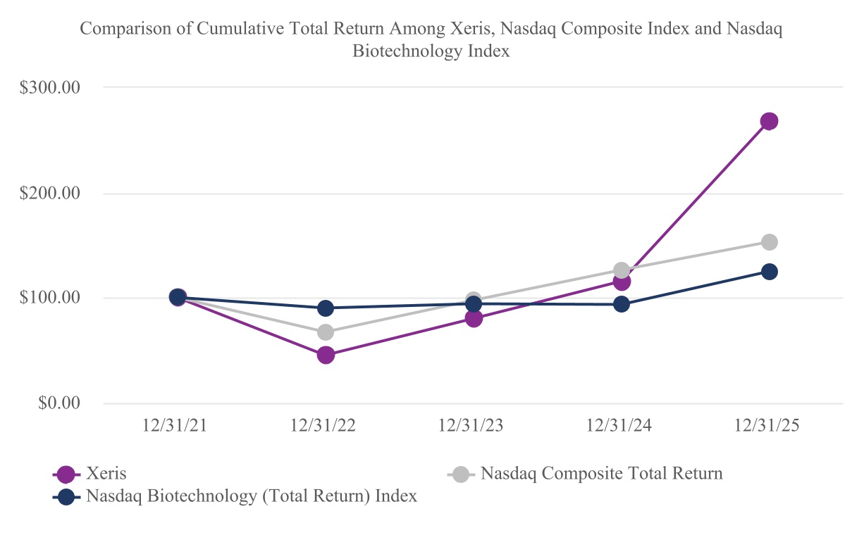

ITEM 6. [RESERVED]

74
Table of Contents
ITEM 7. MANAGEMENT’S DISCUSSION AND ANALYSIS OF FINANCIAL CONDITION AND RESULTS OF OPERATIONS

The following discussion of our financial condition and results of operations should be read in conjunction with our consolidated financial statements and related notes appearing elsewhere in this Annual Report on Form 10-K ("Annual Report"). This discussion contains forward-looking statements that involve significant risks and uncertainties. Our actual results could differ materially from those discussed in these forward-looking statements. Factors that could cause or contribute to such differences include, but are not limited to, those set forth in Part I, Item 1A. Risk Factors, of this Annual Report. This discussion and analysis compares 2025 results to 2024. For discussion and analysis that compares 2024 results to 2023, see Item 7. Management's Discussion and Analysis of Financial Condition and Results of Operations in Part II, Item 7. of this Annual Report for the year ended December 31, 2024.

Overview
Xeris Biopharma Holdings, Inc. along with its subsidiaries, is referenced herein as the "Company", "Xeris", "Xeris Biopharma", "we" or "our". Throughout this document, unless otherwise noted, references to Gvoke include Gvoke PFS, Gvoke HypoPen, and Gvoke Kit.
We are a commercial-stage biopharmaceutical company focused on developing and commercializing therapies for people with chronic endocrine and neurological diseases in the United States. We offer Recorlev for the treatment of endogenous hypercortisolemia in patients with Cushing’s syndrome, Gvoke for the treatment of severe hypoglycemia, and Keveyis for the treatment of Primary Periodic Paralysis ("PPP"). We are advancing our Phase 3-ready pipeline product, XP-8121, once-weekly subcutaneous ("SC") levothyroxine, which leverages our proprietary technology XeriSol.
Financing
We have funded our operations to date primarily with proceeds from the sale of our common stock and debt financing.
For the year ended December 31, 2025 we reported a net income of $0.6 million. For the year ended December 31, 2024 we reported a net loss of $54.8 million. The year ended December 31, 2025 is the first year we have been profitable since inception, and, as of December 31, 2025, our accumulated deficit was $671.3 million. In the near term, we may incur net losses as we:
 |  |  | < |  |  |  |  |  | continue our marketing and selling efforts related to commercialization of Recorlev, Gvoke and Keveyis;
 |  |  | < |  |  |  |  |  | continue our research and development efforts;
 |  |  | < |  |  |  |  |  | continue to operate as a public company; and
 |  |  | < |  |  |  |  |  | continue to fund our operations with an increased cost of borrowing due to a higher interest rate environment and tighter lending requirements.
We may continue to seek public equity and debt financing to meet our capital requirements. There can be no assurance that such funding may be available to us on acceptable terms, or at all, or that we will be able to commercialize our product candidates, if approved. In addition, we may not be profitable even if we commercialize any of our product candidates.

Components of our Results of Operations
The following discussion sets forth certain components of the statement of operations of Xeris for the year ended December 31, 2025 and 2024 as well as factors that impact those items.
Product revenue, net
Product revenue, net, represents gross product sales less estimated allowances for patient copay assistance programs, prompt payment discounts, payor rebates, chargebacks, service fees, and product returns, all of which are recorded at the time of sale to the pharmaceutical wholesaler or other customer. We apply significant judgment and estimates in determining some of these allowances. If actual results differ from our estimates, we make adjustments to these allowances in the period in which the actual results or updates to estimates become known.
Royalty, contract and other revenue
Royalty and contract revenue is recognized as earned in accordance with contract terms when it can be reasonably estimated and collectability is reasonably assured. Revenue generated from various collaboration and technology partnerships are included in this line item.
Cost of goods sold
Cost of goods sold primarily includes product costs, which include all costs directly related to the purchase of raw materials, charges from our contract manufacturing organizations, and manufacturing overhead costs, as well as shipping and distribution charges. Cost of goods sold also includes losses from excess, slow-moving or obsolete inventory and inventory purchase commitments, if any.
75
Table of Contents
Research and development expenses
Research and development expenses consist of expenses incurred in connection with the discovery and development of our products and product candidates. We recognize research and development expenses as incurred. Expenses that are paid in advance of performance are capitalized until services are provided or goods are delivered. We track external research and development costs by project, however, personnel related expenses related to research and development are not allocated by project. Research and development expenses primarily include:
 |  |  | < |  |  |  |  |  | the cost of acquiring and manufacturing preclinical study and clinical trial materials and manufacturing costs related to commercial production and scale-up until a product is approved and initially available for commercial sale;
 |  |  | < |  |  |  |  |  | expenses incurred under agreements with contract research organizations ("CROs") as well as investigative sites and consultants that conduct our preclinical studies and clinical trials;
 |  |  | < |  |  |  |  |  | personnel-related expenses, which include salaries, benefits and stock-based compensation;
 |  |  | < |  |  |  |  |  | laboratory materials and supplies used to support our research activities;
 |  |  | < |  |  |  |  |  | outsourced product development services;
 |  |  | < |  |  |  |  |  | expenses relating to regulatory activities, including filing fees paid to regulatory agencies; and
 |  |  | < |  |  |  |  |  | allocated expenses for facility-related costs.
Research and development activities are central to our business model. We expect to continue to incur significant research and development expenses as we advance our pipeline candidates and in particular plan and conduct clinical trials, prepare regulatory filings for our product candidates, and utilize internal resources to support these efforts.
Our research and development expenses may vary significantly over time due to uncertainties relating to the timing and results of our clinical trials, feedback received from interactions with the FDA and the timing of regulatory approvals.
Selling, general and administrative expenses
Selling, general and administrative expenses consist primarily of compensation and related personnel costs, marketing and selling expenses, professional fees and facility costs not otherwise included in research and development expenses.
Amortization of intangible assets
Amortization of intangible assets relates to the amortization of our products: Recorlev and Keveyis. These two intangible assets are being amortized over a five-year and fourteen-year period, respectively, using the straight-line method.
Other income (expense)
Other income (expense) consists primarily of interest expense related to our loan and convertible debt, interest income earned on deposits and investments, debt refinancing costs and gains and losses on the change in fair value of the Contingent Value Rights ("CVRs").

Results of Operations
The following table summarizes our results of operations for the years ended December 31, 2025 and 2024 (in thousands):
76
Table of Contents
 |  |  |  |  |  |  | Years Ended December 31, |  |  |  |  | Change
 |  |  |  |  |  |  |  |  | 2025 |  |  | 2024 |  |  |  |  |  |  | $ |  |  | %
Product revenue, net:
Recorlev |  |  |  |  |  |  |  |  | $ | 139,283 |  | $ | 64,277 |  |  |  |  |  | $ | 75,006 |  | 116.7
Gvoke |  |  |  |  |  |  |  |  | 94,108 |  |  | 82,829 |  |  |  |  |  |  | 11,279 |  |  | 13.6
Keveyis |  |  |  |  |  |  |  |  | 47,649 |  |  | 49,530 |  |  |  |  |  |  | (1,881) |  |  | (3.8)
Other product revenue |  |  |  |  |  |  |  |  | 1,963 |  |  | — |  |  |  |  |  |  | 1,963 |  |  | —
Product revenue, net |  |  |  |  |  |  |  |  | 283,003 |  |  | 196,636 |  |  |  |  |  |  | 86,367 |  |  | 43.9
Royalty, contract and other revenue |  |  |  |  |  |  |  |  | 8,842 |  |  | 6,434 |  |  |  |  |  |  | 2,408 |  |  | 37.4
Total revenue |  |  |  |  |  |  |  |  | 291,845 |  |  | 203,070 |  |  |  |  |  |  | 88,775 |  |  | 43.7
Cost and expenses:
Cost of goods sold, excluding amortization of intangible assets |  |  |  |  |  |  |  |  | 42,569 |  |  | 36,832 |  |  |  |  |  |  | 5,737 |  |  | 15.6
Research and development |  |  |  |  |  |  |  |  | 31,165 |  |  | 25,560 |  |  |  |  |  |  | 5,605 |  |  | 21.9
Selling, general and administrative |  |  |  |  |  |  |  |  | 182,372 |  |  | 163,481 |  |  |  |  |  |  | 18,891 |  |  | 11.6
Amortization of intangible assets |  |  |  |  |  |  |  |  | 10,843 |  |  | 10,843 |  |  |  |  |  |  | — |  |  | —
Total cost and expenses |  |  |  |  |  |  |  |  | 266,949 |  |  | 236,716 |  |  |  |  |  |  | 30,233 |  |  | 12.8
Income (loss) from operations |  |  |  |  |  |  |  |  | 24,896 |  |  | (33,646) |  |  |  |  |  |  | 58,542 |  |  | 174.0
Other income (expense):
Interest and other income |  |  |  |  |  |  |  |  | 4,742 |  |  | 5,321 |  |  |  |  |  |  | (579) |  |  | (10.9)
Debt refinancing costs |  |  |  |  |  |  |  |  | — |  |  | (2,690) |  |  |  |  |  |  | 2,690 |  |  | 100.0
Interest expense |  |  |  |  |  |  |  |  | (29,084) |  |  | (30,485) |  |  |  |  |  |  | 1,401 |  |  | (4.6)
Change in fair value of warrants |  |  |  |  |  |  |  |  | — |  |  | 8 |  |  |  |  |  |  | (8) |  |  | (100.0)
Change in fair value of contingent value rights |  |  |  |  |  |  |  |  | — |  |  | 4,388 |  |  |  |  |  |  | (4,388) |  |  | (100.0)
Total other expense |  |  |  |  |  |  |  |  | (24,342) |  |  | (23,458) |  |  |  |  |  |  | (884) |  |  | 3.8
Net income (loss) before income taxes |  |  |  |  |  |  |  |  | 554 |  |  | (57,104) |  |  |  |  |  |  | 57,658 |  |  | 101.0
Income tax benefit |  |  |  |  |  |  |  |  | — |  |  | 2,268 |  |  |  |  |  |  | (2,268) |  |  | 100.0
Net income (loss) |  |  |  |  |  |  |  |  | $ | 554 |  | $ | (54,836) |  |  |  |  |  | $ | 55,390 |  | 101.0
Product revenue, net
Recorlev
Net revenue increased by $75.0 million or 116.7% for the year ended December 31, 2025 compared to the year ended December 31, 2024. The increase was due to higher volume ($79.6 million or 123.9%), primarily driven by increased patient demand, offset by unfavorable net pricing ($4.6 million or 7.2%).
Gvoke
Net revenue increased by $11.3 million or 13.6% for the year ended December 31, 2025 compared to the year ended December 31, 2024. The increase was due to favorable net pricing ($8.6 million or 10.4%) and higher volume ($2.7 million or 3.2%).
Keveyis
Net revenue decreased by $1.9 million or 3.8% for the year ended December 31, 2025 compared to the year ended December 31, 2024. The decrease was due to unfavorable net pricing ($5.0 million or 10.1%), offset by higher volume ($3.1 million or 6.3%).
Other product revenue
Net revenue increased by $2.0 million for the year ended December 31, 2025. This includes sales of our products to commercialization partners.
Royalty, contract and other revenue
Royalty, contract and other revenue increased $2.4 million for the year ended December 31, 2025 compared to the year ended December 31, 2024. The increase primarily reflects the recognition of milestones from partnership agreements.
77
Table of Contents
Cost of goods sold
Cost of goods sold increased by $5.7 million or 15.6% for the year ended December 31, 2025 compared to the same period ended December 31, 2024.
Cost of goods sold as a percent of total revenue improved by 3.7%, to 15.0% for the year ended December 31, 2025 compared to 18.7% for the same period ended December 31, 2024, primarily due to higher sales of products with a lower cost of goods sold ($8.9 million or 4.5%), offset by a one-time credit for Keveyis purchased in 2024 ($1.6 million or 0.8%).
Research and development expenses
Research and development expenses increased by $5.6 million or 21.9% for the year ended December 31, 2025 compared to the same period ended December 31, 2024.
The following table summarizes our research and development expenses by type for the year ended December 31, 2025 and 2024:
 |  |  |  |  |  |  | Years Ended December 31, |  |  |  |  | Change
 |  |  |  |  |  |  |  |  | 2025 |  |  | 2024 |  |  |  |  |  |  | $ |  |  | %
Project specific expenses:
Pipeline |  |  |  |  |  |  |  |  | $ | 9,681 |  | $ | 6,945 |  |  |  |  |  | $ | 2,736 |  | 39.4
Technology development (1) |  |  |  |  |  |  |  |  | 1,005 |  |  | 1,160 |  |  |  |  |  |  | (155) |  |  | (13.4)
Personnel related expenses |  |  |  |  |  |  |  |  | 17,818 |  |  | 14,296 |  |  |  |  |  |  | 3,522 |  |  | 24.6
Lab supplies and equipment depreciation |  |  |  |  |  |  |  |  | 1,422 |  |  | 1,655 |  |  |  |  |  |  | (233) |  |  | (14.1)
Other |  |  |  |  |  |  |  |  | 1,239 |  |  | 1,504 |  |  |  |  |  |  | (265) |  |  | (17.6)
Total |  |  |  |  |  |  |  |  | $ | 31,165 |  | $ | 25,560 |  |  |  |  |  | $ | 5,605 |  | 21.9
(1) Technology development represents any investment in our proprietary technology platforms, XeriSol and XeriJect.
Selling, general and administrative expenses
Selling, general and administrative expenses increased $18.9 million or 11.6% for the year ended December 31, 2025 compared to the same period ended December 31, 2024. This increase was primarily due to higher personnel related expense ($13.5 million), largely due to personnel-related expenses to support the commercial enterprise, including the Recorlev expansion.
Amortization of intangible assets
For the years ended December 31, 2025 and December 31, 2024, amortization of intangible assets were both $10.8 million, respectively.
Other income (expense)
For the year ended December 31, 2025, interest expense decreased $1.4 million or 4.6% compared to the year ended December 31, 2024. The decrease is primarily due to a lower principal amount of debt outstanding during the period.
For the year ended December 31, 2025, interest and other income decreased $0.6 million or 10.9% compared to the year ended December 31, 2024. The decrease is driven by the decline in interest rates which began in the later half of 2024, resulting in lower overall interest income.

Liquidity and Capital Resources
Our primary uses of cash are to fund costs related to the manufacturing, marketing and selling of products, the research and development of our product candidates, general and administrative expenses and working capital requirements. Historically, we have funded our operations primarily through private placements of convertible preferred stock, public equity offerings of common stock, and the issuance of debt.
Financing Transactions
In May 2022, we entered into an Open Market Sale Agreement with Jefferies LLC, as agent, dated May 11, 2022 ("Sales Agreement") for the offering, issuance and sale of up to a maximum aggregate offering price of $75.0 million of our common stock. The Sales Agreement will terminate upon the earlier of (i) the sale of all shares of common stock subject to the Sales Agreement and (ii) the termination of the Sales Agreement as permitted therein. Either party may each terminate the Sales Agreement at any time upon ten days’ prior notice. To date, we have not sold any shares pursuant to the Sales Agreement.
In September 2023, we completed the exchange of $32.0 million in aggregate principal amount of our 5.00% Convertible Senior Note due 2025 ("2025 Convertible Notes") for $33.6 million in aggregate principal amount of our 8.00% Convertible Senior Note due 2028 ("2028 Convertible Notes").
78
Table of Contents
In March 2024, we entered into an Amended and Restated Credit Agreement and Guaranty (the "Amended and Restated Credit Agreement") with the lenders from time to time parties thereto (the "Lenders") and Hayfin Services LLP, as administrative agent for the New Lenders, pursuant to which we and our subsidiaries granted a first priority security interest on substantially all of our assets, including intellectual property, subject to certain exceptions. The Amended and Restated Credit Agreement provides for the Lenders to extend $200.0 million in term loans to the Company on the closing date and up to an additional $15.2 million in additional term loans, which additional term loans are available only to redeem the Company's then outstanding 2025 Convertible Notes.
In March and April of 2025, holders of the 2025 Convertible Senior Notes converted the outstanding $15.2 million in aggregate principal amount of the notes into 4,978,152 shares of the Company's common stock. As of December 31, 2025, the outstanding balance of the 2028 Convertible Notes was $33.6 million.
Capital Resources and Funding Requirements
We have an accumulated deficit of $671.3 million at December 31, 2025. Based on our current operating plans and existing working capital at December 31, 2025, we believe that our cash resources are sufficient to sustain operations and capital expenditure requirements for at least the next twelve months. We may incur substantial additional expenditures in the near term to support the marketing and selling of Recorlev, Gvoke and Keveyis as well as our ongoing research and development activities. We may incur net losses for at least the next twelve months. Our ability to fund the marketing and selling of Recorlev, Gvoke and Keveyis, as well as our product development and clinical operations, including completion of future clinical trials, will depend on the amount and timing of cash received from product revenue and potential future financings. Our future capital requirements will depend on many factors, including, but not limited to:
 |  |  | < |  |  |  |  |  | our degree of success in commercializing Recorlev, Gvoke and Keveyis;
 |  |  | < |  |  |  |  |  | the costs of commercialization activities, including product marketing, sales and distribution;
 |  |  | < |  |  |  |  |  | the costs, timing and outcomes of clinical trials and regulatory reviews associated with our product candidates;
 |  |  | < |  |  |  |  |  | the effect on our product development activities of actions taken by the FDA or other regulatory authorities;
 |  |  | < |  |  |  |  |  | the number and types of future products we develop and commercialize;
 |  |  | < |  |  |  |  |  | the emergence of competing technologies and products and other adverse market developments; and
 |  |  | < |  |  |  |  |  | the costs of preparing, filing and prosecuting patent applications and maintaining, enforcing and defending intellectual property-related claims.
As we continue the marketing and selling of Recorlev, Gvoke and Keveyis, we may not generate a sufficient amount of product revenue to fund our cash requirements. Accordingly, we may need to obtain additional financing in the future which may include public or private debt and/or equity financings. As detailed in "Note 2 – Liquidity and Capital Resources", there can be no assurance that such funding may be available to us on acceptable terms, or at all, or that we will be able to successfully market and sell Recorlev, Gvoke and Keveyis.

Cash Flows |  |  | Years Ended December 31,
(in thousands) |  |  | 2025 |  |  |  |  |  | 2024
Net cash provided by (used in) operating activities |  |  | $ | 28,626 |  |  |  |  | $ | (36,981)
Net cash provided by (used in) investing activities |  |  | $ | (696) |  |  |  |  | $ | 4,883
Net cash provided by financing activities |  |  | $ | 11,389 |  |  |  |  | $ | 36,168
Operating Activities
Net cash provided by operating activities was $28.6 million for the year ended December 31, 2025, compared to $37.0 million used in operating activities for the year ended December 31, 2024. The increase in net cash provided by operating activities was primarily driven by higher product sales. For a discussion regarding product revenue, net and increases in spending, refer to "Results of Operations" included in this "Item 7 - Management's Discussion and Analysis of Financial Condition and Results of Operations" of Part I of this Annual Report.
Investing Activities
Net cash used in investing activities was $696.0 thousand for the year ended December 31, 2025, compared to $4.9 million in net cash provided by investing activities for the year ended December 31, 2024. The decrease in cash provided by investing activities for the year ended December 31, 2025 was due to was due to fewer purchases of short-term investments.
Financing Activities
Net cash provided by financing activities was $11.4 million for the year ended December 31, 2025, compared to $36.2 million provided by financing activities for the year ended December 31, 2024. The net cash provided by financing activities for the year ended December 31, 2025 was driven by proceeds from the exercise of stock awards and issuance of common shares in settlement of
79
Table of Contents
warrants of $20.7 million offset by repurchase of common stock withheld for taxes of $10.9 million. The net cash provided by financing activities in the year ended December 31, 2024 was primarily due to the net proceeds of $38.2 million from the term loan made to the Company on the closing date of the Amended and Restated Credit Agreement.

CRITICAL ACCOUNTING POLICIES AND USE OF ESTIMATES AND ASSUMPTIONS
Our management’s discussion and analysis of our financial condition and results of operations on our financial statements have been prepared in accordance with generally accepted accounting principles ("GAAP") in the United States. The preparation of these financial statements requires us to make estimates that affect the reported amounts of assets and liabilities and the disclosure of contingent assets and liabilities at the date of the financial statements as well as the reported revenues and expenses during the reporting periods. On an ongoing basis, we evaluate our estimates and judgments, including, among others, those related to revenue recognition and contingent considerations. We base our estimates on historical experience and on various other factors we believe to be appropriate under the circumstances. Actual results may differ from these estimates under different assumptions or conditions.
We believe that the accounting policies discussed below are critical to understanding our historical and future performance, as these policies relate to the more significant areas involving management’s judgments and estimates. Our significant accounting policies are more fully described in "Note 2 - Summary of Significant Accounting Policies" of Item 8 in this Annual Report.
Revenue recognition
We apply the guidance in Accounting Standards Codification ("ASC") Topic 606, Revenue from Contracts with Customers, to all contracts with customers within the scope of the standard.
We sell product primarily to wholesalers or a specialty pharmacy that subsequently resell to retail pharmacies or patients. We enter into arrangements with payors, group purchasing organizations, and healthcare providers that provide for government-mandated or privately-negotiated rebates, chargebacks and discounts related to our products. We currently sell Recorlev, Gvoke and Keveyis in the United States.
Revenue is recognized when our customer (e.g., a wholesaler or specialty pharmacy) obtains control of promised goods, which is when our obligations under the terms of the contract with the customer are satisfied, based on the consideration we expect to receive in exchange for those goods.
Revenues are recorded at the net product sales price, which includes estimated allowances for patient copay assistance programs, prompt payment discounts, payor rebates, chargebacks, service fees, and product returns, all of which are recorded at the time of sale to the pharmaceutical wholesaler or other customer. The Company applies significant judgments and estimates in determining some of these allowances. If actual results differ from its estimates, adjustments are made to these allowances in the period in which the actual results or updates to estimates become known.
Government Rebates
We participate in certain federal and state government rebate programs such as the Medicaid Drug Rebate Program, TRICARE Retail Refunds Program, and Medicare Part D Program. We accrue estimated rebates and discounts based on actual average rebate amounts and estimated percent of product that will be prescribed to qualified patients and record the rebates as a reduction of product revenue. Accrued government rebates are included in accrued trade discounts and rebates on the consolidated balance sheets.
Commercial Rebates
We contract with certain private payor organizations, primarily insurance companies and pharmacy benefit managers, to provide rebates with respect to utilization of the products and contracted formulary status. We accrue estimated rebates based on actual average rebate amounts and estimated percent of product that will be prescribed to qualified patients and record the rebate as a reduction of product revenue. Accrued commercial rebates are included in accrued trade discounts and rebates on the consolidated balance sheets.
Product Returns
For some products, our customers generally have the right to return product during the period beginning six months prior to the product expiration date and up to one year after the product expiration date. We use actual return data to estimate the provision for returns. In a reporting period, we may decide to constrain revenue for product returns based on information from various sources, including channel inventory levels, inventory dating, prescription data, the expiration dates of product currently being shipped, price changes of competitive products and introductions of generic products. We record estimated product returns in accrued returns reserve on the consolidated balance sheets and as a reduction of product revenue.

NEW ACCOUNTING STANDARDS
Refer to "Note 2 - Basis of presentation and summary of significant accounting policies and estimates," for a description of recent accounting pronouncements applicable to our financial statements.

80
Table of Contents
ITEM 7A. QUANTITATIVE AND QUALITATIVE DISCLOSURES ABOUT MARKET RISK
We are subject to certain market risks arising from transactions in the normal course of business, principally risk associated with interest rate and foreign currency exchange rate fluctuations.
Interest Rate Risk
Cash, Cash Equivalents Restricted Cash and Investments—We are exposed to the risk of interest rate fluctuations on the interest income earned on our cash, cash equivalents, restricted cash and investments. A hypothetical one-percentage point increase or decrease in interest rates applicable to our cash, cash equivalents, restricted cash and investments outstanding at December 31, 2025 would increase or decrease interest income by approximately $1.0 million on an annual basis.
Long-term Debt—Our interest rate risk relates primarily to the United States dollar SOFR-indexed borrowings. Based on our outstanding borrowings pursuant to the Amended and Restated Credit Agreement, interest is incurred at a floating per annum rate in an amount equal to the sum of (i) 6.95% (or 5.95% if the replacement rate is in effect) plus (ii) the greater of (x) the forward-looking term rate based on SOFR for a three month tenor (or the replacement rate, if applicable), and (y) 2.00% per annum. The remaining balance of unamortized debt issuance costs have been reflected as a direct reduction to the loan balance. Interest on the 2028 Convertible Notes is assessed at a fixed rate of 8.0% annually and therefore does not subject us to interest rate risk.
Foreign Currency Exchange Risk
We contract with organizations outside the United States at times. We may be subject to fluctuations in foreign currency exchange rates in connection with certain of these agreements. Transactions denominated in currencies other than the functional currency are recorded based on exchange rates at the time such transactions arise. Net foreign currency gains and losses did not have a material effect on our results of operations for the year ended December 31, 2025.

81
Table of Contents
ITEM 8. FINANCIAL STATEMENTS AND SUPPLEMENTARY DATA

Index to Financial Statements
 |  |  |  |  |  |  |  |  |  |  |  |  |  |  | Page
Management’s Report on Internal Control Over Financial Reporting |  |  |  |  |  |  |  |  |  |  |  |  |  |  | 83
Reports of Independent Registered Public Accounting Firm (PCAOB ID: 42) |  |  |  |  |  |  |  |  |  |  |  |  |  |  | 84
Financial Statements
 |  |  | Consolidated Balance Sheets as of December 31, 2025 and December 31, 2024 |  |  |  |  |  |  |  |  |  |  |  | 87
 |  |  | Consolidated Statements of Operations and Comprehensive Income (Loss) for the years ended December 31, 2025, 2024 and 2023 |  |  |  |  |  |  |  |  |  |  |  | 88
 |  |  | Consolidated Statements of Stockholders' Equity (Deficit) for the years ended December 31, 2025, 2024 and 2023 |  |  |  |  |  |  |  |  |  |  |  | 89
 |  |  | Consolidated Statements of Cash Flows for the years ended December 31, 2025, 2024 and 2023 |  |  |  |  |  |  |  |  |  |  |  | 90
 |  |  | Notes to Consolidated Financial Statements |  |  |  |  |  |  |  |  |  |  |  | 92

82
Table of Contents
MANAGEMENT’S REPORT ON INTERNAL CONTROL OVER FINANCIAL REPORTING
The management of Xeris is responsible for establishing and maintaining adequate internal control over financial reporting. Management has designed our internal control over financial reporting to provide reasonable assurance that our published financial statements are fairly presented, in all material respects, in conformity with generally accepted accounting principles.
Management is required by paragraph (c) of Rule 13a-15 of the Securities Exchange Act of 1934, as amended, to assess the effectiveness of our internal control over financial reporting as of each year end. In making this assessment, management used the Internal Control - Integrated Framework (2013) by the Committee of Sponsoring Organizations of the Treadway Commission (COSO).
Management conducted the required assessment of the effectiveness of our internal control over financial reporting as of December 31, 2025. Based upon this assessment, management believes that our internal control over financial reporting is effective as of December 31, 2025.
Ernst & Young LLP, the independent registered public accounting firm that audited our financial statements included in this Annual Report, has also audited our internal control over financial reporting. Their attestation report follows this report of management.

83
Table of Contents
Report of Independent Registered Public Accounting Firm
To the Stockholders and the Board of Directors of Xeris Biopharma Holdings, Inc.
Opinion on the Financial Statements
We have audited the accompanying consolidated balance sheets of Xeris Biopharma Holdings, Inc. (the Company) as of December 31, 2025 and 2024, the related consolidated statements of operations and comprehensive income (loss), stockholders' equity (deficit) and cash flows for each of the three years in the period ended December 31, 2025, and the related notes (collectively referred to as the “consolidated financial statements”). In our opinion, the consolidated financial statements present fairly, in all material respects, the financial position of the Company at December 31, 2025 and 2024, and the results of its operations and its cash flows for each of the three years in the period ended December 31, 2025, in conformity with U.S. generally accepted accounting principles.
We also have audited, in accordance with the standards of the Public Company Accounting Oversight Board (United States) (PCAOB), the Company's internal control over financial reporting as of December 31, 2025, based on criteria established in Internal Control-Integrated Framework issued by the Committee of Sponsoring Organizations of the Treadway Commission (2013 framework) and our report dated March 2, 2026 expressed an unqualified opinion thereon.
Basis for Opinion
These financial statements are the responsibility of the Company's management. Our responsibility is to express an opinion on the Company’s financial statements based on our audits. We are a public accounting firm registered with the PCAOB and are required to be independent with respect to the Company in accordance with the U.S. federal securities laws and the applicable rules and regulations of the Securities and Exchange Commission and the PCAOB.
We conducted our audits in accordance with the standards of the PCAOB. Those standards require that we plan and perform the audit to obtain reasonable assurance about whether the financial statements are free of material misstatement, whether due to error or fraud. Our audits included performing procedures to assess the risks of material misstatement of the financial statements, whether due to error or fraud, and performing procedures that respond to those risks. Such procedures included examining, on a test basis, evidence regarding the amounts and disclosures in the financial statements. Our audits also included evaluating the accounting principles used and significant estimates made by management, as well as evaluating the overall presentation of the financial statements. We believe that our audits provide a reasonable basis for our opinion.
Critical Audit Matter
The critical audit matter communicated below is a matter arising from the current period audit of the financial statements that was communicated or required to be communicated to the audit committee and that: (1) relates to accounts or disclosures that are material to the financial statements and (2) involved our especially challenging, subjective or complex judgments. The communication of the critical audit matter does not alter in any way our opinion on the consolidated financial statements, taken as a whole, and we are not, by communicating the critical audit matter below, providing a separate opinion on the critical audit matter or on the accounts or disclosures to which it relates.
 |  |  | Valuation of the sales rebate accrual
Description of the Matter |  |  | As described in Note 2 to the consolidated financial statements under the caption “Revenue Recognition,” the Company establishes a sales rebate accrual in the same period the related sales occur. At December 31, 2025, the Company had $43.3 million of accrued trade discounts and rebates, a large portion of which related to its sales rebate accruals for commercial and governmental rebate programs. The Company establishes its sales rebate accrual based on the applicable price of the products sold and related estimated payor rebate terms, and the estimated lag time between the sale and payment of the rebate.  Auditing the sales rebate accrual was complex and required significant auditor judgment because the accrual considers two subjective assumptions. These two assumptions are the lag time between the sale to the customer and payment of the rebate, and the final payer related to product sales that determines the applicable rebate terms. In determining these assumptions, the Company uses various sources of information, including historical data, changes to rebate programs and contract terms, legislative changes, or other significant events which indicate a change in the reserve is appropriate.
How We Addressed the Matter in Our Audit |  |  | We obtained an understanding, evaluated the design and tested the operating effectiveness of controls over the Company’s sales rebate accrual. This included testing controls over management’s review of the significant assumptions and other inputs used in the estimation of the sales rebate accrual, including the significant assumptions discussed above. The testing was inclusive of management’s controls to evaluate the accuracy of its reserve judgments to actual rebates paid, rebate validation and processing, and controls to ensure that the data used to evaluate and support the significant assumptions was complete and accurate.  To test the sales rebate accruals, our audit procedures included, among others, understanding and evaluating the significant assumptions and underlying data used in management’s calculations. Our testing of significant assumptions included corroboration of inputs to historical information and source data. We assessed the historical accuracy of management’s estimates by comparing actual activity to previous estimates and performed analytical procedures, based on historical data sources, to evaluate the completeness of the reserves.
84
Table of Contents

/s/ Ernst & Young LLP
We have served as the Company's auditor since 2023.
Grand Rapids, Michigan
March 2, 2026

85
Table of Contents
Report of Independent Registered Public Accounting Firm
To the Stockholders and the Board of Directors of Xeris Biopharma Holdings, Inc.
Opinion on Internal Control Over Financial Reporting
We have audited Xeris Biopharma Holdings, Inc.’s internal control over financial reporting as of December 31, 2025, based on criteria established in Internal Control—Integrated Framework issued by the Committee of Sponsoring Organizations of the Treadway Commission (2013 framework) (the COSO criteria). In our opinion, Xeris Biopharma Holdings, Inc. (the Company) maintained, in all material respects, effective internal control over financial reporting as of December 31, 2025, based on the COSO criteria.
We also have audited, in accordance with the standards of the Public Company Accounting Oversight Board (United States) (PCAOB), the consolidated balance sheets of the Company as of December 31, 2025 and 2024, the related consolidated statements of operations and comprehensive income (loss), stockholders' equity (deficit) and cash flows for each of the three years in the period ended December 31, 2025, and the related notes and our report dated March 2, 2026 expressed an unqualified opinion thereon.
Basis for Opinion
The Company’s management is responsible for maintaining effective internal control over financial reporting and for its assessment of the effectiveness of internal control over financial reporting included in the accompanying Management’s Report on Internal Control Over Financial Reporting. Our responsibility is to express an opinion on the Company’s internal control over financial reporting based on our audit. We are a public accounting firm registered with the PCAOB and are required to be independent with respect to the Company in accordance with the U.S. federal securities laws and the applicable rules and regulations of the Securities and Exchange Commission and the PCAOB.
We conducted our audit in accordance with the standards of the PCAOB. Those standards require that we plan and perform the audit to obtain reasonable assurance about whether effective internal control over financial reporting was maintained in all material respects.
Our audit included obtaining an understanding of internal control over financial reporting, assessing the risk that a material weakness exists, testing and evaluating the design and operating effectiveness of internal control based on the assessed risk, and performing such other procedures as we considered necessary in the circumstances. We believe that our audit provides a reasonable basis for our opinion.
Definition and Limitations of Internal Control Over Financial Reporting
A company’s internal control over financial reporting is a process designed to provide reasonable assurance regarding the reliability of financial reporting and the preparation of financial statements for external purposes in accordance with generally accepted accounting principles. A company’s internal control over financial reporting includes those policies and procedures that (1) pertain to the maintenance of records that, in reasonable detail, accurately and fairly reflect the transactions and dispositions of the assets of the company; (2) provide reasonable assurance that transactions are recorded as necessary to permit preparation of financial statements in accordance with generally accepted accounting principles, and that receipts and expenditures of the company are being made only in accordance with authorizations of management and directors of the company; and (3) provide reasonable assurance regarding prevention or timely detection of unauthorized acquisition, use, or disposition of the company’s assets that could have a material effect on the financial statements.
Because of its inherent limitations, internal control over financial reporting may not prevent or detect misstatements. Also, projections of any evaluation of effectiveness to future periods are subject to the risk that controls may become inadequate because of changes in conditions, or that the degree of compliance with the policies or procedures may deteriorate.
/s/ Ernst & Young LLP
Grand Rapids, Michigan
March 2, 2026

86
Table of Contents
XERIS BIOPHARMA HOLDINGS, INC.
Consolidated Balance Sheets
(in thousands, except share and par value)
 |  |  | December 31, 2025 |  |  |  |  |  | December 31, 2024
Assets
Current assets:
Cash and cash equivalents |  |  | $ | 111,042 |  |  |  |  | $ | 71,621
Trade accounts receivable, net |  |  | 51,050 |  |  |  |  |  | 40,415
Inventory, net |  |  | 68,673 |  |  |  |  |  | 48,175
Prepaid expenses and other current assets |  |  | 9,548 |  |  |  |  |  | 7,451
Total current assets |  |  | 240,313 |  |  |  |  |  | 167,662
Property and equipment, net |  |  | 4,945 |  |  |  |  |  | 5,562
Operating lease right-of-use assets |  |  | 22,112 |  |  |  |  |  | 22,649
Goodwill |  |  | 22,859 |  |  |  |  |  | 22,859
Intangible assets, net |  |  | 88,078 |  |  |  |  |  | 98,921
Other assets |  |  | 5,220 |  |  |  |  |  | 5,407
Total assets |  |  | $ | 383,527 |  |  |  |  | $ | 323,060
Liabilities and Stockholders' Equity (deficit)
Current liabilities:
Accounts payable |  |  | $ | 3,076 |  |  |  |  | $ | 2,290
Current portion of long-term debt |  |  | — |  |  |  |  |  | 15,102
Current operating lease liabilities |  |  | 6,232 |  |  |  |  |  | 6,080
Other accrued liabilities |  |  | 33,155 |  |  |  |  |  | 27,716
Accrued trade discounts and rebates |  |  | 43,253 |  |  |  |  |  | 29,084
Accrued returns reserve |  |  | 18,969 |  |  |  |  |  | 19,082
Other current liabilities |  |  | 4,889 |  |  |  |  |  | 1,089
Total current liabilities |  |  | 109,574 |  |  |  |  |  | 100,443
Long-term debt, net of current portion and unamortized debt issuance costs |  |  | 220,335 |  |  |  |  |  | 217,006
Non-current operating lease liabilities |  |  | 31,531 |  |  |  |  |  | 33,259
Other liabilities |  |  | 8,398 |  |  |  |  |  | 1,967
Total liabilities |  |  | 369,838 |  |  |  |  |  | 352,675
Commitments and contingencies (Note 14)
Stockholders' equity (deficit):
Preferred stock—par value $0.0001, 25,000,000 shares and 25,000,000 shares authorized and no shares issued and outstanding as of December 31, 2025 and December 31, 2024, respectively |  |  | — |  |  |  |  |  | —
Common stock—par value $0.0001, 350,000,000 shares and 350,000,000 shares authorized as of December 31, 2025 and December 31, 2024, respectively; 166,215,410 and 149,429,410 shares issued and outstanding as of December 31, 2025 and December 31, 2024, respectively |  |  | 17 |  |  |  |  |  | 15
Additional paid in capital |  |  | 685,004 |  |  |  |  |  | 642,256
Accumulated deficit |  |  | (671,307) |  |  |  |  |  | (671,861)
Accumulated other comprehensive loss |  |  | (25) |  |  |  |  |  | (25)
Total stockholders' equity (deficit) |  |  | 13,689 |  |  |  |  |  | (29,615)
Total liabilities and stockholders' equity (deficit) |  |  | $ | 383,527 |  |  |  |  | $ | 323,060
See accompanying notes to consolidated financial statements.

87
Table of Contents
XERIS BIOPHARMA HOLDINGS, INC.
Consolidated Statements of Operations and Comprehensive Income (Loss)
(in thousands, except share and per share data)

 |  |  |  |  | Years Ended December 31,
 |  |  |  |  |  |  | 2025 |  |  |  |  |  | 2024 |  |  |  |  |  | 2023
Product revenue, net |  |  |  |  |  |  | $ | 283,003 |  |  |  |  | $ | 196,636 |  |  |  |  | $ | 153,364
Royalty, contract and other revenue |  |  |  |  |  |  | 8,842 |  |  |  |  |  | 6,434 |  |  |  |  |  | 10,550
Total revenue |  |  |  |  |  |  | 291,845 |  |  |  |  |  | 203,070 |  |  |  |  |  | 163,914
Costs and expenses:
Cost of goods sold |  |  |  |  |  |  | 42,569 |  |  |  |  |  | 36,832 |  |  |  |  |  | 28,645
Research and development |  |  |  |  |  |  | 31,165 |  |  |  |  |  | 25,560 |  |  |  |  |  | 22,341
Selling, general and administrative |  |  |  |  |  |  | 182,372 |  |  |  |  |  | 163,481 |  |  |  |  |  | 146,095
Amortization of intangible assets |  |  |  |  |  |  | 10,843 |  |  |  |  |  | 10,843 |  |  |  |  |  | 10,843
Total costs and expenses |  |  |  |  |  |  | 266,949 |  |  |  |  |  | 236,716 |  |  |  |  |  | 207,924
Income (loss) from operations |  |  |  |  |  |  | 24,896 |  |  |  |  |  | (33,646) |  |  |  |  |  | (44,010)
Other income (expense):
Interest and other income |  |  |  |  |  |  | 4,742 |  |  |  |  |  | 5,321 |  |  |  |  |  | 4,751
Loss on debt extinguishment, net |  |  |  |  |  |  | — |  |  |  |  |  | — |  |  |  |  |  | (2,837)
Debt refinancing costs |  |  |  |  |  |  | — |  |  |  |  |  | (2,690) |  |  |  |  |  | —
Interest expense |  |  |  |  |  |  | (29,084) |  |  |  |  |  | (30,485) |  |  |  |  |  | (26,609)
Change in fair value of warrants |  |  |  |  |  |  | — |  |  |  |  |  | 8 |  |  |  |  |  | 1
Change in fair value of contingent value rights |  |  |  |  |  |  | — |  |  |  |  |  | 4,388 |  |  |  |  |  | 5,200
Total other expense |  |  |  |  |  |  | (24,342) |  |  |  |  |  | (23,458) |  |  |  |  |  | (19,494)
Net income (loss) before income taxes |  |  |  |  |  |  | 554 |  |  |  |  |  | (57,104) |  |  |  |  |  | (63,504)
Income tax benefit |  |  |  |  |  |  | — |  |  |  |  |  | 2,268 |  |  |  |  |  | 1,249
Net income (loss) |  |  |  |  |  |  | $ | 554 |  |  |  |  | $ | (54,836) |  |  |  |  | $ | (62,255)
Other comprehensive income (loss), net of tax:
Unrealized gains (losses) on investments |  |  |  |  |  |  | — |  |  |  |  |  | — |  |  |  |  |  | (2)
Comprehensive income (loss) |  |  |  |  |  |  | $ | 554 |  |  |  |  | $ | (54,836) |  |  |  |  | $ | (62,257)
Net income (loss) per common share - basic |  |  |  |  |  |  | $ | — |  |  |  |  | $ | (0.37) |  |  |  |  | $ | (0.45)
Net income (loss) per common share - diluted |  |  |  |  |  |  | $ | — |  |  |  |  | $ | (0.37) |  |  |  |  | $ | (0.45)
Weighted average common shares outstanding:
Basic |  |  |  |  |  |  | 160,425,198 |  |  |  |  |  | 146,772,758 |  |  |  |  |  | 137,674,857
Diluted |  |  |  |  |  |  | 172,742,720 |  |  |  |  |  | 146,772,758 |  |  |  |  |  | 137,674,857
See accompanying notes to consolidated financial statements.

88
Table of Contents
XERIS BIOPHARMA HOLDINGS, INC.
Consolidated Statements of Stockholders’ Equity (Deficit)
(in thousands, except share data)

 |  |  |  |  |  | Common Stock |  |  |  |  |  |  |  |  |  |  |  | Additional Paid In  Capital |  |  |  |  |  | Accumulated Other Comprehensive  Income (Loss) |  |  |  |  |  | Accumulated Deficit |  |  |  |  |  | Total  Stockholders'  Equity (Deficit)
 |  |  |  |  |  | Shares |  |  |  |  |  | Amount
Balance, December 31, 2022 |  |  |  |  |  | 136,273,090 |  |  |  |  |  | $ | 14 |  |  |  |  | $ | 599,966 |  |  |  |  | $ | (23) |  |  |  |  | $ | (554,770) |  |  |  |  | $ | 45,187
Net loss |  |  |  |  |  | — |  |  |  |  |  | — |  |  |  |  |  | — |  |  |  |  |  | — |  |  |  |  |  | (62,255) |  |  |  |  |  | (62,255)
Exercise of stock options |  |  |  |  |  | 14,036 |  |  |  |  |  | — |  |  |  |  |  | 32 |  |  |  |  |  | — |  |  |  |  |  | — |  |  |  |  |  | 32
Vesting of restricted stock units (net of 815,177 shares withheld for tax) |  |  |  |  |  | 1,265,805 |  |  |  |  |  | — |  |  |  |  |  | (1,009) |  |  |  |  |  | — |  |  |  |  |  | — |  |  |  |  |  | (1,009)
Stock-based compensation |  |  |  |  |  | — |  |  |  |  |  | — |  |  |  |  |  | 10,716 |  |  |  |  |  | — |  |  |  |  |  | — |  |  |  |  |  | 10,716
Issuance of common stock through employee stock purchase plan |  |  |  |  |  | 577,784 |  |  |  |  |  | — |  |  |  |  |  | 549 |  |  |  |  |  | — |  |  |  |  |  | — |  |  |  |  |  | 549
Other comprehensive loss |  |  |  |  |  | — |  |  |  |  |  | — |  |  |  |  |  | — |  |  |  |  |  | (2) |  |  |  |  |  | — |  |  |  |  |  | (2)
Balance, December 31, 2023 |  |  |  |  |  | 138,130,715 |  |  |  |  |  | $ | 14 |  |  |  |  | $ | 610,254 |  |  |  |  | $ | (25) |  |  |  |  | $ | (617,025) |  |  |  |  | $ | (6,782)
Net loss |  |  |  |  |  | — |  |  |  |  |  | — |  |  |  |  |  | — |  |  |  |  |  | — |  |  |  |  |  | (54,836) |  |  |  |  |  | (54,836)
Issuance of common stock to settle contingent value rights |  |  |  |  |  | 7,525,048 |  |  |  |  |  | 1 |  |  |  |  |  | 15,802 |  |  |  |  |  | — |  |  |  |  |  | — |  |  |  |  |  | 15,803
Exercise of stock options |  |  |  |  |  | 248,900 |  |  |  |  |  | — |  |  |  |  |  | 489 |  |  |  |  |  | — |  |  |  |  |  | — |  |  |  |  |  | 489
Vesting of restricted stock units (net of 1,553,340 shares withheld for tax) |  |  |  |  |  | 2,862,527 |  |  |  |  |  | — |  |  |  |  |  | (3,734) |  |  |  |  |  | — |  |  |  |  |  | — |  |  |  |  |  | (3,734)
Stock-based compensation |  |  |  |  |  | — |  |  |  |  |  | — |  |  |  |  |  | 18,201 |  |  |  |  |  | — |  |  |  |  |  | — |  |  |  |  |  | 18,201
Issuance of common stock through employee stock purchase plan |  |  |  |  |  | 662,220 |  |  |  |  |  | — |  |  |  |  |  | 1,244 |  |  |  |  |  | — |  |  |  |  |  | — |  |  |  |  |  | 1,244
Balance, December 31, 2024 |  |  |  |  |  | 149,429,410 |  |  |  |  |  | $ | 15 |  |  |  |  | $ | 642,256 |  |  |  |  | $ | (25) |  |  |  |  | $ | (671,861) |  |  |  |  | $ | (29,615)
Net income |  |  |  |  |  | — |  |  |  |  |  | — |  |  |  |  |  | — |  |  |  |  |  | — |  |  |  |  |  | 554 |  |  |  |  |  | 554
Exercise of stock options |  |  |  |  |  | 2,991,911 |  |  |  |  |  | — |  |  |  |  |  | 11,578 |  |  |  |  |  | — |  |  |  |  |  | — |  |  |  |  |  | 11,578
Vesting of restricted stock units (net of 2,697,212 shares withheld for tax) |  |  |  |  |  | 4,953,522 |  |  |  |  |  | 1 |  |  |  |  |  | (10,877) |  |  |  |  |  | — |  |  |  |  |  | — |  |  |  |  |  | (10,876)
Stock-based compensation |  |  |  |  |  | — |  |  |  |  |  | — |  |  |  |  |  | 16,215 |  |  |  |  |  | — |  |  |  |  |  | — |  |  |  |  |  | 16,215
Issuance of common stock through employee stock purchase plan |  |  |  |  |  | 456,086 |  |  |  |  |  | — |  |  |  |  |  | 1,520 |  |  |  |  |  | — |  |  |  |  |  | — |  |  |  |  |  | 1,520
Issuance of common shares in settlement of 2025 Convertible Debt |  |  |  |  |  | 4,978,151 |  |  |  |  |  | — |  |  |  |  |  | 15,146 |  |  |  |  |  | — |  |  |  |  |  | — |  |  |  |  |  | 15,146
Issuance of common shares in settlement of warrants |  |  |  |  |  | 3,406,330 |  |  |  |  |  | 1 |  |  |  |  |  | 9,166 |  |  |  |  |  | — |  |  |  |  |  | — |  |  |  |  |  | 9,167
Balance, December 31, 2025 |  |  |  |  |  | 166,215,410 |  |  |  |  |  | $ | 17 |  |  |  |  | $ | 685,004 |  |  |  |  | $ | (25) |  |  |  |  | $ | (671,307) |  |  |  |  | $ | 13,689

See accompanying notes to consolidated financial statements.

89
Table of Contents

XERIS BIOPHARMA HOLDINGS, INC.
Consolidated Statements of Cash Flows
(in thousands)
 |  |  |  |  | Years Ended December 31,
 |  |  |  |  |  |  |  |  | 2025 |  |  |  |  |  | 2024 |  |  |  |  |  | 2023
Cash flows from operating activities:
Net income (loss) |  |  |  |  |  |  |  |  | $ | 554 |  |  |  |  | $ | (54,836) |  |  |  |  | $ | (62,255)
Adjustments to reconcile net income (loss) to net cash provided by (used in) operating activities:
Depreciation |  |  |  |  |  |  |  |  | 1,313 |  |  |  |  |  | 1,227 |  |  |  |  |  | 1,487
Amortization of intangible assets |  |  |  |  |  |  |  |  | 10,843 |  |  |  |  |  | 10,843 |  |  |  |  |  | 10,843
Amortization of premium/discount on investments |  |  |  |  |  |  |  |  | — |  |  |  |  |  | (747) |  |  |  |  |  | (1,263)
Amortization of debt discount and debt issuance costs |  |  |  |  |  |  |  |  | 3,373 |  |  |  |  |  | 3,007 |  |  |  |  |  | 2,205
Amortization of operating right-of-use assets |  |  |  |  |  |  |  |  | 537 |  |  |  |  |  | 555 |  |  |  |  |  | 830
Deferred income tax expense (benefit) |  |  |  |  |  |  |  |  | — |  |  |  |  |  | (2,268) |  |  |  |  |  | (1,249)
Stock-based compensation |  |  |  |  |  |  |  |  | 22,366 |  |  |  |  |  | 18,363 |  |  |  |  |  | 10,716
Loss on extinguishment of debt |  |  |  |  |  |  |  |  | — |  |  |  |  |  | — |  |  |  |  |  | 2,837
Change in fair value of contingent value rights |  |  |  |  |  |  |  |  | — |  |  |  |  |  | (4,388) |  |  |  |  |  | (5,200)
Other |  |  |  |  |  |  |  |  | — |  |  |  |  |  | 83 |  |  |  |  |  | 320
Changes in operating assets and liabilities:
Trade accounts receivable |  |  |  |  |  |  |  |  | (10,635) |  |  |  |  |  | (1,218) |  |  |  |  |  | (8,367)
Prepaid expenses and other current assets |  |  |  |  |  |  |  |  | (2,097) |  |  |  |  |  | (1,673) |  |  |  |  |  | 3,206
Inventory |  |  |  |  |  |  |  |  | (19,286) |  |  |  |  |  | (8,782) |  |  |  |  |  | (14,804)
Accounts payable |  |  |  |  |  |  |  |  | (69) |  |  |  |  |  | (9,613) |  |  |  |  |  | 6,959
Other accrued liabilities |  |  |  |  |  |  |  |  | 3,306 |  |  |  |  |  | 3,650 |  |  |  |  |  | (5,855)
Accrued trade discounts and rebates |  |  |  |  |  |  |  |  | 16,387 |  |  |  |  |  | 3,924 |  |  |  |  |  | 5,331
Accrued returns reserve |  |  |  |  |  |  |  |  | (113) |  |  |  |  |  | 4,884 |  |  |  |  |  | 3,025
Supply agreement liability |  |  |  |  |  |  |  |  | — |  |  |  |  |  | — |  |  |  |  |  | (6,720)
Operating lease liabilities |  |  |  |  |  |  |  |  | (1,576) |  |  |  |  |  | 1,080 |  |  |  |  |  | 7,538
Other |  |  |  |  |  |  |  |  | 3,723 |  |  |  |  |  | (1,072) |  |  |  |  |  | 3,393
Net cash provided by (used in) operating activities |  |  |  |  |  |  |  |  | 28,626 |  |  |  |  |  | (36,981) |  |  |  |  |  | (47,023)
Cash flows from investing activities:
Capital expenditures |  |  |  |  |  |  |  |  | (696) |  |  |  |  |  | (868) |  |  |  |  |  | (2,263)
Purchases of investments |  |  |  |  |  |  |  |  | — |  |  |  |  |  | (34,485) |  |  |  |  |  | (43,741)
Sales and maturities of investments |  |  |  |  |  |  |  |  | — |  |  |  |  |  | 40,236 |  |  |  |  |  | 40,000
Net cash provided by (used in) investing activities |  |  |  |  |  |  |  |  | (696) |  |  |  |  |  | 4,883 |  |  |  |  |  | (6,004)
Cash flows from financing activities:
Proceeds from debt refinancing |  |  |  |  |  |  |  |  | — |  |  |  |  |  | 50,000 |  |  |  |  |  | —
Payment of debt discount |  |  |  |  |  |  |  |  | — |  |  |  |  |  | (11,831) |  |  |  |  |  | —
Payments of debt issuance costs |  |  |  |  |  |  |  |  | — |  |  |  |  |  | — |  |  |  |  |  | (1,185)
Proceeds from issuance of employee stock purchase plan shares |  |  |  |  |  |  |  |  | 1,520 |  |  |  |  |  | 1,244 |  |  |  |  |  | 549
Proceeds from exercise of stock options |  |  |  |  |  |  |  |  | 11,578 |  |  |  |  |  | 489 |  |  |  |  |  | 32
Proceeds from issuance of common shares in settlement of warrants |  |  |  |  |  |  |  |  | 9,167 |  |  |  |  |  | — |  |  |  |  |  | —
Repurchase of common stock withheld for taxes |  |  |  |  |  |  |  |  | (10,876) |  |  |  |  |  | (3,734) |  |  |  |  |  | (1,009)
Net cash provided by (used in) financing activities |  |  |  |  |  |  |  |  | 11,389 |  |  |  |  |  | 36,168 |  |  |  |  |  | (1,613)
Net cash provided by (used in) in cash, cash equivalents and restricted cash |  |  |  |  |  |  |  |  | 39,319 |  |  |  |  |  | 4,070 |  |  |  |  |  | (54,640)
Cash, cash equivalents and restricted cash, beginning of year |  |  |  |  |  |  |  |  | 75,744 |  |  |  |  |  | 71,674 |  |  |  |  |  | 126,314
Cash, cash equivalents and restricted cash, end of year |  |  |  |  |  |  |  |  | $ | 115,063 |  |  |  |  | $ | 75,744 |  |  |  |  | $ | 71,674
90
Table of Contents

XERIS BIOPHARMA HOLDINGS, INC.
Consolidated Statements of Cash Flows
(in thousands)
 |  |  |  |  | Years Ended December 31,
 |  |  |  |  |  |  |  |  | 2025 |  |  |  |  |  | 2024 |  |  |  |  |  | 2023
Supplemental schedule of cash flow information(1):
Cash paid for interest |  |  |  |  |  |  |  |  | $ | 27,120 |  |  |  |  | $ | 26,948 |  |  |  |  | $ | 27,686
Supplemental schedule of non-cash activities:
Issuance of common shares to settle 2025 Convertible Debt |  |  |  |  |  |  |  |  | $ | 15,146 |  |  |  |  | $ | — |  |  |  |  | $ | —
Issuance of common shares in settlement of CVR liability |  |  |  |  |  |  |  |  | $ | — |  |  |  |  | $ | 15,803 |  |  |  |  | $ | —
Settlement agreement with debt and warrant holders accounted for as extinguishment and re issuance of debt:
Extinguishment of convertible note |  |  |  |  |  |  |  |  | $ | — |  |  |  |  | $ | — |  |  |  |  | $ | (31,975)
Issuance of convertible note |  |  |  |  |  |  |  |  | $ | — |  |  |  |  | $ | — |  |  |  |  | $ | 33,574
(1) There were no income taxes paid for the years ended December 31, 2025, 2024, or 2023.

The following table provides a reconciliation of cash, cash equivalents and restricted cash reported within the consolidated balance sheets that agrees to the same amounts shown in the consolidated statements of cash flows:
 |  |  |  |  |  | Years Ended December 31,
 |  |  |  |  |  | 2025 |  |  |  |  |  | 2024 |  |  |  |  |  | 2023
Cash flows from operating activities:
Cash and cash equivalents |  |  |  |  |  | $ | 111,042 |  |  |  |  | $ | 71,621 |  |  |  |  | $ | 67,449
Restricted cash included in Other assets (1) |  |  |  |  |  | 4,021 |  |  |  |  |  | 4,123 |  |  |  |  |  | 4,225
Total cash, cash equivalents and restricted cash shown in the consolidated statements of cash flows |  |  |  |  |  | $ | 115,063 |  |  |  |  | $ | 75,744 |  |  |  |  | $ | 71,674
(1) These restricted cash items are primarily security deposits in the form of letters of credit for the Company to secure certain leases.

See accompanying notes to consolidated financial statements.

91
Table of Contents

XERIS BIOPHARMA HOLDINGS, INC.
Notes to Consolidated Financial Statements
Note 1. Organization and Business
Nature of Business
Xeris Biopharma Holdings, Inc. ("Xeris Biopharma" or the "Company") is a commercial-stage biopharmaceutical company focused on developing and commercializing therapies for people with chronic endocrine and neurological diseases in the United States. The Company offers Recorlev for the treatment of Cushing’s syndrome, Gvoke for the treatment of severe hypoglycemia, and Keveyis for the treatment of Primary Periodic Paralysis ("PPP"). The Company leverages its proprietary formulation technologies (XeriSol and XeriJect) in the creation of new products such as its own XP-8121 (once-weekly subcutaneous (SC) levothyroxine) as well as through the formation of development partnerships with other biopharmaceutical companies.
Throughout this document, unless otherwise noted, references to Gvoke include Gvoke PFS, Gvoke HypoPen, and Gvoke Kit (glucagon).
The Company is subject to a number of risks similar to other specialty pharmaceutical companies, including, but not limited to, successful commercialization and market acceptance of available products and any future products, if and when approved, successful development of product candidates, the development of new technological innovations by competitors, the ability to acquire additional capital when needed and on acceptable terms, and the ability to successfully protect intellectual property. The Company relies on a number of single source suppliers and manufacturers for the supply of its products and product candidates. Disruptions from these suppliers or manufacturers, which has occurred in the past and could occur in the future, could have a negative impact on the Company's business, financial position and results of operations. In addition, the Company is subject to risks and uncertainties as a result of political and macroeconomic events and conditions.

Note 2. Basis of Presentation and Summary of Significant Accounting Policies and Estimates
Basis of Presentation
The accompanying consolidated financial statements are prepared in accordance with accounting principles generally accepted in the United States of America ("GAAP"). The consolidated financial statements reflect all adjustments, consisting only of normal recurring adjustments, considered necessary for a fair presentation of the Company’s financial position, results of operations and cash flows for the periods presented. The results of operations for such periods are not necessarily indicative of the results that may be expected for any future period.
Any reference in these notes to applicable guidance is meant to refer to GAAP as found in the Accounting Standards Codification ("ASC") and Accounting Standards Update ("ASU") issued by the Financial Accounting Standards Board ("FASB").
Basis of Consolidation
These consolidated financial statements include the financial statements of Xeris Biopharma Holdings, Inc. and its subsidiaries. All intercompany transactions have been eliminated.
Use of Estimates
The preparation of financial statements in conformity with GAAP requires management to make estimates and assumptions that affect the reported amounts of assets, liabilities, revenues and expenses included in the financial statements and accompanying notes. Actual results could differ from those estimates.
Revenue Recognition
The Company applies the guidance in ASC Topic 606, Revenue from Contracts with Customers, to all contracts with customers within the scope of the standard.
The Company sells product primarily to wholesalers or a specialty pharmacy that subsequently resell to retail pharmacies or patients. The Company enters into arrangements with payors, group purchasing organizations, and healthcare providers that provide for government-mandated or privately-negotiated rebates, chargebacks and discounts related to the Company’s products. The Company currently sells Recorlev, Gvoke and Keveyis in the United States only.
Revenue is recognized when the Company's customer (e.g., a wholesaler or specialty pharmacy) obtains control of promised goods, which is when the Company's obligations under the terms of the contract with the customer are satisfied, based on the consideration the Company expects to receive in exchange for those goods.
Revenues are recorded at the net product sales price, which includes estimated allowances for patient copay assistance programs, prompt payment discounts, payor rebates, chargebacks, service fees, and product returns, all of which are recorded at the time of sale to the pharmaceutical wholesaler or other customer. The Company applies significant judgments and estimates in determining some of
92
Table of Contents

XERIS BIOPHARMA HOLDINGS, INC.
Notes to Consolidated Financial Statements
these allowances. If actual results differ from its estimates, adjustments are made to these allowances in the period in which the actual results or updates to estimates become known.
Government Rebates
The Company participates in certain federal and state government rebate programs such as the Medicaid Drug Rebate Program, TRICARE Retail Refunds Program, and Medicare Part D Program. The Company accrues estimated rebates and discounts based on actual average rebate amounts and estimated percent of product that will be prescribed to qualified patients and records the rebates as a reduction of product revenue. Accrued government rebates are included in accrued trade discounts and rebates on the consolidated balance sheets.
Commercial Rebates
The Company contracts with certain private payor organizations, primarily insurance companies and pharmacy benefit managers, to provide rebates with respect to utilization of the products and contracted formulary status. The Company accrues estimated rebates based on actual average rebate amounts and estimated percent of product that will be prescribed to qualified patients and records the rebate as a reduction of product revenue. Accrued commercial rebates are included in accrued trade discounts and rebates on the consolidated balance sheets.
Service Fees
The Company records service fees paid to the wholesaler and specialty pharmacy customers for distribution and inventory management services as a reduction to product revenue. The Company accrues estimated service fees based on contractually determined amounts. Accrued service fees are included in accrued trade discounts and rebates on the consolidated balance sheets.
Chargebacks
The Company arranges with certain commercial and government entities allowing them to buy products directly from wholesalers at specific prices. These entities purchase products through wholesalers at the discounted price and the wholesalers charge the difference between their list price and the discounted price back to the Company. The Company accrues estimated chargebacks based on estimated percentages of products sold to these entities, contract prices, and estimated levels of inventory in the distribution channel and records the chargebacks as a reduction of product revenue. Accrued chargebacks are recorded as an allowance against trade receivables on the consolidated balance sheets.
Product Returns
For some products, the Company's customers may have the right to return product during the period beginning six months prior to the product expiration date and up to one year after the product expiration date. The Company uses actual return data to estimate the provision for returns. In a reporting period, the Company may decide to constrain revenue for product returns based on information from various sources, including channel inventory levels, inventory dating, prescription data, the expiration dates of product currently being shipped, price changes of competitive products and introductions of generic products. The Company records estimated product returns in accrued returns reserve on the consolidated balance sheets and as a reduction of product revenue.
Patient Copay Assistance Program
The Company offers savings programs to commercially insured patients under which the cost of a prescription to a patient is discounted. The Company reimburses pharmacies for this discount through a third-party vendor. The Company records an accrual to reduce gross sales for the estimated copay on units sold to wholesalers and other customers. The estimate is based on estimated percentages of products that will be prescribed to qualified patients, expected patient utilization of the discount program, average assistance paid based on reporting from the third-party vendor as well as industry data and estimated levels of inventory in the distribution channel. Accrued copay fees are recorded as a reduction of product revenue and included in accrued trade discounts and rebates on the consolidated balance sheets.
Prompt Payment Discounts
As an incentive for prompt payment, the Company offers a discount to most customers. The Company expects that all eligible customers will comply with the contractual terms to earn the discount, and, therefore, the Company accrues the discount on all eligible sales. The Company records the discount as an allowance against trade accounts receivable on the consolidated balance sheets and as a reduction of product revenue.
Such revenue is reported as product revenue, net in the consolidated statements of operations and comprehensive income (loss).
93
Table of Contents

XERIS BIOPHARMA HOLDINGS, INC.
Notes to Consolidated Financial Statements
Additionally, the Company earns revenue from research collaborations for the use of Xeris' proprietary formulation technology platforms and royalties from branded products. Such revenue is recognized as earned in accordance with contract terms when it can be reasonably estimated and collectability is reasonably assured. This revenue is reported as royalty, contract and other revenue in the consolidated statements of operations and comprehensive loss. The aggregate amount of the transaction price allocated to research collaboration performance obligations that are unsatisfied as of the end of the reporting period is $4.8 million.
Concentration of Credit Risk
For each of the years ended December 31, 2025, 2024 and 2023, four customers accounted for 97% of the Company’s gross product revenue, respectively. At each of December 31, 2025 and December 31, 2024, the same four customers accounted for 92% and 97% of the trade accounts receivable, net, respectively.
Cost of Goods Sold
Cost of goods sold includes primarily product costs, which include all costs directly related to the purchase of raw materials, charges from contract manufacturing organizations, and manufacturing overhead costs, including shipping and distribution charges. Cost of goods sold also includes losses on excess, slow-moving or obsolete inventory and inventory purchase commitments, if any. Manufacturing costs for Gvoke and Recorlev incurred prior to approval and initial commercialization were expensed as research and development expenses.
The Company does not incur material cost of goods sold related to royalty, contract and other revenue.
Research and Development Expenses
Research and development expenses are expensed as incurred. Research and development expenses include salaries, stock compensation and other personnel-related costs, consulting fees, fees paid for contract research and development services including those for preclinical and clinical trials, laboratory equipment and facilities costs, and other external costs. In addition, manufacturing costs of products prior to approval and initial commercialization are expensed as research and development costs.
Nonrefundable advance payments for goods or services to be received in the future for use in research and development activities are deferred and capitalized. The capitalized amounts are expensed as the related goods are received, the services are performed, or the arrangement is terminated.
Stock-Based Compensation Expense
The Company accounts for stock-based compensation awards in accordance with ASC 718, Compensation-Stock Compensation ("ASC 718"). ASC 718 requires all stock-based payments, including stock options, restricted stock units, employee stock purchases and stock appreciation rights, to be recognized in the statements of operations based on their grant date fair values. Restricted stock units are valued based on the fair market value of the Company’s common stock on the date they were granted. The Company recognizes stock-based compensation expense equal to the grant date fair value of stock options, restricted stock units and employee stock purchases on a straight-line basis over the requisite service period. The Company’s cash settled stock appreciation rights are classified as liability awards. These awards are remeasured at fair value at the end of each reporting period until settlement, with changes in cumulative compensation cost recognized in earnings during the period of change. The Company accounts for forfeitures as they are incurred.
Income Taxes
Income taxes are recorded in accordance with ASC 740, Income Taxes ("ASC 740"), which provides for deferred taxes using an asset and liability approach. The Company recognizes deferred tax assets and liabilities for the expected future tax consequences of events that have been included in the financial statements or tax returns. The Company determines the deferred tax assets and liabilities based on differences between financial reporting and tax bases of assets and liabilities, which are measured using the enacted tax rates and laws that will be in effect when the differences are expected to reverse. Valuation allowances are provided if, based upon the weight of available evidence, it is more likely than not that some or all of the deferred tax assets will not be realized.
The Company accounts for uncertain tax positions in accordance with the provisions of ASC 740. When uncertain tax positions exist, the Company recognizes the tax benefit of tax positions to the extent that the benefit will more likely than not be realized. The determination as to whether the tax benefit will more likely than not be realized is based upon the technical merits of the tax position as well as consideration of the available facts and circumstances. The Company's policy is to include interest and penalties related to uncertain tax positions, if any, within the provision for taxes in the statements of operations and comprehensive loss. For each of the years ended December 31, 2025, 2024 and 2023, the Company did not accrue any interest or penalties on uncertain tax positions.
94
Table of Contents

XERIS BIOPHARMA HOLDINGS, INC.
Notes to Consolidated Financial Statements
Cash and Cash Equivalents
The Company considers all demand deposits with financial institutions and highly liquid investments with an original maturity of three months or less when purchased as cash equivalents.
Restricted Cash
Restricted cash includes amounts required to be held as a security deposit in the form of letters of credit for the Company to secure leases and state licenses.
Investments
The Company classifies investments in debt securities as available-for-sale investments. Investments classified as short-term on the balance sheets have original maturities of greater than 90 days but less than one year.
Inventory
Inventory is stated at the lower of cost or net realizable value, using the first-in, first-out convention. Inventory consists of raw materials, work in process and finished goods. The Company has entered into manufacturing and supply agreements for the manufacture or purchase of raw materials and production supplies. The Company’s inventory includes the direct purchase cost of materials and supplies, charges from contract manufacturing organizations and manufacturing overhead costs. The Company reviews inventory to assess if there is obsolete or excess inventory and records a charge to cost of goods sold if and when applicable.
Property and Equipment
Property and equipment are carried at cost less accumulated depreciation. Depreciation is calculated utilizing the straight-line method over the estimated useful lives of the respective assets:
 |  |  | Lab equipment |  |  |  |  |  | 5 years
 |  |  | Computer equipment |  |  |  |  |  | 3 years
 |  |  | Leasehold improvements |  |  |  |  |  | Lesser of useful life or lease term
 |  |  | Software |  |  |  |  |  | 3-5 years
 |  |  | Furniture and fixtures |  |  |  |  |  | 5 years
 |  |  | Office equipment |  |  |  |  |  | 5 years
Impairment of Long-Lived Assets
The Company periodically evaluates long-lived assets such as property and equipment, intangible assets subject to amortization, and right-of-use assets on operating leases for potential impairment in accordance with ASC 360, Property, Plant and Equipment. Potential impairment is assessed when there is evidence that events or changes in circumstances indicate that the carrying amount of an asset may not be recovered. Recoverability of these assets is assessed based on undiscounted expected future cash flows from the assets, considering a number of factors, including past operating results, budgets and economic projections, market trends and product development cycles. If impairments are identified, assets are written down to their estimated fair value.
The Company recognized no impairment charges for each of the years ended December 31, 2025, 2024 and 2023.
Goodwill
The Company tests goodwill for impairment on an annual basis or whenever events occur that may indicate possible impairment. Goodwill is recorded as the difference, if any, between the aggregate consideration paid for an acquisition and the fair value of the net tangible and identified intangible assets acquired under a business combination. Goodwill is reviewed for impairment at a reporting unit level annually in the fourth quarter, or more frequently if events or circumstances indicate that the goodwill might be impaired. The Company first assesses qualitative factors to determine whether it is necessary to perform the quantitative goodwill impairment test. If, after assessing the totality of events or circumstances, the Company determines that it is not more likely than not that the fair value of the net assets is less than their carrying amount, then the quantitative goodwill impairment test is unnecessary.
If, based on the qualitative assessment, it is determined that it is more likely than not that the fair value of the net assets is less than their carrying amount, then the Company proceeds to perform the quantitative goodwill impairment test. In connection with the annual impairment test conducted in the fourth quarter of 2025, 2024 and 2023, the Company performed a qualitative assessment and determined that it was more likely than not that the fair value of the net assets exceeded their carrying value.
95
Table of Contents

XERIS BIOPHARMA HOLDINGS, INC.
Notes to Consolidated Financial Statements
Debt Issuance Costs
Debt issuance costs incurred in connection with financing arrangements are amortized to interest expense over the life of the respective financing arrangement using the effective interest method. Debt issuance costs, net of related amortization, reduce the carrying value of the related debt.
Lease Accounting
Right-of-use ("ROU") assets represent the Company’s right to use an underlying asset for the lease term and lease liabilities represent the present value of the Company’s obligation to make lease payments arising from the lease over the lease term at the commencement date of the lease. As most of the Company’s leases do not provide an implicit rate, the Company estimated the incremental borrowing rate based on the information available at the date of adoption in determining the present value of lease payments and used the implicit rate when readily determinable. The Company determined incremental borrowing rates through market sources for secured borrowings including relevant industry rates. The Company excludes variable payments from lease ROU assets and lease liabilities to the extent not considered in-substance fixed, and instead, expenses variable payments as incurred. The Company’s operating leases expire at various times in 2031 and 2037, some of which include options to extend leases. The exercise of lease renewal options is at the Company’s sole discretion and the Company’s lease ROU assets and liabilities reflect only the options the Company is reasonably certain that it will exercise. The Company does not have leases with residual value guarantees or similar covenants.
Fair Value of Financial Instruments
Fair value is the price that could be received to sell an asset or paid to transfer a liability in an orderly transaction between market participants. Fair value determination in accordance with applicable accounting guidance requires that a number of significant judgments be made. Additionally, fair value is used on a non-recurring basis to evaluate assets for impairment or as required for disclosure purposes by applicable accounting guidance on disclosures about fair value of financial instruments. Depending on the nature of the assets and liabilities, various valuation techniques and assumptions are used when estimating fair value. The carrying amounts of certain of the Company’s financial instruments, including cash, cash equivalents, restricted cash, accounts receivable, prepaid expenses and other current assets, and accounts payable, are shown at cost, which approximates fair value due to the short-term nature of these instruments. The debt outstanding under the Amended and Restated Loan and Security Agreement approximates fair value due to the variable interest rate on the debt. Items measured at fair value on a recurring basis include the Company’s investments and warrants. The fair value of the convertible senior notes is determined from using current interest rates based on credit ratings and the remaining term of maturity.
Segment Reporting
Operating segments are identified as components of an enterprise for which separate discrete financial information is available and utilized by the chief operating decision maker in making decisions regarding resource allocation and assessing performance. The Company operates in one segment.
Liquidity and Capital Resources
Based on the Company's current operating plans and existing working capital at December 31, 2025, the Company believes that its cash resources are sufficient to sustain operations and capital expenditure requirements for at least the next 12 months from the issuance date of these consolidated financial statements. Cash and cash equivalents were $111.0 million as of December 31, 2025, an increase of $39.3 million from December 31, 2024.
New Accounting Pronouncements
Adopted accounting standards
In December 2023, the FASB issued Accounting Standards Update (ASU) 2023-09, Income Taxes (Topic 740): Improvements to Income Tax Disclosures. Beginning with our 2025 annual reporting, we adopted this ASU on a prospective basis. This standard improves the transparency of income tax disclosures by requiring consistent categories and greater disaggregation of information in the effective tax rate reconciliation and income taxes paid disaggregated by jurisdiction. It also includes certain other amendments to improve the effectiveness of income tax disclosures. The new standard did not have a material impact on the Company's consolidated financial statements. For additional information, see Note 15 — Income Taxes.
Pending accounting standards
In November 2024, the FASB issued ASU 2024-03, Income Statement—Reporting Comprehensive Income—Expense Disaggregation Disclosures (Subtopic 220-40), which requires disaggregated disclosure of income statement expenses for public business entities (PBEs). The ASU does not change the expense captions an entity presents on the face of the income statement; rather, it requires disaggregation of certain expense captions into specified categories in disclosures within the footnotes to the financial statements.
96
Table of Contents

XERIS BIOPHARMA HOLDINGS, INC.
Notes to Consolidated Financial Statements
ASU 2024-03 is effective for all PBEs for fiscal years beginning after December 15, 2026, and interim periods within fiscal years beginning after December 15, 2027. Early adoption is permitted. The Company is evaluating the timing and effects of the adoption of this standard on the Company's disclosures.
In November 2024, the FASB issued ASU 2024-04, Debt - Debt with Conversion and Other Options (Subtopic 470-20) - Induced Conversions of Convertible Debt Instruments. The FASB issued final guidance to clarify the requirements for determining whether to account for certain early settlements of convertible debt instruments as induced conversions. The guidance, which is based on a consensus-for-exposure of the Emerging Issues Task Force (EITF), is intended to address issues that stakeholders encountered when applying the guidance on induced conversions in Accounting Standards Codification (ASC or Codification) 470-20, Debt — Debt with Conversion and Other Options, to certain settlements of cash convertible debt instruments. For all entities, the guidance is effective for fiscal years beginning after December 15, 2025, and interim reporting periods within those fiscal years. Early adoption is permitted for all entities that have adopted ASU 2020-06, which simplified an issuer’s accounting for certain financial instruments with characteristics of liabilities and equity. The Company is evaluating the timing and effects of the adoption of this standard on the Company's disclosures.
In December 2025, the FASB issued ASU No. 2025-11, Interim Reporting (Topic 270): Narrow-Scope Improvements (ASU 2025-11), which clarifies interim disclosure requirements and the applicability of Topic 270. The guidance will be effective for interim periods beginning January 1, 2028. Early adoption is permitted. Upon adoption, the guidance can be applied prospectively or retrospectively. The Company is evaluating the timing and effects of the adoption of this standard on the Company's disclosures.

Note 3. Disaggregated Revenue
Disaggregated revenue by product (in thousands):
 |  |  |  |  |  |  |  | Years Ended December 31,
 |  |  |  |  |  |  |  |  |  | 2025 |  |  |  |  |  | 2024 |  |  |  |  |  | 2023
Product revenue:
Recorlev |  |  |  |  |  |  |  |  |  | $ | 139,283 |  |  |  |  | $ | 64,277 |  |  |  |  | $ | 29,547
Gvoke |  |  |  |  |  |  |  |  |  | 94,108 |  |  |  |  |  | 82,829 |  |  |  |  |  | 67,045
Keveyis |  |  |  |  |  |  |  |  |  | 47,649 |  |  |  |  |  | 49,530 |  |  |  |  |  | 56,772
Other product revenue |  |  |  |  |  |  |  |  |  | 1,963 |  |  |  |  |  | — |  |  |  |  |  | —
Product revenue, net |  |  |  |  |  |  |  |  |  | 283,003 |  |  |  |  |  | 196,636 |  |  |  |  |  | 153,364
Royalty, contract and other revenue |  |  |  |  |  |  |  |  |  | 8,842 |  |  |  |  |  | 6,434 |  |  |  |  |  | 10,550
Total revenue |  |  |  |  |  |  |  |  |  | $ | 291,845 |  |  |  |  | $ | 203,070 |  |  |  |  | $ | 163,914

Note 4. Inventory
The components of inventory consist of the following (in thousands):
 |  |  | December 31, 2025 |  |  |  |  |  | December 31, 2024
Raw materials |  |  | $ | 38,010 |  |  |  |  | $ | 31,732
Work in process |  |  | 11,295 |  |  |  |  |  | 10,991
Finished goods |  |  | 19,368 |  |  |  |  |  | 5,452
Inventory, net |  |  | $ | 68,673 |  |  |  |  | $ | 48,175
Inventory reserves were $7.6 million and $7.7 million at December 31, 2025 and December 31, 2024, respectively.

97
Table of Contents

XERIS BIOPHARMA HOLDINGS, INC.
Notes to Consolidated Financial Statements
Note 5. Property and Equipment
Property and equipment consist of the following (in thousands):
 |  |  | December 31, 2025 |  |  |  |  |  | December 31, 2024
Lab equipment |  |  | $ | 5,325 |  |  |  |  | $ | 4,730
Furniture and fixtures |  |  | 545 |  |  |  |  |  | 530
Computer equipment |  |  | 946 |  |  |  |  |  | 905
Office equipment |  |  | 97 |  |  |  |  |  | 97
Software |  |  | 514 |  |  |  |  |  | 507
Leasehold improvements |  |  | 5,695 |  |  |  |  |  | 6,056
Total property and equipment |  |  | 13,122 |  |  |  |  |  | 12,825
Less: accumulated depreciation and amortization |  |  | (8,177) |  |  |  |  |  | (7,263)
Property and equipment, net |  |  | $ | 4,945 |  |  |  |  | $ | 5,562
Depreciation and amortization expense relating to property and equipment was $1.3 million, $1.2 million and $1.5 million for the years ended December 31, 2025, 2024, and 2023 respectively.

Note 6. Intangible Assets
Identified intangible assets consist of the following (in thousands):
 |  |  |  |  |  | December 31, 2025 |  |  |  |  |  |  |  |  |  |  |  | December 31, 2024
 |  |  | Life (Years) |  |  | Gross assets |  |  | Accumulated amortization |  |  | Net |  |  |  |  |  | Gross assets |  |  | Accumulated amortization |  |  | Net
Definite-lived intangible asset - Keveyis |  |  | 5 |  |  | $ | 11,000 |  | $ | (9,350) |  | $ | 1,650 |  |  |  |  | $ | 11,000 |  | $ | (7,150) |  | $ | 3,850
Definite-lived intangible asset - Recorlev |  |  | 14 |  |  | 121,000 |  |  | (34,572) |  |  | 86,428 |  |  |  |  |  | 121,000 |  |  | (25,929) |  |  | 95,071
Total intangible assets |  |  |  |  |  | $ | 132,000 |  | $ | (43,922) |  | $ | 88,078 |  |  |  |  | $ | 132,000 |  | $ | (33,079) |  | $ | 98,921
As of December 31, 2025, expected amortization expense for intangible assets subject to amortization for the next five years and thereafter is as follows (in thousands):
2026 |  |  | $ | 10,293
2027 |  |  | 8,643
2028 |  |  | 8,643
2029 |  |  | 8,643
2030 |  |  | 8,643
Thereafter |  |  | 43,213
Total |  |  | $ | 88,078

Note 7. Other Accrued Liabilities
Other accrued liabilities consist of the following (in thousands):
 |  |  | December 31, 2025 |  |  |  |  |  | December 31, 2024
Accrued employee costs |  |  | $ | 24,061 |  |  |  |  | $ | 19,577
Accrued interest expense |  |  | 505 |  |  |  |  |  | 2,123
Accrued supply chain costs |  |  | 370 |  |  |  |  |  | 871
Accrued marketing costs |  |  | 1,402 |  |  |  |  |  | 1,506
Accrued research and development costs |  |  | 3,467 |  |  |  |  |  | 766
Accrued other costs |  |  | 3,350 |  |  |  |  |  | 2,873
Other accrued liabilities |  |  | $ | 33,155 |  |  |  |  | $ | 27,716

98
Table of Contents

XERIS BIOPHARMA HOLDINGS, INC.
Notes to Consolidated Financial Statements
Note 8. Debt
The components of debt are as follows (in thousands):
 |  |  | December 31, 2025 |  |  |  |  |  | December 31, 2024
Convertible senior notes |  |  | $ | 33,894 |  |  |  |  | $ | 49,204
Less: unamortized debt issuance costs |  |  | (628) |  |  |  |  |  | (973)
Loan agreement |  |  | 188,768 |  |  |  |  |  | 185,995
Less: unamortized debt issuance costs |  |  | (1,699) |  |  |  |  |  | (2,118)
Debt, net of unamortized debt issuance costs |  |  | $ | 220,335 |  |  |  |  | $ | 232,108
Debt, net of unamortized debt issuance costs, current portion |  |  | $ | — |  |  |  |  | $ | 15,102
Debt, net of unamortized debt issuance costs, non-current portion |  |  | 220,335 |  |  |  |  |  | 217,006
Total debt, net of unamortized debt issuance costs |  |  | $ | 220,335 |  |  |  |  | $ | 232,108

Convertible Senior Notes
In June 2020, Xeris Pharma completed a public offering of $86.3 million aggregate principal amount of Xeris Pharma's 5.00% Convertible Senior Notes due 2025 (the "2025 Convertible Notes"), including $11.3 million pursuant to the underwriters' option to purchase additional notes, which was exercised in full in July 2020. Xeris Pharma incurred debt issuance costs of $5.1 million in connection with the issuance of the 2025 Convertible Notes. At any time before the close of business on the second scheduled trading day immediately before the maturity date, holders of 2025 Convertible Notes may convert their 2025 Convertible Notes at their option into shares of the Company's common stock, together, if applicable, with cash in lieu of any fractional share, at a conversion rate of 326.7974 shares of the Company's common stock per $1,000 principal amount of 2025 Convertible Notes. In the second half of 2020, $39.1 million in principal amount of 2025 Convertible Notes were converted into 13,171,791 shares of Xeris Pharma's common stock.
In September 2023, the Company completed the exchange of $32.0 million in aggregate principal amount of its then outstanding Convertible Notes due 2025 or $33.6 million in aggregate principal amount of new 8.00% Convertible Notes due 2028 (the "2028 Convertible Notes" and together with the 2025 Convertible Notes, the "Convertible Notes").
In March and April of 2025, holders of all outstanding 2025 Convertible Senior Notes, totaling $15.2 million in aggregate principal amount, were converted by the noteholders into 4,978,151 shares of the Company's common stock. As of December 31, 2025, the outstanding balance of the 2028 Convertible Notes was $33.6 million. The remaining balance of unamortized debt issuance costs have been reflected as a direct reduction to the loan balance. The effective interest rate of the 2028 Convertible Notes, including the amortization of debt issuance costs was 8.9%.
The 2028 Convertible Notes are senior, unsecured obligations and are equal in right of payment with the issuer's existing and future senior, unsecured indebtedness, senior in right of payment to its future indebtedness, if any, that is expressly subordinated to the 2028 Convertible Notes, and effectively subordinated to its existing and future secured indebtedness to the extent of the value of the collateral securing that indebtedness. The 2028 Convertible Notes are structurally subordinated to all existing and future indebtedness and other liabilities, including trade payables, and (to the extent the Company or Xeris Pharma is not a holder thereof) preferred equity, if any, of the Company's direct and indirect subsidiaries other than Xeris Pharma.
At any time before the close of business on the second scheduled trading day immediately before the maturity date, holders of 2028 Convertible Notes may convert their 2028 Convertible Notes at their option into shares of the Company's common stock, together, if applicable, with cash in lieu of any fractional share, at a conversion rate of 326.7974 shares of the Company's common stock per $1,000 principal amount of 2028 Convertible Notes, subject to adjustment in certain circumstances.
The fair value of the 2028 Convertible Notes is determined using current interest rates based on credit ratings and the remaining term of maturity. As of December 31, 2025, the fair value of the 2028 Convertible Notes was approximately $89.8 million. The fair value of the convertible debt was estimated using inputs for volatility, the Company's stock price, time to maturity, the risk-free rate and the Company's credit spread, some of which are considered Level 3 inputs in the fair value hierarchy disclosed in "Note 10 - Fair value measurement."
99
Table of Contents

XERIS BIOPHARMA HOLDINGS, INC.
Notes to Consolidated Financial Statements
Loan Agreement
On March 5, 2024, the Company and certain subsidiary guarantors of the Company entered into an Amended and Restated Credit Agreement and Guaranty (the "Amended and Restated Credit Agreement") with the lenders from time to time parties thereto (the "Lenders") and Hayfin Services LLP, as administrative agent for the Lenders, pursuant to which the Company and its subsidiaries party thereto granted a first priority security interest on substantially all of their assets, including intellectual property, subject to certain exceptions. The Amended and Restated Credit Agreement amends and restates in its entirety the Credit Agreement dated March 8, 2022, between the Company, Xeris Pharma, and certain subsidiary guarantors of the Company and Hayfin Services, LLP, as administrative agent for the lenders ("Credit Agreement"). The Amended and Restated Credit Agreement provided for the Lenders to extend $200.0 million in term loans (the "Tranche 1 Loans") to Xeris Pharma on the closing date and $15.2 million in additional term loans (the "Tranche 2 Loans" and, together with the Tranche 1 Loans, the "2029 Loans") on any date after the closing date and through July 15, 2025. The Tranche 2 Loans were only to be used to redeem the then outstanding 2025 Convertible Notes. The Company did not borrow any funds under the Tranche 2 Loans, which expired on July 15, 2025. In conjunction with the execution of the Amended and Restated Credit Agreement, the aggregate principal balance of $150.0 million plus all accrued and unpaid interest outstanding under the Credit Agreement was continued under the Amended and Restated Credit Agreement as Tranche 1 Loans. In addition to utilizing the proceeds to repay the obligations under the Credit Agreement in full, the proceeds of the Tranche 1 Loans are being used for general corporate purposes. After repayment, the 2029 Loans may not be re-borrowed.
The 2029 Loans will mature on March 5, 2029; provided, however, that the 2029 Loans will mature on January 15, 2028 if the 2028 Convertible Notes are outstanding as of such date and either (i) the maturity date of the applicable notes has not been extended to a date not earlier than September 5, 2029 and (ii) the Company has not received net cash proceeds from one or more permitted equity raises or permitted raises of convertible debt which, together with no more than $15.6 million of cash on hand, is sufficient to redeem and discharge the 2028 Convertible Notes in full.
The 2029 Loans incur interest at a floating per annum rate in an amount equal to the sum of (i) 6.95% (or 5.95% if the replacement rate is in effect) plus (ii) the greater of (x) the forward-looking term rate based on SOFR for a three month tenor (or the replacement rate, if applicable), and (y) 2.00% per annum. The remaining balance of unamortized debt issuance costs have been reflected as a direct reduction to the loan balance. The effective interest rate of the 2029 Loans, including the amortization of debt discount and debt issuance costs, amounts to approximately 11.4%. As of December 31, 2025, the fair value of the loan approximates its book value.
The Amended and Restated Credit Agreement allows Xeris Pharma to voluntarily prepay the outstanding amounts thereunder. Xeris Pharma is subject to an early prepayment fee equal to (i) for any prepayment that occurs on or prior to the second anniversary of the closing date, the applicable make-whole amount, (ii) for any prepayment that occurs after the second anniversary of the closing date but on or prior to the fourth anniversary of the closing date, the product of (x) the amount of any principal so prepaid, multiplied by (y) for any prepayment that occurs (A) after the second anniversary of the closing date and on or prior to the third anniversary of the closing date, five percent (5.00%), (B) after the third anniversary of the closing date and on or prior to the fourth anniversary of the closing date, three percent (3.00%), and (C) after the fourth anniversary of the closing date, zero percent (0.00%).
The Amended and Restated Credit Agreement contains customary representations and warranties, events of default and affirmative and negative covenants, including, among others, covenants that limit or restrict the Company's (and its subsidiaries) ability to incur additional indebtedness, grant liens, merge or consolidate, make acquisitions, pay dividends or other distributions or repurchase equity, make investments, dispose of assets and enter into certain transactions with affiliates, in each case subject to certain exceptions.
The Amended and Restated Credit Agreement was accounted for as a modification of debt in accordance with ASC 470-50, Debt - Modifications and Extinguishments, thus there was no gain or loss recognized on the transaction.
100
Table of Contents

XERIS BIOPHARMA HOLDINGS, INC.
Notes to Consolidated Financial Statements
The following table sets forth the Company's future minimum principal payments on the 2028 Convertible Notes and the 2029 Loans (in thousands):
2026 |  |  | $ | —
2027 |  |  | —
2028 |  |  | 33,574
2029 |  |  | 200,000
2030 |  |  | —
Thereafter |  |  | —
 |  |  | $ | 233,574
For the years ended December 31, 2025, 2024, and 2023, the Company recognized interest expense of $29.1 million, $30.5 million, and $26.6 million, respectively, of which $3.4 million, $3.0 million, and $2.2 million, respectively, related to the amortization of debt discount and issuance costs, respectively.

Note 9. Warrants
As of December 31, 2025, the following equity classified warrants were outstanding:
Warrants classified as equities: |  |  | Outstanding Warrants |  |  | Exercise Price per Warrant |  |  | Expiration  Date
Warrants in connection with Horizon and Oxford loan agreement |  |  | 125,999 |  |  | $3.130 |  |  | December 2026
Warrants in connection with Armistice securities purchase agreement |  |  | 2,275,313 |  |  | $3.223 |  |  | February 2027
Warrants in connection with Hayfin Amended and Restated Credit Agreement |  |  | 263,158 |  |  | $2.280 |  |  | March 2029
 |  |  | 2,664,470
In August 2025, the Company issued an aggregate of 2,844,141 shares of its common stock pursuant to a notice of cash exercise of warrants by Armistice Capital for an aggregate purchase price of $9.2 million. Additionally, the Company issued an aggregate of 111,604 shares of its common stock pursuant to a notice of cashless exercise of 209,633 warrants by Avenue Capital.
In February 2025, the Company issued an aggregate of 450,585 shares of its common stock pursuant to a notice of cashless exercise of 1,052,631 warrants by Hayfin Services LLP, as administrative agent for the Lenders under the Credit Agreement, and 209,633 warrants by Avenue Capital.
Subsequent to year end, in January 2026, the Company issued an aggregate of 2,275,313 shares of its common stock pursuant to a notice of cash exercise of all warrants held by Armistice Capital at December 31, 2025 for an aggregate purchase price of $7.3 million.

Note 10. Fair Value Measurements
Fair value is the price that would be received to sell an asset or paid to transfer a liability in an orderly transaction between market participants at the measurement date. Fair value measurements are classified and disclosed in one of the following categories:
Level 1: Measured using unadjusted quoted prices in active markets that are accessible at the measurement date for identical, unrestricted assets or liabilities.
Level 2: Measured using quoted prices in active markets for similar assets or liabilities, quoted prices for identical or similar assets or liabilities in markets that are not active, or inputs, other than quoted prices in active markets, that are observable either directly or indirectly.
Level 3: Measured based on prices or valuation models that require inputs that are both significant to the fair value measurement and less observable from objective sources (i.e., supported by little or no market activity).
Fair value measurements are classified based on the lowest level of input that is significant to the measurement. The Company's assessment of the significance of a particular input to the fair value measurement requires judgment, which may affect the valuation of the assets and liabilities and their placement within the fair value hierarchy levels. The determination of the fair values stated below considers the market for the financial assets and liabilities, the associated credit risk and other factors as required. The Company considers active markets as those in which transactions for the assets or liabilities occur in sufficient frequency and volume to provide pricing information on an ongoing basis.
101
Table of Contents

XERIS BIOPHARMA HOLDINGS, INC.
Notes to Consolidated Financial Statements
The following tables present the Company's fair value hierarchy for those assets and liabilities measured at fair value as of December 31, 2025 and December 31, 2024 (in thousands):
 |  |  |  |  |  | Total as of  December 31, 2025 |  |  |  |  |  | Level 1 |  |  |  |  |  | Level 2 |  |  |  |  |  | Level 3
Assets
Cash and cash equivalents:
Cash and money market funds |  |  |  |  |  | $ | 111,042 |  |  |  |  | $ | 111,042 |  |  |  |  | $ | — |  |  |  |  | $ | —
Other assets:
Restricted cash |  |  |  |  |  | $ | 4,021 |  |  |  |  | $ | 4,021 |  |  |  |  | $ | — |  |  |  |  | $ | —
 |  |  |  |  |  | Total as of December 31, 2024 |  |  |  |  |  | Level 1 |  |  |  |  |  | Level 2 |  |  |  |  |  | Level 3
Assets
Cash and cash equivalents:
Cash and money market funds |  |  |  |  |  | $ | 71,621 |  |  |  |  | $ | 71,621 |  |  |  |  | $ | — |  |  |  |  | $ | —
Other assets:
Restricted cash |  |  |  |  |  | $ | 4,123 |  |  |  |  | $ | 4,123 |  |  |  |  | $ | — |  |  |  |  | $ | —

Note 11. Stock Compensation Plan
In 2011, the Company adopted the 2011 Stock Option Issuance Plan (the "2011 Plan") and subsequently amended it to authorize the Board of Directors to issue up to 4,714,982 incentive stock option and non-qualified stock option awards. The 2018 Stock Option and Incentive Plan (the "2018 Plan") was adopted by the Board of Directors in April 2018 and approved by the Company's stockholders in June 2018 to award up to 1,822,000 shares of common stock. The 2018 Plan replaced the 2011 Plan as the Board of Directors decided not to make additional awards under the 2011 Plan following the closing of the Xeris Pharmaceutical IPO, which occurred in June 2018. The 2018 Plan allows the compensation committee to make equity-based and cash-based incentive awards to the Company's officers, employees, directors and other key persons (including consultants). No grants of stock options or other awards may be made under the 2018 Plan after the tenth anniversary of the effective date. As of December 31, 2025, there were 6.7 million shares of common stock available for future issuance under the 2018 Plan.
The 2018 Employee Stock Purchase Plan (the "ESPP") was adopted by the Board of Directors in April 2018 and approved by the Company's stockholders in June 2018 to issue up to 193,000 shares of common stock to participating employees. In June 2024, the Company's stockholders approved an amendment to the ESPP that removed the "evergreen" provision which provided for annual increases in the aggregate number of shares available for issuance thereunder and increased the aggregate number of shares available for issuance thereunder by 6,636,632 additional shares. Through the ESPP, eligible employees may authorize payroll deductions of up to 15% of their compensation to purchase up to the number of shares of common stock determined by dividing $25,000 by the closing market price of Xeris common stock on the offering date. The purchase price per share at each purchase date is equal to 85% of the lower of (i) the closing market price per share of Xeris common stock on the employee's offering date or (ii) the closing market price per share of Xeris common stock on the purchase date. Each offering period has a six-month duration and purchase interval. As of December 31, 2025, there were 5.9 million shares available for issuance under the ESPP.
The Equity Inducement Plan (the "Inducement Plan") was adopted by the Board of Directors in February 2019. The Inducement Plan allows the Company to make stock option or restricted stock unit awards to prospective employees of the Company as an inducement to such individuals to commence employment with the Company. The Company uses this Inducement Plan to help it attract and retain prospective employees who are necessary to support the commercialization of products and the expansion of the Company generally. As of December 31, 2025, there were 0.7 million shares of common stock available for future issuance under the Inducement Plan.
Assumed Plans
On the acquisition date of Strongbridge, the Company assumed all then-outstanding stock options and shares available and reserved for issuance under some legacy equity incentive plans of Strongbridge, including the Strongbridge 2015 equity compensation plan and Strongbridge 2017 inducement plan (collectively, the "Assumed Plans"). Shares reserved under the Assumed Plans will be available for future grants. The Company also assumed all then-outstanding stock options from the remainder of the legacy equity incentive plans of Strongbridge without assuming the shares available and reserved for issuance under those plans. The number of shares subject
102
Table of Contents

XERIS BIOPHARMA HOLDINGS, INC.
Notes to Consolidated Financial Statements
to stock options outstanding under all Strongbridge legacy equity incentive plans are included in the tables below. As of December 31, 2025, there were 0.2 million shares reserved for future grants under the Assumed Plans.
Stock Options
Stock options are granted with an exercise price equal to the market price of the Company's common stock at the date of grant. Stock option awards typically vest over three years after the grant date and expire seven to ten years from the grant date.
No stock options were granted during the years ended December 31, 2025 or 2024, or 2023; therefore, no weighted-average grant date fair value or related valuation assumptions are presented for these periods.
Stock option activity under the 2011 Plan, 2018 Plan, Inducement Plan and Assumed Plans for the year ended December 31, 2025:
 |  |  | Number of Options |  |  |  |  |  | Weighted Average Exercise Price  Per Share |  |  |  |  |  | Weighted Average Contractual Life (Years) |  |  |  |  |  | Aggregate Intrinsic Value (in millions)
Outstanding - December 31, 2024 |  |  | 8,832,170 |  |  |  |  |  | $5.31 |  |  |  |  |  | 2.77 |  |  |  |  |  | $2.42
Exercised |  |  | (2,991,911) |  |  |  |  |  | $3.87
Forfeited |  |  | (22) |  |  |  |  |  | $5.29
Expired |  |  | (530,378) |  |  |  |  |  | $11.02
Outstanding - December 31, 2025 |  |  | 5,309,859 |  |  |  |  |  | $5.54 |  |  |  |  |  | 2.78 |  |  |  |  |  | $16.3
Vested and expected to vest at December 31, 2025 |  |  | 5,309,859 |  |  |  |  |  | $5.54 |  |  |  |  |  | 2.78 |  |  |  |  |  | $16.3
Exercisable - December 31, 2025 |  |  | 5,309,859 |  |  |  |  |  | $5.54 |  |  |  |  |  | 2.78 |  |  |  |  |  | $16.3
Intrinsic value for stock options is defined as the difference between the current market value of the Company's common stock and the exercise price.
At December 31, 2025, there was no unrecognized stock based compensation expense related to stock options.
Restricted Stock Units
The Company grants Restricted Stock Units ("RSUs") to employees. RSUs that are granted vest over either three years in equal annual installments beginning on the one-year anniversary of the date of grant, provided that the employee is employed by the Company on such vesting date. If and when the RSUs vest, the Company will issue one share of common stock for each whole RSU that has vested, subject to satisfaction of the employee's tax withholding obligations. Upon vesting and settlement of RSUs or exercise of stock options, at the election of the grantee, the Company does not collect withholding taxes in cash from employees. Instead, the Company withholds upon settlement as RSUs vest, or as stock options are exercised, the portion of those shares with a fair market value equal to the amount of the minimum statutory withholding taxes due. The withheld shares are accounted for as repurchases of common stock. Stock-based compensation expense related to RSUs is recognized on a straight-line basis over the employee's requisite service period.
A summary of outstanding RSU awards and the activity for the year ended December 31, 2025:
 |  |  | Number of Units |  |  |  |  |  | Weighted Average Grant Date Fair Value  Per Share
Unvested balance - December 31, 2024 |  |  | 16,420,640 |  |  |  |  |  | $ | 2.12
Granted |  |  | 5,971,175 |  |  |  |  |  | $ | 4.00
Vested |  |  | (7,650,734) |  |  |  |  |  | $ | 2.09
Forfeited |  |  | (1,229,743) |  |  |  |  |  | $ | 2.56
Unvested balance - December 31, 2025 |  |  | 13,511,338 |  |  |  |  |  | $ | 2.93
The total fair value of RSUs vested for the year ended December 31, 2025 was $31.5 million. Of the vested RSUs, 2.7 million shares were surrendered to fulfill tax withholding obligations.
As of December 31, 2025, there was $23.1 million of unrecognized stock-based compensation expense related to RSUs, which is expected to be recognized over the weighted-average remaining vesting period of 1.4 years. For the years ended December 31, 2025 and December 31, 2024, the weighted-average grant date fair value per share of RSUs granted was $4.00 and $2.46, respectfully.
103
Table of Contents

XERIS BIOPHARMA HOLDINGS, INC.
Notes to Consolidated Financial Statements
Stock Appreciation Rights
Stock appreciation rights ("SARs") are granted under the 2018 Plan. SARs are granted with an exercise price equal to the market price of the Company's common stock at the date of grant. SARs allow the recipient to receive the appreciation in the fair market value of the Company's common stock between the exercise date and the date of grant. SARs are settled in cash and vest in full and automatically exercise on the second anniversary of the date of grant, subject to continued service through the vesting date. SARs are settled in cash, and accordingly are classified as liabilities in the Company's Consolidated Balance Sheets and are remeasured to fair value at the end of each reporting period using the Black-Scholes option-pricing model.

SARs activity under the 2018 Plan for the year ended December 31, 2025 was as follows:
 |  |  | Number of SARs |  |  |  |  |  | Weighted Average Exercise Price  Per Share |  |  |  |  |  | Weighted Average Remaining Contractual Life (in Years) |  |  |  |  |  | Aggregate Intrinsic Value (in millions)
Outstanding - December 31, 2024 |  |  | 500,000 |  |  |  |  |  | $ | 2.43 |  |  |  |  | 1.58 |  |  |  |  |  | $ | 0.5
Granted |  |  | 2,150,000 |  |  |  |  |  | $ | 3.63
Outstanding - December 31, 2025 |  |  | 2,650,000 |  |  |  |  |  | $ | 3.36 |  |  |  |  | 0.98 |  |  |  |  |  | $ | 11.8
Vested and exercisable at December 31, 2025 |  |  | — |  |  |  |  |  | $ | — |  |  |  |  | — |  |  |  |  |  | $ | —
SARs value assumptions:
 |  |  | Years Ended December 31,
 |  |  | 2025 |  |  |  |  |  | 2024
Expected term (in years) |  |  | 2.0 |  |  |  |  |  | 2.0
Risk-free interest rate |  |  | 3.5% |  |  |  |  |  | 4.2%
Expected stock price volatility |  |  | 60.2% |  |  |  |  |  | 65.4%
Expected dividend yield |  |  | —% |  |  |  |  |  | —%
No SARs were granted during the year ended December 31, 2023.
The risk-free interest rate for SARs is based on the United States Treasury yield curve in effect at the time of remeasurement. Expected stock price volatility is based on the historical volatility of the Company's stock. As of December 31, 2025, there was $6.1 million of unrecognized stock-based compensation expense related to SARs.
Stock-based Compensation Expense
The following table summarizes the reporting of total stock-based compensation expense resulting from stock options, RSUs, SARs, and the ESPP (in thousands):
 |  |  |  |  |  | Years Ended December 31,
 |  |  |  |  |  | 2025 |  |  |  |  |  | 2024 |  |  |  |  |  | 2023
Research and development |  |  |  |  |  | $ | 1,595 |  |  |  |  | $ | 1,367 |  |  |  |  | $ | 1,413
Selling, general and administrative |  |  |  |  |  | 20,771 |  |  |  |  |  | 16,996 |  |  |  |  |  | 9,303
Total stock-based compensation expense |  |  |  |  |  | $ | 22,366 |  |  |  |  | $ | 18,363 |  |  |  |  | $ | 10,716

Note 12. Other Employee Benefit Plans
Defined Contribution Plan
The Company sponsors an employee retirement plan qualifying under Section 401(k) of the Internal Revenue Code of 1986, as amended, for all eligible employees in the United States. Employees become eligible to contribute to the plan upon meeting certain age requirements and 30 days of service. Commencing in 2019, the Company began discretionary matching employee contributions up to certain limits. For the years ended December 31, 2025, 2024 and 2023, the Company made $3.2 million, $2.0 million and $2.4 million of matching contributions to the plan, respectively.

104
Table of Contents

XERIS BIOPHARMA HOLDINGS, INC.
Notes to Consolidated Financial Statements
Note 13. Leases
The Company has non-cancellable operating leases for office and laboratory space, which expire at various times in 2031 and 2036. The non-cancellable lease agreements provide for monthly lease payments, which increase during the term of each lease agreement.
All of the Company's leases are classified as operating leases, which are included as operating lease right-of-use assets and current and non-current operating lease liabilities in the consolidated balance sheets. The Company's operating lease costs are included in operating expenses in the accompanying consolidated statements of operations and comprehensive loss. The Company's lease agreements do not contain any material residual value guarantees or material restrictive covenants.
A majority of the Company's lease agreements include fixed rental payments. Certain lease agreements include fixed rental payments that are adjusted periodically by a fixed rate. The fixed payments, including the effects of changes in the fixed rate or amount, and renewal options reasonably certain to be exercised, are included in the measurement of the related lease liability. The exercise of lease renewal options is at the Company's sole discretion. The depreciable life of assets and leasehold improvements are limited by the expected lease term, which includes renewal options reasonably certain to be exercised. The majority of the Company's real estate leases require that the Company pay maintenance, real estate taxes and insurance in addition to rent. These payments are generally variable and based on actual costs incurred by the lessor. Therefore, these amounts are not included in the consideration of the contract when determining the right-of-use asset and lease liability but are reflected as variable lease expenses.
As the interest rate implicit in the lease is not readily determinable, the Company uses the incremental borrowing rate as the discount rate. The Company considers observable inputs as of the effective date of the ASC 842 adoption including the credit rating, existing borrowings and other relevant borrowing rates, such as risk-free rates like the United States Treasury rate, and then adjusting as necessary for the appropriate lease term. The incremental borrowing rate is reassessed if there is a change to the lease term or if a modification occurs and it is not accounted for as a separate contract. As of December 31, 2025, the Company's operating leases had a weighted-average remaining lease term of 9.7 years and a weighted-average discount rate of 11.9%.
Supplemental cash flow information related to the Company's operating leases was as follows (in thousands):
 |  |  |  |  |  |  |  | Years Ended December 31,
 |  |  |  |  |  |  |  |  |  | 2025 |  |  |  |  |  | 2024 |  |  |  |  |  | 2023
Cash paid for amounts included in the measurement of lease liabilities:
Operating cash flows for operating leases |  |  |  |  |  |  |  |  |  | $ | 6,080 |  |  |  |  | $ | 3,495 |  |  |  |  | 1,648
Right of use assets obtained in exchange for new lease obligations:
Operating leases |  |  |  |  |  |  |  |  |  | $ | — |  |  |  |  | $ | — |  |  |  |  | $ | 20,043
The Company reports the amortization of operating lease right-of-use assets and the change in operating lease liabilities on a net basis in other in the operating activities of the accompanying consolidated statements of cash flows.
105
Table of Contents

XERIS BIOPHARMA HOLDINGS, INC.
Notes to Consolidated Financial Statements
The components of lease expense were as follows (in thousands):
 |  |  |  |  |  | Years Ended December 31,
Lease expense |  |  |  |  |  |  |  |  |  | 2025 |  |  |  |  |  | 2024 |  |  |  |  |  | 2023
Operating lease expense |  |  |  |  |  |  |  |  |  | $ | 5,163 |  |  |  |  | $ | 5,276 |  |  |  |  | $ | 4,474
Variable lease expense |  |  |  |  |  |  |  |  |  | 3,915 |  |  |  |  |  | 1,938 |  |  |  |  |  | 1,208
Sublease income |  |  |  |  |  |  |  |  |  | (1,101) |  |  |  |  |  | (590) |  |  |  |  |  | (216)
Total lease expense |  |  |  |  |  |  |  |  |  | $ | 7,977 |  |  |  |  | $ | 6,624 |  |  |  |  | $ | 5,466
The operating and variable lease expenses are reported within operating expenses while sublease income is reported in interest and other income.
As of December 31, 2025, maturities of lease liabilities are summarized as follows (in thousands):
2026 |  |  | $ | 6,232
2027 |  |  | 6,389
2028 |  |  | 6,549
2029 |  |  | 6,714
2030 |  |  | 6,883
Thereafter |  |  | 31,844
Total lease payments |  |  | 64,611
Less: Effect of discounting to net present value |  |  | (26,848)
Present value of lease liabilities |  |  | $ | 37,763
Operating lease liabilities, current |  |  | $ | 6,232
Operating lease liabilities, non-current |  |  | 31,531
Total operating lease liabilities |  |  | $ | 37,763

Note 14. Commitments and Contingencies
Commitments
Commitments to Taro
The Company has a supply agreement with Taro Pharmaceuticals North America, Inc. ("Taro") to produce Keveyis. In 2023, the Company amended the agreement to extend the initial term until March 2027. As part of the agreement, as amended, the Company has agreed to certain annual minimum marketing spend requirements and minimum purchase order quantities for each year, which in the case of the minimum purchase order quantities, is based on the previous year's purchases.
Leases
As of December 31, 2025, the Company had unused letters of credit of $4.0 million, which were issued primarily to secure leases. These letters of credit are collateralized by $4.0 million of restricted cash, which is recorded in other assets in the consolidated balance sheets.
106
Table of Contents

XERIS BIOPHARMA HOLDINGS, INC.
Notes to Consolidated Financial Statements
Contingencies
Legal Matters
The Company received Paragraph IV certification notice letters (each, a “Notice Letter”) from three pharmaceutical companies (each, an “ANDA Filer”), providing notification to us that each ANDA Filer had submitted an ANDA to the FDA seeking approval to manufacture, use or sell a generic version of RECORLEV®. The ANDAs each contained Paragraph IV certifications alleging that four of the Company’s Orange Book listed patents covering RECORLEV® that are scheduled to expire in March 2040 (U.S. Patent Numbers 11,020,393, 11,278,547, 11,903,940, and 12,377,096) are invalid, unenforceable and/or will not be infringed by each ANDA Filer’s manufacture, use or sale of the generic product described in its respective ANDA submission.

On February 26, 2026, the Company's wholly-owned subsidiaries, Xeris Pharmaceuticals, Inc. and Strongbridge Dublin Limited, filed a patent infringement lawsuit under the Hatch-Waxman Act in the United States District Court for the District of New Jersey against Torrent Pharmaceuticals Limited (along with its affiliate, "Torrent") and Somerset Therapeutics, LLC (along with its affiliates, "Somerset"). The Company's complaint alleges that, by filing the ANDAs, each of Torrent and Somerset has infringed RECORLEV®’s Orange Book patents included in its respective Paragraph IV certification, and seek an injunction preventing the FDA from granting final approval of the ANDA before the expiration of the asserted patents, and a permanent injunction to prevent Torrent and Somerset from commercializing a generic version of RECORLEV®, until the expiration of the asserted patents, including any applicable extensions and additional periods of exclusivity. No trial date has been set. The filing of the lawsuit within 45 days of receipt of each of the respective Notice Letters triggered an automatic stay of the FDA’s approval of each of the respective ANDAs for up to 30 months in accordance with the Hatch-Waxman Act..

The Company may receive additional Notice Letters in the future from ANDA filers seeking approval of a generic version of RECORLEV® and may file additional ANDA lawsuits in the future.

From time to time, the Company may become involved in various legal actions arising in the ordinary course of business. As of December 31, 2025, management was not aware of any existing, pending or threatened legal actions that would have a material impact on the financial position or results of operations of the Company.
Long Term Debt
The 2029 Loans will mature on March 5, 2029; provided, however, that the 2029 Loans will mature on January 15, 2028 if the 2028 Convertible Notes are outstanding as of such date and either (i) the maturity date of the applicable notes has not been extended to a date not earlier than September 5, 2029 and (ii) the Company has not received net cash proceeds from one or more permitted equity raises or permitted raises of convertible debt which, together with no more than $15.6 million of cash on hand, is sufficient to redeem and discharge the 2028 Convertible Notes in full.

Note 15. Income Taxes
The components of loss before income taxes by source were as follows (in thousands):
 |  |  |  |  |  | Years Ended December 31,
 |  |  |  |  |  | 2025 |  |  |  |  |  | 2024 |  |  |  |  |  | 2023
Foreign |  |  |  |  |  | $ | 46,460 |  |  |  |  | $ | 21,304 |  |  |  |  | $ | 3,757
United States |  |  |  |  |  | (45,906) |  |  |  |  |  | (78,408) |  |  |  |  |  | (67,261)
Total income (loss) before income taxes |  |  |  |  |  | $ | 554 |  |  |  |  | $ | (57,104) |  |  |  |  | $ | (63,504)
The components of income tax benefit by source was as follows (in thousands):
 |  |  |  |  |  | Years Ended December 31,
 |  |  |  |  |  | 2025 |  |  |  |  |  | 2024 |  |  |  |  |  | 2023
Foreign |  |  |  |  |  | $ | 6,464 |  |  |  |  | $ | (14,761) |  |  |  |  | $ | 387
United States |  |  |  |  |  | 7,856 |  |  |  |  |  | (13,410) |  |  |  |  |  | (15,855)
Change in valuation allowance |  |  |  |  |  | (14,320) |  |  |  |  |  | 25,903 |  |  |  |  |  | 14,219
Total income tax benefit |  |  |  |  |  | $ | — |  |  |  |  | $ | (2,268) |  |  |  |  | $ | (1,249)
107
Table of Contents

XERIS BIOPHARMA HOLDINGS, INC.
Notes to Consolidated Financial Statements

Beginning in 2025 annual reporting, the Company adopted ASU 2023-09 prospectively. See Note 2 — Basis of Presentation and Summary of Significant Accounting Policies and Estimates – Recently Adopted Accounting Pronouncements for additional details on the adoption of ASU 2023-09. A reconciliation of the U.S. federal statutory income tax rate to the Company's effective tax rate pursuant to the disclosure requirements of ASU 2023-09 for the year ended December 31, 2025 is as follows (in thousands, except percentages):
 |  |  |  |  |  | Year ended December 31, 2025
 |  |  |  |  |  | $ |  |  | %
U.S. Federal Statutory Tax Rate |  |  |  |  |  | $ | 116 |  | 21.00%
State and Local Income Taxes, Net of Federal Income Tax Effect |  |  |  |  |  | — |  |  | nm1
Foreign Tax Effects
Ireland
Statutory tax rate difference between Ireland and United States |  |  |  |  |  | (3,832) |  |  | nm
Changes in valuation allowance |  |  |  |  |  | (6,061) |  |  | nm
Other |  |  |  |  |  | (49) |  |  | nm
Other foreign jurisdictions tax effects |  |  |  |  |  | (290) |  |  | nm
Effect of Cross-Border Tax Laws
Subpart F income |  |  |  |  |  | 12,606 |  |  | nm
Tax credits
Research and development tax credits |  |  |  |  |  | (1,224) |  |  | nm
Changes in valuation allowance |  |  |  |  |  | (3,712) |  |  | nm
Nontaxable or Nondeductible Items
Compensation subject to the Section 162(m) limitation |  |  |  |  |  | 1,276 |  |  | nm
Stock compensation |  |  |  |  |  | 795 |  |  | nm
Non-deductible expenses |  |  |  |  |  | 277 |  |  | nm
Other adjustments |  |  |  |  |  | 98 |  |  | nm
Effective tax rate |  |  |  |  |  | $ | — |  | —%
1not meaningful
108
Table of Contents

XERIS BIOPHARMA HOLDINGS, INC.
Notes to Consolidated Financial Statements
A reconciliation of the U.S. federal statutory income tax rate of 21% to the Company's effective income tax rate for the years ended December 31, 2024 and 2023 (in thousands):
 |  |  |  |  |  | Years Ended December 31,
 |  |  |  |  |  | 2024 |  |  |  |  |  | 2023
Federal tax benefit at statutory rate |  |  |  |  |  | $ | (11,992) |  |  |  |  | $ | (13,336)
State tax benefit, net of federal benefit |  |  |  |  |  | (4,594) |  |  |  |  |  | (4,201)
Research and development and orphan drug credits |  |  |  |  |  | (608) |  |  |  |  |  | —
Uncertain tax positions |  |  |  |  |  | 18 |  |  |  |  |  | (28)
Subpart F income |  |  |  |  |  | 6,613 |  |  |  |  |  | 3,092
Return to provision adjustment |  |  |  |  |  | (16,792) |  |  |  |  |  | (1,080)
Statutory tax rate differential |  |  |  |  |  | (1,840) |  |  |  |  |  | (330)
Changes in valuation allowance |  |  |  |  |  | 25,903 |  |  |  |  |  | 14,219
Other |  |  |  |  |  | 1,024 |  |  |  |  |  | 415
Total income tax benefit |  |  |  |  |  | $ | (2,268) |  |  |  |  | $ | (1,249)
The benefit for income taxes for 2024 was attributable to the deferred tax liability set up with the Strongbridge acquisition.
Deferred income taxes reflect the net tax effects of temporary differences between the carrying amount of the assets and liabilities for financial reporting purposes and the amounts used for income tax purposes. A valuation allowance is required to be established or maintained when, based on currently available information, it is more likely than not that all or a portion of a deferred tax asset will not be realized. The guidance on accounting for income taxes provides important factors in determining whether a deferred tax asset will be realized, including whether there has been sufficient taxable income in recent years and whether sufficient income can reasonably be expected in future years in order to utilize the deferred tax asset. For the years ended December 31, 2025, 2024 and 2023, the Company evaluated the need to maintain a valuation allowance for deferred tax assets based on the assessment of whether it is more likely than not that deferred tax benefits will be realized through the generation of future taxable income. Appropriate consideration is given to all available evidence, both positive and negative, in assessing the need for a valuation allowance.
109
Table of Contents

XERIS BIOPHARMA HOLDINGS, INC.
Notes to Consolidated Financial Statements
Significant components of the Company’s deferred tax assets and liabilities are as follows (in thousands):
 |  |  |  |  |  | December 31, 2025 |  |  |  |  |  | December 31, 2024
Deferred tax assets:
Net operating losses |  |  |  |  |  | $ | 119,813 |  |  |  |  | $ | 116,743
Federal research, orphan drug and state tax credits |  |  |  |  |  | 10,761 |  |  |  |  |  | 9,762
Stock-based compensation |  |  |  |  |  | 4,765 |  |  |  |  |  | 9,690
Section 163(j) interest |  |  |  |  |  | 21,919 |  |  |  |  |  | 25,286
Capitalized R&D |  |  |  |  |  | — |  |  |  |  |  | 8,330
Operating lease liabilities |  |  |  |  |  | 9,613 |  |  |  |  |  | 10,584
Accrued expenses |  |  |  |  |  | 16,630 |  |  |  |  |  | 12,683
Inventory reserve |  |  |  |  |  | 6,765 |  |  |  |  |  | 7,201
Other temporary differences |  |  |  |  |  | 3,987 |  |  |  |  |  | 4,978
Valuation allowance |  |  |  |  |  | (184,845) |  |  |  |  |  | (199,165)
Total assets |  |  |  |  |  | 9,408 |  |  |  |  |  | 6,092
Deferred tax liabilities:
Fixed and intangible assets |  |  |  |  |  | (3,147) |  |  |  |  |  | —
Operating lease right-of-use assets |  |  |  |  |  | (5,630) |  |  |  |  |  | (6,092)
Other deferred tax liabilities |  |  |  |  |  | (631) |  |  |  |  |  | —
Total liabilities |  |  |  |  |  | (9,408) |  |  |  |  |  | (6,092)
Net deferred tax liabilities |  |  |  |  |  | $ | — |  |  |  |  | $ | —
As of December 31, 2025, the Company had federal net operating loss carryforwards of $490.7 million and various state net operating loss carryforwards of $429.4 million. As of December 31, 2024, the Company had federal net operating loss carryforwards of $480.1 million and various state net operating loss carryforwards of $375.1 million. Net operating loss carryforwards for the United States federal income tax purposes that were generated prior to January 1, 2018 have a twenty-year carryforward life and will expire in 2037. Under the Tax Cuts and Jobs Act of 2017, federal net operating losses incurred in 2018 and later years may be carried forward indefinitely, but the deductibility of such net operating losses is limited to 80% of the current year’s taxable income. The United States state net operating loss carryforwards will start to expire in 2029 for the earliest net operating loss layers to the extent there is not sufficient state taxable income to utilize those net operating loss carryforwards.
At December 31, 2025, the Company had $7.0 million and $5.8 million of federal and state income tax credits, respectively, to reduce future tax liabilities. At December 31, 2024, the Company had $6.1 million and $5.5 million of federal and state income tax credits, respectively, to reduce future tax liabilities. The federal income tax credits consist primarily of orphan drug credits and research and development credits. The United States state income tax credits consist primarily of California and Illinois research and development credits, as well as Illinois Economic Development for a Growing Economy Tax Credit. Both the United States federal orphan drug credits and research and development credits have a twenty-year carryforward life. The United States federal orphan drug credits and research and development credits will both begin to expire in 2038.

110
Table of Contents

XERIS BIOPHARMA HOLDINGS, INC.
Notes to Consolidated Financial Statements
A reconciliation of the beginning and ending amounts of valuation allowances for the years ended December 31, 2025, 2024 and 2023 is as follows (in thousands):
Valuation allowance at December 31, 2023 |  |  |  |  |  | $ | (173,262)
Increase for 2024 activity |  |  |  |  |  | (25,903)
Valuation allowance at December 31, 2024 |  |  |  |  |  | (199,165)
Decrease for 2025 activity |  |  |  |  |  | 14,320
Valuation allowance at December 31, 2025 |  |  |  |  |  | $ | (184,845)
The Company is required to recognize the financial statement effects of a tax position when it is more likely than not, based on the technical merits, that the position will be sustained upon examination. The Company accounts for the uncertainty in income taxes by utilizing a comprehensive model for the recognition, measurement, presentation and disclosure in financial statements of any uncertain tax positions that have been taken, or are expected to be taken, on an income tax return. The changes in the Company's uncertain income tax positions for the years ended December 31, 2025, 2024 and 2023, excluding interest and penalties, consisted of the following (in thousands):
 |  |  |  |  |  | Years Ended December 31,
 |  |  |  |  |  | 2025 |  |  |  |  |  | 2024 |  |  |  |  |  | 2023
Beginning balance - uncertain tax positions |  |  |  |  |  | $ | 712 |  |  |  |  | $ | 694 |  |  |  |  | $ | 722
Increases related to tax positions taken during the current year |  |  |  |  |  | 123 |  |  |  |  |  | 61 |  |  |  |  |  | —
Increases/(decreases) related to tax positions taken during the prior year |  |  |  |  |  | (1) |  |  |  |  |  | (43) |  |  |  |  |  | (28)
Ending balance - uncertain tax positions |  |  |  |  |  | $ | 834 |  |  |  |  | $ | 712 |  |  |  |  | $ | 694
For the years ended December 31, 2025 and 2024, the increase in current year uncertain tax positions was attributable primarily to the United States federal orphan drug credits and research and development and orphan drug credits and the decrease related to tax positions taken during December 31, 2023, was a result of return to provision adjustments. In the Company’s balance sheet, uncertain tax positions of $0.8 million were offset against deferred tax assets. Tax years prior to 2021 generally are not subject to examination by the Internal Revenue Service or state or local taxing authorities.
The Company policy is to include interest and penalties related to uncertain tax penalties, if any, within the provision for taxes in the statements of operations. During the years ended December 31, 2025, 2024 and 2023, the Company incurred no interest and penalties related to income taxes.

111
Table of Contents

XERIS BIOPHARMA HOLDINGS, INC.
Notes to Consolidated Financial Statements
Note 16. Net Income (Loss) Per Common Share
Basic and diluted net income (loss) per common share are determined by dividing net income (loss) applicable to common stockholders by the weighted average common shares outstanding during the period. For periods in which the Company was in a net loss, the shares issuable upon conversion, exercise or vesting of Convertible Notes, warrants, stock option awards and RSUs have been excluded from the calculation because their effects would be anti-dilutive. Therefore, the weighted average common shares outstanding used to calculate both basic and diluted net loss per common share are the same.
A reconciliation of the numerator and denominator used in the calculation of basic and diluted net income (loss) per share is as follows (in thousands):
 |  |  |  |  | Years Ended December 31,
 |  |  |  |  |  |  | 2025 |  |  |  |  |  | 2024 |  |  |  |  |  | 2023
Numerator (basic and diluted):
Net income (loss) |  |  |  |  |  |  | $ | 554 |  |  |  |  | $ | (54,836) |  |  |  |  | $ | (62,255)
Denominator:
Weighted-average shares outstanding for basic net income (loss) per share |  |  |  |  |  |  | 160,425,198 |  |  |  |  |  | 146,772,758 |  |  |  |  |  | 137,674,857
Effect of dilutive securities:
Stock options |  |  |  |  |  |  | 1,759,487 |  |  |  |  |  | — |  |  |  |  |  | —
RSUs |  |  |  |  |  |  | 8,392,992 |  |  |  |  |  | — |  |  |  |  |  | —
Warrants |  |  |  |  |  |  | 2,165,043 |  |  |  |  |  | — |  |  |  |  |  | —
Weighted-average shares outstanding for diluted net income (loss) per share |  |  |  |  |  |  | 172,742,720 |  |  |  |  |  | 146,772,758 |  |  |  |  |  | 137,674,857

The following potentially dilutive securities were excluded from the computation of diluted weighted average common shares outstanding due to their anti-dilutive effect:
 |  |  |  |  | Years Ended December 31,
 |  |  |  |  |  |  | 2025 |  |  |  |  |  | 2024 |  |  |  |  |  | 2023
Shares to be issued upon conversion of 2028 and 2025 Convertible Notes |  |  |  |  |  |  | 12,441,368 |  |  |  |  |  | 15,939,216 |  |  |  |  |  | 15,939,216
Stock Options |  |  |  |  |  |  | — |  |  |  |  |  | 8,832,170 |  |  |  |  |  | 9,199,744
Restricted stock units (RSUs) |  |  |  |  |  |  | — |  |  |  |  |  | 16,420,640 |  |  |  |  |  | 11,579,548
Warrants |  |  |  |  |  |  | — |  |  |  |  |  | 8,053,148 |  |  |  |  |  | 8,362,270
Total anti-dilutive securities excluded from EPS computation |  |  |  |  |  |  | 12,441,368 |  |  |  |  |  | 49,245,174 |  |  |  |  |  | 45,080,778

Note 17. Segment Reporting
The Company is a single operating and reporting segment dedicated to developing and commercializing therapies for people with chronic endocrine and neurological diseases. The Company has identified the Chief Executive Officer as the chief operating decision maker ("CODM").
The CODM regularly reviews consolidated financial information, including net income (loss), to assess the performance of the Company and allocate resources. The CODM also considers budget versus actual results and revenue trends to evaluate expenditures and allocate resources across the organization.
The consolidated financial statements provide a comprehensive view of the Company’s overall financial condition, including information on segment assets and liabilities reported in the consolidated balance sheets. The significant expense categories are consistent with those presented on the face of the consolidated statements of operations and comprehensive income (loss), and the CODM does not receive or use any other disaggregated or significant expense information for decision making purposes.

112
Table of Contents
ITEM 9. CHANGES IN AND DISAGREEMENTS WITH ACCOUNTANTS ON ACCOUNTING AND FINANCIAL DISCLOSURE
None.

ITEM 9A. CONTROLS AND PROCEDURES
Evaluation of Disclosure Controls and Procedures
Our management, with the participation of our chief executive officer (principal executive officer) and chief financial officer (principal financial officer), evaluated the effectiveness of our disclosure controls and procedures, as such term is defined under Rules 13a-15(e) and 15d-15(e) promulgated under the Securities Exchange Act of 1934, as amended ("Exchange Act"). Based on such evaluation, our chief executive officer and chief financial officer have concluded that the disclosure controls and procedures were effective as of December 31, 2025 to ensure that information required to be disclosed by the Company in the reports it files or submits under the Exchange Act is recorded, processed, summarized and reported within the time period specified in the U.S. Securities and Exchange Commission's ("SEC") rules and forms, and to ensure that information required to be disclosed by the Company in the reports it files or submits under the Exchange Act is accumulated and communicated to the Company's management, including its chief executive and chief financial officers, as appropriate, to allow timely decisions regarding required disclosure.
Management's Report on Internal Control Over Financial Reporting
Management's report on internal control over financial reporting and report of our independent registered public accounting firm are included in Part II, Item 8 of this Annual Report on Form 10-K.
Changes in Internal Control Over Financial Reporting
There were no changes in our internal control over financial reporting identified in connection with the evaluation required by Rule 13a-15(d) and 15d-15(d) of the Exchange Act that occurred during the three months ended December 31, 2025 that have materially affected, or are reasonably likely to materially affect, our internal control over financial reporting.

ITEM 9B. OTHER INFORMATION
Securities Trading Plans of Directors and Executive Officers
On November 26, 2025, James Brady, a member of the Company's board of directors, adopted a Rule 10b5-1 trading arrangement providing for the sale from time to time of an aggregate of up to 21,667 shares of the Company's common stock. Mr. Brady’s Rule 10b5-1 trading arrangement was adopted in order to sell-to-cover a number of shares of the Company’s common stock to satisfy tax withholding obligations in connection with the vesting of Mr. Brady's restricted stock units. The trading arrangement is intended to satisfy the affirmative defense conditions of Rule 10b5-1(c). The duration of the trading arrangement is until April 2, 2027, subject to the earlier termination as provided in the plan.
During the three months ended December 31, 2025, no other directors or officers of the Company adopted, materially modified, or terminated any contract, instruction, or written plan for the purchase or sale of Company securities under a "Rule 10b5-1 trading arrangement" or any "non-Rule 10b5-1 trading arrangement," as each term is defined in Item 408(c) of Regulation S-K of the Exchange Act.

ITEM 9C. DISCLOSURE REGARDING FOREIGN JURISDICTIONS THAT PREVENT INSPECTIONS
Not Applicable.

113
Table of Contents
PART III

ITEM 10. DIRECTORS, EXECUTIVE OFFICERS AND CORPORATE GOVERNANCE
The information required by this item will be contained in our Definitive Proxy Statement to be filed with the SEC in connection with the Annual Meeting of Stockholders within 120 days after the conclusion of our fiscal year ended December 31, 2025 and is incorporated in this Annual Report on Form 10-K by reference.

ITEM 11. EXECUTIVE COMPENSATION
The information required by this item will be contained in our Definitive Proxy Statement to be filed with the SEC in connection with the Annual Meeting of Stockholders within 120 days after the conclusion of our fiscal year ended December 31, 2025 and is incorporated in this Annual Report on Form 10-K by reference.

ITEM 12. SECURITY OWNERSHIP OF CERTAIN BENEFICIAL OWNERS AND MANAGEMENT AND RELATED STOCKHOLDER MATTERS
The information required by this item will be contained in our Definitive Proxy Statement to be filed with the SEC in connection with the Annual Meeting of Stockholders within 120 days after the conclusion of our fiscal year ended December 31, 2025 and is incorporated in this Annual Report on Form 10-K by reference.

ITEM 13. CERTAIN RELATIONSHIPS AND RELATED TRANSACTIONS, AND DIRECTOR INDEPENDENCE
The information required by this item will be contained in our Definitive Proxy Statement to be filed with the SEC in connection with the Annual Meeting of Stockholders within 120 days after the conclusion of our fiscal year ended December 31, 2025 and is incorporated in this Annual Report on Form 10-K by reference.

ITEM 14. PRINCIPAL ACCOUNTING FEES AND SERVICES
Our registered independent public accounting firm is Ernst & Young LLP, Grand Rapids, Michigan, PCAOB Auditor ID: 42.
The information required by this item will be contained in our Definitive Proxy Statement to be filed with the SEC in connection with the Annual Meeting of Stockholders within 120 days after the conclusion of our fiscal year ended December 31, 2025 and is incorporated in this Annual Report on Form 10-K by reference.

114
Table of Contents
PART IV

ITEM 15. EXHIBIT AND FINANCIAL STATEMENT SCHEDULES
(a) The following documents are filed as part of this Annual Report:
1. Financial Statements
See Index to Financial Statements at Item 8 herein.
2. Financial Statement Schedules
All schedules are omitted because they are not applicable or the required information is shown in the
financial statements or notes thereto.
3. Exhibits

ITEM 16. FORM 10-K SUMMARY
Not applicable.

115
Table of Contents
XERIS BIOPHARMA HOLDINGS, INC.
FORM 10-K
INDEX TO EXHIBITS

Exhibit No. |  |  |  |  |  | Description
2.1 |  |  |  |  |  | Transaction Agreement, dated May 24, 2021, by and between the Registrant, Strongbridge Biopharma plc, Xeris Pharmaceuticals, Inc. and Wells MergerSub, Inc. (incorporated herein by reference to Annex A to the Registrant’s Registration Statement on Form S-4 (File No. 333-257642) filed on July 2, 2021)
3.1 |  |  |  |  |  | Amended and Restated Certificate of Incorporation of the Registrant (incorporated herein by reference to Exhibit 3.1 to the Registrant's Current Report on Form 8-K12B (File No. 001-40880) filed on October 5, 2021)
3.2 |  |  |  |  |  | Amended and Restated Bylaws of the Registrant (incorporated herein by reference to Exhibit 3.2 to the Registrant's Current Report on Form 8-K12B (File No. 001-40880) filed on October 5, 2021)
4.1 |  |  |  |  |  | Specimen Stock Certificate Evidencing Shares of Common Stock of the Registrant (incorporated herein by reference to Exhibit 4.1 to the Registrant's Registration Statement on Form S-3 (File No. 333-262404) filed on January 28, 2022)
4.2 |  |  |  |  |  | Description of Registrant's Securities (incorporated herein by reference to Exhibit 4.3 to the Registrant's Annual Report on Form 10-K (File No. 001-40880) filed on March 11, 2022)
4.3 |  |  |  |  |  | Second Amended and Restated Investors’ Rights Agreement, dated December 31, 2015, by and between Xeris Pharmaceuticals, Inc. and certain of its stockholders (incorporated herein by reference to Exhibit 4.1 to Xeris Pharmaceuticals, Inc.'s Registration Statement on Form S-1 (File No. 333-225191) filed on May 24, 2018)
4.4 |  |  |  |  |  | Indenture, dated September 29, 2023, by and between the Registrant, the Guarantor and the Trustee (incorporated herein by reference to Exhibit 4.1 to the Registrant's Current Report on Form 8-K (File No. 001-40880) filed on September 29, 2023)
4.5 |  |  |  |  |  | Form of 8.00% Convertible Senior Notes due 2028 (incorporated herein by reference to Exhibit 4.2 to the Registrant's Current Report on Form 8-K (File No. 001-40880) filed on September 29, 2023)
4.6 |  |  |  |  |  | Form of Warrant to Purchase Common Stock by and between the Registrant and Hayfin Services LLP (incorporated herein by reference to Exhibit 4.1 to the Registrant's Quarterly Report on Form 10-Q (File 001-40880) filed on May 11, 2022)
4.7^ |  |  |  |  |  | Form of Lender Warrant issued December 28, 2016 in connection with the Horizon and Oxford Loan Agreement (incorporated herein by reference to Exhibit 4.11 to the Registrant's Annual Report on Form 10-K (File 001-40880) filed on March 8, 2023)
10.1# |  |  |  |  |  | Xeris Pharmaceuticals, Inc. 2011 Stock Option and Incentive Plan and forms of award agreements thereunder (incorporated herein by reference to Exhibit 10.1 to Xeris Pharmaceuticals, Inc.’s Registration Statement on Form S-1 (File No. 333-225191) filed on May 24, 2018)
10.2# |  |  |  |  |  | Strongbridge Biopharma plc 2015 Equity Compensation Plan (incorporated herein by reference to Exhibit 10.13 to Strongbridge Biopharma plc’s Annual Report on Form 10-K (File No. 001-37569) filed on February 27, 2019)
10.3# |  |  |  |  |  | Xeris Pharmaceuticals, Inc. 2018 Stock Option and Incentive Plan and forms of award agreements thereunder (incorporated herein by reference to Exhibit 10.3 to the Registrant’s Annual Report on Form 10-K (File No. 001-40880) filed on March 6, 2025)
10.4# |  |  |  |  |  | Xeris Pharmaceuticals, Inc. 2018 Employee Stock Purchase Plan (incorporated herein by reference to Exhibit 10.18 to Xeris Pharmaceuticals, Inc.’s Registration Statement on Form S-1/A (File No. 333-225191) filed on June 11, 2018)
10.5# |  |  |  |  |  | First Amendment to Xeris Pharmaceuticals, Inc. 2018 Employee Stock Purchase Plan (incorporated herein by reference to Exhibit 10.1 to the Registrant’s Current Report on Form 8-K (File No. 001-40880) filed on June 5, 2024
116
Table of Contents
10.6# |  |  |  |  |  | Strongbridge Biopharma plc 2017 Inducement Plan (incorporated herein by reference to Exhibit 10.15 to Strongbridge Biopharma plc’s Annual Report on Form 10-K (File No. 001-37569) filed on February 27, 2019)
10.7# |  |  |  |  |  | Amendment to Strongbridge Biopharma plc 2017 Inducement Plan (incorporated herein by reference to Exhibit 10.4 to the Registrant’s Quarterly Report on Form 10-Q (File No. 001-40880) filed on May 9, 2024)
10.8# |  |  |  |  |  | Xeris Pharmaceuticals, Inc. Inducement Equity Plan (incorporated herein by reference to Exhibit 99.1 to Xeris Pharmaceuticals, Inc.’s Registration Statement on Form S-8 (File No. 333-229587) filed on February 8, 2019)
10.9# |  |  |  |  |  | Amendment to Xeris Pharmaceuticals, Inc. Inducement Equity Plan (incorporated herein by reference to Exhibit 4.3 to the Registrant’s Registration Statement on Form S-8 (File No. 333-277701) filed on March 6, 2024)
10.10# |  |  |  |  |  | Xeris Pharmaceuticals, Inc. Deferred Compensation Plan (incorporated herein by reference to Exhibit 10.1 to Xeris Pharmaceuticals, Inc.’s Current Report on Form 8-K (File No. 001-38536) filed April 10, 2020)
10.11# |  |  |  |  |  | Strongbridge Biopharma plc Non-Employee Director Equity Compensation Plan (incorporated herein by reference to Exhibit 10.14 to Strongbridge Biopharma plc’s Annual Report on Form 10-K (File No. 001-37569) filed on February 27, 2019)
10.12*# |  |  |  |  |  | Xeris Biopharma Holdings, Inc. Non-Employee Director Compensation Policy
10.13# |  |  |  |  |  | Xeris Pharmaceuticals, Inc. Senior Executive Cash Incentive Bonus Plan (incorporated herein by reference to Exhibit 10.3 to Xeris Pharmaceuticals, Inc.’s Registration Statement on Form S-1 (File No. 333-225191) filed on May 24, 2018)
10.14# |  |  |  |  |  | Form of Director Indemnification Agreement (incorporated herein by reference to Exhibit 10.2 to the Registrant's Current Report on Form 8-K12B (File No. 001-40880) filed on October 5, 2021)
10.15# |  |  |  |  |  | Form of Officer Indemnification Agreement (incorporated herein by reference to Exhibit 10.3 to the Registrant's Current Report on Form 8-K12B (File No. 001-40880) filed on October 5, 2021)
10.16# |  |  |  |  |  | Transition Agreement, dated July 7, 2024, by and between the Registrant and Paul Edick, (incorporated herein by reference to Exhibit 10.1 to the Registrant’s Current Report on Form 8-K (File No. 001-40880) filed on July 8, 2024)
10.17# |  |  |  |  |  | Second Amended and Restated Employment Agreement, dated July 7, 2024, by and between the Registrant, Xeris Pharmaceuticals, Inc. and John Shannon (incorporated herein by reference to Exhibit 10.2 to the Registrant’s Current Report on Form 8-K (File No. 001-40880) filed on July 8, 2024)
10.18# |  |  |  |  |  | Amended and Restated Employment Agreement, effective as of October 5, 2021, by and between the Registrant, Xeris Pharmaceuticals, Inc. and Steven Pieper (incorporated herein by reference to Exhibit 10.3 to the Registrant's Current Report on Form 8-K (File No. 001-40880) filed on October 5, 2021)
10.19# |  |  |  |  |  | Amended and Restated Employment Agreement, effective as of October 5, 2021, by and between the Registrant, Xeris Pharmaceuticals, Inc. and Beth Hecht (incorporated herein by reference to Exhibit 10.1 to the Registrant's Quarterly Report on Form 10-Q (File 001-40880) filed on May 11, 2022)
10.20# |  |  |  |  |  | Second Amended and Restated Employment Agreement, dated August 1, 2024, by and between the Registrant, Xeris Pharmaceuticals, Inc. and Kevin McCulloch (incorporated herein by reference to Exhibit 10.1 to the Registrant’s Current Report on Form 8-K (File No. 001-40880) filed on August 2, 2024)
117
Table of Contents
10.21# |  |  |  |  |  | Amended and Restated Employment Agreement, effective as of October 5, 2021, by and between the Registrant, Xeris Pharmaceuticals, Inc. and Ken Johnson (incorporated herein by reference to Exhibit 10.22 to the Registrant’s Annual Report on Form 10-K (File No. 001-40880) filed on March 6, 2025)
10.22# |  |  |  |  |  | Consulting Agreement, dated April 1, 2025, by and between Xeris Pharmaceuticals, Inc. and Ken Johnson (incorporated herein by reference to Exhibit 10.2 to the Registrant’s Quarterly Report on Form 10-Q (File No. 001-40880) filed on May 8, 2025)
10.23#* |  |  |  |  |  | Amendment No. 1 to Consulting Agreement, dated December 5, 2025, by and between Xeris Pharmaceuticals, Inc. and Ken Johnson
10.24#* |  |  |  |  |  | Employment Agreement, effective as of February 20, 2025, by and between the Registrant, Xeris Pharmaceuticals, Inc. and Anh Nguyen
10.25† |  |  |  |  |  | API Supply Agreement, dated January 1, 2018, by and between Xeris Pharmaceuticals, Inc. and Bachem Americas, Inc. (incorporated herein by reference to Exhibit 10.12 to Xeris Pharmaceuticals, Inc.’s Registration Statement on Form S-1 (File No. 333-225191) filed on May 24, 2018)
10.26† |  |  |  |  |  | First Amendment to API Supply Agreement, dated February 26, 2021, by and between Xeris Pharmaceuticals, Inc. and Bachem Americas, Inc. (incorporated herein by reference to Exhibit 10.1 to Xeris Pharmaceuticals, Inc.’s Quarterly Report on Form 10-Q (File No. 001-38536) filed on May 13, 2021)
10.27† |  |  |  |  |  | Second Amendment to API Supply Agreement, dated May 2, 2022, by and between Xeris Pharmaceuticals, Inc. and Bachem Americas, Inc. (incorporated herein by reference to Exhibit 10.1 to the Registrant's Quarterly Report on Form 10-Q (File 001-40880) filed on August 10, 2022)
10.28† |  |  |  |  |  | Third Amendment to API Supply Agreement, dated October 15, 2024, by and between Xeris Pharmaceuticals, Inc. and Bachem Americas, Inc. (incorporated herein by reference to Exhibit 10.5 to the Registrant’s Quarterly Report on Form 10-Q (File No. 001-40880) filed on November 8, 2024)
10.29† |  |  |  |  |  | Commercial Supply Agreement, dated May 14, 2018, by and between Pyramid Laboratories Inc. and Xeris Pharmaceuticals, Inc. (incorporated herein by reference to Exhibit 10.14 to Xeris Pharmaceuticals, Inc.’s Registration Statement on Form S-1/A (File No. 333-225191) filed on June 14, 2018)
10.30† |  |  |  |  |  | Amendment No. 2 to the Commercial Supply Agreement, dated May 13, 2021, by and between Pyramid Laboratories Inc. and Xeris Pharmaceuticals, Inc. (incorporated herein by reference to Exhibit 10.2 to Xeris Pharmaceuticals, Inc.’s Quarterly Report on Form 10-Q (File No. 001-38536) filed on August 5, 2021)
10.31† |  |  |  |  |  | Amendment No. 3 to Commercial Supply Agreement, dated August 31, 2022, by and between Pyramid Laboratories Inc. and Xeris Pharmaceuticals, Inc. (incorporated herein by reference to Exhibit 10.3 to the Registrant's Quarterly Report on Form 10-Q (File 001-40880) filed on November 9, 2022)
10.32† |  |  |  |  |  | Amendment No. 4 to Commercial Supply Agreement, dated January 26, 2023, by and between Pyramid Laboratories Inc. and Xeris Pharmaceuticals, Inc. (incorporated herein by reference to Exhibit 10.2 to the Registrant's Quarterly Report on Form 10-Q (File 001-40880) filed on May 9, 2023)
10.33† |  |  |  |  |  | Amended and Restated Product Supply Agreement, effective as of January 30, 2023, by and between Xeris Pharmaceuticals, Inc. and SHL Pharma LLC (incorporated herein by reference to Exhibit 10.3 to the Registrant's Quarterly Report on Form 10-Q (File 001-40880) filed on May 9, 2023)
10.34† |  |  |  |  |  | First Amendment to Amended and Restated Product Supply Agreement, dated September 20, 2024, by and between Xeris Pharmaceuticals, Inc. and SHL Pharma LLC (incorporated herein by reference to Exhibit 10.2 to the Registrant’s Quarterly Report on Form 10-Q (File No. 001-40880) filed on November 8, 2024)
10.35† |  |  |  |  |  | Statement of Work #1 – Device, effective as of January 30, 2023, by and between Xeris Pharmaceuticals, Inc. and SHL Pharma, LLC (incorporated herein by reference to Exhibit 10.4 to the Registrant's Quarterly Report on Form 10-Q (File 001-40880) filed on May 9, 2023)
118
Table of Contents
10.36† |  |  |  |  |  | First Amendment to Statement of Work No. 1 - Device, dated September 20, 2024, by and between Xeris Pharmaceuticals, Inc. and SHL Pharma LLC (incorporated herein by reference to Exhibit 10.3 to the Registrant’s Quarterly Report on Form 10-Q (File No. 001-40880) filed on November 8, 2024)
10.37† |  |  |  |  |  | Statement of Work #2 – Product, effective as of January 30, 2023, by and between Xeris Pharmaceuticals, Inc. and SHL Pharma, LLC (incorporated herein by reference to Exhibit 10.5 to the Registrant's Quarterly Report on Form 10-Q (File 001-40880) filed on May 9, 2023)
10.38† |  |  |  |  |  | First Amendment to the Statement of Work No. 2 - Product, dated October 17, 2023, by and between Xeris Pharmaceuticals, Inc. and SHL Pharma LLC (incorporated herein by reference to Exhibit 10.39 to the Registrant’s Annual Report on Form 10-K (File No. 001-40880) filed on March 6, 2024)
10.39† |  |  |  |  |  | Second Amendment to Statement of Work No. 2 - Product, dated September 20, 2024, by and between Xeris Pharmaceuticals, Inc. and SHL Pharma LLC (incorporated herein by reference to Exhibit 10.4 to the Registrant’s Quarterly Report on Form 10-Q (File No. 001-40880) filed on November 8, 2024)
10.40† |  |  |  |  |  | Manufacturing and Supply Agreement, dated January 14, 2022, by and between Strongbridge Dublin Limited and Regis Technologies, Inc. (incorporated herein by reference to Exhibit 10.1 to the Registrant’s Quarterly Report on Form 10-Q (File No. 001-40880) filed on August 8, 2024)
10.41† |  |  |  |  |  | Commercial Manufacturing Services and Supply Agreement, dated May 4, 2021, by and between Strongbridge Dublin Limited and Xcelience, LLC (incorporated herein by reference to Exhibit 10.2 to the Registrant’s Quarterly Report on Form 10-Q (File No. 001-40880) filed on August 8, 2024)
10.42† |  |  |  |  |  | Amendment No 1 to Commercial Manufacturing Services and Supply Agreement, dated May 23, 2024, by and between Lonza Tampa, LLC (f/k/a Xcelience, LLC) and Strongbridge Dublin Limited (incorporated herein by reference to Exhibit 10.3 to the Registrant’s Quarterly Report on Form 10-Q (File No. 001-40880) filed on August 8, 2024)
10.43 |  |  |  |  |  | Omnibus Assignment and Assumption Agreement and Amendment No. 1 to Asset Purchase Agreement and Supply Agreement, effective as of March 13, 2023, by and between Xeris Pharmaceuticals, Inc., Strongbridge Dublin Limited and Taro Pharmaceuticals North America, Inc (incorporated herein by reference to Exhibit 10.6 to the Registrant's Quarterly Report on Form 10-Q (File 001-40880) filed on May 9, 2023)
10.44 |  |  |  |  |  | Omnibus Amendment No. 2 to Asset Purchase Agreement and Supply Agreement, effective as of March 13, 2023, by and between Xeris Pharmaceuticals, Inc. and Taro Pharmaceuticals North America, Inc (incorporated herein by reference to Exhibit 10.7 to the Registrant's Quarterly Report on Form 10-Q (File 001-40880) filed on May 9, 2023)
10.45† |  |  |  |  |  | Asset Purchase Agreement, dated December 12, 2016, by and between Taro Pharmaceutical North America, Inc. and Strongbridge Biopharma plc (incorporated herein by reference to Exhibit 10.3 to Strongbridge Biopharma plc’s Form F-3 (File No. 333-215531) filed on January 12, 2017)
10.46† |  |  |  |  |  | Supply Agreement, dated December 12, 2016, by and between Taro Pharmaceutical North America, Inc. and Strongbridge plc (incorporated herein by reference to Exhibit 10.4 to Strongbridge Biopharma plc’s Form F-3 (File No. 333-215531) filed on January 12, 2017)
10.47 |  |  |  |  |  | Amended and Restated Lease, dated September 29, 2022, by and between Xeris Pharmaceuticals, Inc. and Fulton Ogden Venture, LLC (incorporated herein by reference to Exhibit 10.1 to the Registrant's Quarterly Report on Form 10-Q (File 001-40880) filed on November 9, 2022)
10.48 |  |  |  |  |  | Amended and Restated Credit Agreement and Guaranty, dated March 5, 2024, by and between the Registrant, Xeris Pharmaceuticals, Inc., Strongbridge Biopharma Limited, Strongbridge Dublin Limited, Cortendo AB, the lenders from time to time parties thereto and Hayfin Services LLP, as administrative agent (incorporated herein by reference to Exhibit 10.1 to the Registrant’s Quarterly Report on Form 10-Q (File No. 001-40880) filed on May 9, 2024.
19.1 |  |  |  |  |  | Xeris Biopharma Holdings, Inc. Statement of Company Policy on Insider Trading and Disclosure and Rule 10b5-1 Trading Plan Policy (incorporated herein by reference to Exhibit 19.1 to the Registrant’s Annual Report on Form 10-K (File No. 001-40880) filed on March 6, 2025)
21.1* |  |  |  |  |  | Subsidiaries of the Registrant
23.1* |  |  |  |  |  | Consent of Independent Registered Public Accounting Firm, Ernst & Young LLP
31.1* |  |  |  |  |  | Certification of Principal Executive Officer pursuant to Rule 13a-14(a) of the Securities Exchange Act of 1934, as amended
31.2* |  |  |  |  |  | Certification of Principal Financial Officer pursuant to Rule 13a-14(a) of the Securities Exchange Act of 1934, as amended
32.1* |  |  |  |  |  | Certification of Principal Executive Officer pursuant to 18 U.S.C. Section 1350, as adopted pursuant to Section 906 of the Sarbanes-Oxley Act of 2002
119
Table of Contents
32.2* |  |  |  |  |  | Certification of Principal Financial Officer pursuant to 18 U.S.C. Section 1350, as adopted pursuant to Section 906 of the Sarbanes-Oxley Act of 2002
97.1# |  |  |  |  |  | Xeris Biopharma Holdings, Inc. Compensation Recovery Policy (incorporated herein by reference to Exhibit 97.1 to the Registrant’s Annual Report of Form 10-K (File No. 001-04880) filed on March 6, 2024)
101.INS* |  |  |  |  |  | XBRL Instance Document
101.SCH* |  |  |  |  |  | Inline XBRL Taxonomy Extension Schema Document
101.CAL* |  |  |  |  |  | Inline XBRL Taxonomy Extension Calculation Linkbase Document
101.DEF* |  |  |  |  |  | Inline XBRL Taxonomy Extension Definition Linkbase Document
101.LAB* |  |  |  |  |  | Inline XBRL Taxonomy Extension Label Linkbase Document
101.PRE* |  |  |  |  |  | Inline XBRL Taxonomy Extension Presentation Linkbase Document
104* |  |  |  |  |  | Cover Page Interactive Data File (embedded within the Inline XBRL document)

* Filed herewith. All other exhibits listed have previously been filed with the SEC and are incorporated herein by reference.
# Indicates a management contract or any compensatory plan, contract or arrangement
+ The certifications furnished in Exhibit 32.1 and Exhibit 32.2 hereto are deemed to accompany this report and will not be deemed "filed" for purposes of Section 18 of the Securities Exchange Act of 1934, as amended. Such certifications will not be deemed to be incorporated by reference into any filings under the Securities Act of 1933, as amended, or the Securities Act of 1934, as amended, except to the extent that the Registrant specifically incorporates it by reference.
† Portions of this exhibit have been omitted because they are both (i) not material and (ii) would likely cause competitive harm to the registrant if publicly disclosed.
^ Pertains to certain Strongbridge warrants assumed by the Company in connection with the Strongbridge acquisition.
120
Table of Contents

SIGNATURES

Pursuant to the requirements of Section 13 or 15(d) of the Securities Exchange Act of 1934, the registrant has duly caused this report to be signed on its behalf by the undersigned, thereunto duly authorized.
 |  |  |  |  |  |  |  |  | Xeris Biopharma Holdings, Inc.
 |  |  |  |  |  |  |  |  | By |  |  | /s/ John Shannon
 |  |  |  |  |  |  |  |  |  |  |  | John Shannon
 |  |  |  |  |  |  |  |  |  |  |  | Chief Executive Officer and Director
 |  |  |  |  |  |  |  |  | Date |  |  | March 2, 2026

Pursuant to the requirements of the Securities Exchange Act of 1934, this report has been signed below as of March 2, 2026, by the following persons on behalf of the registrant and in the capacities indicated.

SIGNATURE |  |  |  |  |  | TITLE
/s/ John Shannon |  |  |  |  |  | Chief Executive Officer and Director  (Principal Executive Officer)
John Shannon
/s/ Steven M. Pieper |  |  |  |  |  | Chief Financial Officer  (Principal Financial Officer and Principal Accounting officer)
Steven M. Pieper
/s/ Marla Persky |  |  |  |  |  | Chairperson of the Board of Directors
Marla Persky
/s/ B.J. Bormann |  |  |  |  |  | Director
B.J. Bormann
/s/ James Brady |  |  |  |  |  | Director
James Brady
/s/ Dawn Halkuff |  |  |  |  |  | Director
Dawn Halkuff
/s/ John H. Johnson |  |  |  |  |  | Director
John H. Johnson
/s/ Garheng Kong |  |  |  |  |  | Director
Garheng Kong
/s/ Jeffrey Sherman |  |  |  |  |  | Director
Jeffrey Sherman
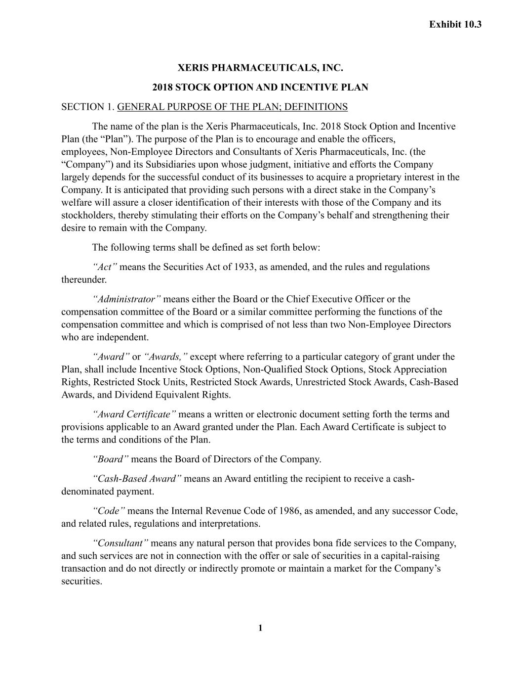
121
1 XERIS PHARMACEUTICALS, INC. 2018 STOCK OPTION AND INCENTIVE PLAN SECTION 1. GENERAL PURPOSE OF THE PLAN; DEFINITIONS The name of the plan is the Xeris Pharmaceuticals, Inc. 2018 Stock Option and Incentive Plan (the “Plan”). The purpose of the Plan is to encourage and enable the officers, employees, Non-Employee Directors and Consultants of Xeris Pharmaceuticals, Inc. (the “Company”) and its Subsidiaries upon whose judgment, initiative and efforts the Company largely depends for the successful conduct of its businesses to acquire a proprietary interest in the Company. It is anticipated that providing such persons with a direct stake in the Company’s welfare will assure a closer identification of their interests with those of the Company and its stockholders, thereby stimulating their efforts on the Company’s behalf and strengthening their desire to remain with the Company. The following terms shall be defined as set forth below: “Act” means the Securities Act of 1933, as amended, and the rules and regulations thereunder. “Administrator” means either the Board or the Chief Executive Officer or the compensation committee of the Board or a similar committee performing the functions of the compensation committee and which is comprised of not less than two Non-Employee Directors who are independent. “Award” or “Awards,” except where referring to a particular category of grant under the Plan, shall include Incentive Stock Options, Non-Qualified Stock Options, Stock Appreciation Rights, Restricted Stock Units, Restricted Stock Awards, Unrestricted Stock Awards, Cash-Based Awards, and Dividend Equivalent Rights. “Award Certificate” means a written or electronic document setting forth the terms and provisions applicable to an Award granted under the Plan. Each Award Certificate is subject to the terms and conditions of the Plan. “Board” means the Board of Directors of the Company. “Cash-Based Award” means an Award entitling the recipient to receive a cash- denominated payment. “Code” means the Internal Revenue Code of 1986, as amended, and any successor Code, and related rules, regulations and interpretations. “Consultant” means any natural person that provides bona fide services to the Company, and such services are not in connection with the offer or sale of securities in a capital-raising transaction and do not directly or indirectly promote or maintain a market for the Company’s securities. Exhibit 10.3

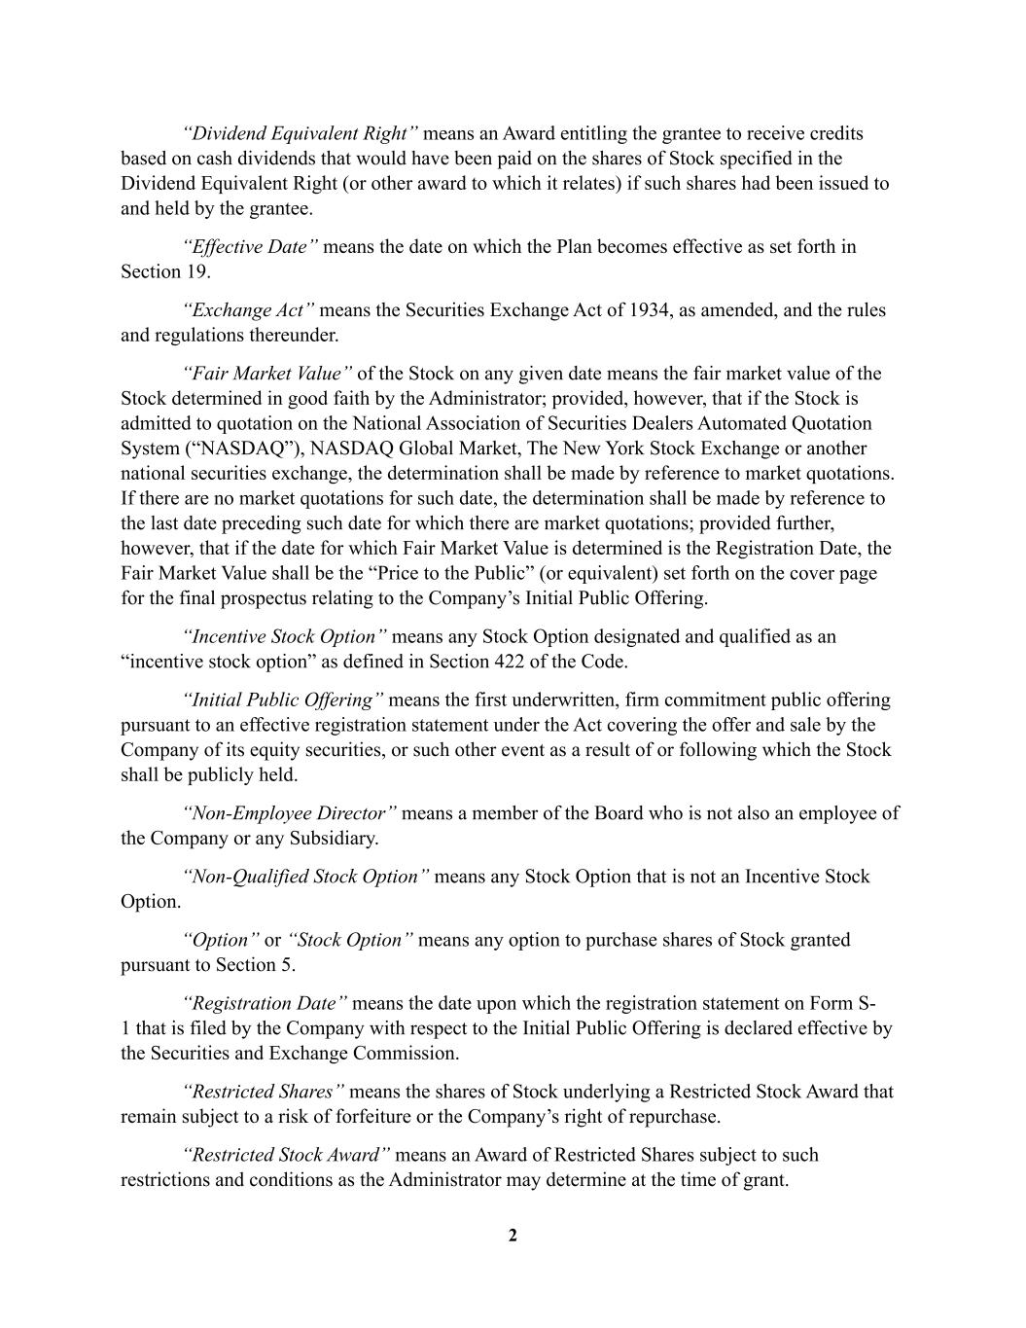
2 “Dividend Equivalent Right” means an Award entitling the grantee to receive credits based on cash dividends that would have been paid on the shares of Stock specified in the Dividend Equivalent Right (or other award to which it relates) if such shares had been issued to and held by the grantee. “Effective Date” means the date on which the Plan becomes effective as set forth in Section 19. “Exchange Act” means the Securities Exchange Act of 1934, as amended, and the rules and regulations thereunder. “Fair Market Value” of the Stock on any given date means the fair market value of the Stock determined in good faith by the Administrator; provided, however, that if the Stock is admitted to quotation on the National Association of Securities Dealers Automated Quotation System (“NASDAQ”), NASDAQ Global Market, The New York Stock Exchange or another national securities exchange, the determination shall be made by reference to market quotations. If there are no market quotations for such date, the determination shall be made by reference to the last date preceding such date for which there are market quotations; provided further, however, that if the date for which Fair Market Value is determined is the Registration Date, the Fair Market Value shall be the “Price to the Public” (or equivalent) set forth on the cover page for the final prospectus relating to the Company’s Initial Public Offering. “Incentive Stock Option” means any Stock Option designated and qualified as an “incentive stock option” as defined in Section 422 of the Code. “Initial Public Offering” means the first underwritten, firm commitment public offering pursuant to an effective registration statement under the Act covering the offer and sale by the Company of its equity securities, or such other event as a result of or following which the Stock shall be publicly held. “Non-Employee Director” means a member of the Board who is not also an employee of the Company or any Subsidiary. “Non-Qualified Stock Option” means any Stock Option that is not an Incentive Stock Option. “Option” or “Stock Option” means any option to purchase shares of Stock granted pursuant to Section 5. “Registration Date” means the date upon which the registration statement on Form S- 1 that is filed by the Company with respect to the Initial Public Offering is declared effective by the Securities and Exchange Commission. “Restricted Shares” means the shares of Stock underlying a Restricted Stock Award that remain subject to a risk of forfeiture or the Company’s right of repurchase. “Restricted Stock Award” means an Award of Restricted Shares subject to such restrictions and conditions as the Administrator may determine at the time of grant.

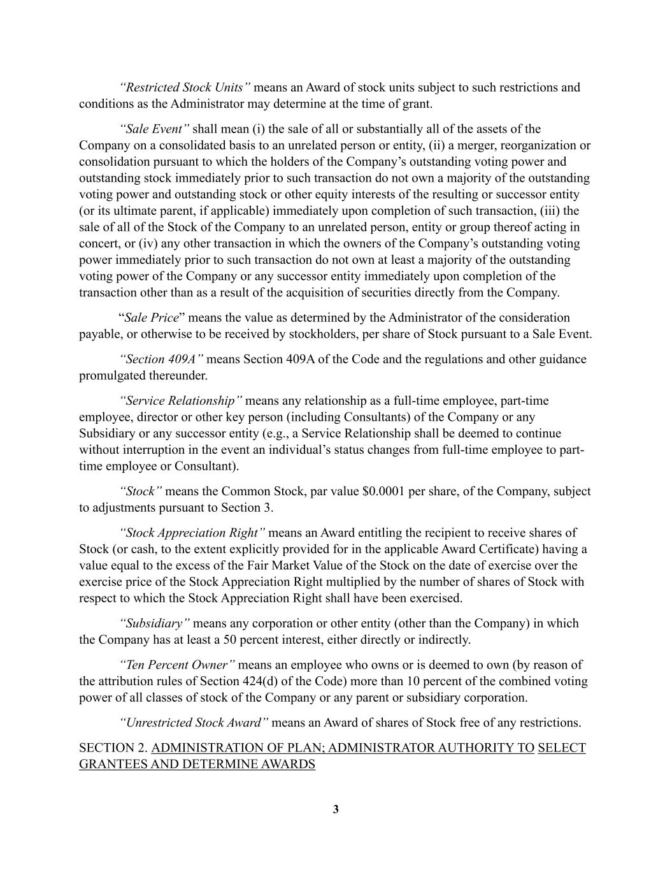
3 “Restricted Stock Units” means an Award of stock units subject to such restrictions and conditions as the Administrator may determine at the time of grant. “Sale Event” shall mean (i) the sale of all or substantially all of the assets of the Company on a consolidated basis to an unrelated person or entity, (ii) a merger, reorganization or consolidation pursuant to which the holders of the Company’s outstanding voting power and outstanding stock immediately prior to such transaction do not own a majority of the outstanding voting power and outstanding stock or other equity interests of the resulting or successor entity (or its ultimate parent, if applicable) immediately upon completion of such transaction, (iii) the sale of all of the Stock of the Company to an unrelated person, entity or group thereof acting in concert, or (iv) any other transaction in which the owners of the Company’s outstanding voting power immediately prior to such transaction do not own at least a majority of the outstanding voting power of the Company or any successor entity immediately upon completion of the transaction other than as a result of the acquisition of securities directly from the Company. “Sale Price” means the value as determined by the Administrator of the consideration payable, or otherwise to be received by stockholders, per share of Stock pursuant to a Sale Event. “Section 409A” means Section 409A of the Code and the regulations and other guidance promulgated thereunder. “Service Relationship” means any relationship as a full-time employee, part-time employee, director or other key person (including Consultants) of the Company or any Subsidiary or any successor entity (e.g., a Service Relationship shall be deemed to continue without interruption in the event an individual’s status changes from full-time employee to part- time employee or Consultant). “Stock” means the Common Stock, par value $0.0001 per share, of the Company, subject to adjustments pursuant to Section 3. “Stock Appreciation Right” means an Award entitling the recipient to receive shares of Stock (or cash, to the extent explicitly provided for in the applicable Award Certificate) having a value equal to the excess of the Fair Market Value of the Stock on the date of exercise over the exercise price of the Stock Appreciation Right multiplied by the number of shares of Stock with respect to which the Stock Appreciation Right shall have been exercised. “Subsidiary” means any corporation or other entity (other than the Company) in which the Company has at least a 50 percent interest, either directly or indirectly. “Ten Percent Owner” means an employee who owns or is deemed to own (by reason of the attribution rules of Section 424(d) of the Code) more than 10 percent of the combined voting power of all classes of stock of the Company or any parent or subsidiary corporation. “Unrestricted Stock Award” means an Award of shares of Stock free of any restrictions. SECTION 2. ADMINISTRATION OF PLAN; ADMINISTRATOR AUTHORITY TO SELECT GRANTEES AND DETERMINE AWARDS

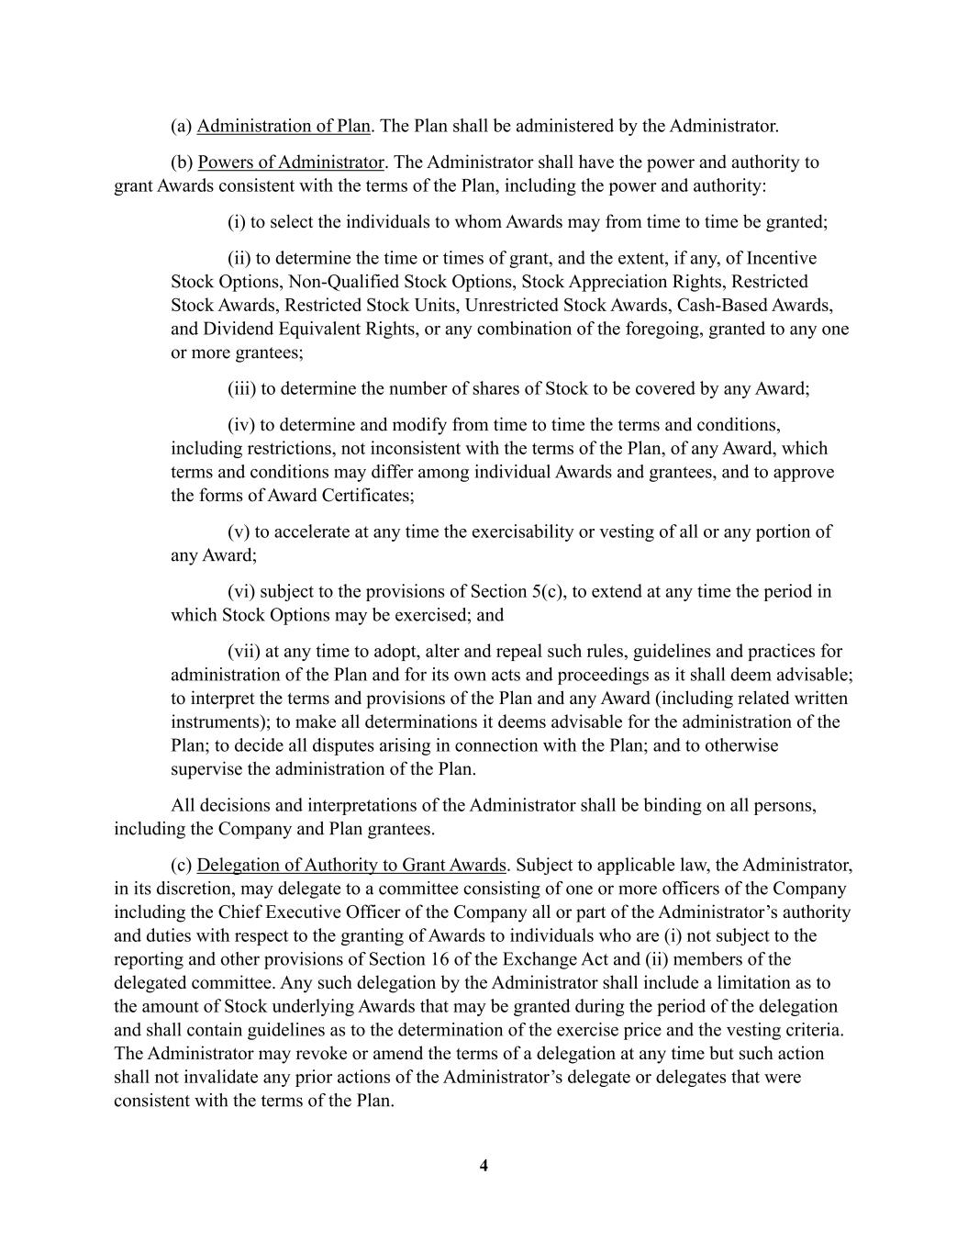
4 (a) Administration of Plan. The Plan shall be administered by the Administrator. (b) Powers of Administrator. The Administrator shall have the power and authority to grant Awards consistent with the terms of the Plan, including the power and authority: (i) to select the individuals to whom Awards may from time to time be granted; (ii) to determine the time or times of grant, and the extent, if any, of Incentive Stock Options, Non-Qualified Stock Options, Stock Appreciation Rights, Restricted Stock Awards, Restricted Stock Units, Unrestricted Stock Awards, Cash-Based Awards, and Dividend Equivalent Rights, or any combination of the foregoing, granted to any one or more grantees; (iii) to determine the number of shares of Stock to be covered by any Award; (iv) to determine and modify from time to time the terms and conditions, including restrictions, not inconsistent with the terms of the Plan, of any Award, which terms and conditions may differ among individual Awards and grantees, and to approve the forms of Award Certificates; (v) to accelerate at any time the exercisability or vesting of all or any portion of any Award; (vi) subject to the provisions of Section 5(c), to extend at any time the period in which Stock Options may be exercised; and (vii) at any time to adopt, alter and repeal such rules, guidelines and practices for administration of the Plan and for its own acts and proceedings as it shall deem advisable; to interpret the terms and provisions of the Plan and any Award (including related written instruments); to make all determinations it deems advisable for the administration of the Plan; to decide all disputes arising in connection with the Plan; and to otherwise supervise the administration of the Plan. All decisions and interpretations of the Administrator shall be binding on all persons, including the Company and Plan grantees. (c) Delegation of Authority to Grant Awards. Subject to applicable law, the Administrator, in its discretion, may delegate to a committee consisting of one or more officers of the Company including the Chief Executive Officer of the Company all or part of the Administrator’s authority and duties with respect to the granting of Awards to individuals who are (i) not subject to the reporting and other provisions of Section 16 of the Exchange Act and (ii) members of the delegated committee. Any such delegation by the Administrator shall include a limitation as to the amount of Stock underlying Awards that may be granted during the period of the delegation and shall contain guidelines as to the determination of the exercise price and the vesting criteria. The Administrator may revoke or amend the terms of a delegation at any time but such action shall not invalidate any prior actions of the Administrator’s delegate or delegates that were consistent with the terms of the Plan.

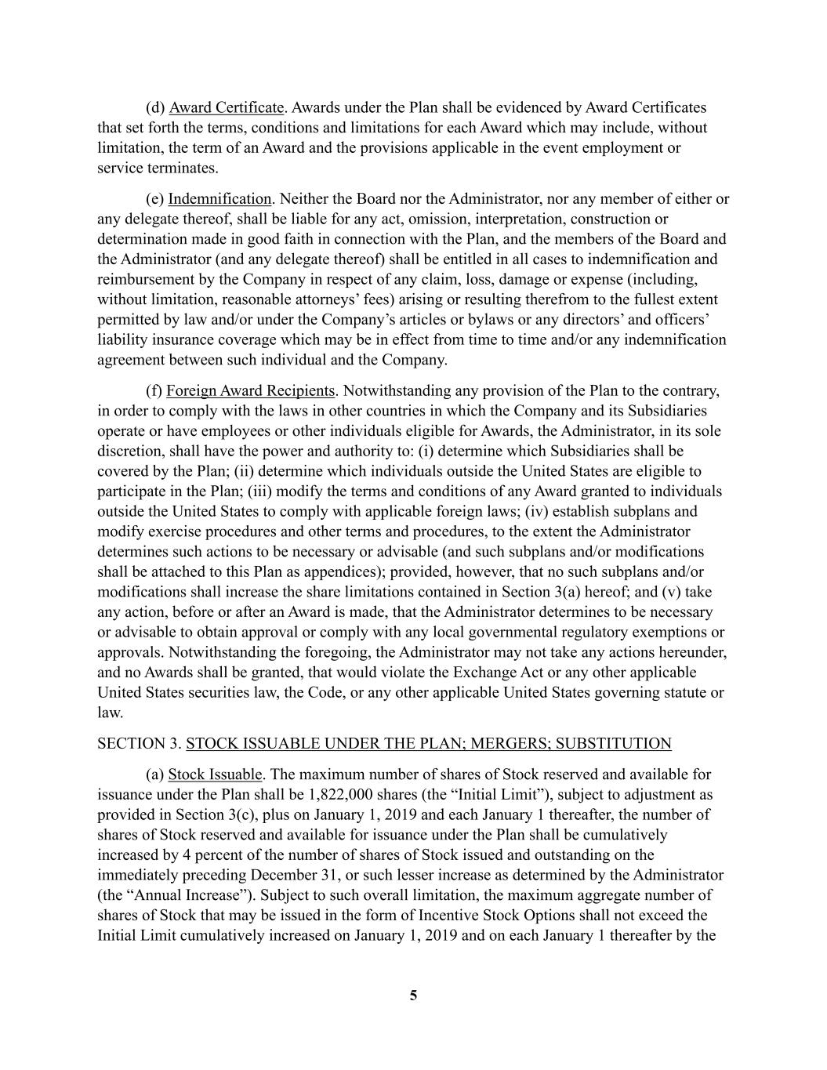
5 (d) Award Certificate. Awards under the Plan shall be evidenced by Award Certificates that set forth the terms, conditions and limitations for each Award which may include, without limitation, the term of an Award and the provisions applicable in the event employment or service terminates. (e) Indemnification. Neither the Board nor the Administrator, nor any member of either or any delegate thereof, shall be liable for any act, omission, interpretation, construction or determination made in good faith in connection with the Plan, and the members of the Board and the Administrator (and any delegate thereof) shall be entitled in all cases to indemnification and reimbursement by the Company in respect of any claim, loss, damage or expense (including, without limitation, reasonable attorneys’ fees) arising or resulting therefrom to the fullest extent permitted by law and/or under the Company’s articles or bylaws or any directors’ and officers’ liability insurance coverage which may be in effect from time to time and/or any indemnification agreement between such individual and the Company. (f) Foreign Award Recipients. Notwithstanding any provision of the Plan to the contrary, in order to comply with the laws in other countries in which the Company and its Subsidiaries operate or have employees or other individuals eligible for Awards, the Administrator, in its sole discretion, shall have the power and authority to: (i) determine which Subsidiaries shall be covered by the Plan; (ii) determine which individuals outside the United States are eligible to participate in the Plan; (iii) modify the terms and conditions of any Award granted to individuals outside the United States to comply with applicable foreign laws; (iv) establish subplans and modify exercise procedures and other terms and procedures, to the extent the Administrator determines such actions to be necessary or advisable (and such subplans and/or modifications shall be attached to this Plan as appendices); provided, however, that no such subplans and/or modifications shall increase the share limitations contained in Section 3(a) hereof; and (v) take any action, before or after an Award is made, that the Administrator determines to be necessary or advisable to obtain approval or comply with any local governmental regulatory exemptions or approvals. Notwithstanding the foregoing, the Administrator may not take any actions hereunder, and no Awards shall be granted, that would violate the Exchange Act or any other applicable United States securities law, the Code, or any other applicable United States governing statute or law. SECTION 3. STOCK ISSUABLE UNDER THE PLAN; MERGERS; SUBSTITUTION (a) Stock Issuable. The maximum number of shares of Stock reserved and available for issuance under the Plan shall be 1,822,000 shares (the “Initial Limit”), subject to adjustment as provided in Section 3(c), plus on January 1, 2019 and each January 1 thereafter, the number of shares of Stock reserved and available for issuance under the Plan shall be cumulatively increased by 4 percent of the number of shares of Stock issued and outstanding on the immediately preceding December 31, or such lesser increase as determined by the Administrator (the “Annual Increase”). Subject to such overall limitation, the maximum aggregate number of shares of Stock that may be issued in the form of Incentive Stock Options shall not exceed the Initial Limit cumulatively increased on January 1, 2019 and on each January 1 thereafter by the

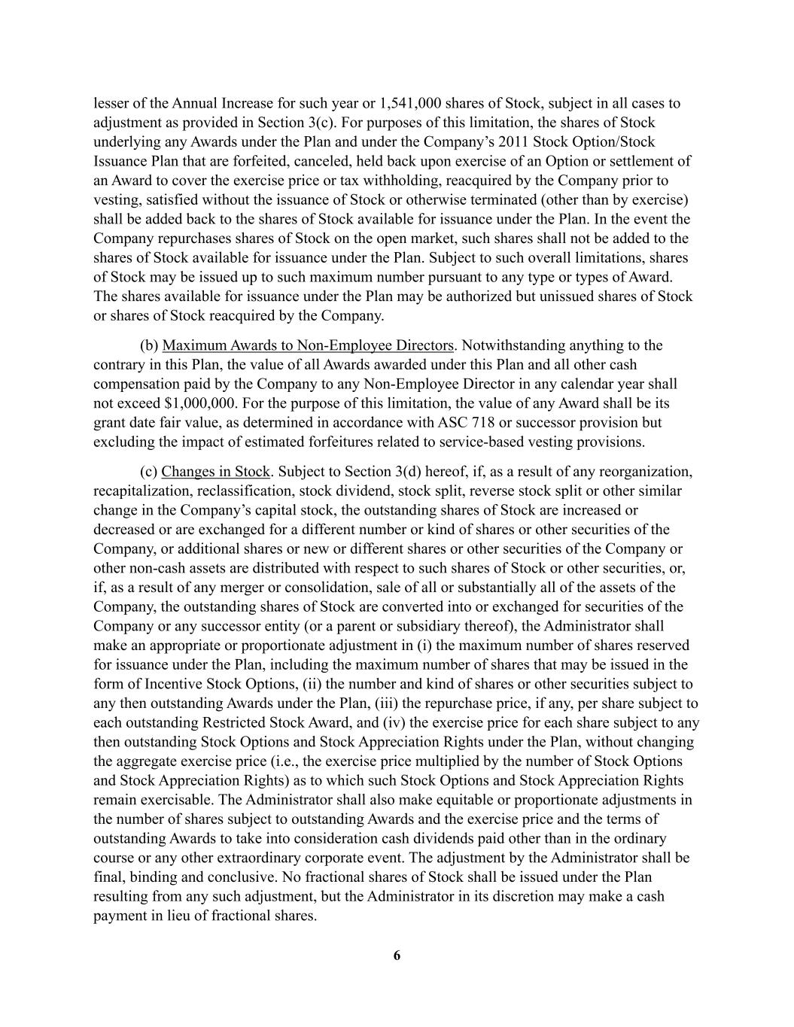
6 lesser of the Annual Increase for such year or 1,541,000 shares of Stock, subject in all cases to adjustment as provided in Section 3(c). For purposes of this limitation, the shares of Stock underlying any Awards under the Plan and under the Company’s 2011 Stock Option/Stock Issuance Plan that are forfeited, canceled, held back upon exercise of an Option or settlement of an Award to cover the exercise price or tax withholding, reacquired by the Company prior to vesting, satisfied without the issuance of Stock or otherwise terminated (other than by exercise) shall be added back to the shares of Stock available for issuance under the Plan. In the event the Company repurchases shares of Stock on the open market, such shares shall not be added to the shares of Stock available for issuance under the Plan. Subject to such overall limitations, shares of Stock may be issued up to such maximum number pursuant to any type or types of Award. The shares available for issuance under the Plan may be authorized but unissued shares of Stock or shares of Stock reacquired by the Company. (b) Maximum Awards to Non-Employee Directors. Notwithstanding anything to the contrary in this Plan, the value of all Awards awarded under this Plan and all other cash compensation paid by the Company to any Non-Employee Director in any calendar year shall not exceed $1,000,000. For the purpose of this limitation, the value of any Award shall be its grant date fair value, as determined in accordance with ASC 718 or successor provision but excluding the impact of estimated forfeitures related to service-based vesting provisions. (c) Changes in Stock. Subject to Section 3(d) hereof, if, as a result of any reorganization, recapitalization, reclassification, stock dividend, stock split, reverse stock split or other similar change in the Company’s capital stock, the outstanding shares of Stock are increased or decreased or are exchanged for a different number or kind of shares or other securities of the Company, or additional shares or new or different shares or other securities of the Company or other non-cash assets are distributed with respect to such shares of Stock or other securities, or, if, as a result of any merger or consolidation, sale of all or substantially all of the assets of the Company, the outstanding shares of Stock are converted into or exchanged for securities of the Company or any successor entity (or a parent or subsidiary thereof), the Administrator shall make an appropriate or proportionate adjustment in (i) the maximum number of shares reserved for issuance under the Plan, including the maximum number of shares that may be issued in the form of Incentive Stock Options, (ii) the number and kind of shares or other securities subject to any then outstanding Awards under the Plan, (iii) the repurchase price, if any, per share subject to each outstanding Restricted Stock Award, and (iv) the exercise price for each share subject to any then outstanding Stock Options and Stock Appreciation Rights under the Plan, without changing the aggregate exercise price (i.e., the exercise price multiplied by the number of Stock Options and Stock Appreciation Rights) as to which such Stock Options and Stock Appreciation Rights remain exercisable. The Administrator shall also make equitable or proportionate adjustments in the number of shares subject to outstanding Awards and the exercise price and the terms of outstanding Awards to take into consideration cash dividends paid other than in the ordinary course or any other extraordinary corporate event. The adjustment by the Administrator shall be final, binding and conclusive. No fractional shares of Stock shall be issued under the Plan resulting from any such adjustment, but the Administrator in its discretion may make a cash payment in lieu of fractional shares.

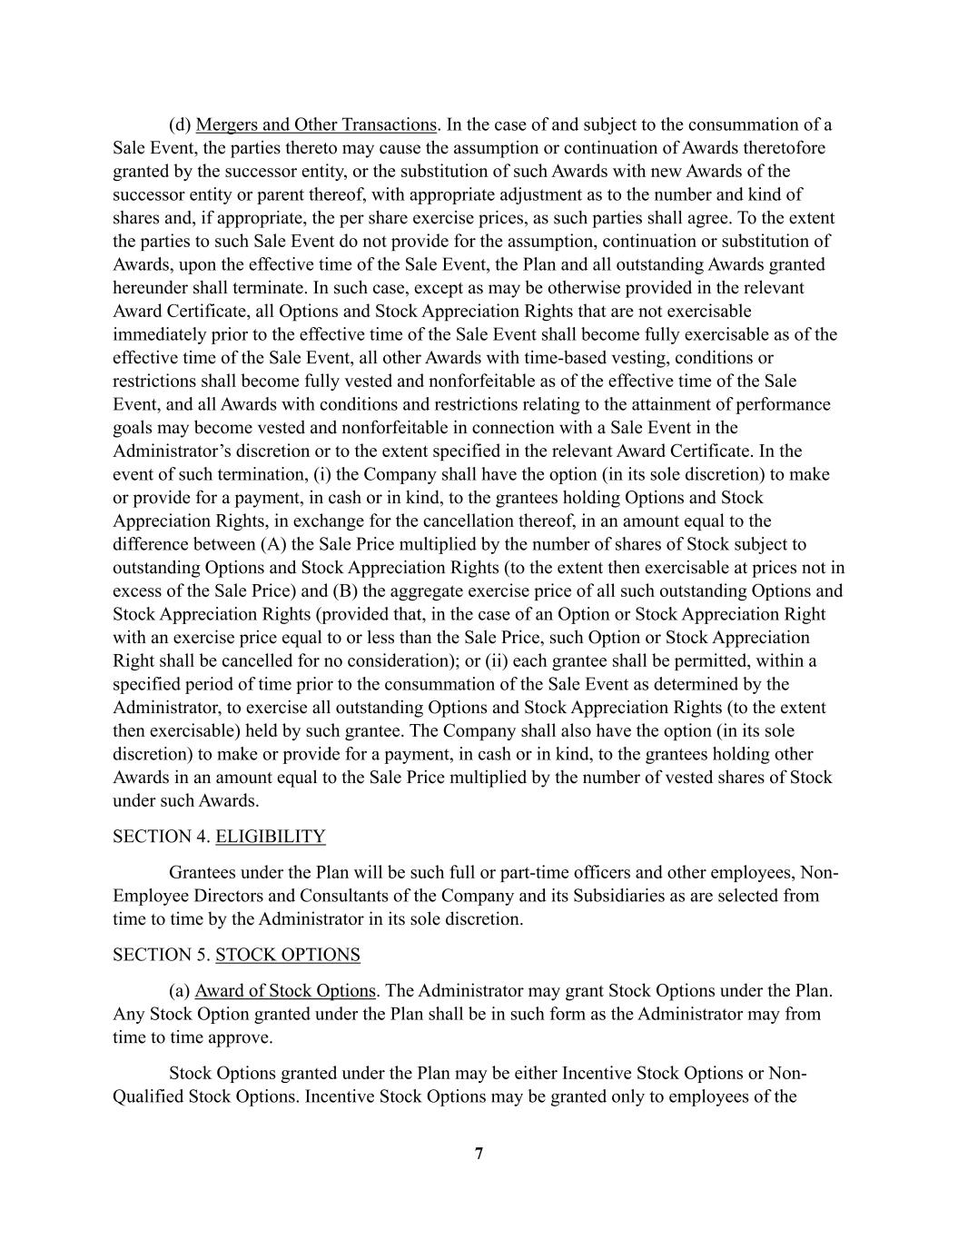
7 (d) Mergers and Other Transactions. In the case of and subject to the consummation of a Sale Event, the parties thereto may cause the assumption or continuation of Awards theretofore granted by the successor entity, or the substitution of such Awards with new Awards of the successor entity or parent thereof, with appropriate adjustment as to the number and kind of shares and, if appropriate, the per share exercise prices, as such parties shall agree. To the extent the parties to such Sale Event do not provide for the assumption, continuation or substitution of Awards, upon the effective time of the Sale Event, the Plan and all outstanding Awards granted hereunder shall terminate. In such case, except as may be otherwise provided in the relevant Award Certificate, all Options and Stock Appreciation Rights that are not exercisable immediately prior to the effective time of the Sale Event shall become fully exercisable as of the effective time of the Sale Event, all other Awards with time-based vesting, conditions or restrictions shall become fully vested and nonforfeitable as of the effective time of the Sale Event, and all Awards with conditions and restrictions relating to the attainment of performance goals may become vested and nonforfeitable in connection with a Sale Event in the Administrator’s discretion or to the extent specified in the relevant Award Certificate. In the event of such termination, (i) the Company shall have the option (in its sole discretion) to make or provide for a payment, in cash or in kind, to the grantees holding Options and Stock Appreciation Rights, in exchange for the cancellation thereof, in an amount equal to the difference between (A) the Sale Price multiplied by the number of shares of Stock subject to outstanding Options and Stock Appreciation Rights (to the extent then exercisable at prices not in excess of the Sale Price) and (B) the aggregate exercise price of all such outstanding Options and Stock Appreciation Rights (provided that, in the case of an Option or Stock Appreciation Right with an exercise price equal to or less than the Sale Price, such Option or Stock Appreciation Right shall be cancelled for no consideration); or (ii) each grantee shall be permitted, within a specified period of time prior to the consummation of the Sale Event as determined by the Administrator, to exercise all outstanding Options and Stock Appreciation Rights (to the extent then exercisable) held by such grantee. The Company shall also have the option (in its sole discretion) to make or provide for a payment, in cash or in kind, to the grantees holding other Awards in an amount equal to the Sale Price multiplied by the number of vested shares of Stock under such Awards. SECTION 4. ELIGIBILITY Grantees under the Plan will be such full or part-time officers and other employees, Non- Employee Directors and Consultants of the Company and its Subsidiaries as are selected from time to time by the Administrator in its sole discretion. SECTION 5. STOCK OPTIONS (a) Award of Stock Options. The Administrator may grant Stock Options under the Plan. Any Stock Option granted under the Plan shall be in such form as the Administrator may from time to time approve. Stock Options granted under the Plan may be either Incentive Stock Options or Non- Qualified Stock Options. Incentive Stock Options may be granted only to employees of the

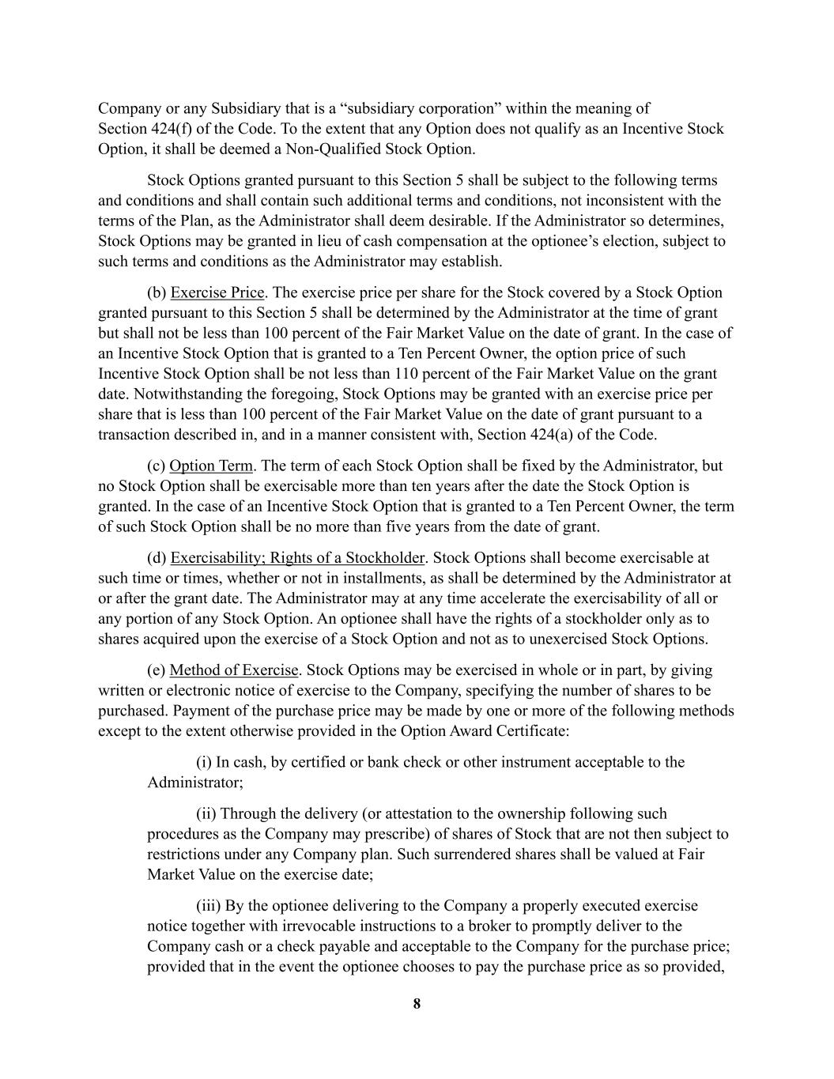
8 Company or any Subsidiary that is a “subsidiary corporation” within the meaning of Section 424(f) of the Code. To the extent that any Option does not qualify as an Incentive Stock Option, it shall be deemed a Non-Qualified Stock Option. Stock Options granted pursuant to this Section 5 shall be subject to the following terms and conditions and shall contain such additional terms and conditions, not inconsistent with the terms of the Plan, as the Administrator shall deem desirable. If the Administrator so determines, Stock Options may be granted in lieu of cash compensation at the optionee’s election, subject to such terms and conditions as the Administrator may establish. (b) Exercise Price. The exercise price per share for the Stock covered by a Stock Option granted pursuant to this Section 5 shall be determined by the Administrator at the time of grant but shall not be less than 100 percent of the Fair Market Value on the date of grant. In the case of an Incentive Stock Option that is granted to a Ten Percent Owner, the option price of such Incentive Stock Option shall be not less than 110 percent of the Fair Market Value on the grant date. Notwithstanding the foregoing, Stock Options may be granted with an exercise price per share that is less than 100 percent of the Fair Market Value on the date of grant pursuant to a transaction described in, and in a manner consistent with, Section 424(a) of the Code. (c) Option Term. The term of each Stock Option shall be fixed by the Administrator, but no Stock Option shall be exercisable more than ten years after the date the Stock Option is granted. In the case of an Incentive Stock Option that is granted to a Ten Percent Owner, the term of such Stock Option shall be no more than five years from the date of grant. (d) Exercisability; Rights of a Stockholder. Stock Options shall become exercisable at such time or times, whether or not in installments, as shall be determined by the Administrator at or after the grant date. The Administrator may at any time accelerate the exercisability of all or any portion of any Stock Option. An optionee shall have the rights of a stockholder only as to shares acquired upon the exercise of a Stock Option and not as to unexercised Stock Options. (e) Method of Exercise. Stock Options may be exercised in whole or in part, by giving written or electronic notice of exercise to the Company, specifying the number of shares to be purchased. Payment of the purchase price may be made by one or more of the following methods except to the extent otherwise provided in the Option Award Certificate: (i) In cash, by certified or bank check or other instrument acceptable to the Administrator; (ii) Through the delivery (or attestation to the ownership following such procedures as the Company may prescribe) of shares of Stock that are not then subject to restrictions under any Company plan. Such surrendered shares shall be valued at Fair Market Value on the exercise date; (iii) By the optionee delivering to the Company a properly executed exercise notice together with irrevocable instructions to a broker to promptly deliver to the Company cash or a check payable and acceptable to the Company for the purchase price; provided that in the event the optionee chooses to pay the purchase price as so provided,

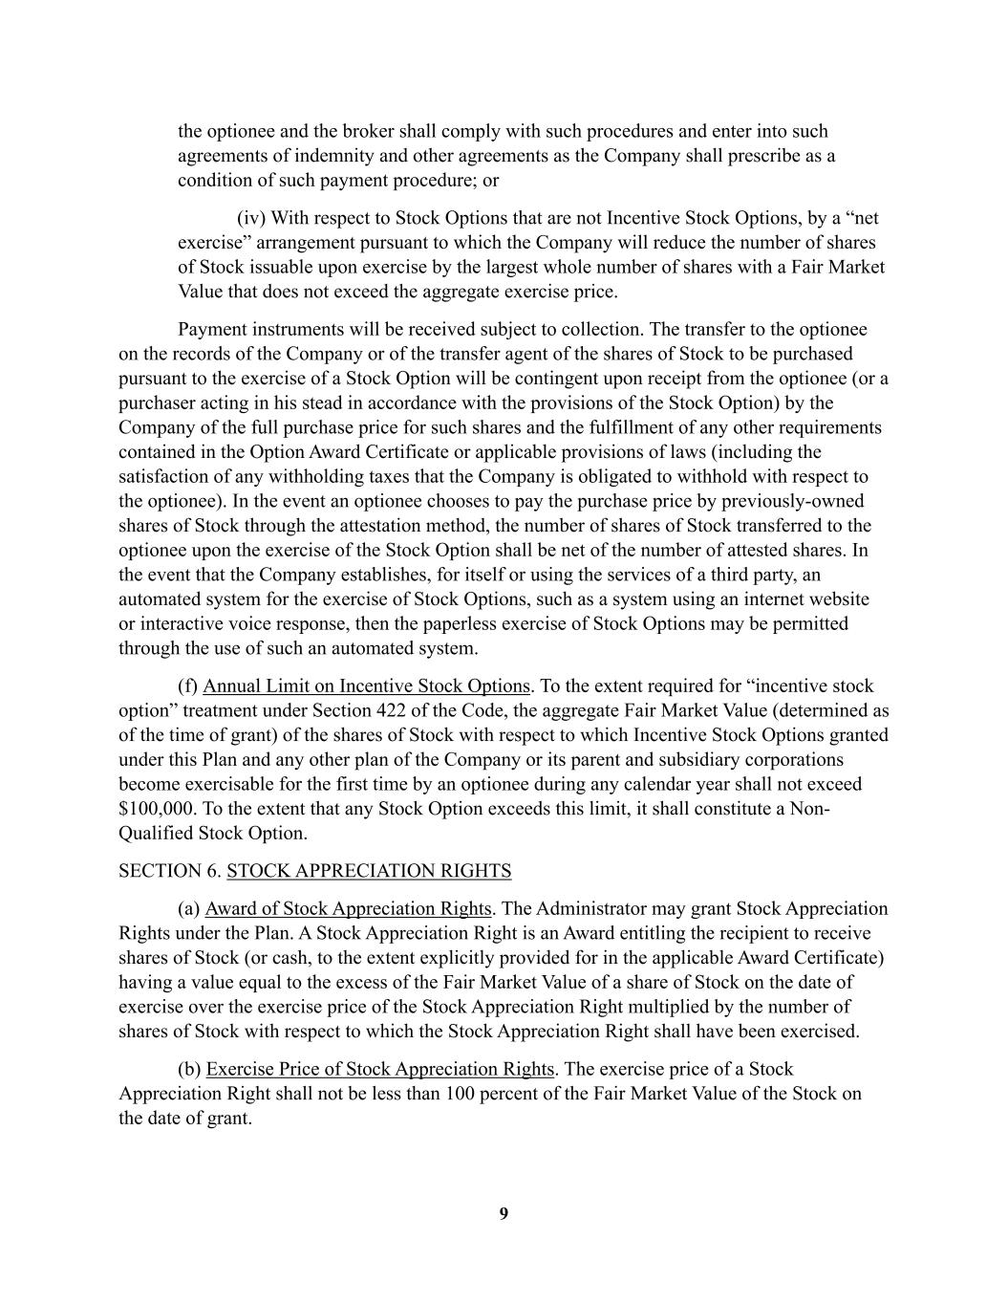
9 the optionee and the broker shall comply with such procedures and enter into such agreements of indemnity and other agreements as the Company shall prescribe as a condition of such payment procedure; or (iv) With respect to Stock Options that are not Incentive Stock Options, by a “net exercise” arrangement pursuant to which the Company will reduce the number of shares of Stock issuable upon exercise by the largest whole number of shares with a Fair Market Value that does not exceed the aggregate exercise price. Payment instruments will be received subject to collection. The transfer to the optionee on the records of the Company or of the transfer agent of the shares of Stock to be purchased pursuant to the exercise of a Stock Option will be contingent upon receipt from the optionee (or a purchaser acting in his stead in accordance with the provisions of the Stock Option) by the Company of the full purchase price for such shares and the fulfillment of any other requirements contained in the Option Award Certificate or applicable provisions of laws (including the satisfaction of any withholding taxes that the Company is obligated to withhold with respect to the optionee). In the event an optionee chooses to pay the purchase price by previously-owned shares of Stock through the attestation method, the number of shares of Stock transferred to the optionee upon the exercise of the Stock Option shall be net of the number of attested shares. In the event that the Company establishes, for itself or using the services of a third party, an automated system for the exercise of Stock Options, such as a system using an internet website or interactive voice response, then the paperless exercise of Stock Options may be permitted through the use of such an automated system. (f) Annual Limit on Incentive Stock Options. To the extent required for “incentive stock option” treatment under Section 422 of the Code, the aggregate Fair Market Value (determined as of the time of grant) of the shares of Stock with respect to which Incentive Stock Options granted under this Plan and any other plan of the Company or its parent and subsidiary corporations become exercisable for the first time by an optionee during any calendar year shall not exceed $100,000. To the extent that any Stock Option exceeds this limit, it shall constitute a Non- Qualified Stock Option. SECTION 6. STOCK APPRECIATION RIGHTS (a) Award of Stock Appreciation Rights. The Administrator may grant Stock Appreciation Rights under the Plan. A Stock Appreciation Right is an Award entitling the recipient to receive shares of Stock (or cash, to the extent explicitly provided for in the applicable Award Certificate) having a value equal to the excess of the Fair Market Value of a share of Stock on the date of exercise over the exercise price of the Stock Appreciation Right multiplied by the number of shares of Stock with respect to which the Stock Appreciation Right shall have been exercised. (b) Exercise Price of Stock Appreciation Rights. The exercise price of a Stock Appreciation Right shall not be less than 100 percent of the Fair Market Value of the Stock on the date of grant.

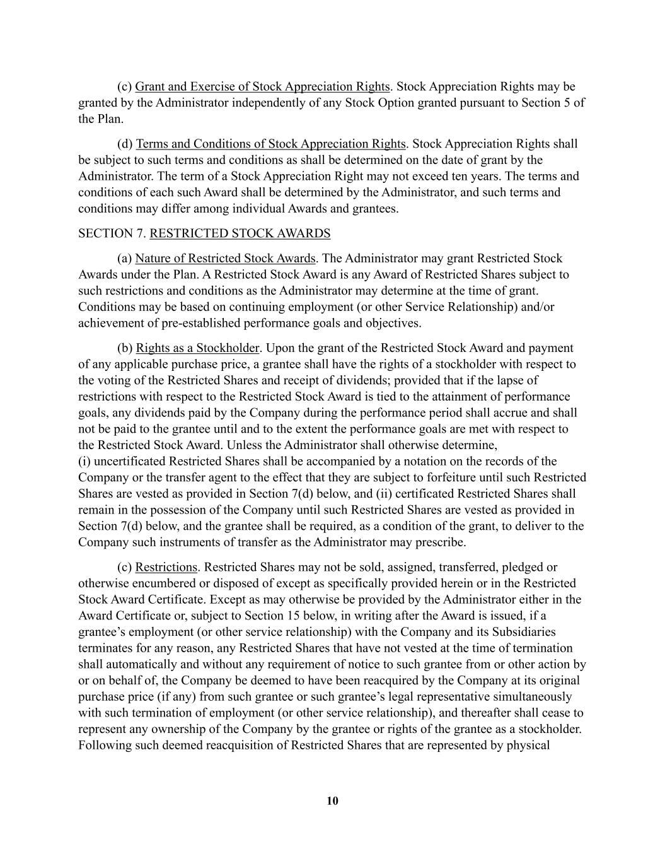
10 (c) Grant and Exercise of Stock Appreciation Rights. Stock Appreciation Rights may be granted by the Administrator independently of any Stock Option granted pursuant to Section 5 of the Plan. (d) Terms and Conditions of Stock Appreciation Rights. Stock Appreciation Rights shall be subject to such terms and conditions as shall be determined on the date of grant by the Administrator. The term of a Stock Appreciation Right may not exceed ten years. The terms and conditions of each such Award shall be determined by the Administrator, and such terms and conditions may differ among individual Awards and grantees. SECTION 7. RESTRICTED STOCK AWARDS (a) Nature of Restricted Stock Awards. The Administrator may grant Restricted Stock Awards under the Plan. A Restricted Stock Award is any Award of Restricted Shares subject to such restrictions and conditions as the Administrator may determine at the time of grant. Conditions may be based on continuing employment (or other Service Relationship) and/or achievement of pre-established performance goals and objectives. (b) Rights as a Stockholder. Upon the grant of the Restricted Stock Award and payment of any applicable purchase price, a grantee shall have the rights of a stockholder with respect to the voting of the Restricted Shares and receipt of dividends; provided that if the lapse of restrictions with respect to the Restricted Stock Award is tied to the attainment of performance goals, any dividends paid by the Company during the performance period shall accrue and shall not be paid to the grantee until and to the extent the performance goals are met with respect to the Restricted Stock Award. Unless the Administrator shall otherwise determine, (i) uncertificated Restricted Shares shall be accompanied by a notation on the records of the Company or the transfer agent to the effect that they are subject to forfeiture until such Restricted Shares are vested as provided in Section 7(d) below, and (ii) certificated Restricted Shares shall remain in the possession of the Company until such Restricted Shares are vested as provided in Section 7(d) below, and the grantee shall be required, as a condition of the grant, to deliver to the Company such instruments of transfer as the Administrator may prescribe. (c) Restrictions. Restricted Shares may not be sold, assigned, transferred, pledged or otherwise encumbered or disposed of except as specifically provided herein or in the Restricted Stock Award Certificate. Except as may otherwise be provided by the Administrator either in the Award Certificate or, subject to Section 15 below, in writing after the Award is issued, if a grantee’s employment (or other service relationship) with the Company and its Subsidiaries terminates for any reason, any Restricted Shares that have not vested at the time of termination shall automatically and without any requirement of notice to such grantee from or other action by or on behalf of, the Company be deemed to have been reacquired by the Company at its original purchase price (if any) from such grantee or such grantee’s legal representative simultaneously with such termination of employment (or other service relationship), and thereafter shall cease to represent any ownership of the Company by the grantee or rights of the grantee as a stockholder. Following such deemed reacquisition of Restricted Shares that are represented by physical

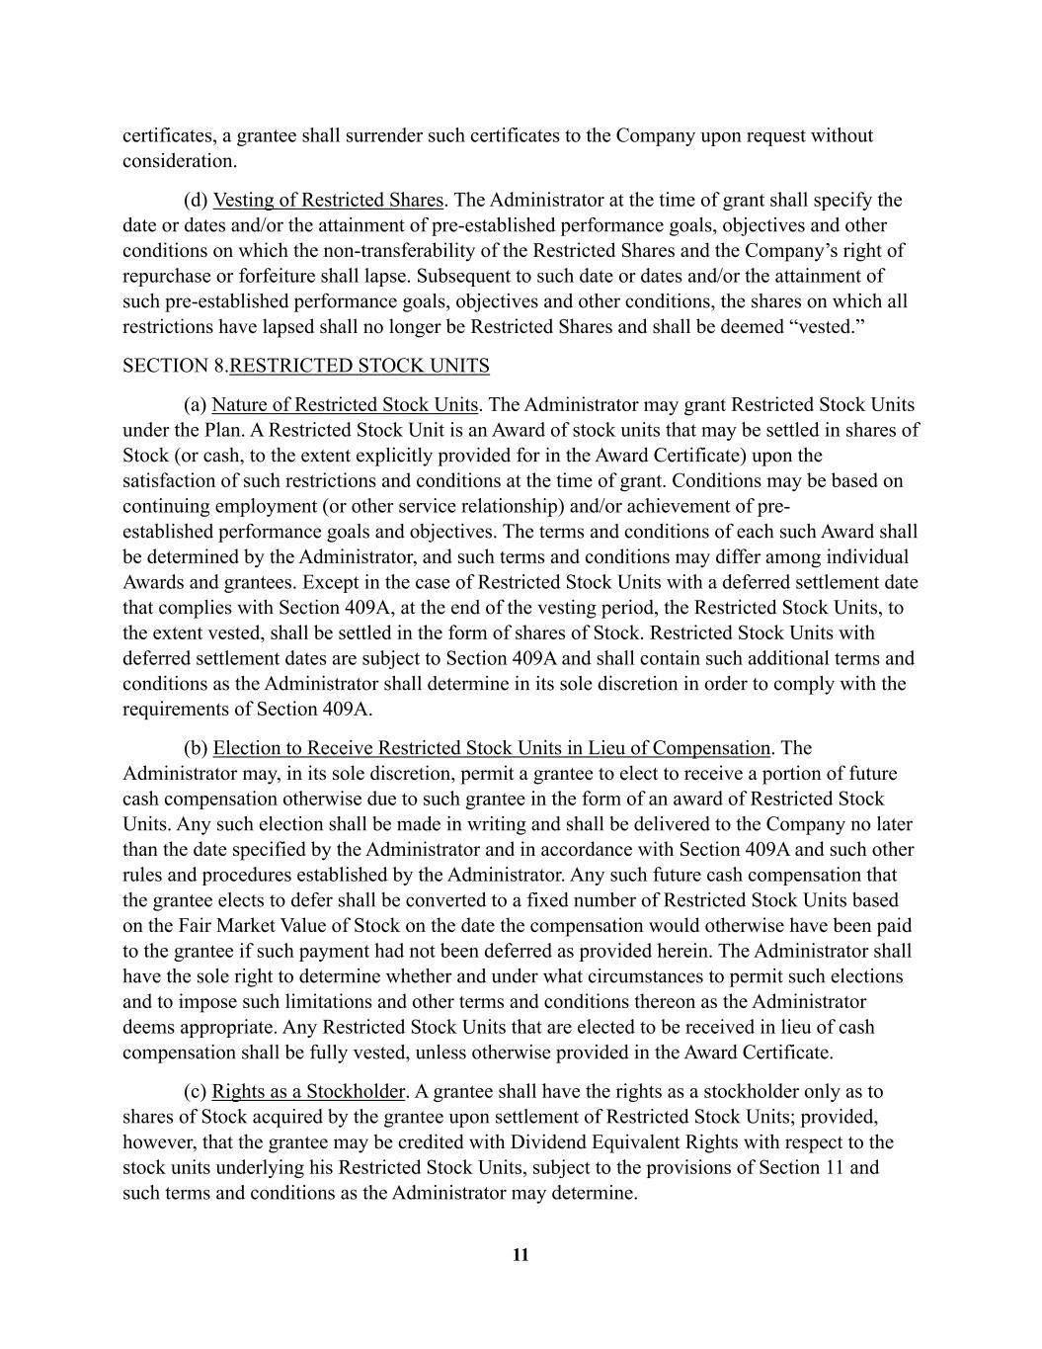
11 certificates, a grantee shall surrender such certificates to the Company upon request without consideration. (d) Vesting of Restricted Shares. The Administrator at the time of grant shall specify the date or dates and/or the attainment of pre-established performance goals, objectives and other conditions on which the non-transferability of the Restricted Shares and the Company’s right of repurchase or forfeiture shall lapse. Subsequent to such date or dates and/or the attainment of such pre-established performance goals, objectives and other conditions, the shares on which all restrictions have lapsed shall no longer be Restricted Shares and shall be deemed “vested.” SECTION 8. RESTRICTED STOCK UNITS (a) Nature of Restricted Stock Units. The Administrator may grant Restricted Stock Units under the Plan. A Restricted Stock Unit is an Award of stock units that may be settled in shares of Stock (or cash, to the extent explicitly provided for in the Award Certificate) upon the satisfaction of such restrictions and conditions at the time of grant. Conditions may be based on continuing employment (or other service relationship) and/or achievement of pre- established performance goals and objectives. The terms and conditions of each such Award shall be determined by the Administrator, and such terms and conditions may differ among individual Awards and grantees. Except in the case of Restricted Stock Units with a deferred settlement date that complies with Section 409A, at the end of the vesting period, the Restricted Stock Units, to the extent vested, shall be settled in the form of shares of Stock. Restricted Stock Units with deferred settlement dates are subject to Section 409A and shall contain such additional terms and conditions as the Administrator shall determine in its sole discretion in order to comply with the requirements of Section 409A. (b) Election to Receive Restricted Stock Units in Lieu of Compensation. The Administrator may, in its sole discretion, permit a grantee to elect to receive a portion of future cash compensation otherwise due to such grantee in the form of an award of Restricted Stock Units. Any such election shall be made in writing and shall be delivered to the Company no later than the date specified by the Administrator and in accordance with Section 409A and such other rules and procedures established by the Administrator. Any such future cash compensation that the grantee elects to defer shall be converted to a fixed number of Restricted Stock Units based on the Fair Market Value of Stock on the date the compensation would otherwise have been paid to the grantee if such payment had not been deferred as provided herein. The Administrator shall have the sole right to determine whether and under what circumstances to permit such elections and to impose such limitations and other terms and conditions thereon as the Administrator deems appropriate. Any Restricted Stock Units that are elected to be received in lieu of cash compensation shall be fully vested, unless otherwise provided in the Award Certificate. (c) Rights as a Stockholder. A grantee shall have the rights as a stockholder only as to shares of Stock acquired by the grantee upon settlement of Restricted Stock Units; provided, however, that the grantee may be credited with Dividend Equivalent Rights with respect to the stock units underlying his Restricted Stock Units, subject to the provisions of Section 11 and such terms and conditions as the Administrator may determine.

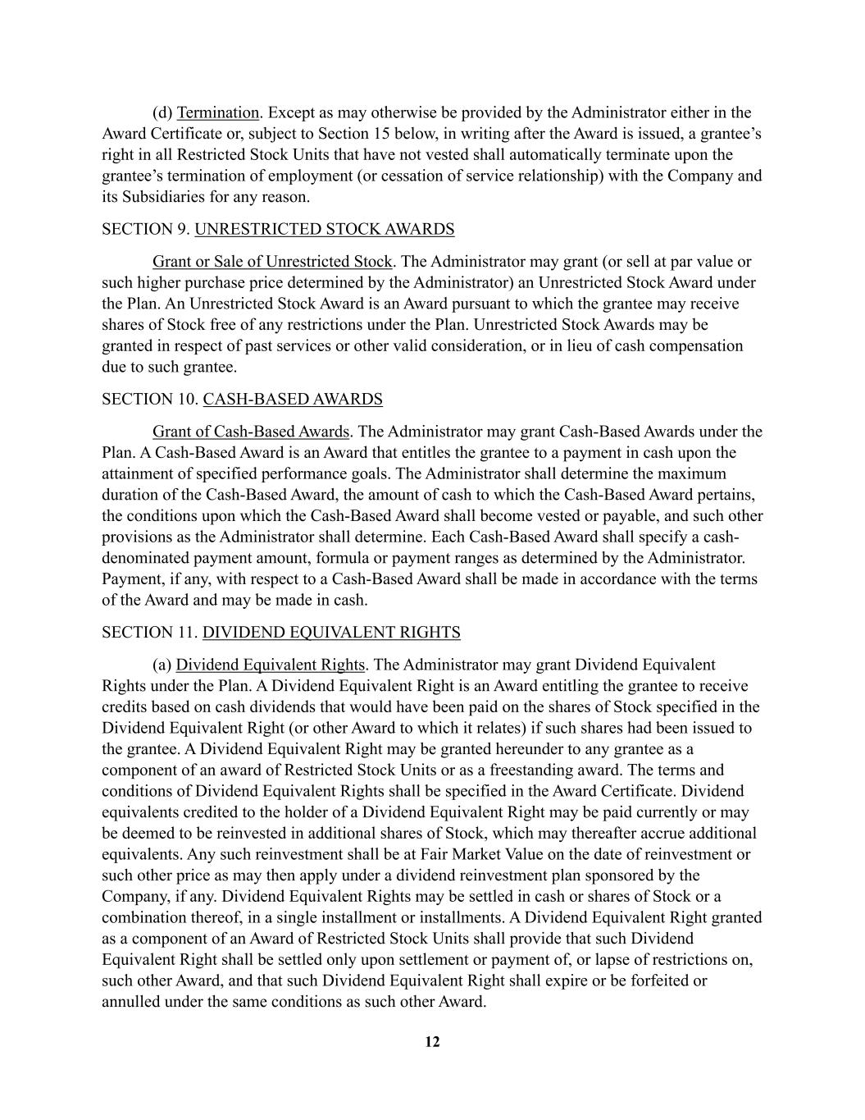
12 (d) Termination. Except as may otherwise be provided by the Administrator either in the Award Certificate or, subject to Section 15 below, in writing after the Award is issued, a grantee’s right in all Restricted Stock Units that have not vested shall automatically terminate upon the grantee’s termination of employment (or cessation of service relationship) with the Company and its Subsidiaries for any reason. SECTION 9. UNRESTRICTED STOCK AWARDS Grant or Sale of Unrestricted Stock. The Administrator may grant (or sell at par value or such higher purchase price determined by the Administrator) an Unrestricted Stock Award under the Plan. An Unrestricted Stock Award is an Award pursuant to which the grantee may receive shares of Stock free of any restrictions under the Plan. Unrestricted Stock Awards may be granted in respect of past services or other valid consideration, or in lieu of cash compensation due to such grantee. SECTION 10. CASH-BASED AWARDS Grant of Cash-Based Awards. The Administrator may grant Cash-Based Awards under the Plan. A Cash-Based Award is an Award that entitles the grantee to a payment in cash upon the attainment of specified performance goals. The Administrator shall determine the maximum duration of the Cash-Based Award, the amount of cash to which the Cash-Based Award pertains, the conditions upon which the Cash-Based Award shall become vested or payable, and such other provisions as the Administrator shall determine. Each Cash-Based Award shall specify a cash- denominated payment amount, formula or payment ranges as determined by the Administrator. Payment, if any, with respect to a Cash-Based Award shall be made in accordance with the terms of the Award and may be made in cash. SECTION 11. DIVIDEND EQUIVALENT RIGHTS (a) Dividend Equivalent Rights. The Administrator may grant Dividend Equivalent Rights under the Plan. A Dividend Equivalent Right is an Award entitling the grantee to receive credits based on cash dividends that would have been paid on the shares of Stock specified in the Dividend Equivalent Right (or other Award to which it relates) if such shares had been issued to the grantee. A Dividend Equivalent Right may be granted hereunder to any grantee as a component of an award of Restricted Stock Units or as a freestanding award. The terms and conditions of Dividend Equivalent Rights shall be specified in the Award Certificate. Dividend equivalents credited to the holder of a Dividend Equivalent Right may be paid currently or may be deemed to be reinvested in additional shares of Stock, which may thereafter accrue additional equivalents. Any such reinvestment shall be at Fair Market Value on the date of reinvestment or such other price as may then apply under a dividend reinvestment plan sponsored by the Company, if any. Dividend Equivalent Rights may be settled in cash or shares of Stock or a combination thereof, in a single installment or installments. A Dividend Equivalent Right granted as a component of an Award of Restricted Stock Units shall provide that such Dividend Equivalent Right shall be settled only upon settlement or payment of, or lapse of restrictions on, such other Award, and that such Dividend Equivalent Right shall expire or be forfeited or annulled under the same conditions as such other Award.

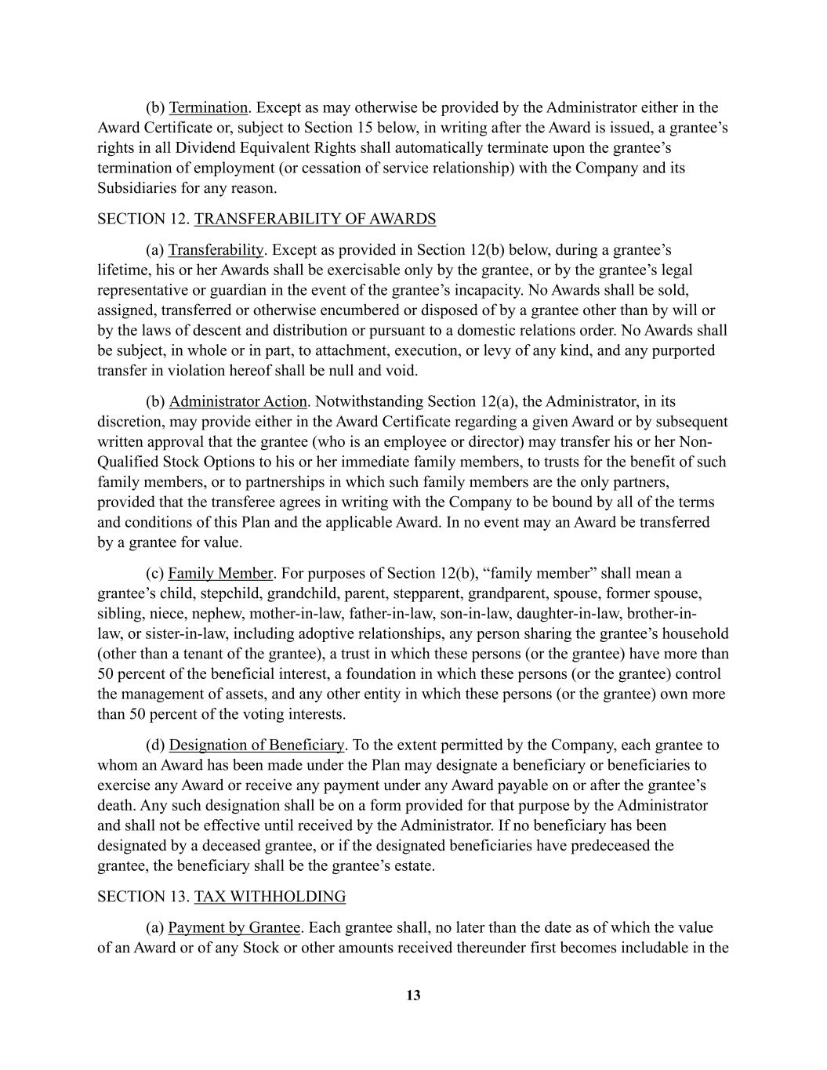
13 (b) Termination. Except as may otherwise be provided by the Administrator either in the Award Certificate or, subject to Section 15 below, in writing after the Award is issued, a grantee’s rights in all Dividend Equivalent Rights shall automatically terminate upon the grantee’s termination of employment (or cessation of service relationship) with the Company and its Subsidiaries for any reason. SECTION 12. TRANSFERABILITY OF AWARDS (a) Transferability. Except as provided in Section 12(b) below, during a grantee’s lifetime, his or her Awards shall be exercisable only by the grantee, or by the grantee’s legal representative or guardian in the event of the grantee’s incapacity. No Awards shall be sold, assigned, transferred or otherwise encumbered or disposed of by a grantee other than by will or by the laws of descent and distribution or pursuant to a domestic relations order. No Awards shall be subject, in whole or in part, to attachment, execution, or levy of any kind, and any purported transfer in violation hereof shall be null and void. (b) Administrator Action. Notwithstanding Section 12(a), the Administrator, in its discretion, may provide either in the Award Certificate regarding a given Award or by subsequent written approval that the grantee (who is an employee or director) may transfer his or her Non- Qualified Stock Options to his or her immediate family members, to trusts for the benefit of such family members, or to partnerships in which such family members are the only partners, provided that the transferee agrees in writing with the Company to be bound by all of the terms and conditions of this Plan and the applicable Award. In no event may an Award be transferred by a grantee for value. (c) Family Member. For purposes of Section 12(b), “family member” shall mean a grantee’s child, stepchild, grandchild, parent, stepparent, grandparent, spouse, former spouse, sibling, niece, nephew, mother-in-law, father-in-law, son-in-law, daughter-in-law, brother-in- law, or sister-in-law, including adoptive relationships, any person sharing the grantee’s household (other than a tenant of the grantee), a trust in which these persons (or the grantee) have more than 50 percent of the beneficial interest, a foundation in which these persons (or the grantee) control the management of assets, and any other entity in which these persons (or the grantee) own more than 50 percent of the voting interests. (d) Designation of Beneficiary. To the extent permitted by the Company, each grantee to whom an Award has been made under the Plan may designate a beneficiary or beneficiaries to exercise any Award or receive any payment under any Award payable on or after the grantee’s death. Any such designation shall be on a form provided for that purpose by the Administrator and shall not be effective until received by the Administrator. If no beneficiary has been designated by a deceased grantee, or if the designated beneficiaries have predeceased the grantee, the beneficiary shall be the grantee’s estate. SECTION 13. TAX WITHHOLDING (a) Payment by Grantee. Each grantee shall, no later than the date as of which the value of an Award or of any Stock or other amounts received thereunder first becomes includable in the

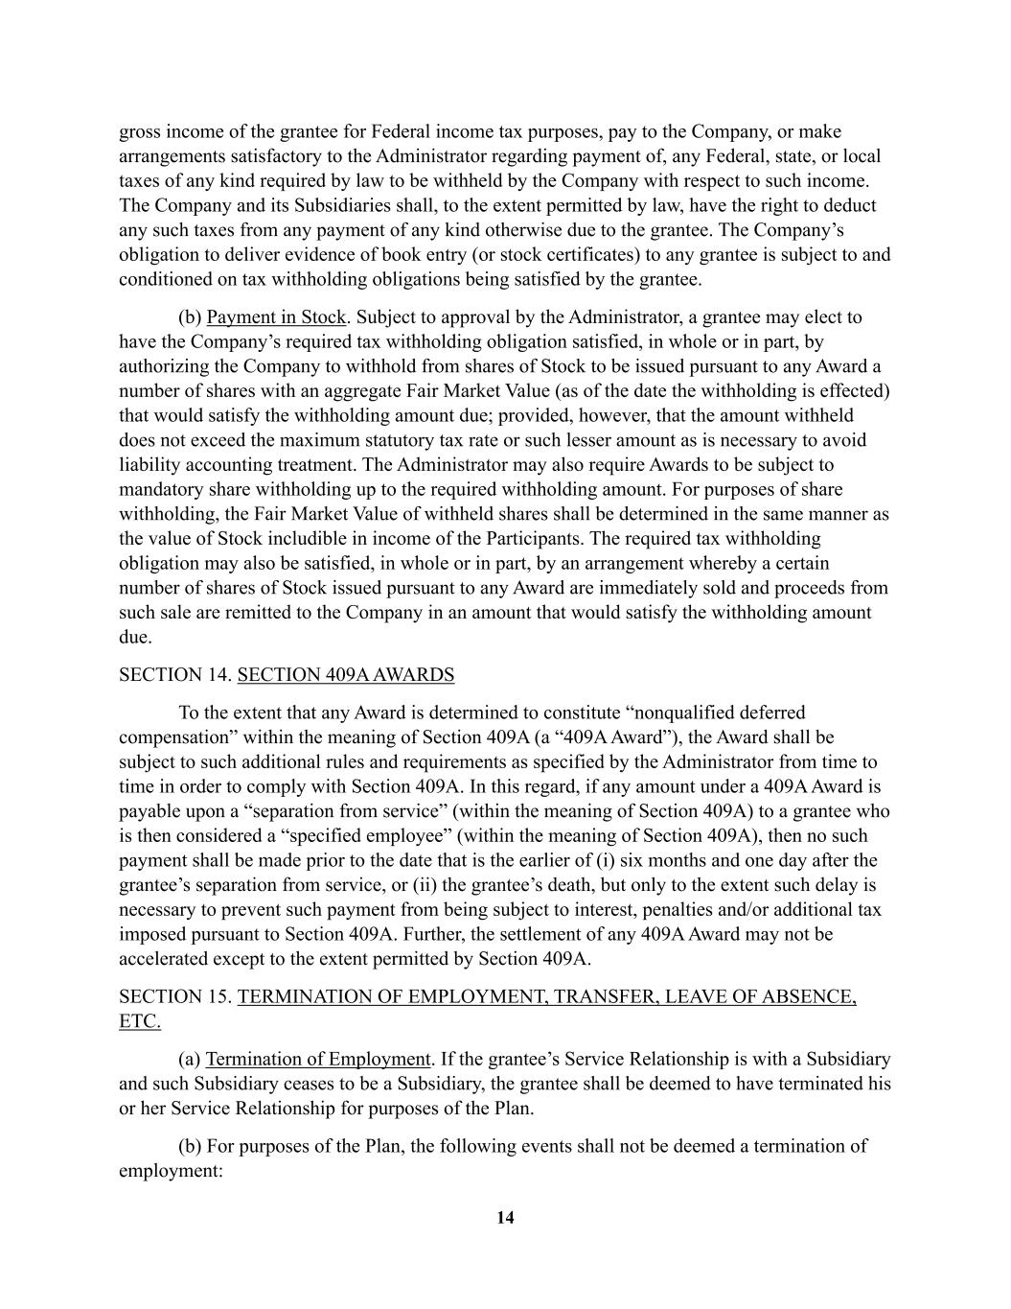
14 gross income of the grantee for Federal income tax purposes, pay to the Company, or make arrangements satisfactory to the Administrator regarding payment of, any Federal, state, or local taxes of any kind required by law to be withheld by the Company with respect to such income. The Company and its Subsidiaries shall, to the extent permitted by law, have the right to deduct any such taxes from any payment of any kind otherwise due to the grantee. The Company’s obligation to deliver evidence of book entry (or stock certificates) to any grantee is subject to and conditioned on tax withholding obligations being satisfied by the grantee. (b) Payment in Stock. Subject to approval by the Administrator, a grantee may elect to have the Company’s required tax withholding obligation satisfied, in whole or in part, by authorizing the Company to withhold from shares of Stock to be issued pursuant to any Award a number of shares with an aggregate Fair Market Value (as of the date the withholding is effected) that would satisfy the withholding amount due; provided, however, that the amount withheld does not exceed the maximum statutory tax rate or such lesser amount as is necessary to avoid liability accounting treatment. The Administrator may also require Awards to be subject to mandatory share withholding up to the required withholding amount. For purposes of share withholding, the Fair Market Value of withheld shares shall be determined in the same manner as the value of Stock includible in income of the Participants. The required tax withholding obligation may also be satisfied, in whole or in part, by an arrangement whereby a certain number of shares of Stock issued pursuant to any Award are immediately sold and proceeds from such sale are remitted to the Company in an amount that would satisfy the withholding amount due. SECTION 14. SECTION 409A AWARDS To the extent that any Award is determined to constitute “nonqualified deferred compensation” within the meaning of Section 409A (a “409A Award”), the Award shall be subject to such additional rules and requirements as specified by the Administrator from time to time in order to comply with Section 409A. In this regard, if any amount under a 409A Award is payable upon a “separation from service” (within the meaning of Section 409A) to a grantee who is then considered a “specified employee” (within the meaning of Section 409A), then no such payment shall be made prior to the date that is the earlier of (i) six months and one day after the grantee’s separation from service, or (ii) the grantee’s death, but only to the extent such delay is necessary to prevent such payment from being subject to interest, penalties and/or additional tax imposed pursuant to Section 409A. Further, the settlement of any 409A Award may not be accelerated except to the extent permitted by Section 409A. SECTION 15. TERMINATION OF EMPLOYMENT, TRANSFER, LEAVE OF ABSENCE, ETC. (a) Termination of Employment. If the grantee’s Service Relationship is with a Subsidiary and such Subsidiary ceases to be a Subsidiary, the grantee shall be deemed to have terminated his or her Service Relationship for purposes of the Plan. (b) For purposes of the Plan, the following events shall not be deemed a termination of employment:

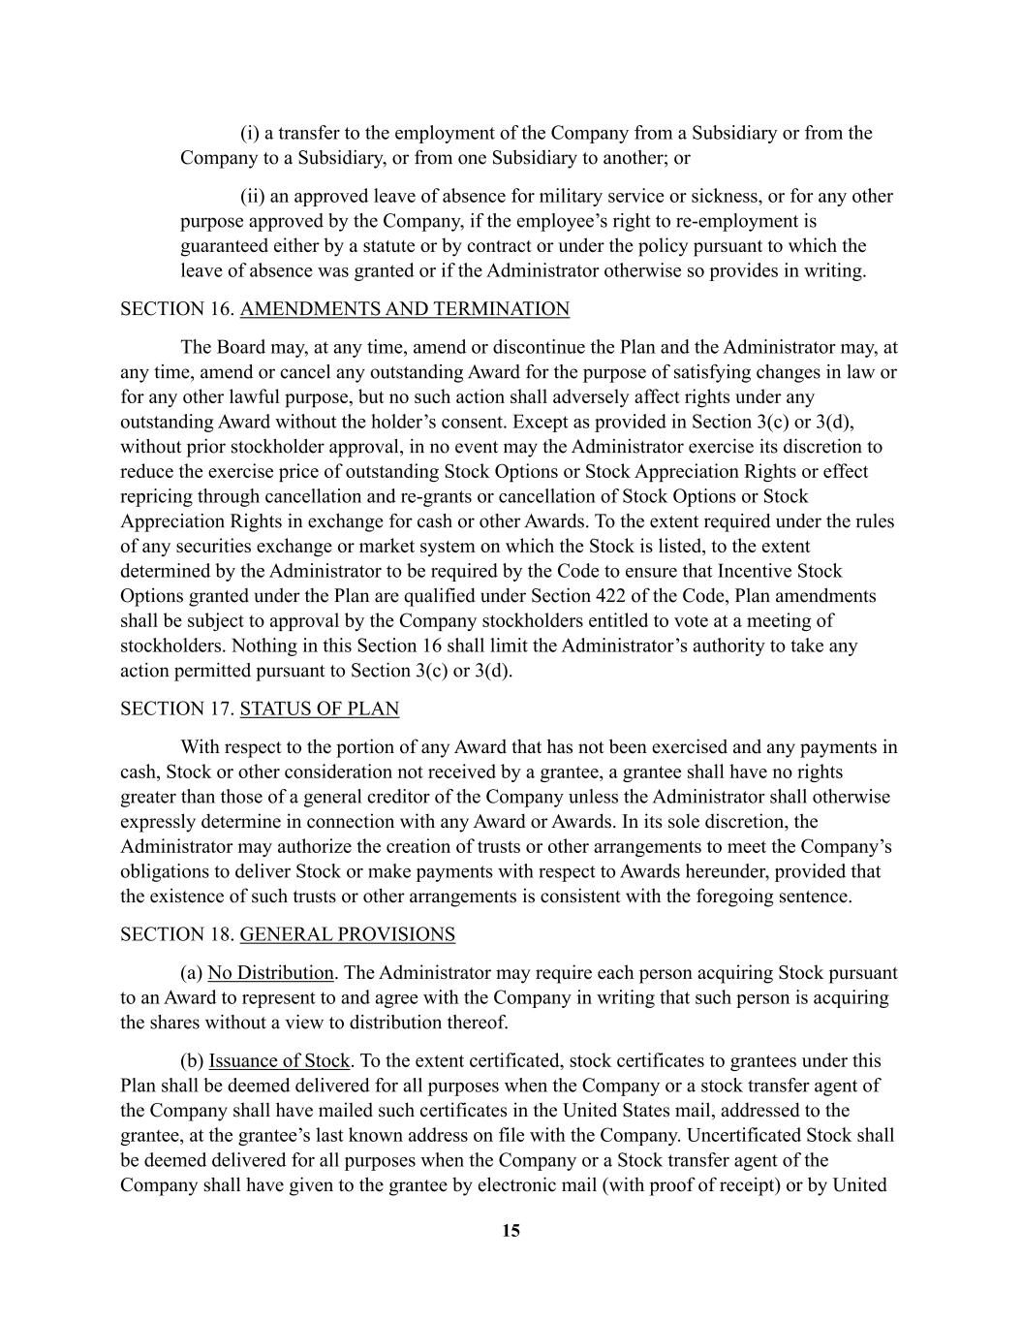
15 (i) a transfer to the employment of the Company from a Subsidiary or from the Company to a Subsidiary, or from one Subsidiary to another; or (ii) an approved leave of absence for military service or sickness, or for any other purpose approved by the Company, if the employee’s right to re-employment is guaranteed either by a statute or by contract or under the policy pursuant to which the leave of absence was granted or if the Administrator otherwise so provides in writing. SECTION 16. AMENDMENTS AND TERMINATION The Board may, at any time, amend or discontinue the Plan and the Administrator may, at any time, amend or cancel any outstanding Award for the purpose of satisfying changes in law or for any other lawful purpose, but no such action shall adversely affect rights under any outstanding Award without the holder’s consent. Except as provided in Section 3(c) or 3(d), without prior stockholder approval, in no event may the Administrator exercise its discretion to reduce the exercise price of outstanding Stock Options or Stock Appreciation Rights or effect repricing through cancellation and re-grants or cancellation of Stock Options or Stock Appreciation Rights in exchange for cash or other Awards. To the extent required under the rules of any securities exchange or market system on which the Stock is listed, to the extent determined by the Administrator to be required by the Code to ensure that Incentive Stock Options granted under the Plan are qualified under Section 422 of the Code, Plan amendments shall be subject to approval by the Company stockholders entitled to vote at a meeting of stockholders. Nothing in this Section 16 shall limit the Administrator’s authority to take any action permitted pursuant to Section 3(c) or 3(d). SECTION 17. STATUS OF PLAN With respect to the portion of any Award that has not been exercised and any payments in cash, Stock or other consideration not received by a grantee, a grantee shall have no rights greater than those of a general creditor of the Company unless the Administrator shall otherwise expressly determine in connection with any Award or Awards. In its sole discretion, the Administrator may authorize the creation of trusts or other arrangements to meet the Company’s obligations to deliver Stock or make payments with respect to Awards hereunder, provided that the existence of such trusts or other arrangements is consistent with the foregoing sentence. SECTION 18. GENERAL PROVISIONS (a) No Distribution. The Administrator may require each person acquiring Stock pursuant to an Award to represent to and agree with the Company in writing that such person is acquiring the shares without a view to distribution thereof. (b) Issuance of Stock. To the extent certificated, stock certificates to grantees under this Plan shall be deemed delivered for all purposes when the Company or a stock transfer agent of the Company shall have mailed such certificates in the United States mail, addressed to the grantee, at the grantee’s last known address on file with the Company. Uncertificated Stock shall be deemed delivered for all purposes when the Company or a Stock transfer agent of the Company shall have given to the grantee by electronic mail (with proof of receipt) or by United

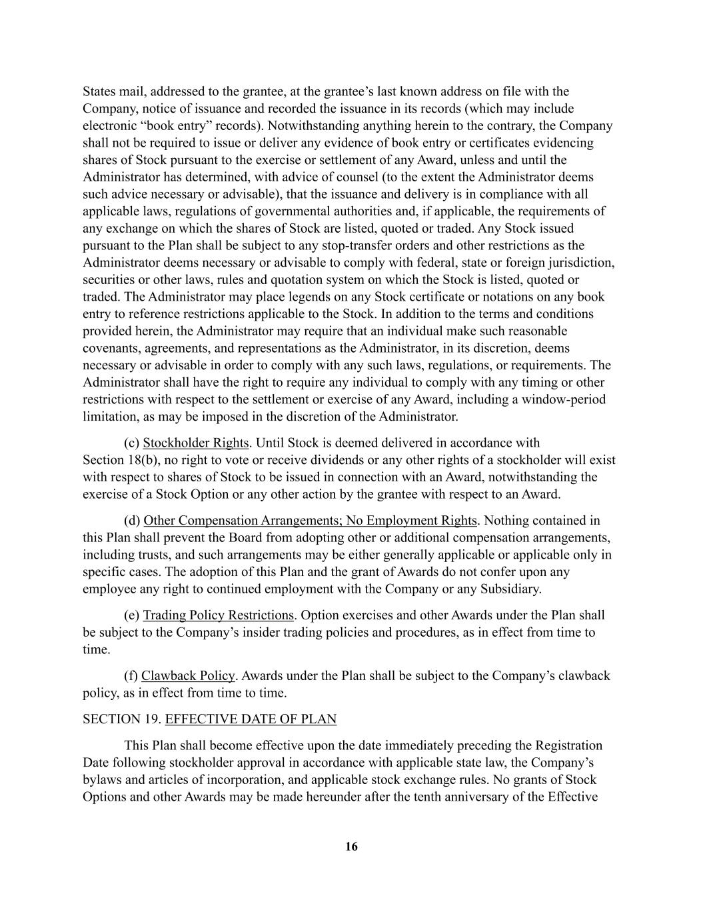
16 States mail, addressed to the grantee, at the grantee’s last known address on file with the Company, notice of issuance and recorded the issuance in its records (which may include electronic “book entry” records). Notwithstanding anything herein to the contrary, the Company shall not be required to issue or deliver any evidence of book entry or certificates evidencing shares of Stock pursuant to the exercise or settlement of any Award, unless and until the Administrator has determined, with advice of counsel (to the extent the Administrator deems such advice necessary or advisable), that the issuance and delivery is in compliance with all applicable laws, regulations of governmental authorities and, if applicable, the requirements of any exchange on which the shares of Stock are listed, quoted or traded. Any Stock issued pursuant to the Plan shall be subject to any stop-transfer orders and other restrictions as the Administrator deems necessary or advisable to comply with federal, state or foreign jurisdiction, securities or other laws, rules and quotation system on which the Stock is listed, quoted or traded. The Administrator may place legends on any Stock certificate or notations on any book entry to reference restrictions applicable to the Stock. In addition to the terms and conditions provided herein, the Administrator may require that an individual make such reasonable covenants, agreements, and representations as the Administrator, in its discretion, deems necessary or advisable in order to comply with any such laws, regulations, or requirements. The Administrator shall have the right to require any individual to comply with any timing or other restrictions with respect to the settlement or exercise of any Award, including a window-period limitation, as may be imposed in the discretion of the Administrator. (c) Stockholder Rights. Until Stock is deemed delivered in accordance with Section 18(b), no right to vote or receive dividends or any other rights of a stockholder will exist with respect to shares of Stock to be issued in connection with an Award, notwithstanding the exercise of a Stock Option or any other action by the grantee with respect to an Award. (d) Other Compensation Arrangements; No Employment Rights. Nothing contained in this Plan shall prevent the Board from adopting other or additional compensation arrangements, including trusts, and such arrangements may be either generally applicable or applicable only in specific cases. The adoption of this Plan and the grant of Awards do not confer upon any employee any right to continued employment with the Company or any Subsidiary. (e) Trading Policy Restrictions. Option exercises and other Awards under the Plan shall be subject to the Company’s insider trading policies and procedures, as in effect from time to time. (f) Clawback Policy. Awards under the Plan shall be subject to the Company’s clawback policy, as in effect from time to time. SECTION 19. EFFECTIVE DATE OF PLAN This Plan shall become effective upon the date immediately preceding the Registration Date following stockholder approval in accordance with applicable state law, the Company’s bylaws and articles of incorporation, and applicable stock exchange rules. No grants of Stock Options and other Awards may be made hereunder after the tenth anniversary of the Effective

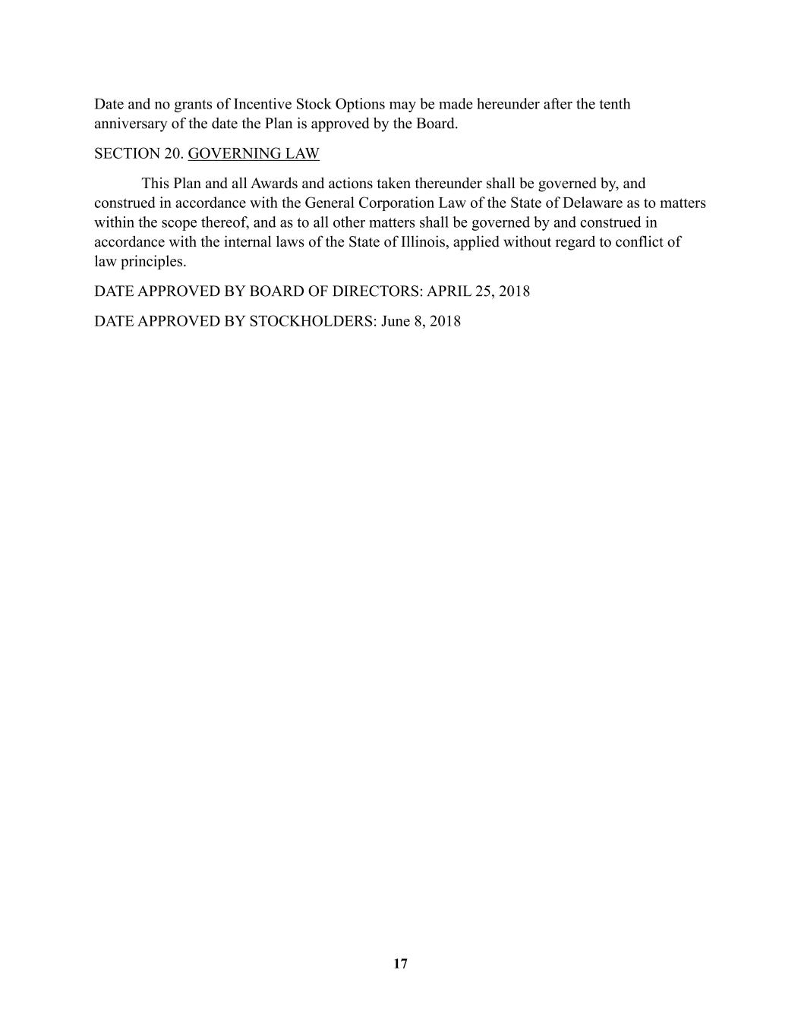
17 Date and no grants of Incentive Stock Options may be made hereunder after the tenth anniversary of the date the Plan is approved by the Board. SECTION 20. GOVERNING LAW This Plan and all Awards and actions taken thereunder shall be governed by, and construed in accordance with the General Corporation Law of the State of Delaware as to matters within the scope thereof, and as to all other matters shall be governed by and construed in accordance with the internal laws of the State of Illinois, applied without regard to conflict of law principles. DATE APPROVED BY BOARD OF DIRECTORS: APRIL 25, 2018 DATE APPROVED BY STOCKHOLDERS: June 8, 2018

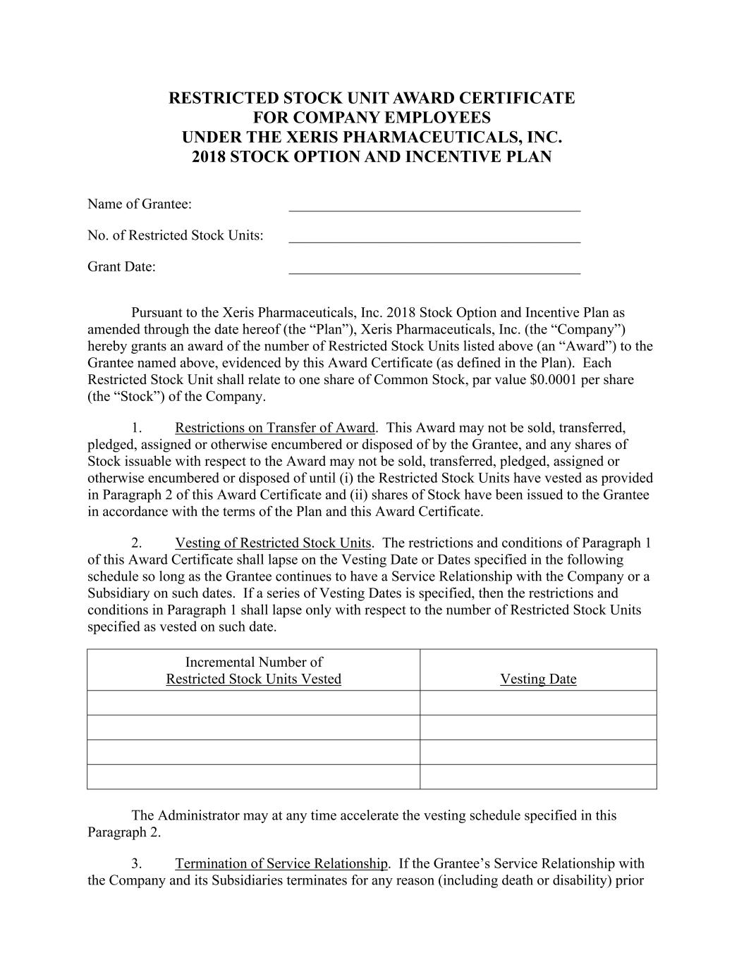
RESTRICTED STOCK UNIT AWARD CERTIFICATE FOR COMPANY EMPLOYEES UNDER THE XERIS PHARMACEUTICALS, INC. 2018 STOCK OPTION AND INCENTIVE PLAN Name of Grantee: ________________________________________ No. of Restricted Stock Units: ________________________________________ Grant Date: ________________________________________ Pursuant to the Xeris Pharmaceuticals, Inc. 2018 Stock Option and Incentive Plan as amended through the date hereof (the “Plan”), Xeris Pharmaceuticals, Inc. (the “Company”) hereby grants an award of the number of Restricted Stock Units listed above (an “Award”) to the Grantee named above, evidenced by this Award Certificate (as defined in the Plan). Each Restricted Stock Unit shall relate to one share of Common Stock, par value $0.0001 per share (the “Stock”) of the Company. 1. Restrictions on Transfer of Award. This Award may not be sold, transferred, pledged, assigned or otherwise encumbered or disposed of by the Grantee, and any shares of Stock issuable with respect to the Award may not be sold, transferred, pledged, assigned or otherwise encumbered or disposed of until (i) the Restricted Stock Units have vested as provided in Paragraph 2 of this Award Certificate and (ii) shares of Stock have been issued to the Grantee in accordance with the terms of the Plan and this Award Certificate. 2. Vesting of Restricted Stock Units. The restrictions and conditions of Paragraph 1 of this Award Certificate shall lapse on the Vesting Date or Dates specified in the following schedule so long as the Grantee continues to have a Service Relationship with the Company or a Subsidiary on such dates. If a series of Vesting Dates is specified, then the restrictions and conditions in Paragraph 1 shall lapse only with respect to the number of Restricted Stock Units specified as vested on such date. Incremental Number of Restricted Stock Units Vested Vesting Date The Administrator may at any time accelerate the vesting schedule specified in this Paragraph 2. 3. Termination of Service Relationship. If the Grantee’s Service Relationship with the Company and its Subsidiaries terminates for any reason (including death or disability) prior

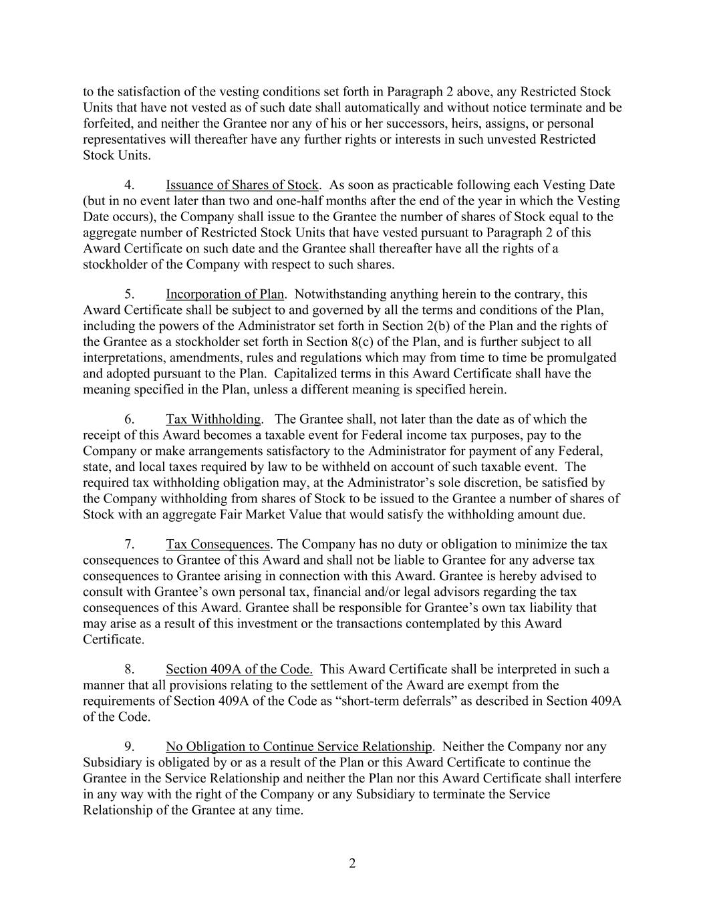
2 to the satisfaction of the vesting conditions set forth in Paragraph 2 above, any Restricted Stock Units that have not vested as of such date shall automatically and without notice terminate and be forfeited, and neither the Grantee nor any of his or her successors, heirs, assigns, or personal representatives will thereafter have any further rights or interests in such unvested Restricted Stock Units. 4. Issuance of Shares of Stock. As soon as practicable following each Vesting Date (but in no event later than two and one-half months after the end of the year in which the Vesting Date occurs), the Company shall issue to the Grantee the number of shares of Stock equal to the aggregate number of Restricted Stock Units that have vested pursuant to Paragraph 2 of this Award Certificate on such date and the Grantee shall thereafter have all the rights of a stockholder of the Company with respect to such shares. 5. Incorporation of Plan. Notwithstanding anything herein to the contrary, this Award Certificate shall be subject to and governed by all the terms and conditions of the Plan, including the powers of the Administrator set forth in Section 2(b) of the Plan and the rights of the Grantee as a stockholder set forth in Section 8(c) of the Plan, and is further subject to all interpretations, amendments, rules and regulations which may from time to time be promulgated and adopted pursuant to the Plan. Capitalized terms in this Award Certificate shall have the meaning specified in the Plan, unless a different meaning is specified herein. 6. Tax Withholding. The Grantee shall, not later than the date as of which the receipt of this Award becomes a taxable event for Federal income tax purposes, pay to the Company or make arrangements satisfactory to the Administrator for payment of any Federal, state, and local taxes required by law to be withheld on account of such taxable event. The required tax withholding obligation may, at the Administrator’s sole discretion, be satisfied by the Company withholding from shares of Stock to be issued to the Grantee a number of shares of Stock with an aggregate Fair Market Value that would satisfy the withholding amount due. 7. Tax Consequences. The Company has no duty or obligation to minimize the tax consequences to Grantee of this Award and shall not be liable to Grantee for any adverse tax consequences to Grantee arising in connection with this Award. Grantee is hereby advised to consult with Grantee’s own personal tax, financial and/or legal advisors regarding the tax consequences of this Award. Grantee shall be responsible for Grantee’s own tax liability that may arise as a result of this investment or the transactions contemplated by this Award Certificate. 8. Section 409A of the Code. This Award Certificate shall be interpreted in such a manner that all provisions relating to the settlement of the Award are exempt from the requirements of Section 409A of the Code as “short-term deferrals” as described in Section 409A of the Code. 9. No Obligation to Continue Service Relationship. Neither the Company nor any Subsidiary is obligated by or as a result of the Plan or this Award Certificate to continue the Grantee in the Service Relationship and neither the Plan nor this Award Certificate shall interfere in any way with the right of the Company or any Subsidiary to terminate the Service Relationship of the Grantee at any time.

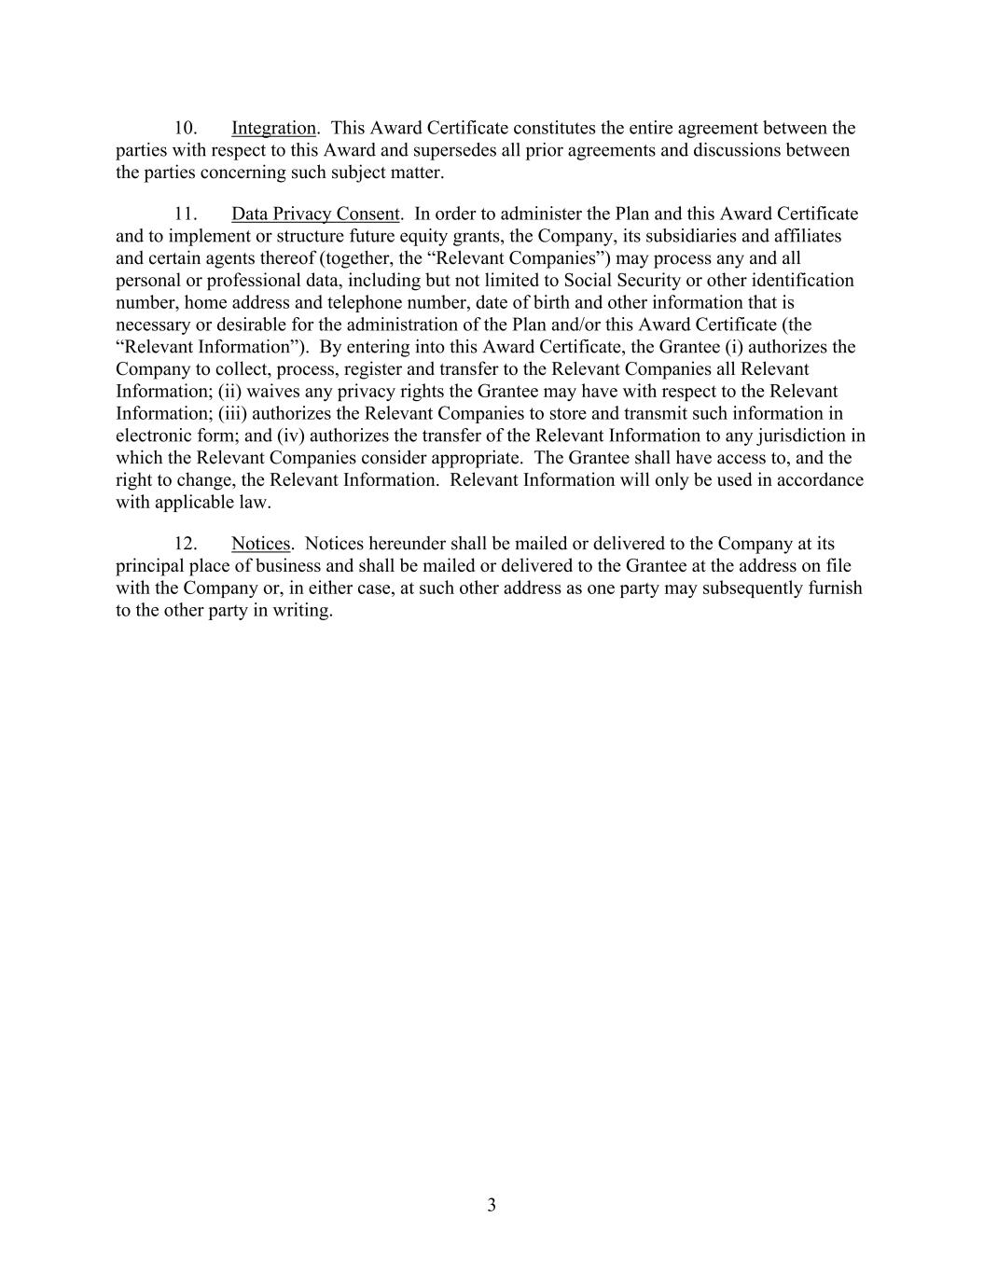
3 10. Integration. This Award Certificate constitutes the entire agreement between the parties with respect to this Award and supersedes all prior agreements and discussions between the parties concerning such subject matter. 11. Data Privacy Consent. In order to administer the Plan and this Award Certificate and to implement or structure future equity grants, the Company, its subsidiaries and affiliates and certain agents thereof (together, the “Relevant Companies”) may process any and all personal or professional data, including but not limited to Social Security or other identification number, home address and telephone number, date of birth and other information that is necessary or desirable for the administration of the Plan and/or this Award Certificate (the “Relevant Information”). By entering into this Award Certificate, the Grantee (i) authorizes the Company to collect, process, register and transfer to the Relevant Companies all Relevant Information; (ii) waives any privacy rights the Grantee may have with respect to the Relevant Information; (iii) authorizes the Relevant Companies to store and transmit such information in electronic form; and (iv) authorizes the transfer of the Relevant Information to any jurisdiction in which the Relevant Companies consider appropriate. The Grantee shall have access to, and the right to change, the Relevant Information. Relevant Information will only be used in accordance with applicable law. 12. Notices. Notices hereunder shall be mailed or delivered to the Company at its principal place of business and shall be mailed or delivered to the Grantee at the address on file with the Company or, in either case, at such other address as one party may subsequently furnish to the other party in writing.

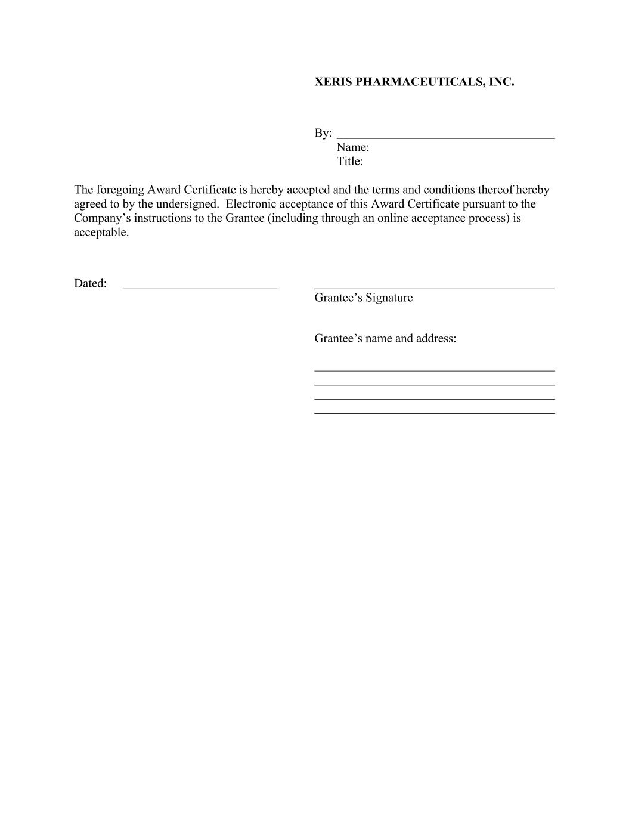
XERIS PHARMACEUTICALS, INC. By: Name: Title: The foregoing Award Certificate is hereby accepted and the terms and conditions thereof hereby agreed to by the undersigned. Electronic acceptance of this Award Certificate pursuant to the Company’s instructions to the Grantee (including through an online acceptance process) is acceptable. Dated: Grantee’s Signature Grantee’s name and address: _______________________________________ _______________________________________ _______________________________________ _______________________________________

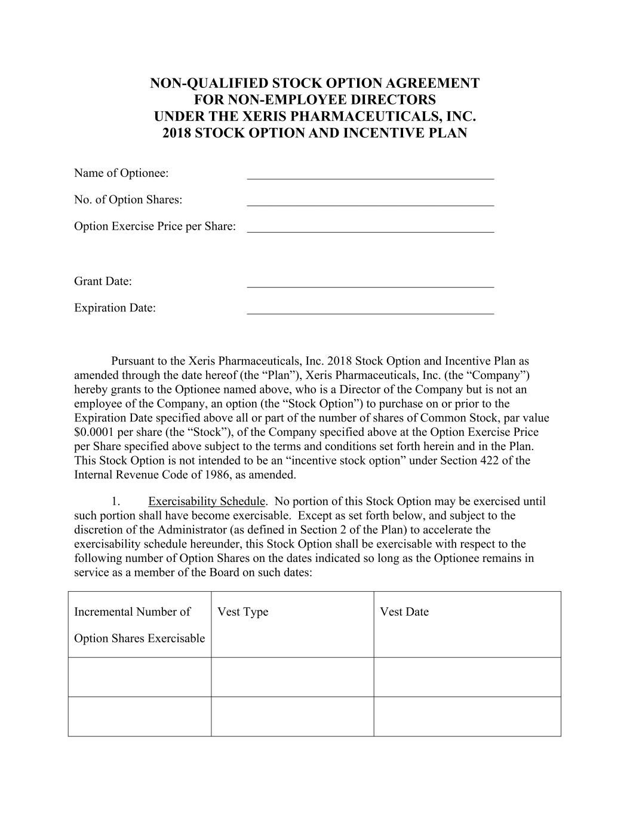
NON-QUALIFIED STOCK OPTION AGREEMENT FOR NON-EMPLOYEE DIRECTORS UNDER THE XERIS PHARMACEUTICALS, INC. 2018 STOCK OPTION AND INCENTIVE PLAN Name of Optionee: ________________________________________ No. of Option Shares: ________________________________________ Option Exercise Price per Share: ________________________________________ Grant Date: ________________________________________ Expiration Date: ________________________________________ Pursuant to the Xeris Pharmaceuticals, Inc. 2018 Stock Option and Incentive Plan as amended through the date hereof (the “Plan”), Xeris Pharmaceuticals, Inc. (the “Company”) hereby grants to the Optionee named above, who is a Director of the Company but is not an employee of the Company, an option (the “Stock Option”) to purchase on or prior to the Expiration Date specified above all or part of the number of shares of Common Stock, par value $0.0001 per share (the “Stock”), of the Company specified above at the Option Exercise Price per Share specified above subject to the terms and conditions set forth herein and in the Plan. This Stock Option is not intended to be an “incentive stock option” under Section 422 of the Internal Revenue Code of 1986, as amended. 1. Exercisability Schedule. No portion of this Stock Option may be exercised until such portion shall have become exercisable. Except as set forth below, and subject to the discretion of the Administrator (as defined in Section 2 of the Plan) to accelerate the exercisability schedule hereunder, this Stock Option shall be exercisable with respect to the following number of Option Shares on the dates indicated so long as the Optionee remains in service as a member of the Board on such dates: Incremental Number of Option Shares Exercisable Vest Type Vest Date

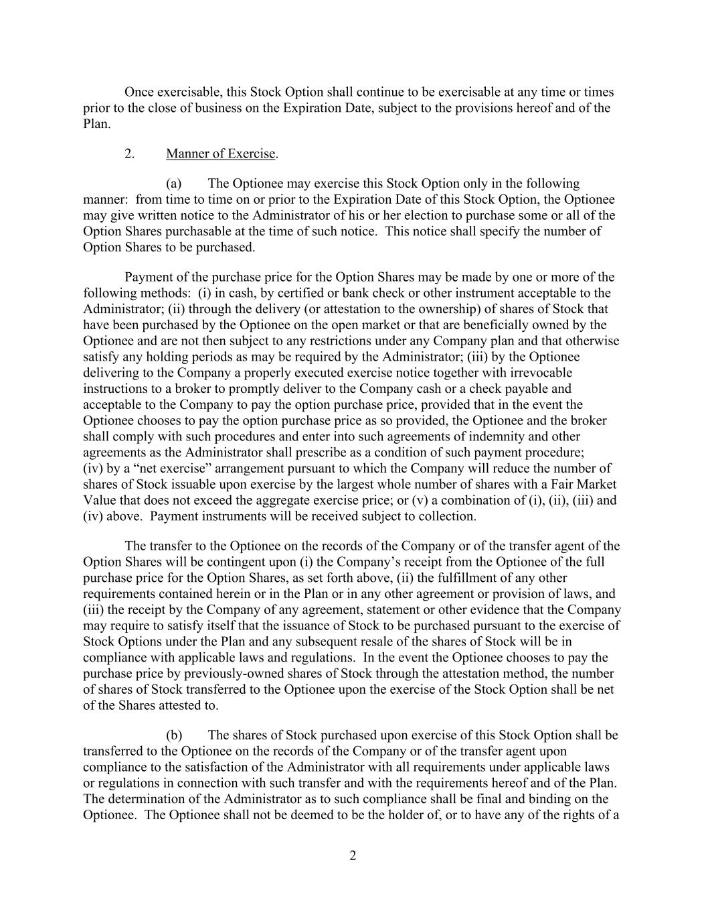
2 Once exercisable, this Stock Option shall continue to be exercisable at any time or times prior to the close of business on the Expiration Date, subject to the provisions hereof and of the Plan. 2. Manner of Exercise. (a) The Optionee may exercise this Stock Option only in the following manner: from time to time on or prior to the Expiration Date of this Stock Option, the Optionee may give written notice to the Administrator of his or her election to purchase some or all of the Option Shares purchasable at the time of such notice. This notice shall specify the number of Option Shares to be purchased. Payment of the purchase price for the Option Shares may be made by one or more of the following methods: (i) in cash, by certified or bank check or other instrument acceptable to the Administrator; (ii) through the delivery (or attestation to the ownership) of shares of Stock that have been purchased by the Optionee on the open market or that are beneficially owned by the Optionee and are not then subject to any restrictions under any Company plan and that otherwise satisfy any holding periods as may be required by the Administrator; (iii) by the Optionee delivering to the Company a properly executed exercise notice together with irrevocable instructions to a broker to promptly deliver to the Company cash or a check payable and acceptable to the Company to pay the option purchase price, provided that in the event the Optionee chooses to pay the option purchase price as so provided, the Optionee and the broker shall comply with such procedures and enter into such agreements of indemnity and other agreements as the Administrator shall prescribe as a condition of such payment procedure; (iv) by a “net exercise” arrangement pursuant to which the Company will reduce the number of shares of Stock issuable upon exercise by the largest whole number of shares with a Fair Market Value that does not exceed the aggregate exercise price; or (v) a combination of (i), (ii), (iii) and (iv) above. Payment instruments will be received subject to collection. The transfer to the Optionee on the records of the Company or of the transfer agent of the Option Shares will be contingent upon (i) the Company’s receipt from the Optionee of the full purchase price for the Option Shares, as set forth above, (ii) the fulfillment of any other requirements contained herein or in the Plan or in any other agreement or provision of laws, and (iii) the receipt by the Company of any agreement, statement or other evidence that the Company may require to satisfy itself that the issuance of Stock to be purchased pursuant to the exercise of Stock Options under the Plan and any subsequent resale of the shares of Stock will be in compliance with applicable laws and regulations. In the event the Optionee chooses to pay the purchase price by previously-owned shares of Stock through the attestation method, the number of shares of Stock transferred to the Optionee upon the exercise of the Stock Option shall be net of the Shares attested to. (b) The shares of Stock purchased upon exercise of this Stock Option shall be transferred to the Optionee on the records of the Company or of the transfer agent upon compliance to the satisfaction of the Administrator with all requirements under applicable laws or regulations in connection with such transfer and with the requirements hereof and of the Plan. The determination of the Administrator as to such compliance shall be final and binding on the Optionee. The Optionee shall not be deemed to be the holder of, or to have any of the rights of a

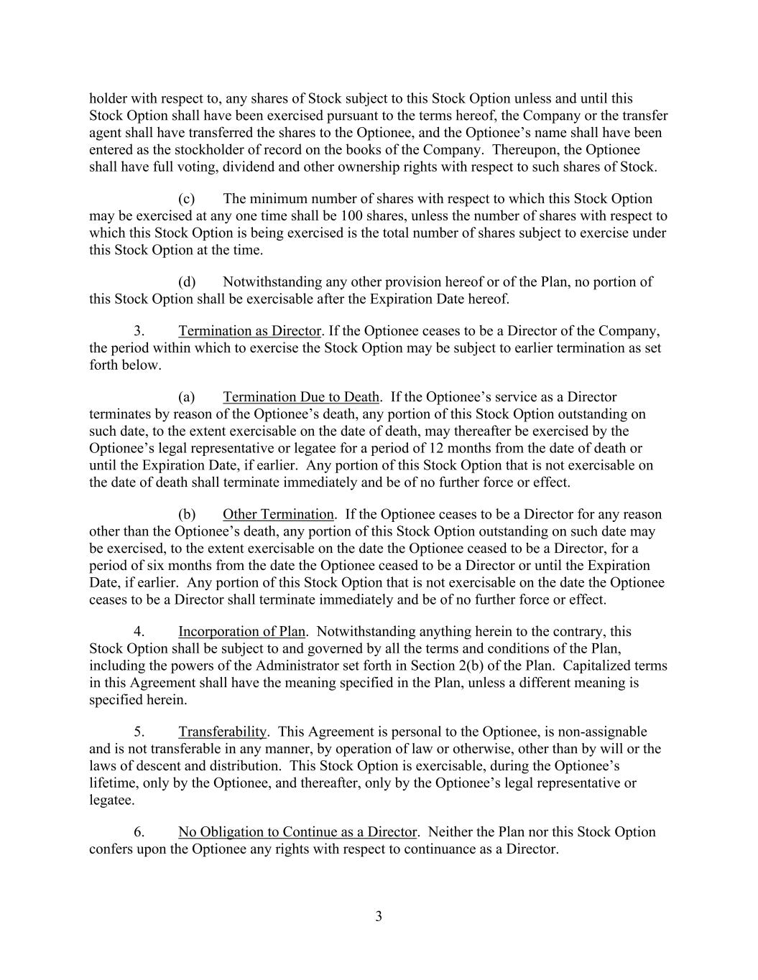
3 holder with respect to, any shares of Stock subject to this Stock Option unless and until this Stock Option shall have been exercised pursuant to the terms hereof, the Company or the transfer agent shall have transferred the shares to the Optionee, and the Optionee’s name shall have been entered as the stockholder of record on the books of the Company. Thereupon, the Optionee shall have full voting, dividend and other ownership rights with respect to such shares of Stock. (c) The minimum number of shares with respect to which this Stock Option may be exercised at any one time shall be 100 shares, unless the number of shares with respect to which this Stock Option is being exercised is the total number of shares subject to exercise under this Stock Option at the time. (d) Notwithstanding any other provision hereof or of the Plan, no portion of this Stock Option shall be exercisable after the Expiration Date hereof. 3. Termination as Director. If the Optionee ceases to be a Director of the Company, the period within which to exercise the Stock Option may be subject to earlier termination as set forth below. (a) Termination Due to Death. If the Optionee’s service as a Director terminates by reason of the Optionee’s death, any portion of this Stock Option outstanding on such date, to the extent exercisable on the date of death, may thereafter be exercised by the Optionee’s legal representative or legatee for a period of 12 months from the date of death or until the Expiration Date, if earlier. Any portion of this Stock Option that is not exercisable on the date of death shall terminate immediately and be of no further force or effect. (b) Other Termination. If the Optionee ceases to be a Director for any reason other than the Optionee’s death, any portion of this Stock Option outstanding on such date may be exercised, to the extent exercisable on the date the Optionee ceased to be a Director, for a period of six months from the date the Optionee ceased to be a Director or until the Expiration Date, if earlier. Any portion of this Stock Option that is not exercisable on the date the Optionee ceases to be a Director shall terminate immediately and be of no further force or effect. 4. Incorporation of Plan. Notwithstanding anything herein to the contrary, this Stock Option shall be subject to and governed by all the terms and conditions of the Plan, including the powers of the Administrator set forth in Section 2(b) of the Plan. Capitalized terms in this Agreement shall have the meaning specified in the Plan, unless a different meaning is specified herein. 5. Transferability. This Agreement is personal to the Optionee, is non-assignable and is not transferable in any manner, by operation of law or otherwise, other than by will or the laws of descent and distribution. This Stock Option is exercisable, during the Optionee’s lifetime, only by the Optionee, and thereafter, only by the Optionee’s legal representative or legatee. 6. No Obligation to Continue as a Director. Neither the Plan nor this Stock Option confers upon the Optionee any rights with respect to continuance as a Director.

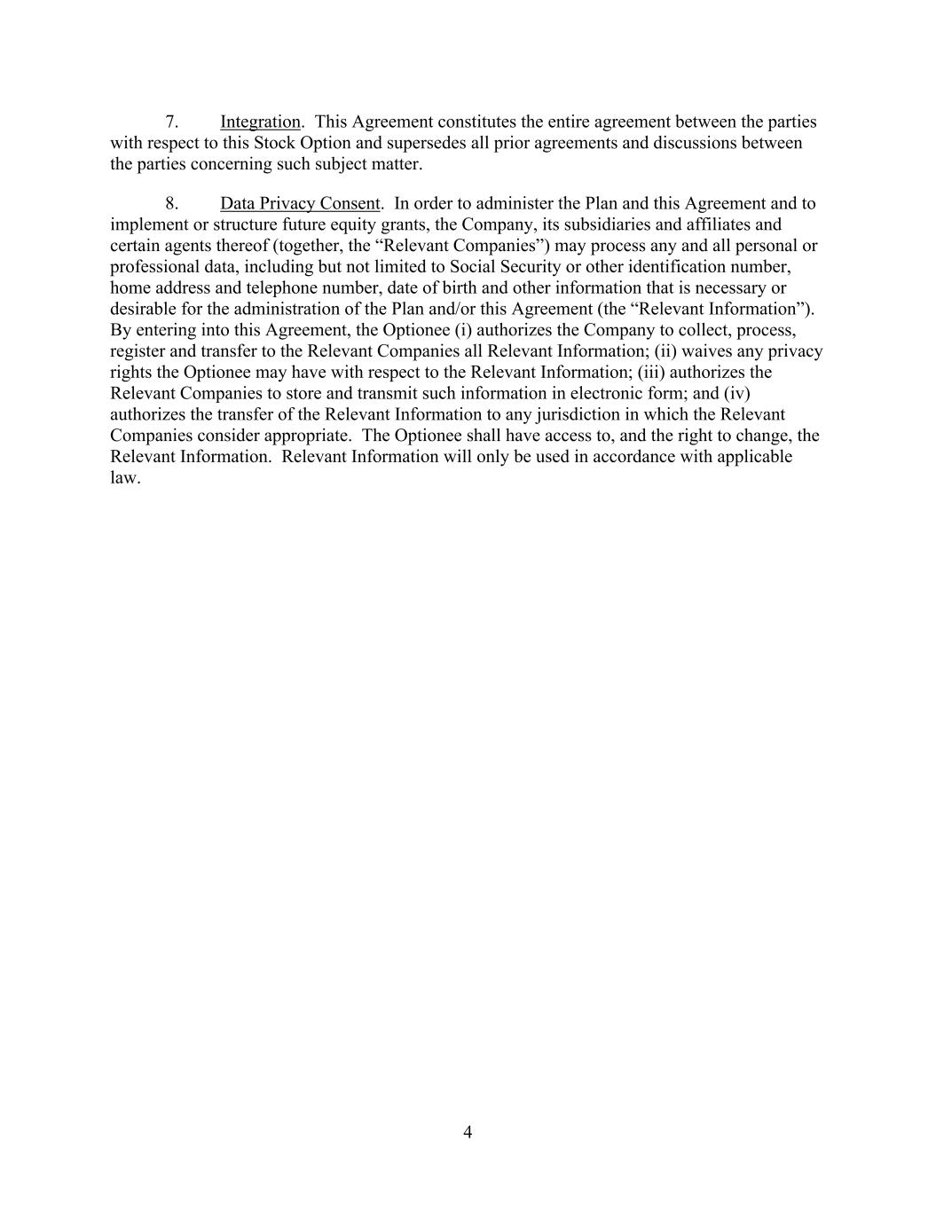
4 7. Integration. This Agreement constitutes the entire agreement between the parties with respect to this Stock Option and supersedes all prior agreements and discussions between the parties concerning such subject matter. 8. Data Privacy Consent. In order to administer the Plan and this Agreement and to implement or structure future equity grants, the Company, its subsidiaries and affiliates and certain agents thereof (together, the “Relevant Companies”) may process any and all personal or professional data, including but not limited to Social Security or other identification number, home address and telephone number, date of birth and other information that is necessary or desirable for the administration of the Plan and/or this Agreement (the “Relevant Information”). By entering into this Agreement, the Optionee (i) authorizes the Company to collect, process, register and transfer to the Relevant Companies all Relevant Information; (ii) waives any privacy rights the Optionee may have with respect to the Relevant Information; (iii) authorizes the Relevant Companies to store and transmit such information in electronic form; and (iv) authorizes the transfer of the Relevant Information to any jurisdiction in which the Relevant Companies consider appropriate. The Optionee shall have access to, and the right to change, the Relevant Information. Relevant Information will only be used in accordance with applicable law.

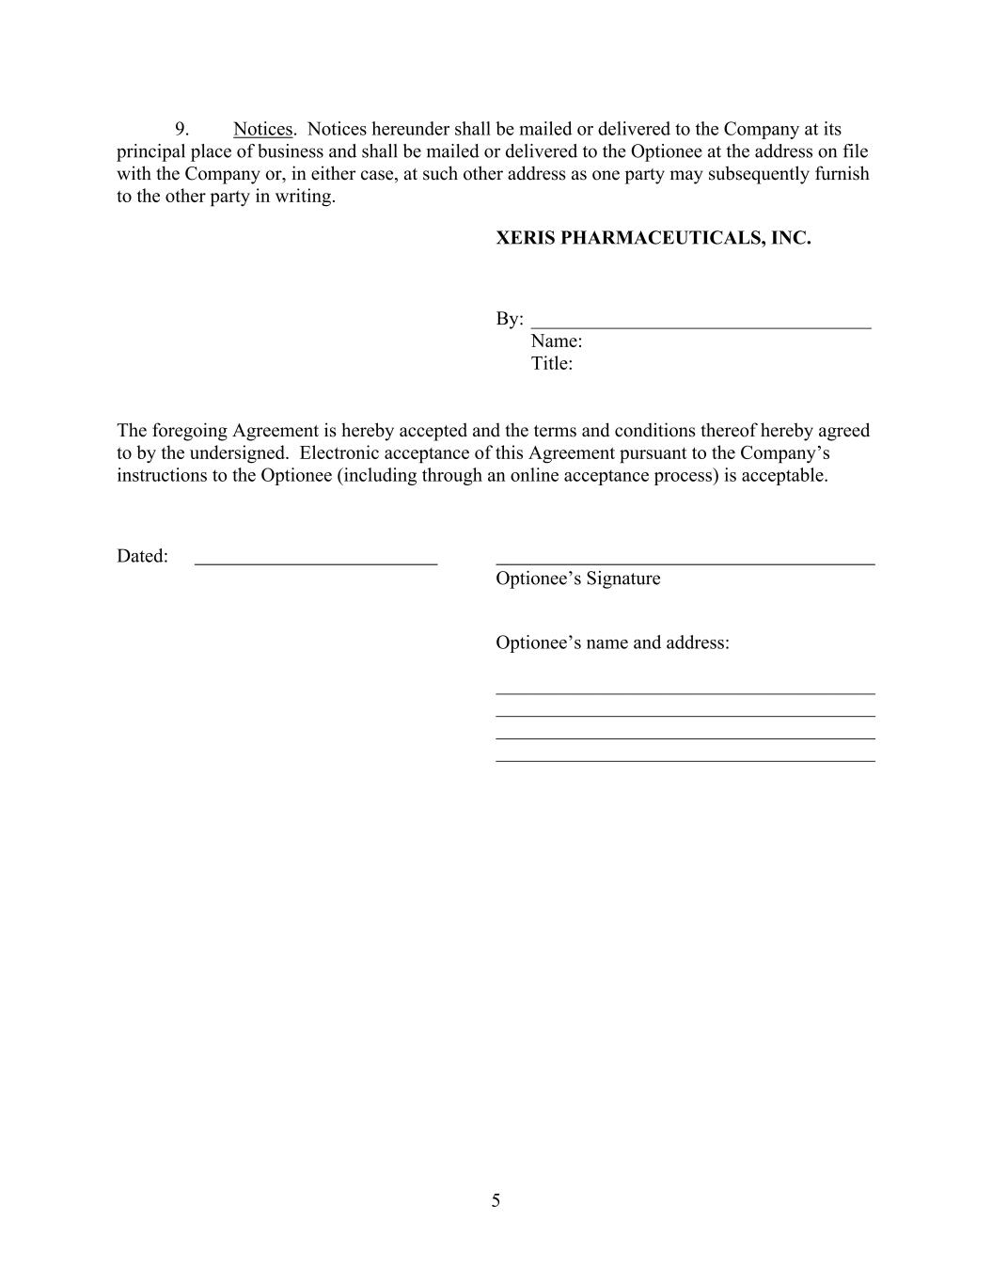
5 9. Notices. Notices hereunder shall be mailed or delivered to the Company at its principal place of business and shall be mailed or delivered to the Optionee at the address on file with the Company or, in either case, at such other address as one party may subsequently furnish to the other party in writing. XERIS PHARMACEUTICALS, INC. By: ___________________________________ Name: Title: The foregoing Agreement is hereby accepted and the terms and conditions thereof hereby agreed to by the undersigned. Electronic acceptance of this Agreement pursuant to the Company’s instructions to the Optionee (including through an online acceptance process) is acceptable. Dated: Optionee’s Signature Optionee’s name and address: _______________________________________ _______________________________________ _______________________________________ _______________________________________

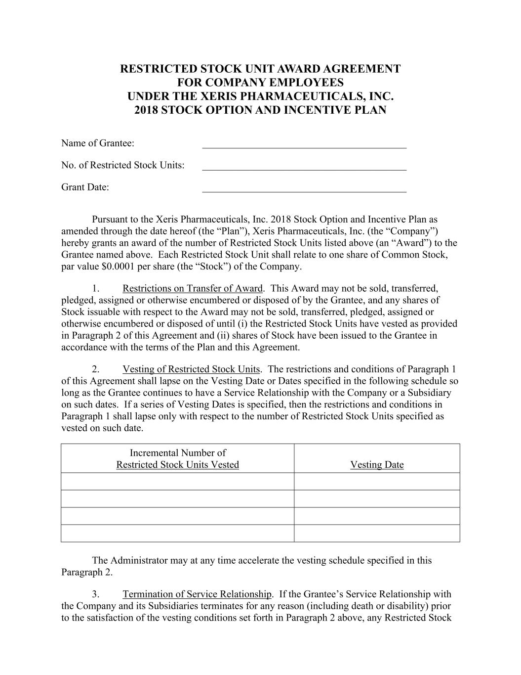
RESTRICTED STOCK UNIT AWARD AGREEMENT FOR COMPANY EMPLOYEES UNDER THE XERIS PHARMACEUTICALS, INC. 2018 STOCK OPTION AND INCENTIVE PLAN Name of Grantee: ________________________________________ No. of Restricted Stock Units: ________________________________________ Grant Date: ________________________________________ Pursuant to the Xeris Pharmaceuticals, Inc. 2018 Stock Option and Incentive Plan as amended through the date hereof (the “Plan”), Xeris Pharmaceuticals, Inc. (the “Company”) hereby grants an award of the number of Restricted Stock Units listed above (an “Award”) to the Grantee named above. Each Restricted Stock Unit shall relate to one share of Common Stock, par value $0.0001 per share (the “Stock”) of the Company. 1. Restrictions on Transfer of Award. This Award may not be sold, transferred, pledged, assigned or otherwise encumbered or disposed of by the Grantee, and any shares of Stock issuable with respect to the Award may not be sold, transferred, pledged, assigned or otherwise encumbered or disposed of until (i) the Restricted Stock Units have vested as provided in Paragraph 2 of this Agreement and (ii) shares of Stock have been issued to the Grantee in accordance with the terms of the Plan and this Agreement. 2. Vesting of Restricted Stock Units. The restrictions and conditions of Paragraph 1 of this Agreement shall lapse on the Vesting Date or Dates specified in the following schedule so long as the Grantee continues to have a Service Relationship with the Company or a Subsidiary on such dates. If a series of Vesting Dates is specified, then the restrictions and conditions in Paragraph 1 shall lapse only with respect to the number of Restricted Stock Units specified as vested on such date. Incremental Number of Restricted Stock Units Vested Vesting Date The Administrator may at any time accelerate the vesting schedule specified in this Paragraph 2. 3. Termination of Service Relationship. If the Grantee’s Service Relationship with the Company and its Subsidiaries terminates for any reason (including death or disability) prior to the satisfaction of the vesting conditions set forth in Paragraph 2 above, any Restricted Stock

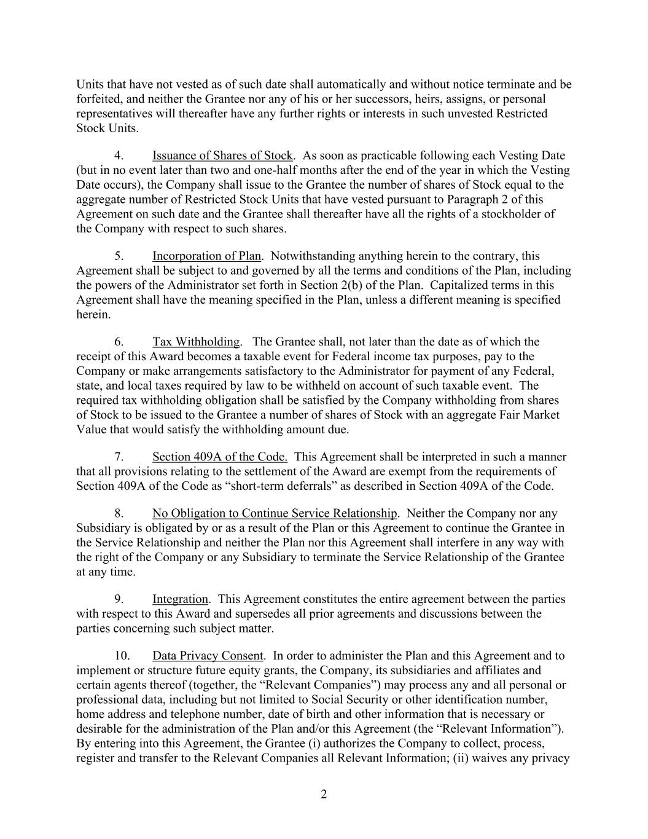
2 Units that have not vested as of such date shall automatically and without notice terminate and be forfeited, and neither the Grantee nor any of his or her successors, heirs, assigns, or personal representatives will thereafter have any further rights or interests in such unvested Restricted Stock Units. 4. Issuance of Shares of Stock. As soon as practicable following each Vesting Date (but in no event later than two and one-half months after the end of the year in which the Vesting Date occurs), the Company shall issue to the Grantee the number of shares of Stock equal to the aggregate number of Restricted Stock Units that have vested pursuant to Paragraph 2 of this Agreement on such date and the Grantee shall thereafter have all the rights of a stockholder of the Company with respect to such shares. 5. Incorporation of Plan. Notwithstanding anything herein to the contrary, this Agreement shall be subject to and governed by all the terms and conditions of the Plan, including the powers of the Administrator set forth in Section 2(b) of the Plan. Capitalized terms in this Agreement shall have the meaning specified in the Plan, unless a different meaning is specified herein. 6. Tax Withholding. The Grantee shall, not later than the date as of which the receipt of this Award becomes a taxable event for Federal income tax purposes, pay to the Company or make arrangements satisfactory to the Administrator for payment of any Federal, state, and local taxes required by law to be withheld on account of such taxable event. The required tax withholding obligation shall be satisfied by the Company withholding from shares of Stock to be issued to the Grantee a number of shares of Stock with an aggregate Fair Market Value that would satisfy the withholding amount due. 7. Section 409A of the Code. This Agreement shall be interpreted in such a manner that all provisions relating to the settlement of the Award are exempt from the requirements of Section 409A of the Code as “short-term deferrals” as described in Section 409A of the Code. 8. No Obligation to Continue Service Relationship. Neither the Company nor any Subsidiary is obligated by or as a result of the Plan or this Agreement to continue the Grantee in the Service Relationship and neither the Plan nor this Agreement shall interfere in any way with the right of the Company or any Subsidiary to terminate the Service Relationship of the Grantee at any time. 9. Integration. This Agreement constitutes the entire agreement between the parties with respect to this Award and supersedes all prior agreements and discussions between the parties concerning such subject matter. 10. Data Privacy Consent. In order to administer the Plan and this Agreement and to implement or structure future equity grants, the Company, its subsidiaries and affiliates and certain agents thereof (together, the “Relevant Companies”) may process any and all personal or professional data, including but not limited to Social Security or other identification number, home address and telephone number, date of birth and other information that is necessary or desirable for the administration of the Plan and/or this Agreement (the “Relevant Information”). By entering into this Agreement, the Grantee (i) authorizes the Company to collect, process, register and transfer to the Relevant Companies all Relevant Information; (ii) waives any privacy

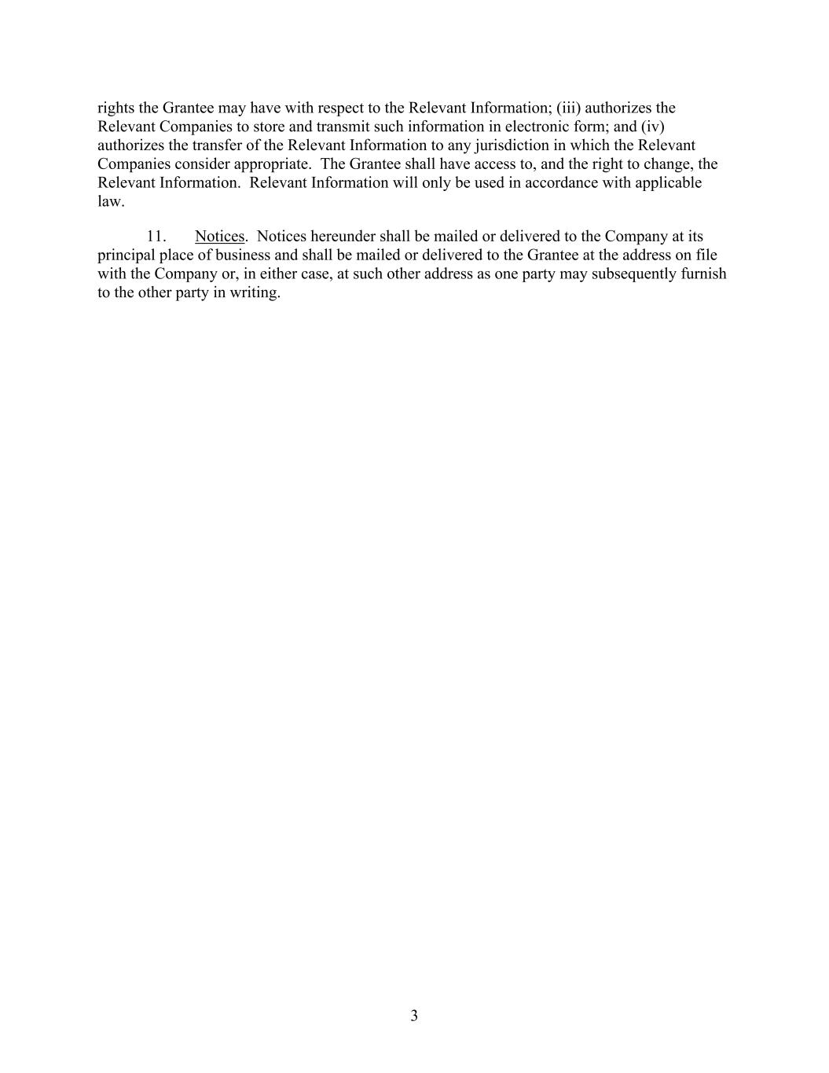
3 rights the Grantee may have with respect to the Relevant Information; (iii) authorizes the Relevant Companies to store and transmit such information in electronic form; and (iv) authorizes the transfer of the Relevant Information to any jurisdiction in which the Relevant Companies consider appropriate. The Grantee shall have access to, and the right to change, the Relevant Information. Relevant Information will only be used in accordance with applicable law. 11. Notices. Notices hereunder shall be mailed or delivered to the Company at its principal place of business and shall be mailed or delivered to the Grantee at the address on file with the Company or, in either case, at such other address as one party may subsequently furnish to the other party in writing.

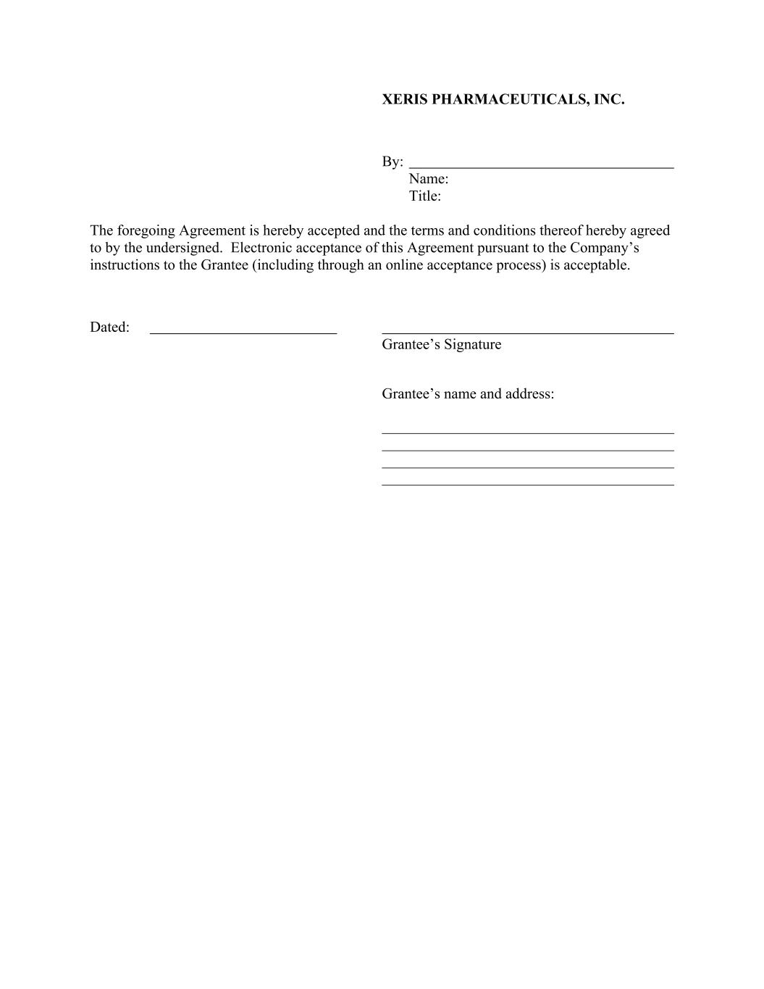
XERIS PHARMACEUTICALS, INC. By: Name: Title: The foregoing Agreement is hereby accepted and the terms and conditions thereof hereby agreed to by the undersigned. Electronic acceptance of this Agreement pursuant to the Company’s instructions to the Grantee (including through an online acceptance process) is acceptable. Dated: Grantee’s Signature Grantee’s name and address: _______________________________________ _______________________________________ _______________________________________ _______________________________________

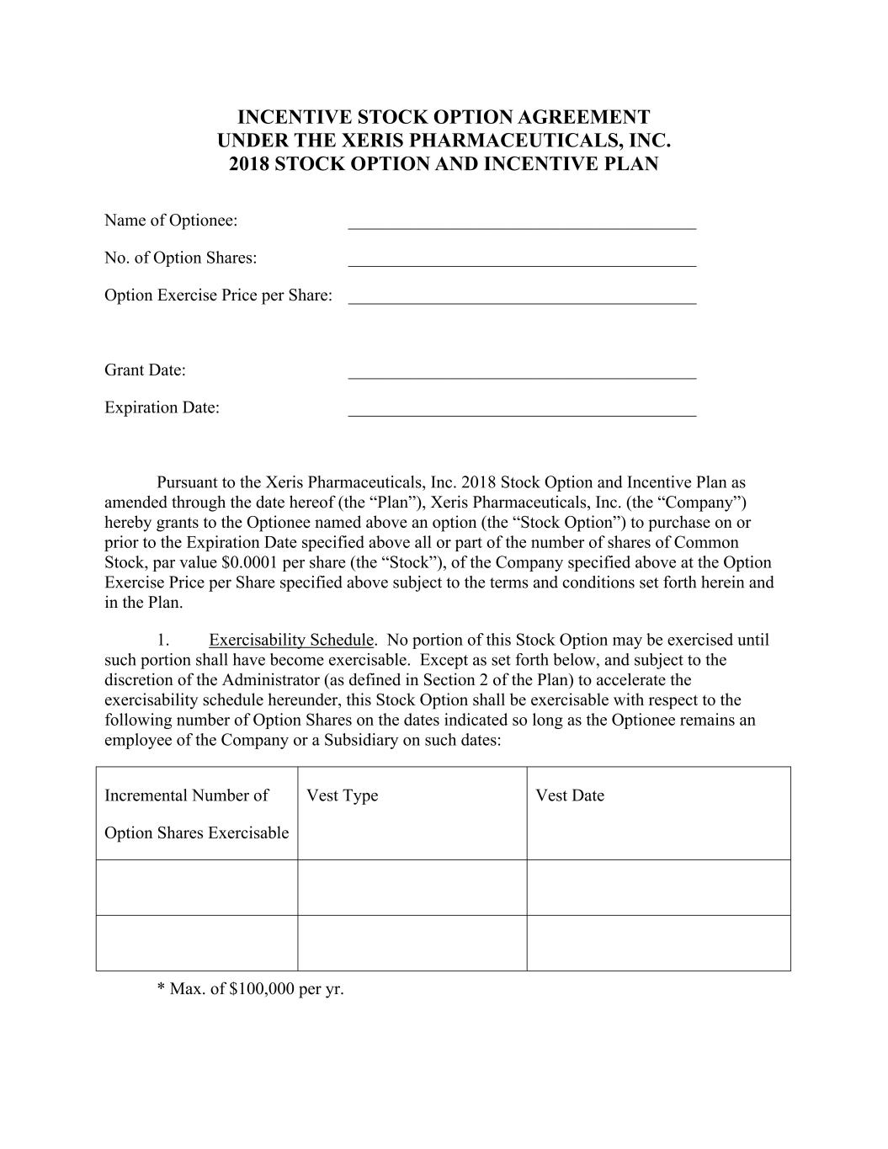
INCENTIVE STOCK OPTION AGREEMENT UNDER THE XERIS PHARMACEUTICALS, INC. 2018 STOCK OPTION AND INCENTIVE PLAN Name of Optionee: ________________________________________ No. of Option Shares: ________________________________________ Option Exercise Price per Share: ________________________________________ Grant Date: ________________________________________ Expiration Date: ________________________________________ Pursuant to the Xeris Pharmaceuticals, Inc. 2018 Stock Option and Incentive Plan as amended through the date hereof (the “Plan”), Xeris Pharmaceuticals, Inc. (the “Company”) hereby grants to the Optionee named above an option (the “Stock Option”) to purchase on or prior to the Expiration Date specified above all or part of the number of shares of Common Stock, par value $0.0001 per share (the “Stock”), of the Company specified above at the Option Exercise Price per Share specified above subject to the terms and conditions set forth herein and in the Plan. 1. Exercisability Schedule. No portion of this Stock Option may be exercised until such portion shall have become exercisable. Except as set forth below, and subject to the discretion of the Administrator (as defined in Section 2 of the Plan) to accelerate the exercisability schedule hereunder, this Stock Option shall be exercisable with respect to the following number of Option Shares on the dates indicated so long as the Optionee remains an employee of the Company or a Subsidiary on such dates: Incremental Number of Option Shares Exercisable Vest Type Vest Date * Max. of $100,000 per yr.

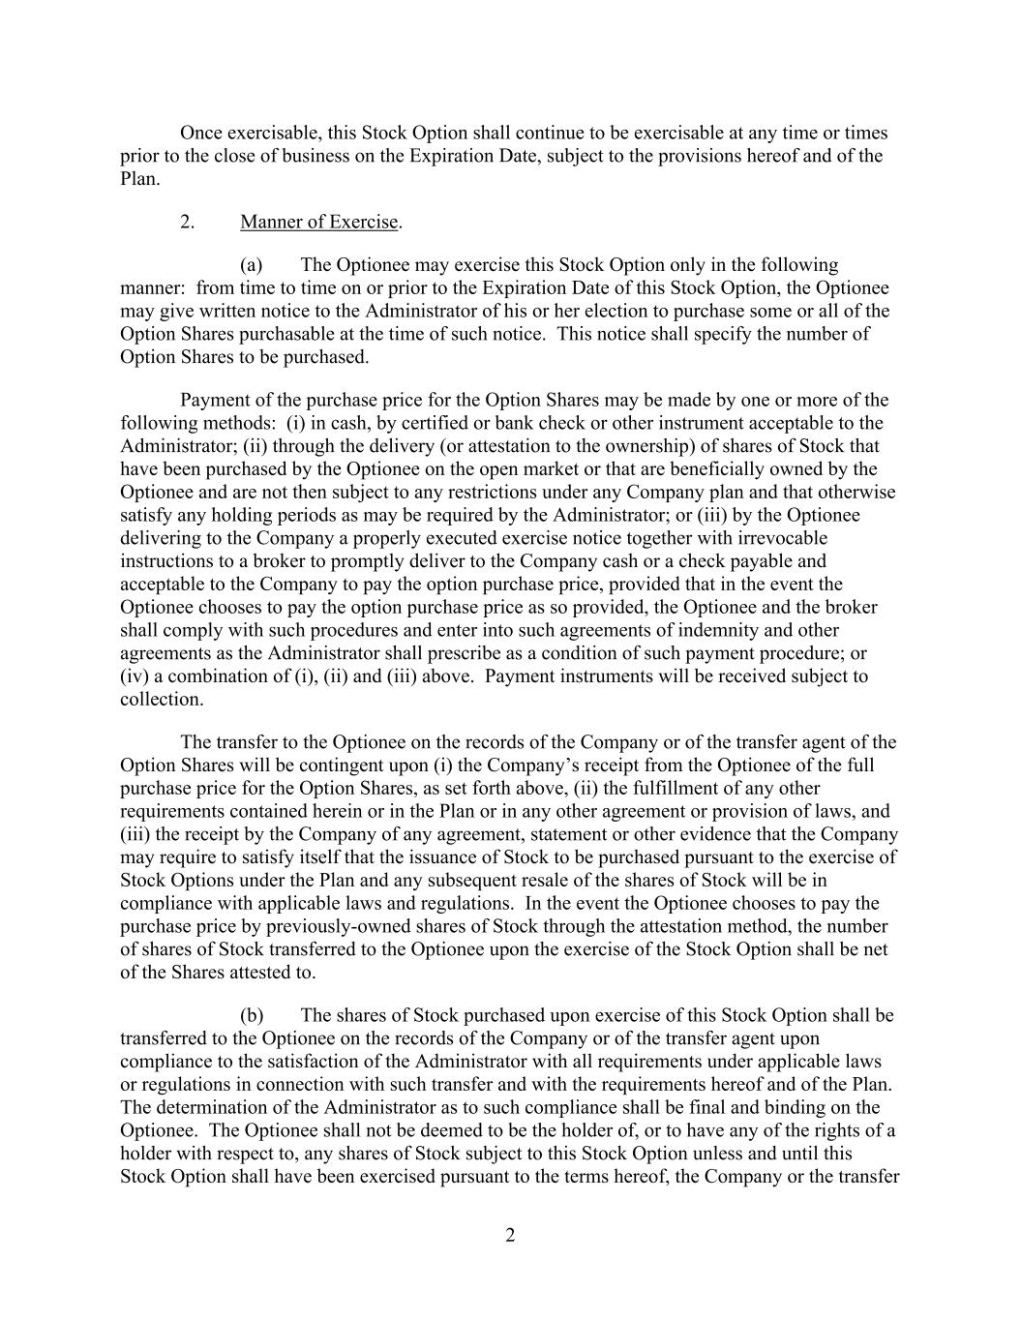
2 Once exercisable, this Stock Option shall continue to be exercisable at any time or times prior to the close of business on the Expiration Date, subject to the provisions hereof and of the Plan. 2. Manner of Exercise. (a) The Optionee may exercise this Stock Option only in the following manner: from time to time on or prior to the Expiration Date of this Stock Option, the Optionee may give written notice to the Administrator of his or her election to purchase some or all of the Option Shares purchasable at the time of such notice. This notice shall specify the number of Option Shares to be purchased. Payment of the purchase price for the Option Shares may be made by one or more of the following methods: (i) in cash, by certified or bank check or other instrument acceptable to the Administrator; (ii) through the delivery (or attestation to the ownership) of shares of Stock that have been purchased by the Optionee on the open market or that are beneficially owned by the Optionee and are not then subject to any restrictions under any Company plan and that otherwise satisfy any holding periods as may be required by the Administrator; or (iii) by the Optionee delivering to the Company a properly executed exercise notice together with irrevocable instructions to a broker to promptly deliver to the Company cash or a check payable and acceptable to the Company to pay the option purchase price, provided that in the event the Optionee chooses to pay the option purchase price as so provided, the Optionee and the broker shall comply with such procedures and enter into such agreements of indemnity and other agreements as the Administrator shall prescribe as a condition of such payment procedure; or (iv) a combination of (i), (ii) and (iii) above. Payment instruments will be received subject to collection. The transfer to the Optionee on the records of the Company or of the transfer agent of the Option Shares will be contingent upon (i) the Company’s receipt from the Optionee of the full purchase price for the Option Shares, as set forth above, (ii) the fulfillment of any other requirements contained herein or in the Plan or in any other agreement or provision of laws, and (iii) the receipt by the Company of any agreement, statement or other evidence that the Company may require to satisfy itself that the issuance of Stock to be purchased pursuant to the exercise of Stock Options under the Plan and any subsequent resale of the shares of Stock will be in compliance with applicable laws and regulations. In the event the Optionee chooses to pay the purchase price by previously-owned shares of Stock through the attestation method, the number of shares of Stock transferred to the Optionee upon the exercise of the Stock Option shall be net of the Shares attested to. (b) The shares of Stock purchased upon exercise of this Stock Option shall be transferred to the Optionee on the records of the Company or of the transfer agent upon compliance to the satisfaction of the Administrator with all requirements under applicable laws or regulations in connection with such transfer and with the requirements hereof and of the Plan. The determination of the Administrator as to such compliance shall be final and binding on the Optionee. The Optionee shall not be deemed to be the holder of, or to have any of the rights of a holder with respect to, any shares of Stock subject to this Stock Option unless and until this Stock Option shall have been exercised pursuant to the terms hereof, the Company or the transfer

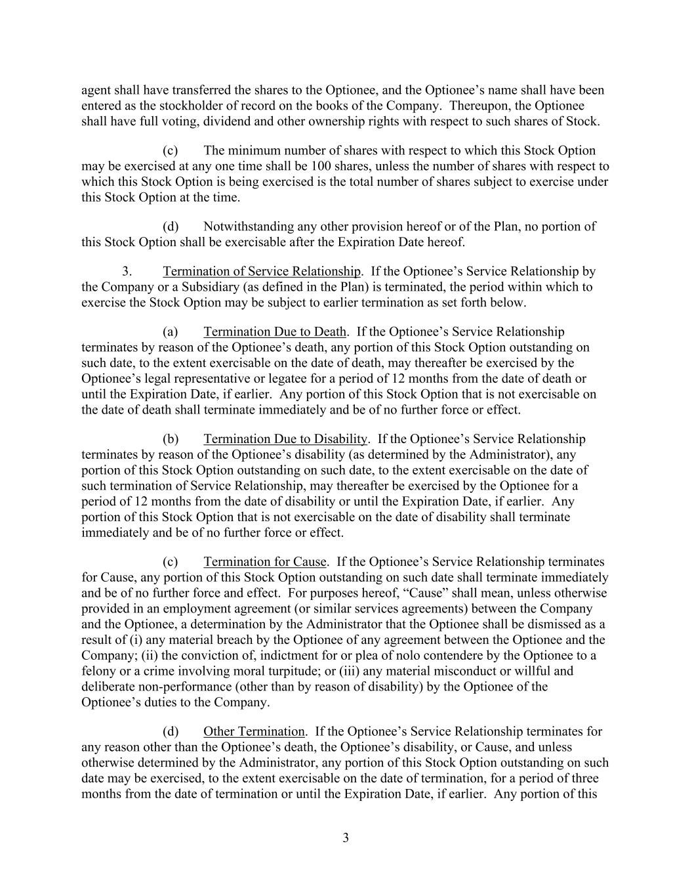
3 agent shall have transferred the shares to the Optionee, and the Optionee’s name shall have been entered as the stockholder of record on the books of the Company. Thereupon, the Optionee shall have full voting, dividend and other ownership rights with respect to such shares of Stock. (c) The minimum number of shares with respect to which this Stock Option may be exercised at any one time shall be 100 shares, unless the number of shares with respect to which this Stock Option is being exercised is the total number of shares subject to exercise under this Stock Option at the time. (d) Notwithstanding any other provision hereof or of the Plan, no portion of this Stock Option shall be exercisable after the Expiration Date hereof. 3. Termination of Service Relationship. If the Optionee’s Service Relationship by the Company or a Subsidiary (as defined in the Plan) is terminated, the period within which to exercise the Stock Option may be subject to earlier termination as set forth below. (a) Termination Due to Death. If the Optionee’s Service Relationship terminates by reason of the Optionee’s death, any portion of this Stock Option outstanding on such date, to the extent exercisable on the date of death, may thereafter be exercised by the Optionee’s legal representative or legatee for a period of 12 months from the date of death or until the Expiration Date, if earlier. Any portion of this Stock Option that is not exercisable on the date of death shall terminate immediately and be of no further force or effect. (b) Termination Due to Disability. If the Optionee’s Service Relationship terminates by reason of the Optionee’s disability (as determined by the Administrator), any portion of this Stock Option outstanding on such date, to the extent exercisable on the date of such termination of Service Relationship, may thereafter be exercised by the Optionee for a period of 12 months from the date of disability or until the Expiration Date, if earlier. Any portion of this Stock Option that is not exercisable on the date of disability shall terminate immediately and be of no further force or effect. (c) Termination for Cause. If the Optionee’s Service Relationship terminates for Cause, any portion of this Stock Option outstanding on such date shall terminate immediately and be of no further force and effect. For purposes hereof, “Cause” shall mean, unless otherwise provided in an employment agreement (or similar services agreements) between the Company and the Optionee, a determination by the Administrator that the Optionee shall be dismissed as a result of (i) any material breach by the Optionee of any agreement between the Optionee and the Company; (ii) the conviction of, indictment for or plea of nolo contendere by the Optionee to a felony or a crime involving moral turpitude; or (iii) any material misconduct or willful and deliberate non-performance (other than by reason of disability) by the Optionee of the Optionee’s duties to the Company. (d) Other Termination. If the Optionee’s Service Relationship terminates for any reason other than the Optionee’s death, the Optionee’s disability, or Cause, and unless otherwise determined by the Administrator, any portion of this Stock Option outstanding on such date may be exercised, to the extent exercisable on the date of termination, for a period of three months from the date of termination or until the Expiration Date, if earlier. Any portion of this

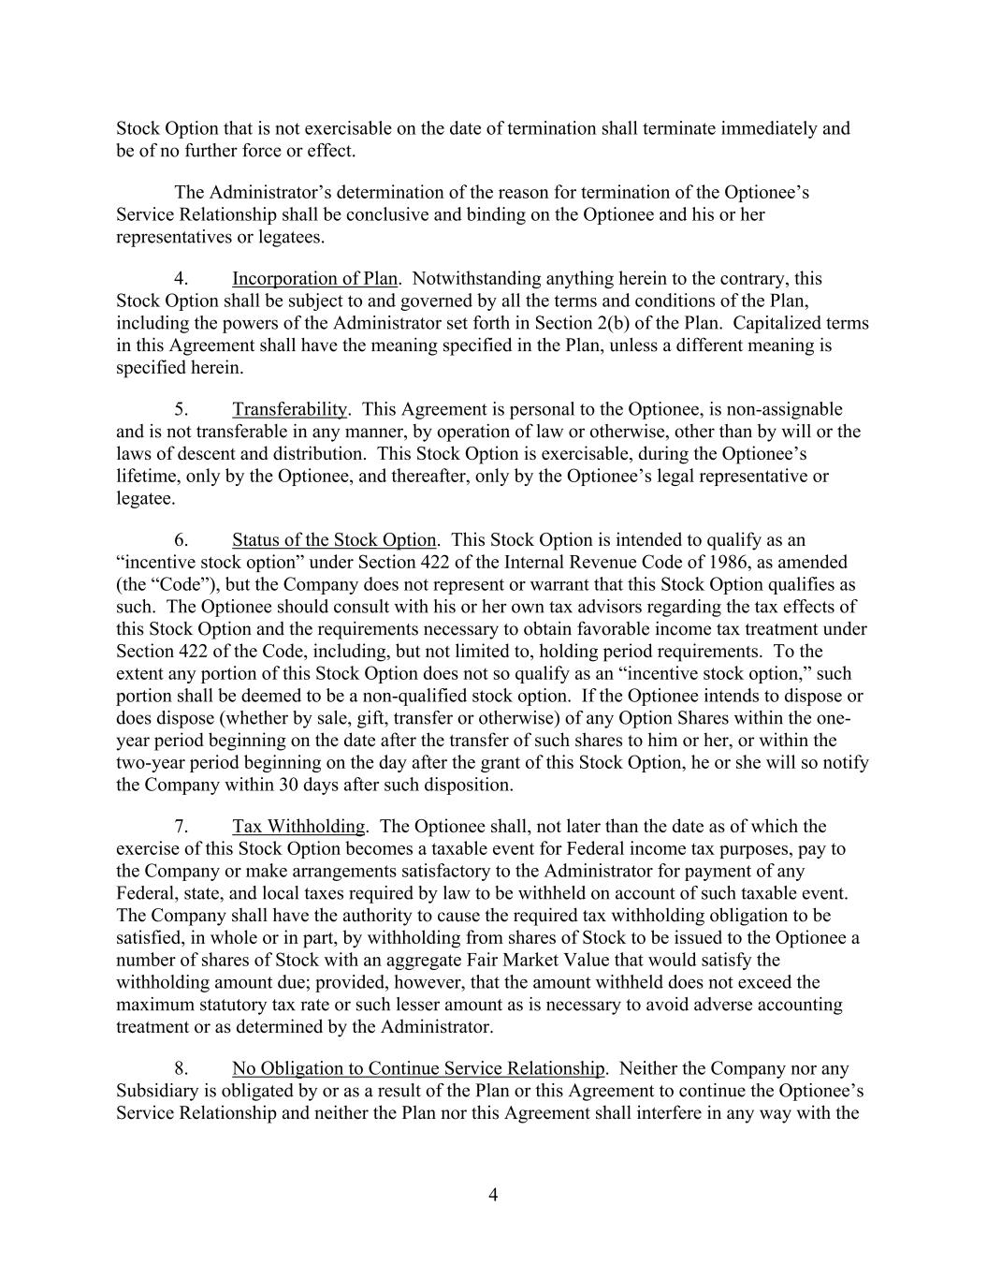
4 Stock Option that is not exercisable on the date of termination shall terminate immediately and be of no further force or effect. The Administrator’s determination of the reason for termination of the Optionee’s Service Relationship shall be conclusive and binding on the Optionee and his or her representatives or legatees. 4. Incorporation of Plan. Notwithstanding anything herein to the contrary, this Stock Option shall be subject to and governed by all the terms and conditions of the Plan, including the powers of the Administrator set forth in Section 2(b) of the Plan. Capitalized terms in this Agreement shall have the meaning specified in the Plan, unless a different meaning is specified herein. 5. Transferability. This Agreement is personal to the Optionee, is non-assignable and is not transferable in any manner, by operation of law or otherwise, other than by will or the laws of descent and distribution. This Stock Option is exercisable, during the Optionee’s lifetime, only by the Optionee, and thereafter, only by the Optionee’s legal representative or legatee. 6. Status of the Stock Option. This Stock Option is intended to qualify as an “incentive stock option” under Section 422 of the Internal Revenue Code of 1986, as amended (the “Code”), but the Company does not represent or warrant that this Stock Option qualifies as such. The Optionee should consult with his or her own tax advisors regarding the tax effects of this Stock Option and the requirements necessary to obtain favorable income tax treatment under Section 422 of the Code, including, but not limited to, holding period requirements. To the extent any portion of this Stock Option does not so qualify as an “incentive stock option,” such portion shall be deemed to be a non-qualified stock option. If the Optionee intends to dispose or does dispose (whether by sale, gift, transfer or otherwise) of any Option Shares within the one- year period beginning on the date after the transfer of such shares to him or her, or within the two-year period beginning on the day after the grant of this Stock Option, he or she will so notify the Company within 30 days after such disposition. 7. Tax Withholding. The Optionee shall, not later than the date as of which the exercise of this Stock Option becomes a taxable event for Federal income tax purposes, pay to the Company or make arrangements satisfactory to the Administrator for payment of any Federal, state, and local taxes required by law to be withheld on account of such taxable event. The Company shall have the authority to cause the required tax withholding obligation to be satisfied, in whole or in part, by withholding from shares of Stock to be issued to the Optionee a number of shares of Stock with an aggregate Fair Market Value that would satisfy the withholding amount due; provided, however, that the amount withheld does not exceed the maximum statutory tax rate or such lesser amount as is necessary to avoid adverse accounting treatment or as determined by the Administrator. 8. No Obligation to Continue Service Relationship. Neither the Company nor any Subsidiary is obligated by or as a result of the Plan or this Agreement to continue the Optionee’s Service Relationship and neither the Plan nor this Agreement shall interfere in any way with the

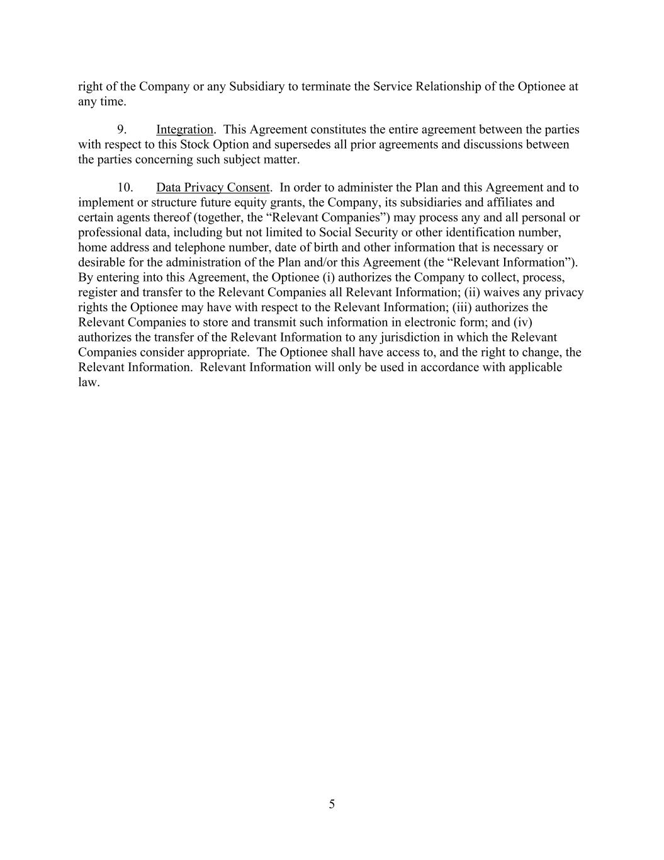
5 right of the Company or any Subsidiary to terminate the Service Relationship of the Optionee at any time. 9. Integration. This Agreement constitutes the entire agreement between the parties with respect to this Stock Option and supersedes all prior agreements and discussions between the parties concerning such subject matter. 10. Data Privacy Consent. In order to administer the Plan and this Agreement and to implement or structure future equity grants, the Company, its subsidiaries and affiliates and certain agents thereof (together, the “Relevant Companies”) may process any and all personal or professional data, including but not limited to Social Security or other identification number, home address and telephone number, date of birth and other information that is necessary or desirable for the administration of the Plan and/or this Agreement (the “Relevant Information”). By entering into this Agreement, the Optionee (i) authorizes the Company to collect, process, register and transfer to the Relevant Companies all Relevant Information; (ii) waives any privacy rights the Optionee may have with respect to the Relevant Information; (iii) authorizes the Relevant Companies to store and transmit such information in electronic form; and (iv) authorizes the transfer of the Relevant Information to any jurisdiction in which the Relevant Companies consider appropriate. The Optionee shall have access to, and the right to change, the Relevant Information. Relevant Information will only be used in accordance with applicable law.

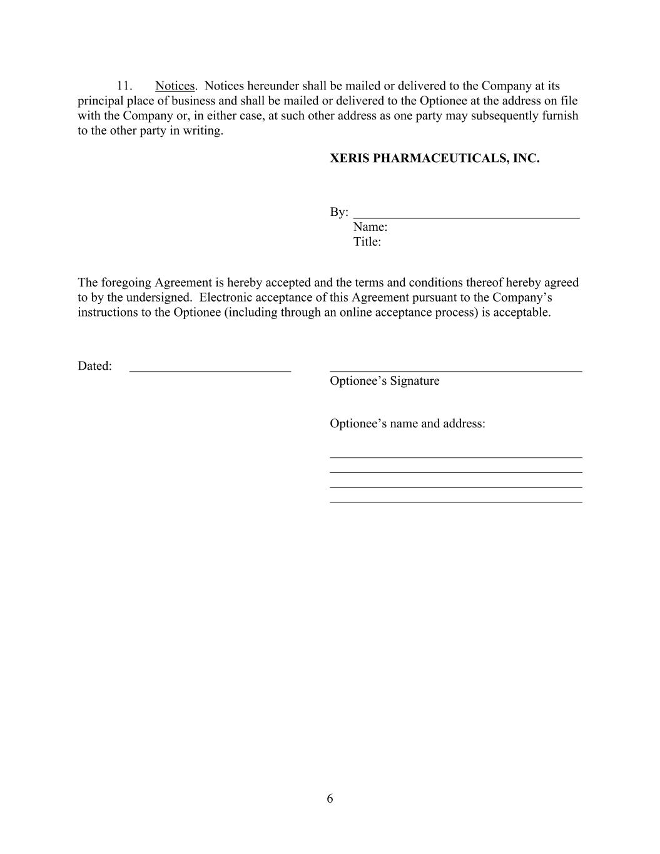
6 11. Notices. Notices hereunder shall be mailed or delivered to the Company at its principal place of business and shall be mailed or delivered to the Optionee at the address on file with the Company or, in either case, at such other address as one party may subsequently furnish to the other party in writing. XERIS PHARMACEUTICALS, INC. By: ___________________________________ Name: Title: The foregoing Agreement is hereby accepted and the terms and conditions thereof hereby agreed to by the undersigned. Electronic acceptance of this Agreement pursuant to the Company’s instructions to the Optionee (including through an online acceptance process) is acceptable. Dated: Optionee’s Signature Optionee’s name and address: _______________________________________ _______________________________________ _______________________________________ _______________________________________

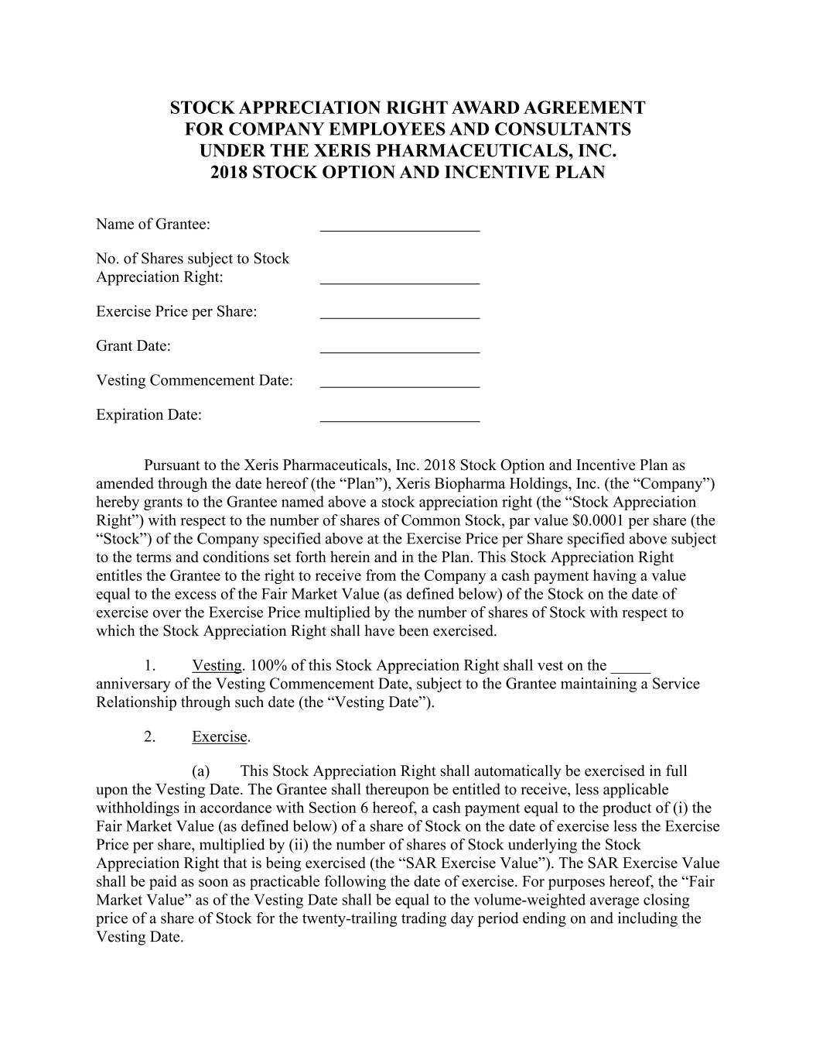
STOCK APPRECIATION RIGHT AWARD AGREEMENT FOR COMPANY EMPLOYEES AND CONSULTANTS UNDER THE XERIS PHARMACEUTICALS, INC. 2018 STOCK OPTION AND INCENTIVE PLAN Name of Grantee: No. of Shares subject to Stock Appreciation Right: Exercise Price per Share: Grant Date: Vesting Commencement Date: Expiration Date: Pursuant to the Xeris Pharmaceuticals, Inc. 2018 Stock Option and Incentive Plan as amended through the date hereof (the “Plan”), Xeris Biopharma Holdings, Inc. (the “Company”) hereby grants to the Grantee named above a stock appreciation right (the “Stock Appreciation Right”) with respect to the number of shares of Common Stock, par value $0.0001 per share (the “Stock”) of the Company specified above at the Exercise Price per Share specified above subject to the terms and conditions set forth herein and in the Plan. This Stock Appreciation Right entitles the Grantee to the right to receive from the Company a cash payment having a value equal to the excess of the Fair Market Value (as defined below) of the Stock on the date of exercise over the Exercise Price multiplied by the number of shares of Stock with respect to which the Stock Appreciation Right shall have been exercised. 1. Vesting. 100% of this Stock Appreciation Right shall vest on the _____ anniversary of the Vesting Commencement Date, subject to the Grantee maintaining a Service Relationship through such date (the “Vesting Date”). 2. Exercise. (a) This Stock Appreciation Right shall automatically be exercised in full upon the Vesting Date. The Grantee shall thereupon be entitled to receive, less applicable withholdings in accordance with Section 6 hereof, a cash payment equal to the product of (i) the Fair Market Value (as defined below) of a share of Stock on the date of exercise less the Exercise Price per share, multiplied by (ii) the number of shares of Stock underlying the Stock Appreciation Right that is being exercised (the “SAR Exercise Value”). The SAR Exercise Value shall be paid as soon as practicable following the date of exercise. For purposes hereof, the “Fair Market Value” as of the Vesting Date shall be equal to the volume-weighted average closing price of a share of Stock for the twenty-trailing trading day period ending on and including the Vesting Date.

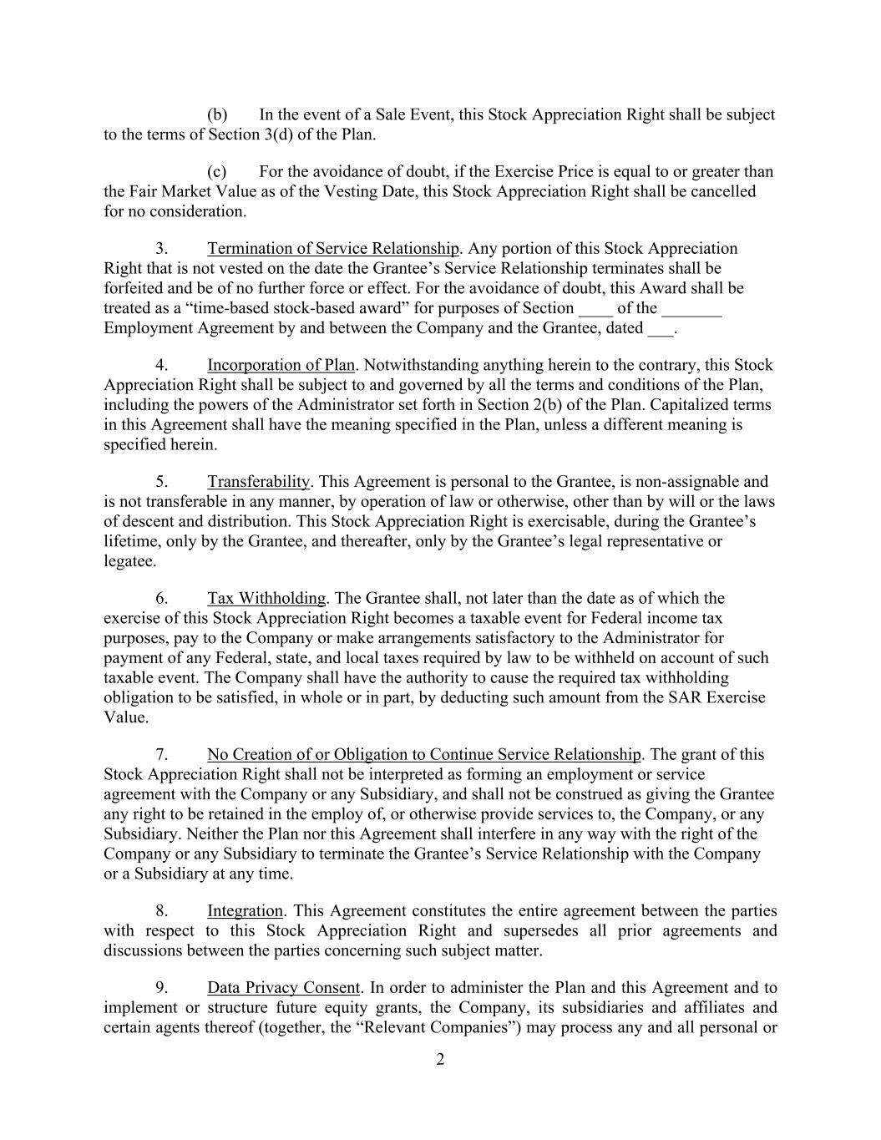
2 (b) In the event of a Sale Event, this Stock Appreciation Right shall be subject to the terms of Section 3(d) of the Plan. (c) For the avoidance of doubt, if the Exercise Price is equal to or greater than the Fair Market Value as of the Vesting Date, this Stock Appreciation Right shall be cancelled for no consideration. 3. Termination of Service Relationship. Any portion of this Stock Appreciation Right that is not vested on the date the Grantee’s Service Relationship terminates shall be forfeited and be of no further force or effect. For the avoidance of doubt, this Award shall be treated as a “time-based stock-based award” for purposes of Section ____ of the _______ Employment Agreement by and between the Company and the Grantee, dated ___. 4. Incorporation of Plan. Notwithstanding anything herein to the contrary, this Stock Appreciation Right shall be subject to and governed by all the terms and conditions of the Plan, including the powers of the Administrator set forth in Section 2(b) of the Plan. Capitalized terms in this Agreement shall have the meaning specified in the Plan, unless a different meaning is specified herein. 5. Transferability. This Agreement is personal to the Grantee, is non-assignable and is not transferable in any manner, by operation of law or otherwise, other than by will or the laws of descent and distribution. This Stock Appreciation Right is exercisable, during the Grantee’s lifetime, only by the Grantee, and thereafter, only by the Grantee’s legal representative or legatee. 6. Tax Withholding. The Grantee shall, not later than the date as of which the exercise of this Stock Appreciation Right becomes a taxable event for Federal income tax purposes, pay to the Company or make arrangements satisfactory to the Administrator for payment of any Federal, state, and local taxes required by law to be withheld on account of such taxable event. The Company shall have the authority to cause the required tax withholding obligation to be satisfied, in whole or in part, by deducting such amount from the SAR Exercise Value. 7. No Creation of or Obligation to Continue Service Relationship. The grant of this Stock Appreciation Right shall not be interpreted as forming an employment or service agreement with the Company or any Subsidiary, and shall not be construed as giving the Grantee any right to be retained in the employ of, or otherwise provide services to, the Company, or any Subsidiary. Neither the Plan nor this Agreement shall interfere in any way with the right of the Company or any Subsidiary to terminate the Grantee’s Service Relationship with the Company or a Subsidiary at any time. 8. Integration. This Agreement constitutes the entire agreement between the parties with respect to this Stock Appreciation Right and supersedes all prior agreements and discussions between the parties concerning such subject matter. 9. Data Privacy Consent. In order to administer the Plan and this Agreement and to implement or structure future equity grants, the Company, its subsidiaries and affiliates and certain agents thereof (together, the “Relevant Companies”) may process any and all personal or

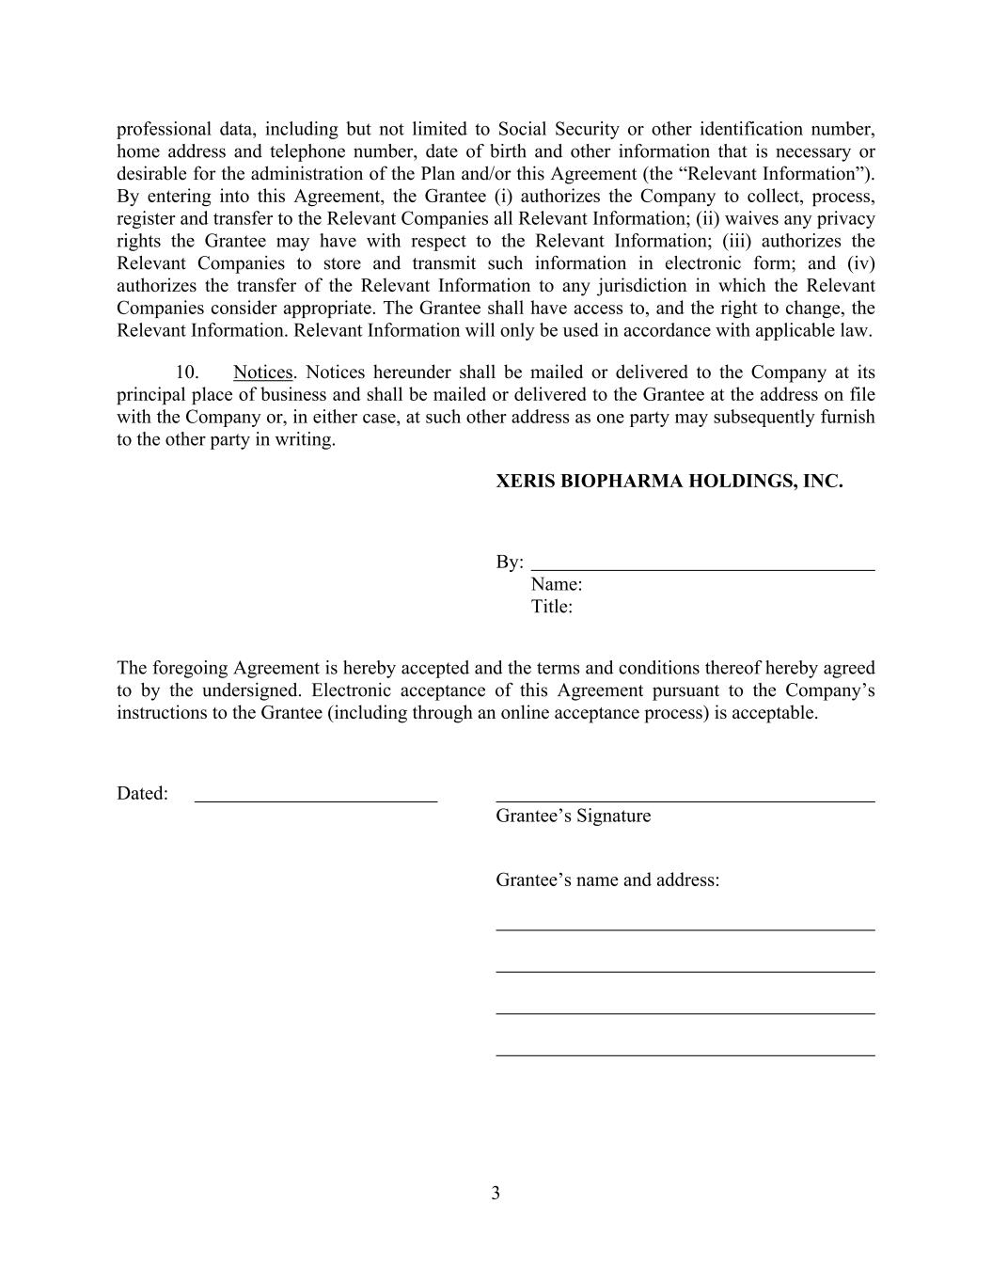
3 professional data, including but not limited to Social Security or other identification number, home address and telephone number, date of birth and other information that is necessary or desirable for the administration of the Plan and/or this Agreement (the “Relevant Information”). By entering into this Agreement, the Grantee (i) authorizes the Company to collect, process, register and transfer to the Relevant Companies all Relevant Information; (ii) waives any privacy rights the Grantee may have with respect to the Relevant Information; (iii) authorizes the Relevant Companies to store and transmit such information in electronic form; and (iv) authorizes the transfer of the Relevant Information to any jurisdiction in which the Relevant Companies consider appropriate. The Grantee shall have access to, and the right to change, the Relevant Information. Relevant Information will only be used in accordance with applicable law. 10. Notices. Notices hereunder shall be mailed or delivered to the Company at its principal place of business and shall be mailed or delivered to the Grantee at the address on file with the Company or, in either case, at such other address as one party may subsequently furnish to the other party in writing. XERIS BIOPHARMA HOLDINGS, INC. By: Name: Title: The foregoing Agreement is hereby accepted and the terms and conditions thereof hereby agreed to by the undersigned. Electronic acceptance of this Agreement pursuant to the Company’s instructions to the Grantee (including through an online acceptance process) is acceptable. Dated: Grantee’s Signature Grantee’s name and address:

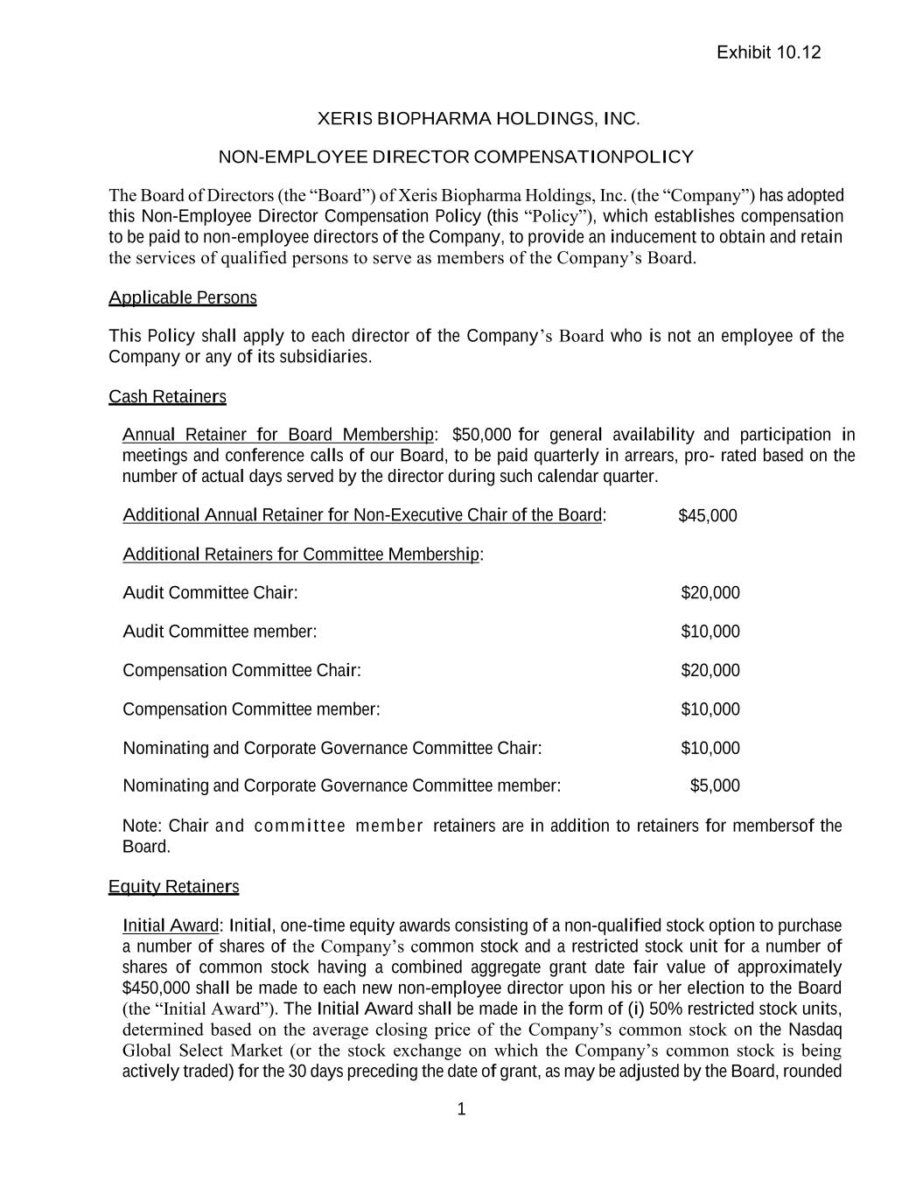
1 XERIS BIOPHARMA HOLDINGS, INC. NON-EMPLOYEE DIRECTOR COMPENSATION POLICY The Board of Directors (the “Board”) of Xeris Biopharma Holdings, Inc. (the “Company”) has adopted this Non-Employee Director Compensation Policy (this “Policy”), which establishes compensation to be paid to non-employee directors of the Company, to provide an inducement to obtain and retain the services of qualified persons to serve as members of the Company’s Board. Applicable Persons This Policy shall apply to each director of the Company’s Board who is not an employee of the Company or any of its subsidiaries. Cash Retainers Annual Retainer for Board Membership: $50,000 for general availability and participation in meetings and conference calls of our Board, to be paid quarterly in arrears, pro- rated based on the number of actual days served by the director during such calendar quarter. Additional Annual Retainer for Non-Executive Chair of the Board: $45,000 Additional Retainers for Committee Membership: Audit Committee Chair: $20,000 Audit Committee member: $10,000 Compensation Committee Chair: $20,000 Compensation Committee member: $10,000 Nominating and Corporate Governance Committee Chair: $10,000 Nominating and Corporate Governance Committee member: $5,000 Note: Chair and commit tee member retainers are in addition to retainers for members of the Board. Equity Retainers Initial Award: Initial, one-time equity awards consisting of a non-qualified stock option to purchase a number of shares of the Company’s common stock and a restricted stock unit for a number of shares of common stock having a combined aggregate grant date fair value of approximately $450,000 shall be made to each new non-employee director upon his or her election to the Board (the “Initial Award”). The Initial Award shall be made in the form of (i) 50% restricted stock units, determined based on the average closing price of the Company’s common stock on the Nasdaq Global Select Market (or the stock exchange on which the Company’s common stock is being actively traded) for the 30 days preceding the date of grant, as may be adjusted by the Board, rounded Exhibit 10.12

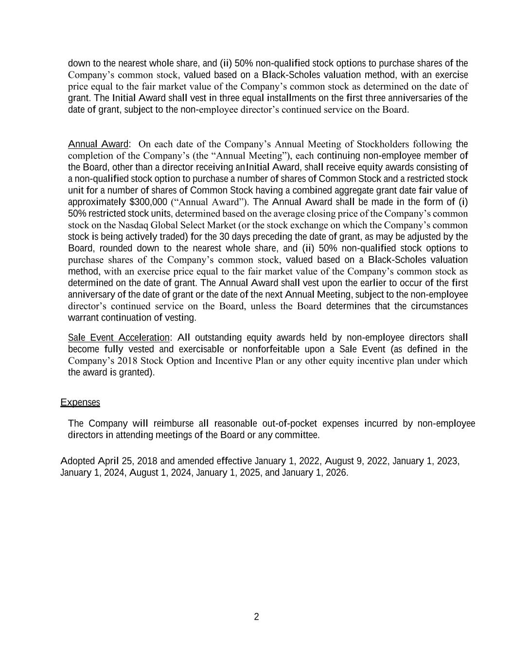
2 down to the nearest whole share, and (ii) 50% non-qualified stock options to purchase shares of the Company’s common stock, valued based on a Black-Scholes valuation method, with an exercise price equal to the fair market value of the Company’s common stock as determined on the date of grant. The Initial Award shall vest in three equal installments on the first three anniversaries of the date of grant, subject to the non-employee director’s continued service on the Board. Annual Award: On each date of the Company’s Annual Meeting of Stockholders following the completion of the Company’s (the “Annual Meeting”), each continuing non-employee member of the Board, other than a director receiving an Initial Award, shall receive equity awards consisting of a non-qualified stock option to purchase a number of shares of Common Stock and a restricted stock unit for a number of shares of Common Stock having a combined aggregate grant date fair value of approximately $300,000 (“Annual Award”). The Annual Award shall be made in the form of (i) 50% restricted stock units, determined based on the average closing price of the Company’s common stock on the Nasdaq Global Select Market (or the stock exchange on which the Company’s common stock is being actively traded) for the 30 days preceding the date of grant, as may be adjusted by the Board, rounded down to the nearest whole share, and (ii) 50% non-qualified stock options to purchase shares of the Company’s common stock, valued based on a Black-Scholes valuation method, with an exercise price equal to the fair market value of the Company’s common stock as determined on the date of grant. The Annual Award shall vest upon the earlier to occur of the first anniversary of the date of grant or the date of the next Annual Meeting, subject to the non-employee director’s continued service on the Board, unless the Board determines that the circumstances warrant continuation of vesting. Sale Event Acceleration: All outstanding equity awards held by non-employee directors shall become fully vested and exercisable or nonforfeitable upon a Sale Event (as defined in the Company’s 2018 Stock Option and Incentive Plan or any other equity incentive plan under which the award is granted). Expenses The Company will reimburse all reasonable out-of-pocket expenses incurred by non- employee directors in attending meetings of the Board or any committee. Adopted April 25, 2018 and amended effective January 1, 2022, August 9, 2022, January 1, 2023, January 1, 2024, August 1, 2024, January 1, 2025, and January 1, 2026.

Exhibit 10.23
AMENDMENT NO. 1 TO CONSULTING AGREEMENT
This Amendment No. 1 to Consulting Agreement (this “Amendment”) has been made and entered into as of December 5, 2025 by and between Xeris Pharmaceuticals, Inc. (the “Company”) and Ken Johnson (the “Consultant”). This Amendment amends that certain Consulting Agreement (the “Agreement”) dated April 1, 2025 by and between the parties to this Amendment. Capitalized terms used but not otherwise defined herein shall have the meanings ascribed to them in the Agreement.
NOW, THEREFORE, the parties intending to be legally bound, hereby agree as follows:

1.Amendment. The Agreement is hereby amended such that Section 2 is hereby deleted in its entirety and replaced with the following:
“2. Term. The term of this Agreement shall commence on the Effective Date and shall continue until February 1, 2027, unless the relationship ends on an earlier date due to your resignation, death or disability (the “Consultation Period”).”
2.Miscellaneous. Except as amended hereby, the terms of the Agreement shall remain in full force and effect, and the Agreement, as amended by this Amendment, is binding on each of the parties to this Amendment. Sections 9-16 and Section 19 of the Agreement shall apply to this Amendment directly as if incorporated herein.
* * *

IN WITNESS WHEREOF, the parties hereto have executed this Amendment as of the date first written above.
Xeris Pharmaceuticals, Inc.:
By: /s/ Anh Nguyen
Name: Anh Nguyen
Title: Chief Medical Officer
Ken Johnson:
/s/ Ken Johnson

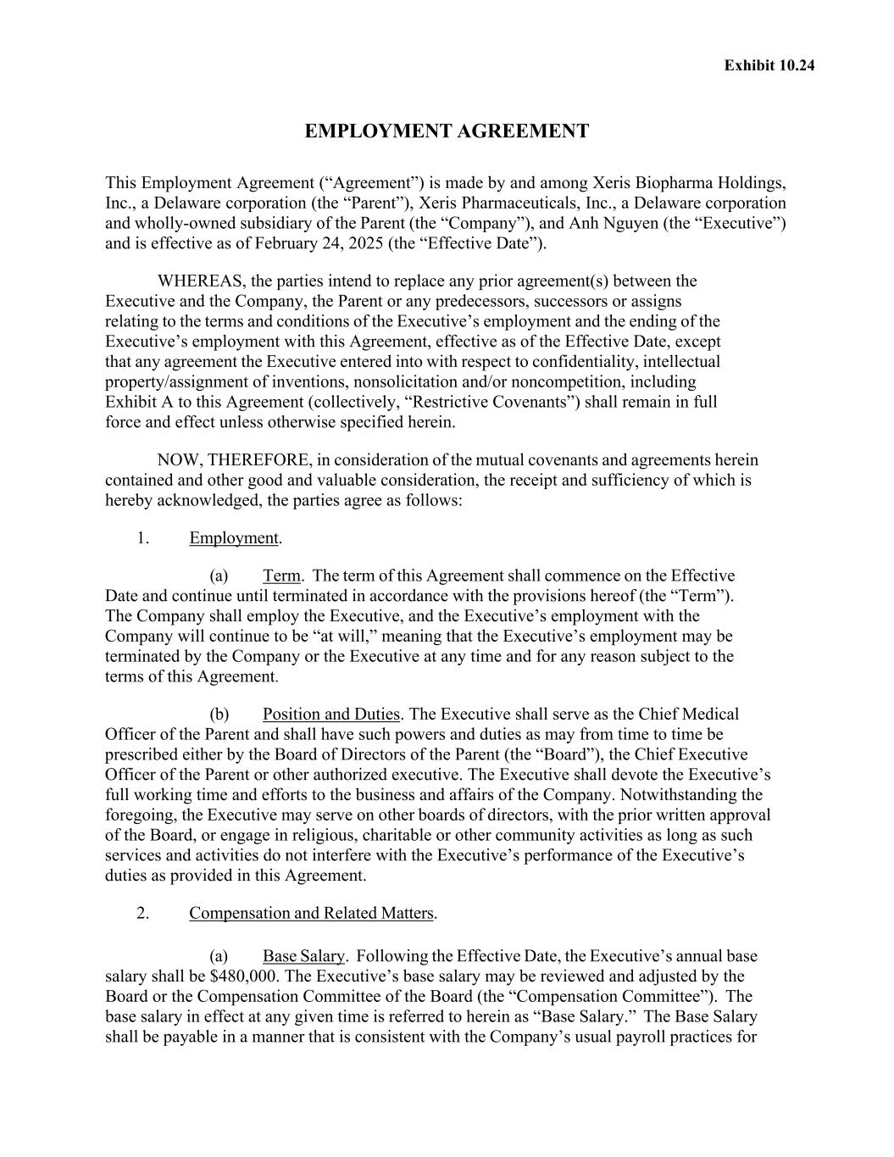

Exhibit 10.24 EMPLOYMENT AGREEMENT This Employment Agreement (“Agreement”) is made by and among Xeris Biopharma Holdings, Inc., a Delaware corporation (the “Parent”), Xeris Pharmaceuticals, Inc., a Delaware corporation and wholly-owned subsidiary of the Parent (the “Company”), and Anh Nguyen (the “Executive”) and is effective as of February 24, 2025 (the “Effective Date”). WHEREAS, the parties intend to replace any prior agreement(s) between the Executive and the Company, the Parent or any predecessors, successors or assigns relating to the terms and conditions of the Executive’s employment and the ending of the Executive’s employment with this Agreement, effective as of the Effective Date, except that any agreement the Executive entered into with respect to confidentiality, intellectual property/assignment of inventions, nonsolicitation and/or noncompetition, including Exhibit A to this Agreement (collectively, “Restrictive Covenants”) shall remain in full force and effect unless otherwise specified herein. NOW, THEREFORE, in consideration of the mutual covenants and agreements herein contained and other good and valuable consideration, the receipt and sufficiency of which is hereby acknowledged, the parties agree as follows: 1. Employment. (a) Term. The term of this Agreement shall commence on the Effective Date and continue until terminated in accordance with the provisions hereof (the “Term”). The Company shall employ the Executive, and the Executive’s employment with the Company will continue to be “at will,” meaning that the Executive’s employment may be terminated by the Company or the Executive at any time and for any reason subject to the terms of this Agreement. (b) Position and Duties. The Executive shall serve as the Chief Medical Officer of the Parent and shall have such powers and duties as may from time to time be prescribed either by the Board of Directors of the Parent (the “Board”), the Chief Executive Officer of the Parent or other authorized executive. The Executive shall devote the Executive’s full working time and efforts to the business and affairs of the Company. Notwithstanding the foregoing, the Executive may serve on other boards of directors, with the prior written approval of the Board, or engage in religious, charitable or other community activities as long as such services and activities do not interfere with the Executive’s performance of the Executive’s duties as provided in this Agreement. 2. Compensation and Related Matters. (a) Base Salary. Following the Effective Date, the Executive’s annual base salary shall be $480,000. The Executive’s base salary may be reviewed and adjusted by the Board or the Compensation Committee of the Board (the “Compensation Committee”). The base salary in effect at any given time is referred to herein as “Base Salary.” The Base Salary shall be payable in a manner that is consistent with the Company’s usual payroll practices for

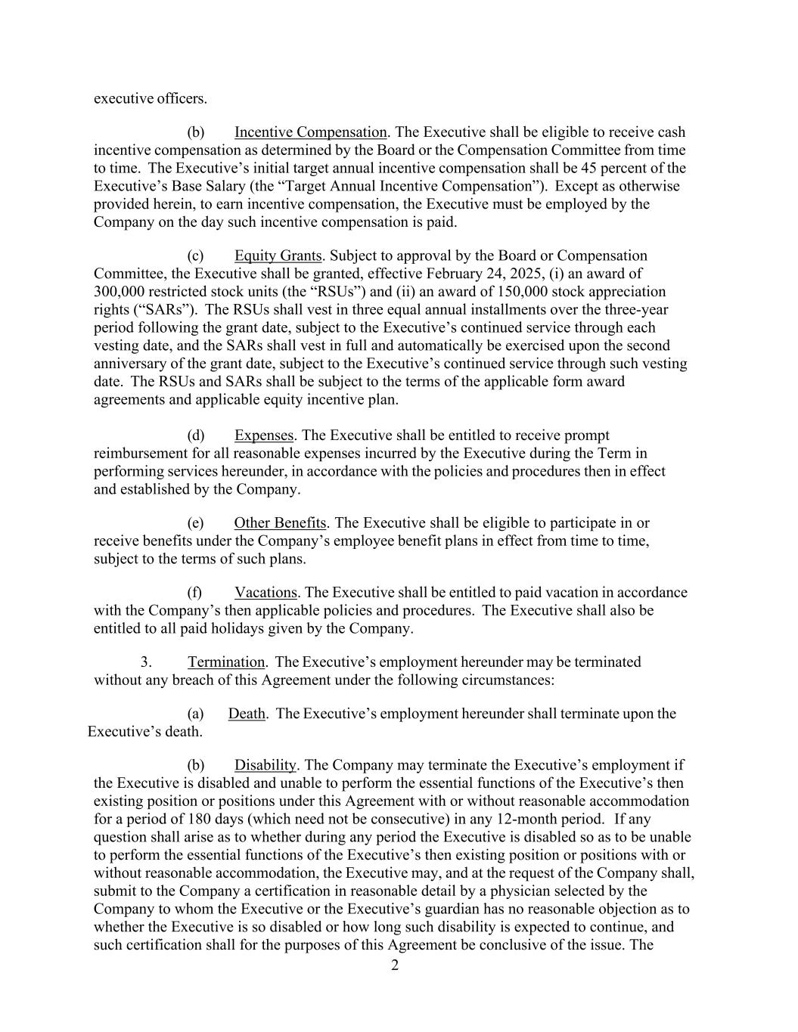
2 executive officers. (b) Incentive Compensation. The Executive shall be eligible to receive cash incentive compensation as determined by the Board or the Compensation Committee from time to time. The Executive’s initial target annual incentive compensation shall be 45 percent of the Executive’s Base Salary (the “Target Annual Incentive Compensation”). Except as otherwise provided herein, to earn incentive compensation, the Executive must be employed by the Company on the day such incentive compensation is paid. (c) Equity Grants. Subject to approval by the Board or Compensation Committee, the Executive shall be granted, effective February 24, 2025, (i) an award of 300,000 restricted stock units (the “RSUs”) and (ii) an award of 150,000 stock appreciation rights (“SARs”). The RSUs shall vest in three equal annual installments over the three-year period following the grant date, subject to the Executive’s continued service through each vesting date, and the SARs shall vest in full and automatically be exercised upon the second anniversary of the grant date, subject to the Executive’s continued service through such vesting date. The RSUs and SARs shall be subject to the terms of the applicable form award agreements and applicable equity incentive plan. (d) Expenses. The Executive shall be entitled to receive prompt reimbursement for all reasonable expenses incurred by the Executive during the Term in performing services hereunder, in accordance with the policies and procedures then in effect and established by the Company. (e) Other Benefits. The Executive shall be eligible to participate in or receive benefits under the Company’s employee benefit plans in effect from time to time, subject to the terms of such plans. (f) Vacations. The Executive shall be entitled to paid vacation in accordance with the Company’s then applicable policies and procedures. The Executive shall also be entitled to all paid holidays given by the Company. 3. Termination. The Executive’s employment hereunder may be terminated without any breach of this Agreement under the following circumstances: (a) Death. The Executive’s employment hereunder shall terminate upon the Executive’s death. (b) Disability. The Company may terminate the Executive’s employment if the Executive is disabled and unable to perform the essential functions of the Executive’s then existing position or positions under this Agreement with or without reasonable accommodation for a period of 180 days (which need not be consecutive) in any 12-month period. If any question shall arise as to whether during any period the Executive is disabled so as to be unable to perform the essential functions of the Executive’s then existing position or positions with or without reasonable accommodation, the Executive may, and at the request of the Company shall, submit to the Company a certification in reasonable detail by a physician selected by the Company to whom the Executive or the Executive’s guardian has no reasonable objection as to whether the Executive is so disabled or how long such disability is expected to continue, and such certification shall for the purposes of this Agreement be conclusive of the issue. The

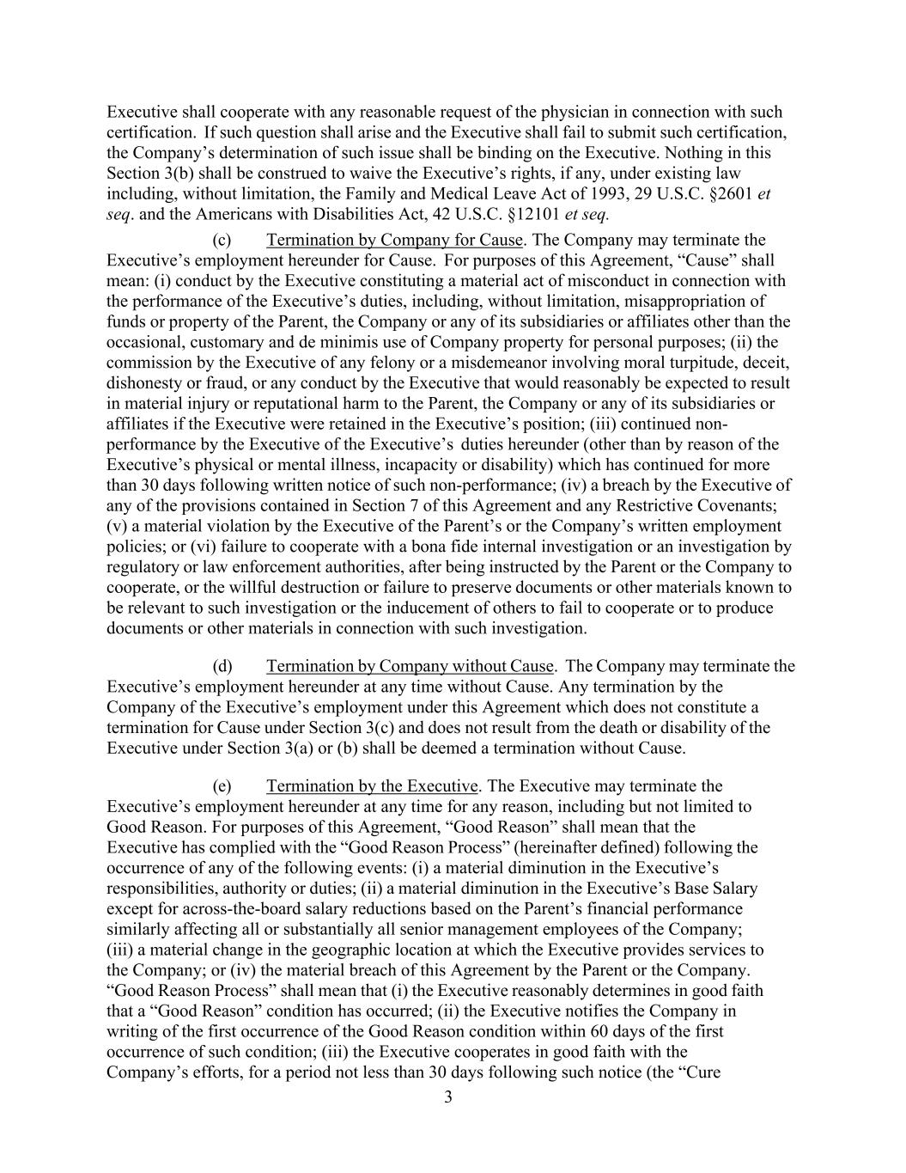
3 Executive shall cooperate with any reasonable request of the physician in connection with such certification. If such question shall arise and the Executive shall fail to submit such certification, the Company’s determination of such issue shall be binding on the Executive. Nothing in this Section 3(b) shall be construed to waive the Executive’s rights, if any, under existing law including, without limitation, the Family and Medical Leave Act of 1993, 29 U.S.C. §2601 et seq. and the Americans with Disabilities Act, 42 U.S.C. §12101 et seq. (c) Termination by Company for Cause. The Company may terminate the Executive’s employment hereunder for Cause. For purposes of this Agreement, “Cause” shall mean: (i) conduct by the Executive constituting a material act of misconduct in connection with the performance of the Executive’s duties, including, without limitation, misappropriation of funds or property of the Parent, the Company or any of its subsidiaries or affiliates other than the occasional, customary and de minimis use of Company property for personal purposes; (ii) the commission by the Executive of any felony or a misdemeanor involving moral turpitude, deceit, dishonesty or fraud, or any conduct by the Executive that would reasonably be expected to result in material injury or reputational harm to the Parent, the Company or any of its subsidiaries or affiliates if the Executive were retained in the Executive’s position; (iii) continued non- performance by the Executive of the Executive’s duties hereunder (other than by reason of the Executive’s physical or mental illness, incapacity or disability) which has continued for more than 30 days following written notice of such non-performance; (iv) a breach by the Executive of any of the provisions contained in Section 7 of this Agreement and any Restrictive Covenants; (v) a material violation by the Executive of the Parent’s or the Company’s written employment policies; or (vi) failure to cooperate with a bona fide internal investigation or an investigation by regulatory or law enforcement authorities, after being instructed by the Parent or the Company to cooperate, or the willful destruction or failure to preserve documents or other materials known to be relevant to such investigation or the inducement of others to fail to cooperate or to produce documents or other materials in connection with such investigation. (d) Termination by Company without Cause. The Company may terminate the Executive’s employment hereunder at any time without Cause. Any termination by the Company of the Executive’s employment under this Agreement which does not constitute a termination for Cause under Section 3(c) and does not result from the death or disability of the Executive under Section 3(a) or (b) shall be deemed a termination without Cause. (e) Termination by the Executive. The Executive may terminate the Executive’s employment hereunder at any time for any reason, including but not limited to Good Reason. For purposes of this Agreement, “Good Reason” shall mean that the Executive has complied with the “Good Reason Process” (hereinafter defined) following the occurrence of any of the following events: (i) a material diminution in the Executive’s responsibilities, authority or duties; (ii) a material diminution in the Executive’s Base Salary except for across-the-board salary reductions based on the Parent’s financial performance similarly affecting all or substantially all senior management employees of the Company; (iii) a material change in the geographic location at which the Executive provides services to the Company; or (iv) the material breach of this Agreement by the Parent or the Company. “Good Reason Process” shall mean that (i) the Executive reasonably determines in good faith that a “Good Reason” condition has occurred; (ii) the Executive notifies the Company in writing of the first occurrence of the Good Reason condition within 60 days of the first occurrence of such condition; (iii) the Executive cooperates in good faith with the Company’s efforts, for a period not less than 30 days following such notice (the “Cure

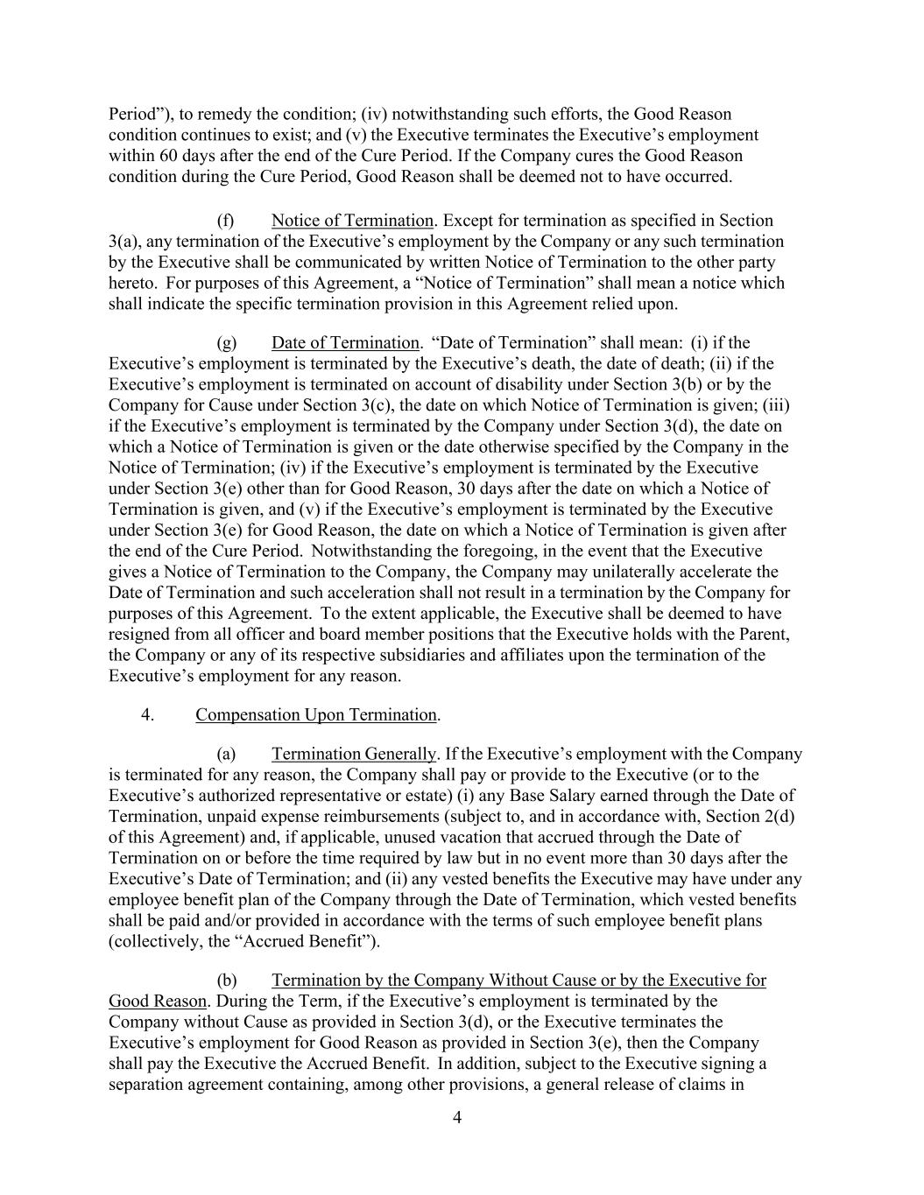
4 Period”), to remedy the condition; (iv) notwithstanding such efforts, the Good Reason condition continues to exist; and (v) the Executive terminates the Executive’s employment within 60 days after the end of the Cure Period. If the Company cures the Good Reason condition during the Cure Period, Good Reason shall be deemed not to have occurred. (f) Notice of Termination. Except for termination as specified in Section 3(a), any termination of the Executive’s employment by the Company or any such termination by the Executive shall be communicated by written Notice of Termination to the other party hereto. For purposes of this Agreement, a “Notice of Termination” shall mean a notice which shall indicate the specific termination provision in this Agreement relied upon. (g) Date of Termination. “Date of Termination” shall mean: (i) if the Executive’s employment is terminated by the Executive’s death, the date of death; (ii) if the Executive’s employment is terminated on account of disability under Section 3(b) or by the Company for Cause under Section 3(c), the date on which Notice of Termination is given; (iii) if the Executive’s employment is terminated by the Company under Section 3(d), the date on which a Notice of Termination is given or the date otherwise specified by the Company in the Notice of Termination; (iv) if the Executive’s employment is terminated by the Executive under Section 3(e) other than for Good Reason, 30 days after the date on which a Notice of Termination is given, and (v) if the Executive’s employment is terminated by the Executive under Section 3(e) for Good Reason, the date on which a Notice of Termination is given after the end of the Cure Period. Notwithstanding the foregoing, in the event that the Executive gives a Notice of Termination to the Company, the Company may unilaterally accelerate the Date of Termination and such acceleration shall not result in a termination by the Company for purposes of this Agreement. To the extent applicable, the Executive shall be deemed to have resigned from all officer and board member positions that the Executive holds with the Parent, the Company or any of its respective subsidiaries and affiliates upon the termination of the Executive’s employment for any reason. 4. Compensation Upon Termination. (a) Termination Generally. If the Executive’s employment with the Company is terminated for any reason, the Company shall pay or provide to the Executive (or to the Executive’s authorized representative or estate) (i) any Base Salary earned through the Date of Termination, unpaid expense reimbursements (subject to, and in accordance with, Section 2(d) of this Agreement) and, if applicable, unused vacation that accrued through the Date of Termination on or before the time required by law but in no event more than 30 days after the Executive’s Date of Termination; and (ii) any vested benefits the Executive may have under any employee benefit plan of the Company through the Date of Termination, which vested benefits shall be paid and/or provided in accordance with the terms of such employee benefit plans (collectively, the “Accrued Benefit”). (b) Termination by the Company Without Cause or by the Executive for Good Reason. During the Term, if the Executive’s employment is terminated by the Company without Cause as provided in Section 3(d), or the Executive terminates the Executive’s employment for Good Reason as provided in Section 3(e), then the Company shall pay the Executive the Accrued Benefit. In addition, subject to the Executive signing a separation agreement containing, among other provisions, a general release of claims in

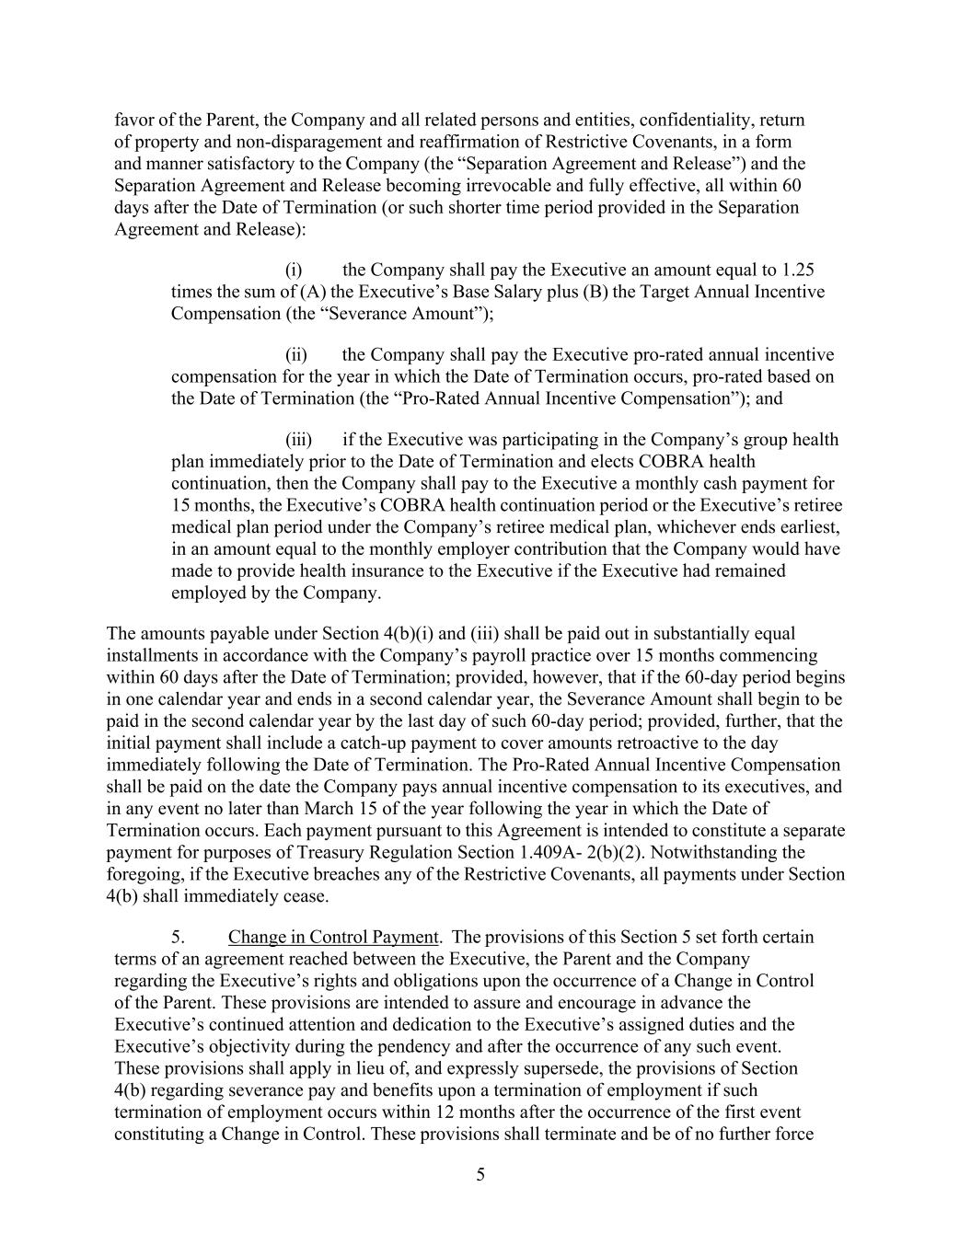
5 favor of the Parent, the Company and all related persons and entities, confidentiality, return of property and non-disparagement and reaffirmation of Restrictive Covenants, in a form and manner satisfactory to the Company (the “Separation Agreement and Release”) and the Separation Agreement and Release becoming irrevocable and fully effective, all within 60 days after the Date of Termination (or such shorter time period provided in the Separation Agreement and Release): (i) the Company shall pay the Executive an amount equal to 1.25 times the sum of (A) the Executive’s Base Salary plus (B) the Target Annual Incentive Compensation (the “Severance Amount”); (ii) the Company shall pay the Executive pro-rated annual incentive compensation for the year in which the Date of Termination occurs, pro-rated based on the Date of Termination (the “Pro-Rated Annual Incentive Compensation”); and (iii) if the Executive was participating in the Company’s group health plan immediately prior to the Date of Termination and elects COBRA health continuation, then the Company shall pay to the Executive a monthly cash payment for 15 months, the Executive’s COBRA health continuation period or the Executive’s retiree medical plan period under the Company’s retiree medical plan, whichever ends earliest, in an amount equal to the monthly employer contribution that the Company would have made to provide health insurance to the Executive if the Executive had remained employed by the Company. The amounts payable under Section 4(b)(i) and (iii) shall be paid out in substantially equal installments in accordance with the Company’s payroll practice over 15 months commencing within 60 days after the Date of Termination; provided, however, that if the 60-day period begins in one calendar year and ends in a second calendar year, the Severance Amount shall begin to be paid in the second calendar year by the last day of such 60-day period; provided, further, that the initial payment shall include a catch-up payment to cover amounts retroactive to the day immediately following the Date of Termination. The Pro-Rated Annual Incentive Compensation shall be paid on the date the Company pays annual incentive compensation to its executives, and in any event no later than March 15 of the year following the year in which the Date of Termination occurs. Each payment pursuant to this Agreement is intended to constitute a separate payment for purposes of Treasury Regulation Section 1.409A- 2(b)(2). Notwithstanding the foregoing, if the Executive breaches any of the Restrictive Covenants, all payments under Section 4(b) shall immediately cease. 5. Change in Control Payment. The provisions of this Section 5 set forth certain terms of an agreement reached between the Executive, the Parent and the Company regarding the Executive’s rights and obligations upon the occurrence of a Change in Control of the Parent. These provisions are intended to assure and encourage in advance the Executive’s continued attention and dedication to the Executive’s assigned duties and the Executive’s objectivity during the pendency and after the occurrence of any such event. These provisions shall apply in lieu of, and expressly supersede, the provisions of Section 4(b) regarding severance pay and benefits upon a termination of employment if such termination of employment occurs within 12 months after the occurrence of the first event constituting a Change in Control. These provisions shall terminate and be of no further force

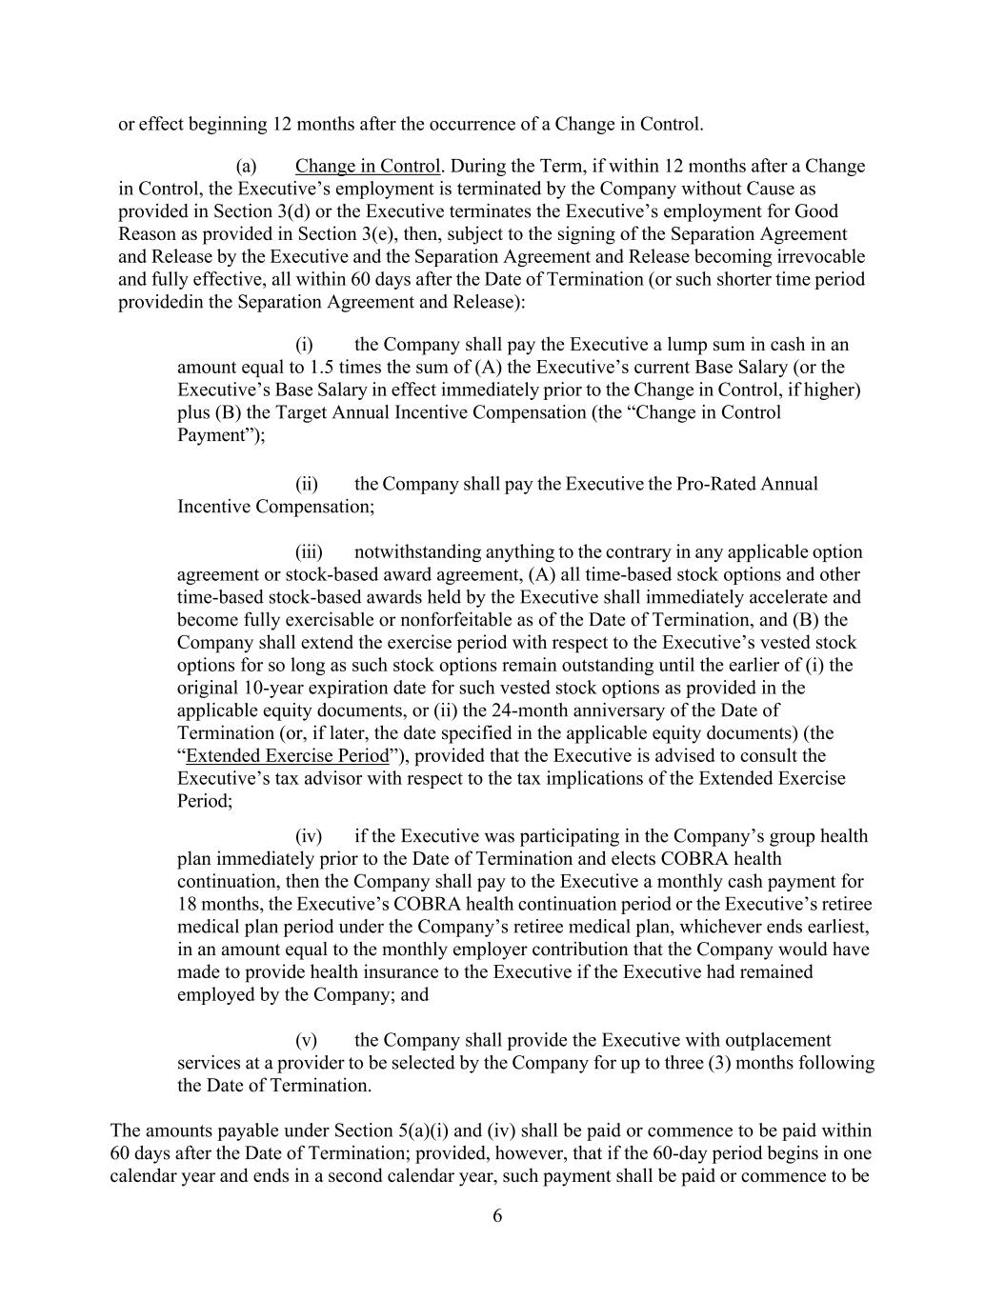
6 or effect beginning 12 months after the occurrence of a Change in Control. (a) Change in Control. During the Term, if within 12 months after a Change in Control, the Executive’s employment is terminated by the Company without Cause as provided in Section 3(d) or the Executive terminates the Executive’s employment for Good Reason as provided in Section 3(e), then, subject to the signing of the Separation Agreement and Release by the Executive and the Separation Agreement and Release becoming irrevocable and fully effective, all within 60 days after the Date of Termination (or such shorter time period providedin the Separation Agreement and Release): (i) the Company shall pay the Executive a lump sum in cash in an amount equal to 1.5 times the sum of (A) the Executive’s current Base Salary (or the Executive’s Base Salary in effect immediately prior to the Change in Control, if higher) plus (B) the Target Annual Incentive Compensation (the “Change in Control Payment”); (ii) the Company shall pay the Executive the Pro-Rated Annual Incentive Compensation; (iii) notwithstanding anything to the contrary in any applicable option agreement or stock-based award agreement, (A) all time-based stock options and other time-based stock-based awards held by the Executive shall immediately accelerate and become fully exercisable or nonforfeitable as of the Date of Termination, and (B) the Company shall extend the exercise period with respect to the Executive’s vested stock options for so long as such stock options remain outstanding until the earlier of (i) the original 10-year expiration date for such vested stock options as provided in the applicable equity documents, or (ii) the 24-month anniversary of the Date of Termination (or, if later, the date specified in the applicable equity documents) (the “Extended Exercise Period”), provided that the Executive is advised to consult the Executive’s tax advisor with respect to the tax implications of the Extended Exercise Period; (iv) if the Executive was participating in the Company’s group health plan immediately prior to the Date of Termination and elects COBRA health continuation, then the Company shall pay to the Executive a monthly cash payment for 18 months, the Executive’s COBRA health continuation period or the Executive’s retiree medical plan period under the Company’s retiree medical plan, whichever ends earliest, in an amount equal to the monthly employer contribution that the Company would have made to provide health insurance to the Executive if the Executive had remained employed by the Company; and (v) the Company shall provide the Executive with outplacement services at a provider to be selected by the Company for up to three (3) months following the Date of Termination. The amounts payable under Section 5(a)(i) and (iv) shall be paid or commence to be paid within 60 days after the Date of Termination; provided, however, that if the 60-day period begins in one calendar year and ends in a second calendar year, such payment shall be paid or commence to be

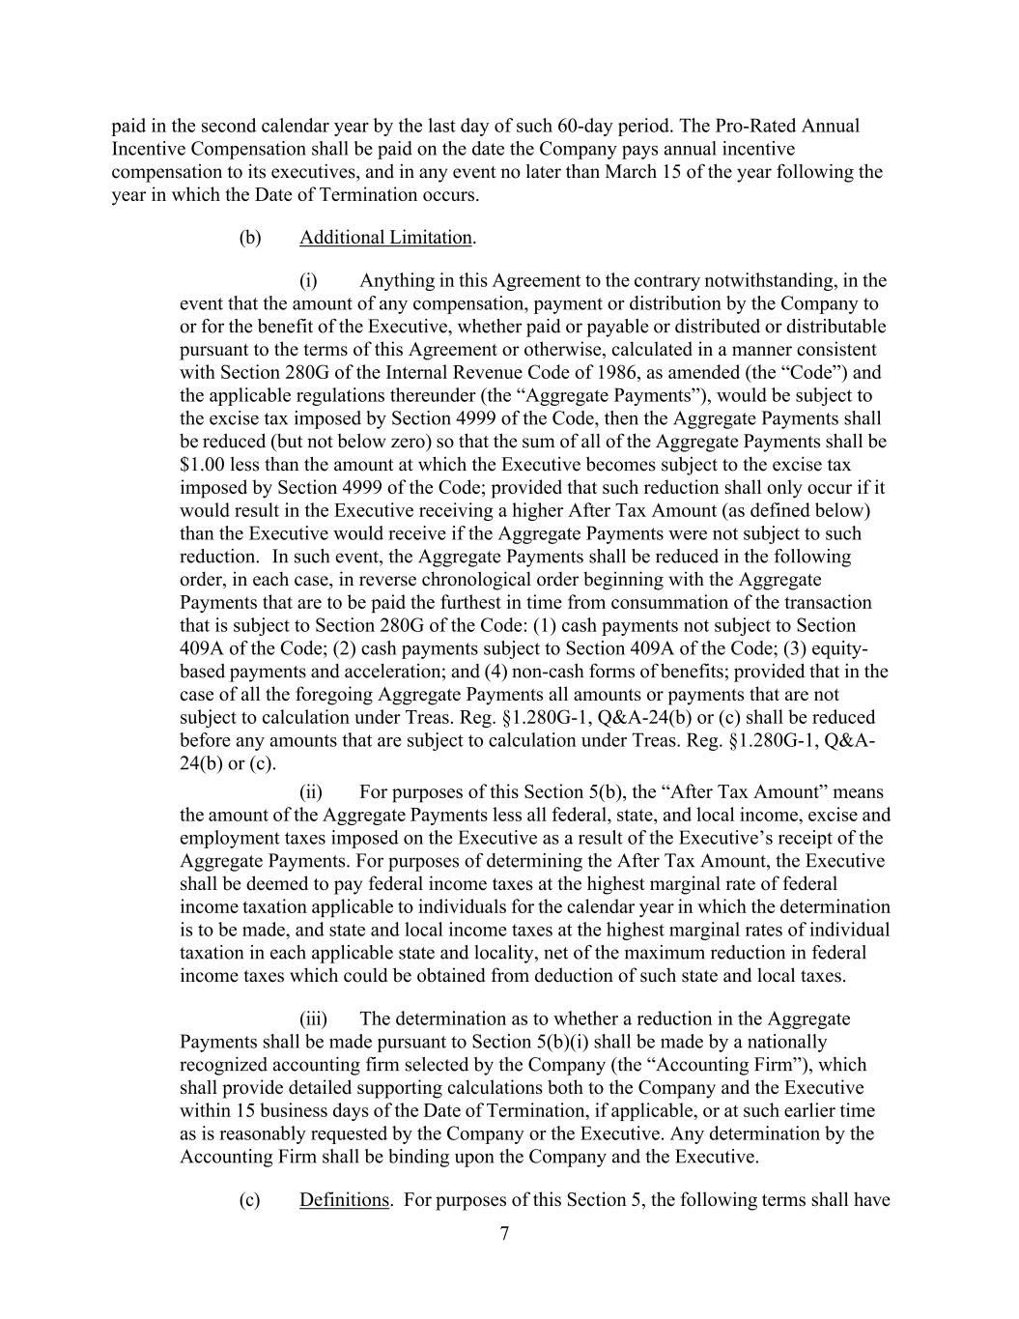
7 paid in the second calendar year by the last day of such 60-day period. The Pro-Rated Annual Incentive Compensation shall be paid on the date the Company pays annual incentive compensation to its executives, and in any event no later than March 15 of the year following the year in which the Date of Termination occurs. (b) Additional Limitation. (i) Anything in this Agreement to the contrary notwithstanding, in the event that the amount of any compensation, payment or distribution by the Company to or for the benefit of the Executive, whether paid or payable or distributed or distributable pursuant to the terms of this Agreement or otherwise, calculated in a manner consistent with Section 280G of the Internal Revenue Code of 1986, as amended (the “Code”) and the applicable regulations thereunder (the “Aggregate Payments”), would be subject to the excise tax imposed by Section 4999 of the Code, then the Aggregate Payments shall be reduced (but not below zero) so that the sum of all of the Aggregate Payments shall be $1.00 less than the amount at which the Executive becomes subject to the excise tax imposed by Section 4999 of the Code; provided that such reduction shall only occur if it would result in the Executive receiving a higher After Tax Amount (as defined below) than the Executive would receive if the Aggregate Payments were not subject to such reduction. In such event, the Aggregate Payments shall be reduced in the following order, in each case, in reverse chronological order beginning with the Aggregate Payments that are to be paid the furthest in time from consummation of the transaction that is subject to Section 280G of the Code: (1) cash payments not subject to Section 409A of the Code; (2) cash payments subject to Section 409A of the Code; (3) equity- based payments and acceleration; and (4) non-cash forms of benefits; provided that in the case of all the foregoing Aggregate Payments all amounts or payments that are not subject to calculation under Treas. Reg. §1.280G-1, Q&A-24(b) or (c) shall be reduced before any amounts that are subject to calculation under Treas. Reg. §1.280G-1, Q&A- 24(b) or (c). (ii) For purposes of this Section 5(b), the “After Tax Amount” means the amount of the Aggregate Payments less all federal, state, and local income, excise and employment taxes imposed on the Executive as a result of the Executive’s receipt of the Aggregate Payments. For purposes of determining the After Tax Amount, the Executive shall be deemed to pay federal income taxes at the highest marginal rate of federal income taxation applicable to individuals for the calendar year in which the determination is to be made, and state and local income taxes at the highest marginal rates of individual taxation in each applicable state and locality, net of the maximum reduction in federal income taxes which could be obtained from deduction of such state and local taxes. (iii) The determination as to whether a reduction in the Aggregate Payments shall be made pursuant to Section 5(b)(i) shall be made by a nationally recognized accounting firm selected by the Company (the “Accounting Firm”), which shall provide detailed supporting calculations both to the Company and the Executive within 15 business days of the Date of Termination, if applicable, or at such earlier time as is reasonably requested by the Company or the Executive. Any determination by the Accounting Firm shall be binding upon the Company and the Executive. (c) Definitions. For purposes of this Section 5, the following terms shall have

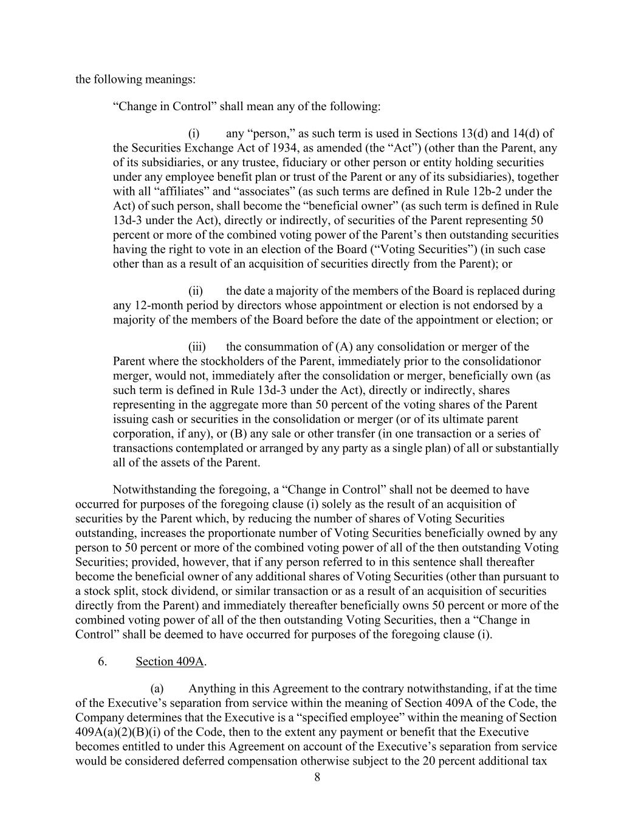
8 the following meanings: “Change in Control” shall mean any of the following: (i) any “person,” as such term is used in Sections 13(d) and 14(d) of the Securities Exchange Act of 1934, as amended (the “Act”) (other than the Parent, any of its subsidiaries, or any trustee, fiduciary or other person or entity holding securities under any employee benefit plan or trust of the Parent or any of its subsidiaries), together with all “affiliates” and “associates” (as such terms are defined in Rule 12b-2 under the Act) of such person, shall become the “beneficial owner” (as such term is defined in Rule 13d-3 under the Act), directly or indirectly, of securities of the Parent representing 50 percent or more of the combined voting power of the Parent’s then outstanding securities having the right to vote in an election of the Board (“Voting Securities”) (in such case other than as a result of an acquisition of securities directly from the Parent); or (ii) the date a majority of the members of the Board is replaced during any 12-month period by directors whose appointment or election is not endorsed by a majority of the members of the Board before the date of the appointment or election; or (iii) the consummation of (A) any consolidation or merger of the Parent where the stockholders of the Parent, immediately prior to the consolidationor merger, would not, immediately after the consolidation or merger, beneficially own (as such term is defined in Rule 13d-3 under the Act), directly or indirectly, shares representing in the aggregate more than 50 percent of the voting shares of the Parent issuing cash or securities in the consolidation or merger (or of its ultimate parent corporation, if any), or (B) any sale or other transfer (in one transaction or a series of transactions contemplated or arranged by any party as a single plan) of all or substantially all of the assets of the Parent. Notwithstanding the foregoing, a “Change in Control” shall not be deemed to have occurred for purposes of the foregoing clause (i) solely as the result of an acquisition of securities by the Parent which, by reducing the number of shares of Voting Securities outstanding, increases the proportionate number of Voting Securities beneficially owned by any person to 50 percent or more of the combined voting power of all of the then outstanding Voting Securities; provided, however, that if any person referred to in this sentence shall thereafter become the beneficial owner of any additional shares of Voting Securities (other than pursuant to a stock split, stock dividend, or similar transaction or as a result of an acquisition of securities directly from the Parent) and immediately thereafter beneficially owns 50 percent or more of the combined voting power of all of the then outstanding Voting Securities, then a “Change in Control” shall be deemed to have occurred for purposes of the foregoing clause (i). 6. Section 409A. (a) Anything in this Agreement to the contrary notwithstanding, if at the time of the Executive’s separation from service within the meaning of Section 409A of the Code, the Company determines that the Executive is a “specified employee” within the meaning of Section 409A(a)(2)(B)(i) of the Code, then to the extent any payment or benefit that the Executive becomes entitled to under this Agreement on account of the Executive’s separation from service would be considered deferred compensation otherwise subject to the 20 percent additional tax

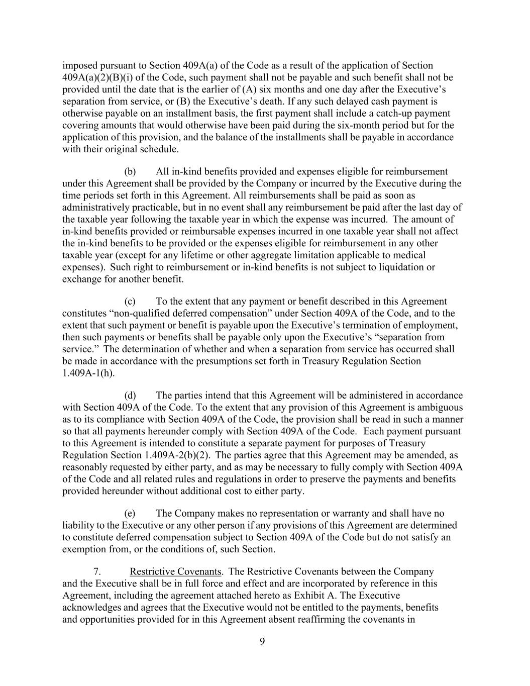
9 imposed pursuant to Section 409A(a) of the Code as a result of the application of Section 409A(a)(2)(B)(i) of the Code, such payment shall not be payable and such benefit shall not be provided until the date that is the earlier of (A) six months and one day after the Executive’s separation from service, or (B) the Executive’s death. If any such delayed cash payment is otherwise payable on an installment basis, the first payment shall include a catch-up payment covering amounts that would otherwise have been paid during the six-month period but for the application of this provision, and the balance of the installments shall be payable in accordance with their original schedule. (b) All in-kind benefits provided and expenses eligible for reimbursement under this Agreement shall be provided by the Company or incurred by the Executive during the time periods set forth in this Agreement. All reimbursements shall be paid as soon as administratively practicable, but in no event shall any reimbursement be paid after the last day of the taxable year following the taxable year in which the expense was incurred. The amount of in-kind benefits provided or reimbursable expenses incurred in one taxable year shall not affect the in-kind benefits to be provided or the expenses eligible for reimbursement in any other taxable year (except for any lifetime or other aggregate limitation applicable to medical expenses). Such right to reimbursement or in-kind benefits is not subject to liquidation or exchange for another benefit. (c) To the extent that any payment or benefit described in this Agreement constitutes “non-qualified deferred compensation” under Section 409A of the Code, and to the extent that such payment or benefit is payable upon the Executive’s termination of employment, then such payments or benefits shall be payable only upon the Executive’s “separation from service.” The determination of whether and when a separation from service has occurred shall be made in accordance with the presumptions set forth in Treasury Regulation Section 1.409A-1(h). (d) The parties intend that this Agreement will be administered in accordance with Section 409A of the Code. To the extent that any provision of this Agreement is ambiguous as to its compliance with Section 409A of the Code, the provision shall be read in such a manner so that all payments hereunder comply with Section 409A of the Code. Each payment pursuant to this Agreement is intended to constitute a separate payment for purposes of Treasury Regulation Section 1.409A-2(b)(2). The parties agree that this Agreement may be amended, as reasonably requested by either party, and as may be necessary to fully comply with Section 409A of the Code and all related rules and regulations in order to preserve the payments and benefits provided hereunder without additional cost to either party. (e) The Company makes no representation or warranty and shall have no liability to the Executive or any other person if any provisions of this Agreement are determined to constitute deferred compensation subject to Section 409A of the Code but do not satisfy an exemption from, or the conditions of, such Section. 7. Restrictive Covenants. The Restrictive Covenants between the Company and the Executive shall be in full force and effect and are incorporated by reference in this Agreement, including the agreement attached hereto as Exhibit A. The Executive acknowledges and agrees that the Executive would not be entitled to the payments, benefits and opportunities provided for in this Agreement absent reaffirming the covenants in

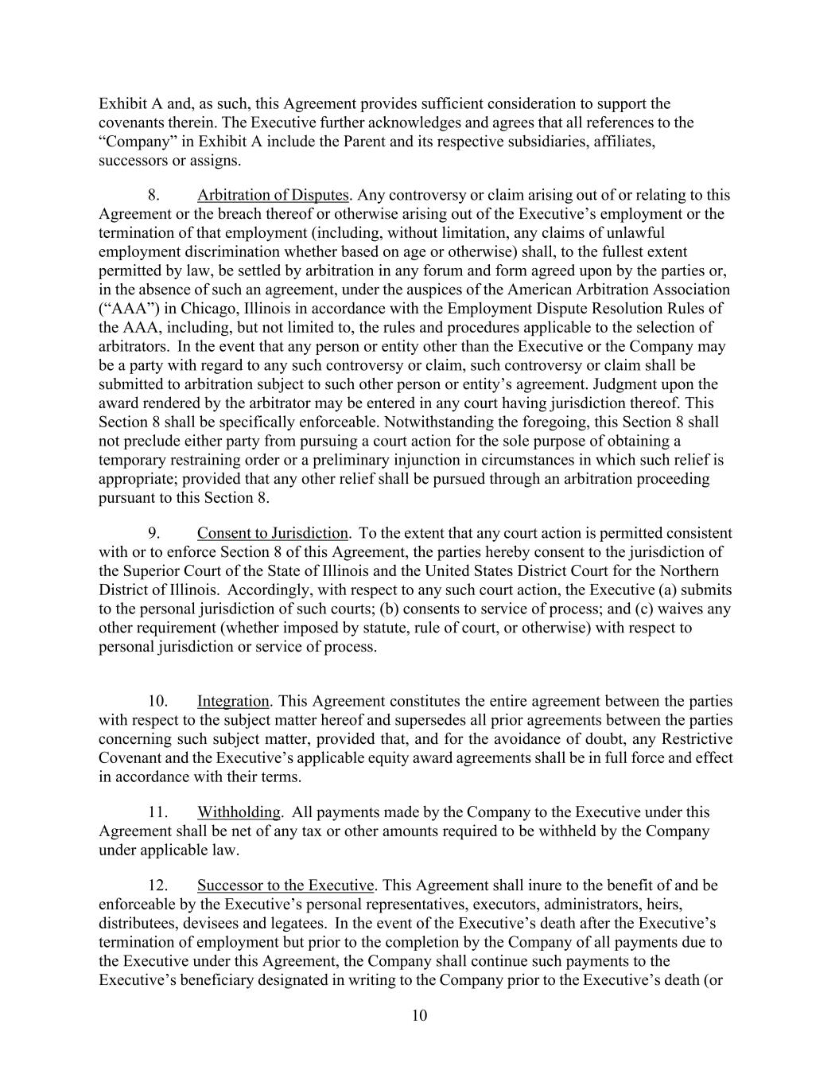
10 Exhibit A and, as such, this Agreement provides sufficient consideration to support the covenants therein. The Executive further acknowledges and agrees that all references to the “Company” in Exhibit A include the Parent and its respective subsidiaries, affiliates, successors or assigns. 8. Arbitration of Disputes. Any controversy or claim arising out of or relating to this Agreement or the breach thereof or otherwise arising out of the Executive’s employment or the termination of that employment (including, without limitation, any claims of unlawful employment discrimination whether based on age or otherwise) shall, to the fullest extent permitted by law, be settled by arbitration in any forum and form agreed upon by the parties or, in the absence of such an agreement, under the auspices of the American Arbitration Association (“AAA”) in Chicago, Illinois in accordance with the Employment Dispute Resolution Rules of the AAA, including, but not limited to, the rules and procedures applicable to the selection of arbitrators. In the event that any person or entity other than the Executive or the Company may be a party with regard to any such controversy or claim, such controversy or claim shall be submitted to arbitration subject to such other person or entity’s agreement. Judgment upon the award rendered by the arbitrator may be entered in any court having jurisdiction thereof. This Section 8 shall be specifically enforceable. Notwithstanding the foregoing, this Section 8 shall not preclude either party from pursuing a court action for the sole purpose of obtaining a temporary restraining order or a preliminary injunction in circumstances in which such relief is appropriate; provided that any other relief shall be pursued through an arbitration proceeding pursuant to this Section 8. 9. Consent to Jurisdiction. To the extent that any court action is permitted consistent with or to enforce Section 8 of this Agreement, the parties hereby consent to the jurisdiction of the Superior Court of the State of Illinois and the United States District Court for the Northern District of Illinois. Accordingly, with respect to any such court action, the Executive (a) submits to the personal jurisdiction of such courts; (b) consents to service of process; and (c) waives any other requirement (whether imposed by statute, rule of court, or otherwise) with respect to personal jurisdiction or service of process. 10. Integration. This Agreement constitutes the entire agreement between the parties with respect to the subject matter hereof and supersedes all prior agreements between the parties concerning such subject matter, provided that, and for the avoidance of doubt, any Restrictive Covenant and the Executive’s applicable equity award agreements shall be in full force and effect in accordance with their terms. 11. Withholding. All payments made by the Company to the Executive under this Agreement shall be net of any tax or other amounts required to be withheld by the Company under applicable law. 12. Successor to the Executive. This Agreement shall inure to the benefit of and be enforceable by the Executive’s personal representatives, executors, administrators, heirs, distributees, devisees and legatees. In the event of the Executive’s death after the Executive’s termination of employment but prior to the completion by the Company of all payments due to the Executive under this Agreement, the Company shall continue such payments to the Executive’s beneficiary designated in writing to the Company prior to the Executive’s death (or

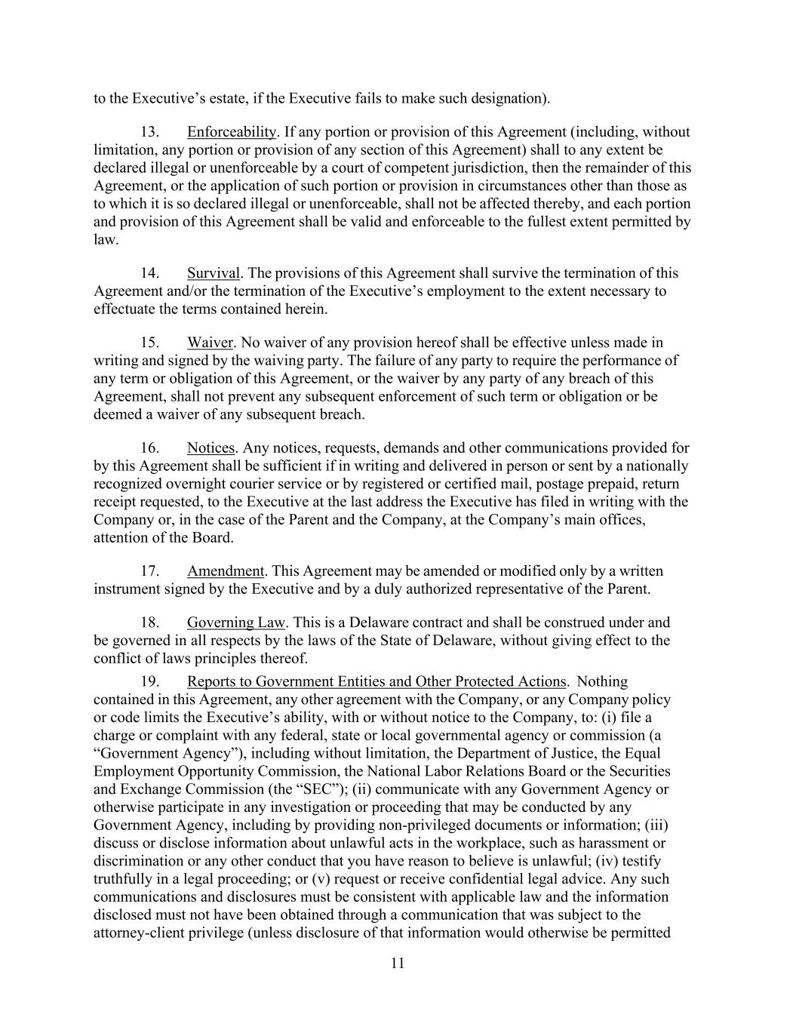
11 to the Executive’s estate, if the Executive fails to make such designation). 13. Enforceability. If any portion or provision of this Agreement (including, without limitation, any portion or provision of any section of this Agreement) shall to any extent be declared illegal or unenforceable by a court of competent jurisdiction, then the remainder of this Agreement, or the application of such portion or provision in circumstances other than those as to which it is so declared illegal or unenforceable, shall not be affected thereby, and each portion and provision of this Agreement shall be valid and enforceable to the fullest extent permitted by law. 14. Survival. The provisions of this Agreement shall survive the termination of this Agreement and/or the termination of the Executive’s employment to the extent necessary to effectuate the terms contained herein. 15. Waiver. No waiver of any provision hereof shall be effective unless made in writing and signed by the waiving party. The failure of any party to require the performance of any term or obligation of this Agreement, or the waiver by any party of any breach of this Agreement, shall not prevent any subsequent enforcement of such term or obligation or be deemed a waiver of any subsequent breach. 16. Notices. Any notices, requests, demands and other communications provided for by this Agreement shall be sufficient if in writing and delivered in person or sent by a nationally recognized overnight courier service or by registered or certified mail, postage prepaid, return receipt requested, to the Executive at the last address the Executive has filed in writing with the Company or, in the case of the Parent and the Company, at the Company’s main offices, attention of the Board. 17. Amendment. This Agreement may be amended or modified only by a written instrument signed by the Executive and by a duly authorized representative of the Parent. 18. Governing Law. This is a Delaware contract and shall be construed under and be governed in all respects by the laws of the State of Delaware, without giving effect to the conflict of laws principles thereof. 19. Reports to Government Entities and Other Protected Actions. Nothing contained in this Agreement, any other agreement with the Company, or any Company policy or code limits the Executive’s ability, with or without notice to the Company, to: (i) file a charge or complaint with any federal, state or local governmental agency or commission (a “Government Agency”), including without limitation, the Department of Justice, the Equal Employment Opportunity Commission, the National Labor Relations Board or the Securities and Exchange Commission (the “SEC”); (ii) communicate with any Government Agency or otherwise participate in any investigation or proceeding that may be conducted by any Government Agency, including by providing non-privileged documents or information; (iii) discuss or disclose information about unlawful acts in the workplace, such as harassment or discrimination or any other conduct that you have reason to believe is unlawful; (iv) testify truthfully in a legal proceeding; or (v) request or receive confidential legal advice. Any such communications and disclosures must be consistent with applicable law and the information disclosed must not have been obtained through a communication that was subject to the attorney-client privilege (unless disclosure of that information would otherwise be permitted

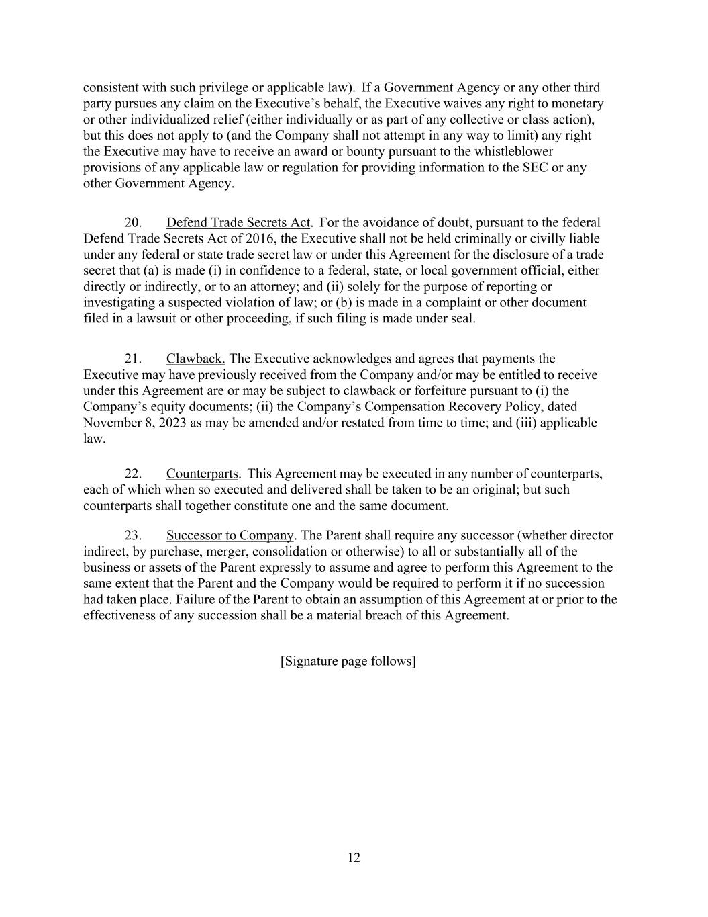
12 consistent with such privilege or applicable law). If a Government Agency or any other third party pursues any claim on the Executive’s behalf, the Executive waives any right to monetary or other individualized relief (either individually or as part of any collective or class action), but this does not apply to (and the Company shall not attempt in any way to limit) any right the Executive may have to receive an award or bounty pursuant to the whistleblower provisions of any applicable law or regulation for providing information to the SEC or any other Government Agency. 20. Defend Trade Secrets Act. For the avoidance of doubt, pursuant to the federal Defend Trade Secrets Act of 2016, the Executive shall not be held criminally or civilly liable under any federal or state trade secret law or under this Agreement for the disclosure of a trade secret that (a) is made (i) in confidence to a federal, state, or local government official, either directly or indirectly, or to an attorney; and (ii) solely for the purpose of reporting or investigating a suspected violation of law; or (b) is made in a complaint or other document filed in a lawsuit or other proceeding, if such filing is made under seal. 21. Clawback. The Executive acknowledges and agrees that payments the Executive may have previously received from the Company and/or may be entitled to receive under this Agreement are or may be subject to clawback or forfeiture pursuant to (i) the Company’s equity documents; (ii) the Company’s Compensation Recovery Policy, dated November 8, 2023 as may be amended and/or restated from time to time; and (iii) applicable law. 22. Counterparts. This Agreement may be executed in any number of counterparts, each of which when so executed and delivered shall be taken to be an original; but such counterparts shall together constitute one and the same document. 23. Successor to Company. The Parent shall require any successor (whether director indirect, by purchase, merger, consolidation or otherwise) to all or substantially all of the business or assets of the Parent expressly to assume and agree to perform this Agreement to the same extent that the Parent and the Company would be required to perform it if no succession had taken place. Failure of the Parent to obtain an assumption of this Agreement at or prior to the effectiveness of any succession shall be a material breach of this Agreement. [Signature page follows]

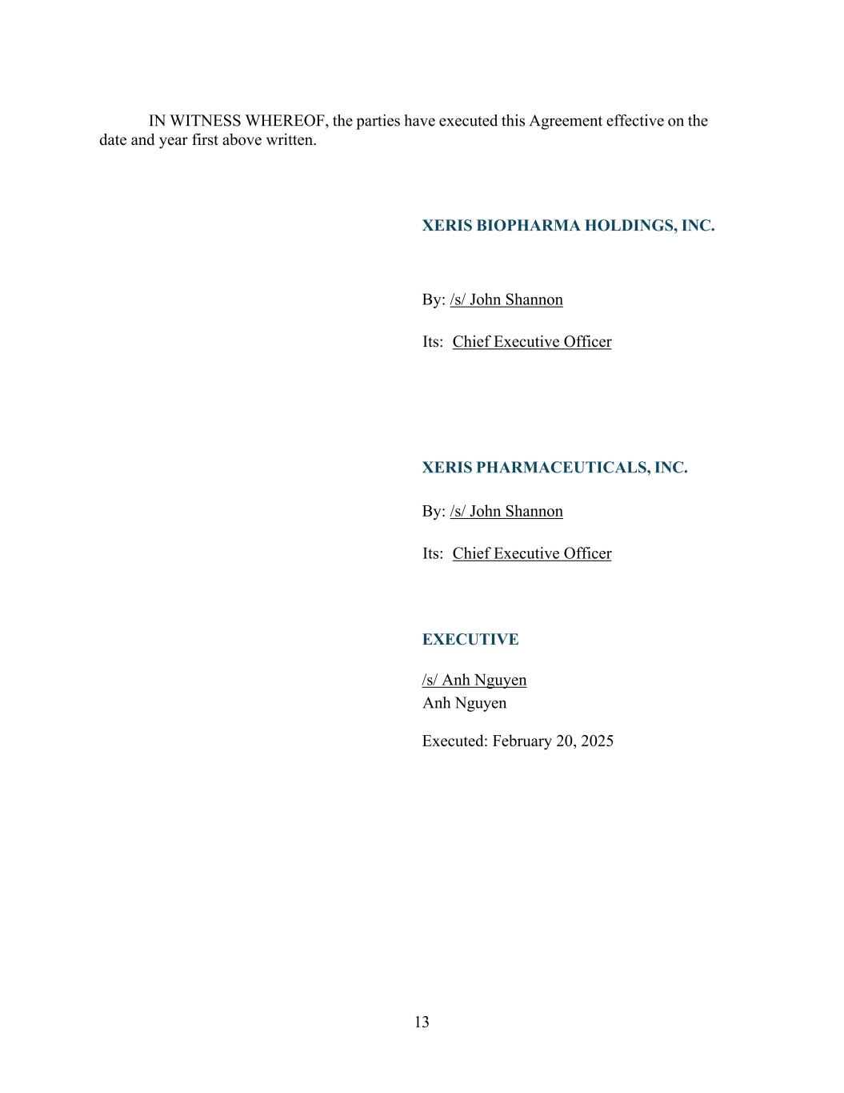
13 IN WITNESS WHEREOF, the parties have executed this Agreement effective on the date and year first above written. XERIS BIOPHARMA HOLDINGS, INC. By: /s/ John Shannon Its: Chief Executive Officer XERIS PHARMACEUTICALS, INC. By: /s/ John Shannon Its: Chief Executive Officer EXECUTIVE /s/ Anh Nguyen Anh Nguyen Executed: February 20, 2025


14 EXHIBIT A PIIA

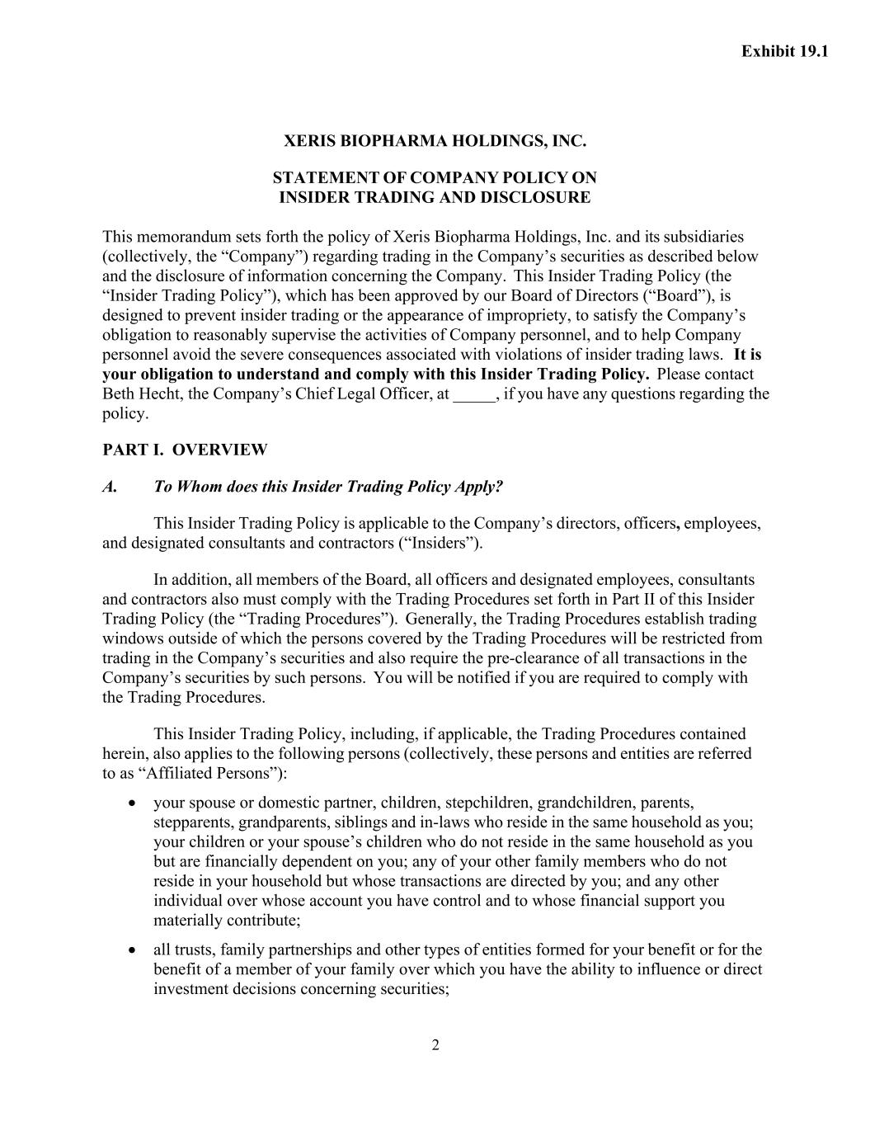
2 XERIS BIOPHARMA HOLDINGS, INC. STATEMENT OF COMPANY POLICY ON INSIDER TRADING AND DISCLOSURE This memorandum sets forth the policy of Xeris Biopharma Holdings, Inc. and its subsidiaries (collectively, the “Company”) regarding trading in the Company’s securities as described below and the disclosure of information concerning the Company. This Insider Trading Policy (the “Insider Trading Policy”), which has been approved by our Board of Directors (“Board”), is designed to prevent insider trading or the appearance of impropriety, to satisfy the Company’s obligation to reasonably supervise the activities of Company personnel, and to help Company personnel avoid the severe consequences associated with violations of insider trading laws. It is your obligation to understand and comply with this Insider Trading Policy. Please contact Beth Hecht, the Company’s Chief Legal Officer, at _____, if you have any questions regarding the policy. PART I. OVERVIEW A. To Whom does this Insider Trading Policy Apply? This Insider Trading Policy is applicable to the Company’s directors, officers, employees, and designated consultants and contractors (“Insiders”). In addition, all members of the Board, all officers and designated employees, consultants and contractors also must comply with the Trading Procedures set forth in Part II of this Insider Trading Policy (the “Trading Procedures”). Generally, the Trading Procedures establish trading windows outside of which the persons covered by the Trading Procedures will be restricted from trading in the Company’s securities and also require the pre-clearance of all transactions in the Company’s securities by such persons. You will be notified if you are required to comply with the Trading Procedures. This Insider Trading Policy, including, if applicable, the Trading Procedures contained herein, also applies to the following persons (collectively, these persons and entities are referred to as “Affiliated Persons”): • your spouse or domestic partner, children, stepchildren, grandchildren, parents, stepparents, grandparents, siblings and in-laws who reside in the same household as you; your children or your spouse’s children who do not reside in the same household as you but are financially dependent on you; any of your other family members who do not reside in your household but whose transactions are directed by you; and any other individual over whose account you have control and to whose financial support you materially contribute; • all trusts, family partnerships and other types of entities formed for your benefit or for the benefit of a member of your family over which you have the ability to influence or direct investment decisions concerning securities; Exhibit 19.1

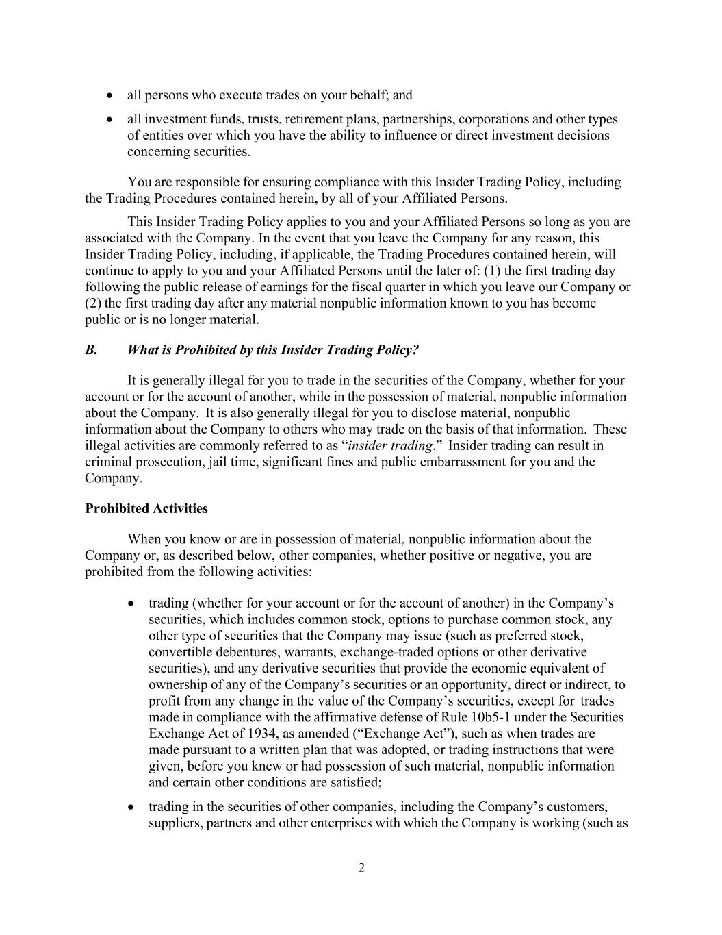
2 • all persons who execute trades on your behalf; and • all investment funds, trusts, retirement plans, partnerships, corporations and other types of entities over which you have the ability to influence or direct investment decisions concerning securities. You are responsible for ensuring compliance with this Insider Trading Policy, including the Trading Procedures contained herein, by all of your Affiliated Persons. This Insider Trading Policy applies to you and your Affiliated Persons so long as you are associated with the Company. In the event that you leave the Company for any reason, this Insider Trading Policy, including, if applicable, the Trading Procedures contained herein, will continue to apply to you and your Affiliated Persons until the later of: (1) the first trading day following the public release of earnings for the fiscal quarter in which you leave our Company or (2) the first trading day after any material nonpublic information known to you has become public or is no longer material. B. What is Prohibited by this Insider Trading Policy? It is generally illegal for you to trade in the securities of the Company, whether for your account or for the account of another, while in the possession of material, nonpublic information about the Company. It is also generally illegal for you to disclose material, nonpublic information about the Company to others who may trade on the basis of that information. These illegal activities are commonly referred to as “insider trading.” Insider trading can result in criminal prosecution, jail time, significant fines and public embarrassment for you and the Company. Prohibited Activities When you know or are in possession of material, nonpublic information about the Company or, as described below, other companies, whether positive or negative, you are prohibited from the following activities: • trading (whether for your account or for the account of another) in the Company’s securities, which includes common stock, options to purchase common stock, any other type of securities that the Company may issue (such as preferred stock, convertible debentures, warrants, exchange-traded options or other derivative securities), and any derivative securities that provide the economic equivalent of ownership of any of the Company’s securities or an opportunity, direct or indirect, to profit from any change in the value of the Company’s securities, except for trades made in compliance with the affirmative defense of Rule 10b5-1 under the Securities Exchange Act of 1934, as amended (“Exchange Act”), such as when trades are made pursuant to a written plan that was adopted, or trading instructions that were given, before you knew or had possession of such material, nonpublic information and certain other conditions are satisfied; • trading in the securities of other companies, including the Company’s customers, suppliers, partners and other enterprises with which the Company is working (such as

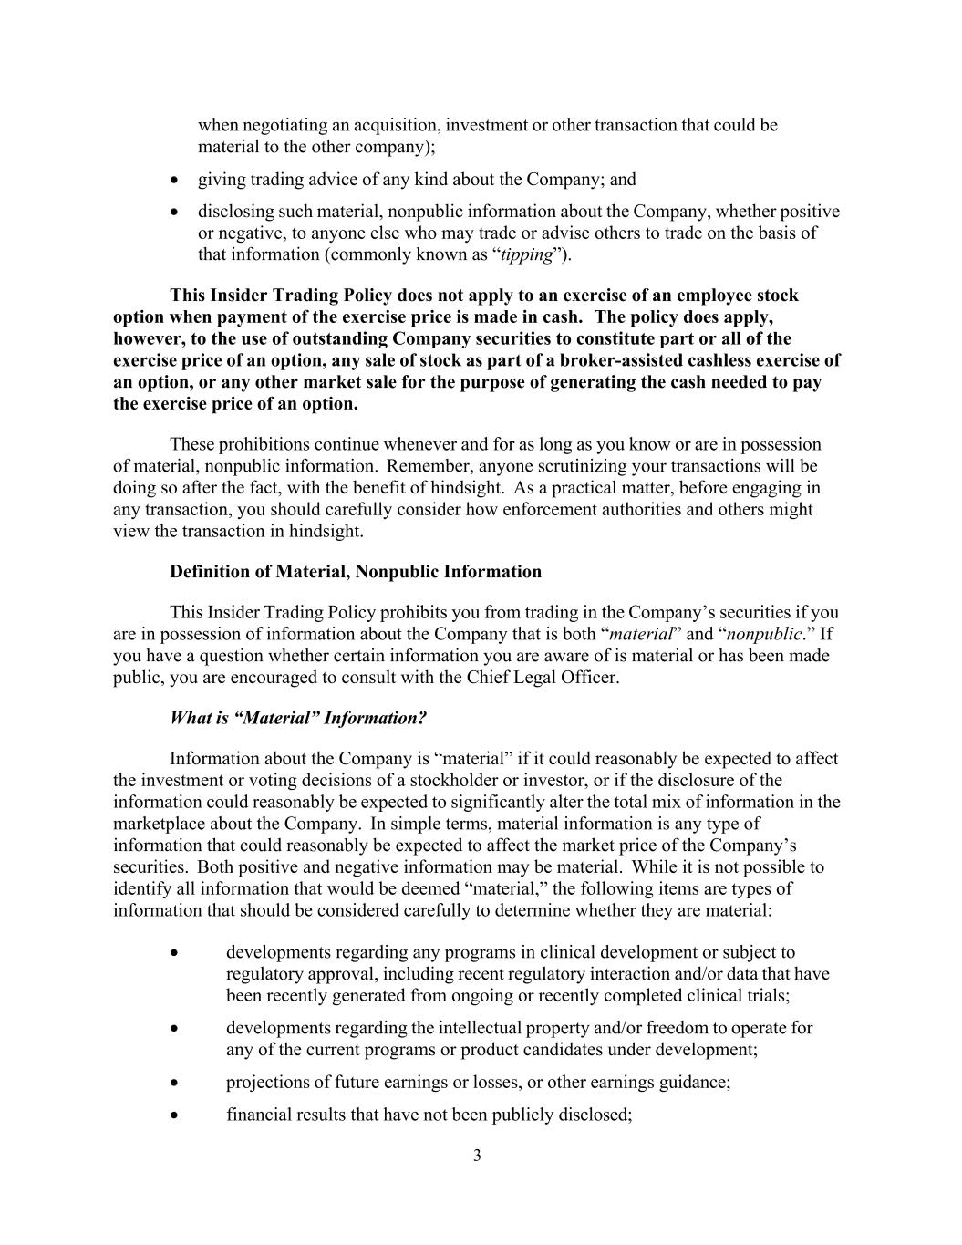
3 when negotiating an acquisition, investment or other transaction that could be material to the other company); • giving trading advice of any kind about the Company; and • disclosing such material, nonpublic information about the Company, whether positive or negative, to anyone else who may trade or advise others to trade on the basis of that information (commonly known as “tipping”). This Insider Trading Policy does not apply to an exercise of an employee stock option when payment of the exercise price is made in cash. The policy does apply, however, to the use of outstanding Company securities to constitute part or all of the exercise price of an option, any sale of stock as part of a broker-assisted cashless exercise of an option, or any other market sale for the purpose of generating the cash needed to pay the exercise price of an option. These prohibitions continue whenever and for as long as you know or are in possession of material, nonpublic information. Remember, anyone scrutinizing your transactions will be doing so after the fact, with the benefit of hindsight. As a practical matter, before engaging in any transaction, you should carefully consider how enforcement authorities and others might view the transaction in hindsight. Definition of Material, Nonpublic Information This Insider Trading Policy prohibits you from trading in the Company’s securities if you are in possession of information about the Company that is both “material” and “nonpublic.” If you have a question whether certain information you are aware of is material or has been made public, you are encouraged to consult with the Chief Legal Officer. What is “Material” Information? Information about the Company is “material” if it could reasonably be expected to affect the investment or voting decisions of a stockholder or investor, or if the disclosure of the information could reasonably be expected to significantly alter the total mix of information in the marketplace about the Company. In simple terms, material information is any type of information that could reasonably be expected to affect the market price of the Company’s securities. Both positive and negative information may be material. While it is not possible to identify all information that would be deemed “material,” the following items are types of information that should be considered carefully to determine whether they are material: • developments regarding any programs in clinical development or subject to regulatory approval, including recent regulatory interaction and/or data that have been recently generated from ongoing or recently completed clinical trials; • developments regarding the intellectual property and/or freedom to operate for any of the current programs or product candidates under development; • projections of future earnings or losses, or other earnings guidance; • financial results that have not been publicly disclosed;

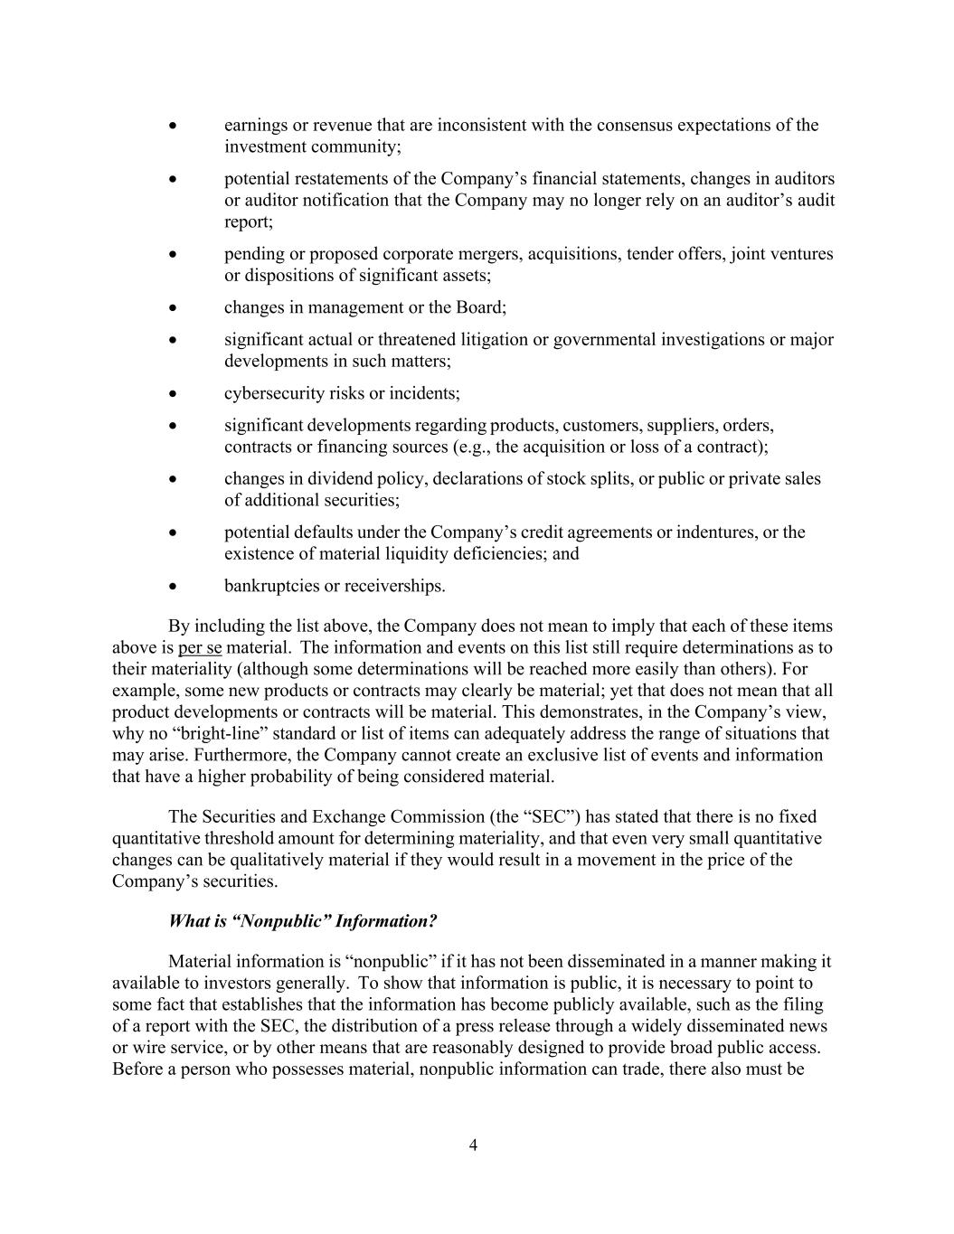
4 • earnings or revenue that are inconsistent with the consensus expectations of the investment community; • potential restatements of the Company’s financial statements, changes in auditors or auditor notification that the Company may no longer rely on an auditor’s audit report; • pending or proposed corporate mergers, acquisitions, tender offers, joint ventures or dispositions of significant assets; • changes in management or the Board; • significant actual or threatened litigation or governmental investigations or major developments in such matters; • cybersecurity risks or incidents; • significant developments regarding products, customers, suppliers, orders, contracts or financing sources (e.g., the acquisition or loss of a contract); • changes in dividend policy, declarations of stock splits, or public or private sales of additional securities; • potential defaults under the Company’s credit agreements or indentures, or the existence of material liquidity deficiencies; and • bankruptcies or receiverships. By including the list above, the Company does not mean to imply that each of these items above is per se material. The information and events on this list still require determinations as to their materiality (although some determinations will be reached more easily than others). For example, some new products or contracts may clearly be material; yet that does not mean that all product developments or contracts will be material. This demonstrates, in the Company’s view, why no “bright-line” standard or list of items can adequately address the range of situations that may arise. Furthermore, the Company cannot create an exclusive list of events and information that have a higher probability of being considered material. The Securities and Exchange Commission (the “SEC”) has stated that there is no fixed quantitative threshold amount for determining materiality, and that even very small quantitative changes can be qualitatively material if they would result in a movement in the price of the Company’s securities. What is “Nonpublic” Information? Material information is “nonpublic” if it has not been disseminated in a manner making it available to investors generally. To show that information is public, it is necessary to point to some fact that establishes that the information has become publicly available, such as the filing of a report with the SEC, the distribution of a press release through a widely disseminated news or wire service, or by other means that are reasonably designed to provide broad public access. Before a person who possesses material, nonpublic information can trade, there also must be

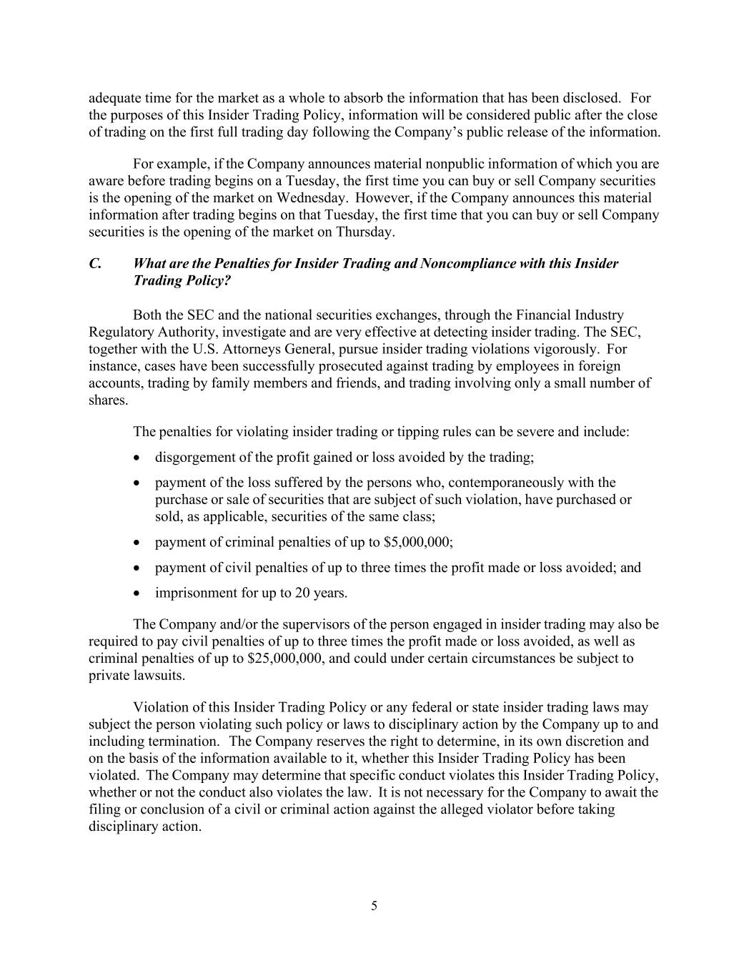
5 adequate time for the market as a whole to absorb the information that has been disclosed. For the purposes of this Insider Trading Policy, information will be considered public after the close of trading on the first full trading day following the Company’s public release of the information. For example, if the Company announces material nonpublic information of which you are aware before trading begins on a Tuesday, the first time you can buy or sell Company securities is the opening of the market on Wednesday. However, if the Company announces this material information after trading begins on that Tuesday, the first time that you can buy or sell Company securities is the opening of the market on Thursday. C. What are the Penalties for Insider Trading and Noncompliance with this Insider Trading Policy? Both the SEC and the national securities exchanges, through the Financial Industry Regulatory Authority, investigate and are very effective at detecting insider trading. The SEC, together with the U.S. Attorneys General, pursue insider trading violations vigorously. For instance, cases have been successfully prosecuted against trading by employees in foreign accounts, trading by family members and friends, and trading involving only a small number of shares. The penalties for violating insider trading or tipping rules can be severe and include: • disgorgement of the profit gained or loss avoided by the trading; • payment of the loss suffered by the persons who, contemporaneously with the purchase or sale of securities that are subject of such violation, have purchased or sold, as applicable, securities of the same class; • payment of criminal penalties of up to $5,000,000; • payment of civil penalties of up to three times the profit made or loss avoided; and • imprisonment for up to 20 years. The Company and/or the supervisors of the person engaged in insider trading may also be required to pay civil penalties of up to three times the profit made or loss avoided, as well as criminal penalties of up to $25,000,000, and could under certain circumstances be subject to private lawsuits. Violation of this Insider Trading Policy or any federal or state insider trading laws may subject the person violating such policy or laws to disciplinary action by the Company up to and including termination. The Company reserves the right to determine, in its own discretion and on the basis of the information available to it, whether this Insider Trading Policy has been violated. The Company may determine that specific conduct violates this Insider Trading Policy, whether or not the conduct also violates the law. It is not necessary for the Company to await the filing or conclusion of a civil or criminal action against the alleged violator before taking disciplinary action.

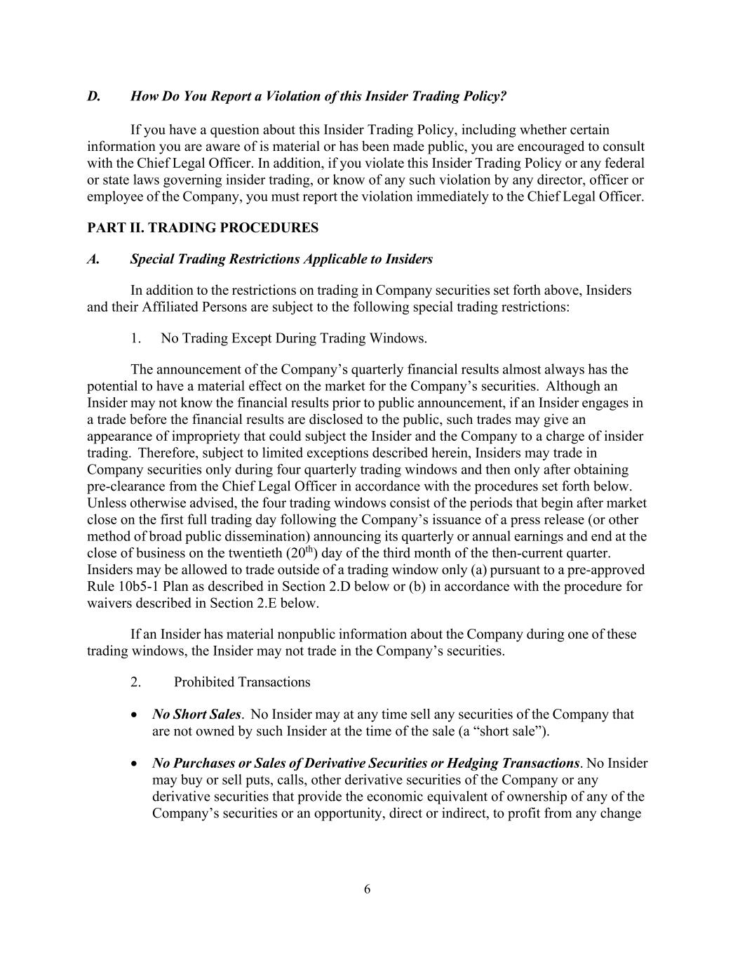
6 D. How Do You Report a Violation of this Insider Trading Policy? If you have a question about this Insider Trading Policy, including whether certain information you are aware of is material or has been made public, you are encouraged to consult with the Chief Legal Officer. In addition, if you violate this Insider Trading Policy or any federal or state laws governing insider trading, or know of any such violation by any director, officer or employee of the Company, you must report the violation immediately to the Chief Legal Officer. PART II. TRADING PROCEDURES A. Special Trading Restrictions Applicable to Insiders In addition to the restrictions on trading in Company securities set forth above, Insiders and their Affiliated Persons are subject to the following special trading restrictions: 1. No Trading Except During Trading Windows. The announcement of the Company’s quarterly financial results almost always has the potential to have a material effect on the market for the Company’s securities. Although an Insider may not know the financial results prior to public announcement, if an Insider engages in a trade before the financial results are disclosed to the public, such trades may give an appearance of impropriety that could subject the Insider and the Company to a charge of insider trading. Therefore, subject to limited exceptions described herein, Insiders may trade in Company securities only during four quarterly trading windows and then only after obtaining pre-clearance from the Chief Legal Officer in accordance with the procedures set forth below. Unless otherwise advised, the four trading windows consist of the periods that begin after market close on the first full trading day following the Company’s issuance of a press release (or other method of broad public dissemination) announcing its quarterly or annual earnings and end at the close of business on the twentieth (20th) day of the third month of the then-current quarter. Insiders may be allowed to trade outside of a trading window only (a) pursuant to a pre-approved Rule 10b5-1 Plan as described in Section 2.D below or (b) in accordance with the procedure for waivers described in Section 2.E below. If an Insider has material nonpublic information about the Company during one of these trading windows, the Insider may not trade in the Company’s securities. 2. Prohibited Transactions • No Short Sales. No Insider may at any time sell any securities of the Company that are not owned by such Insider at the time of the sale (a “short sale”). • No Purchases or Sales of Derivative Securities or Hedging Transactions. No Insider may buy or sell puts, calls, other derivative securities of the Company or any derivative securities that provide the economic equivalent of ownership of any of the Company’s securities or an opportunity, direct or indirect, to profit from any change

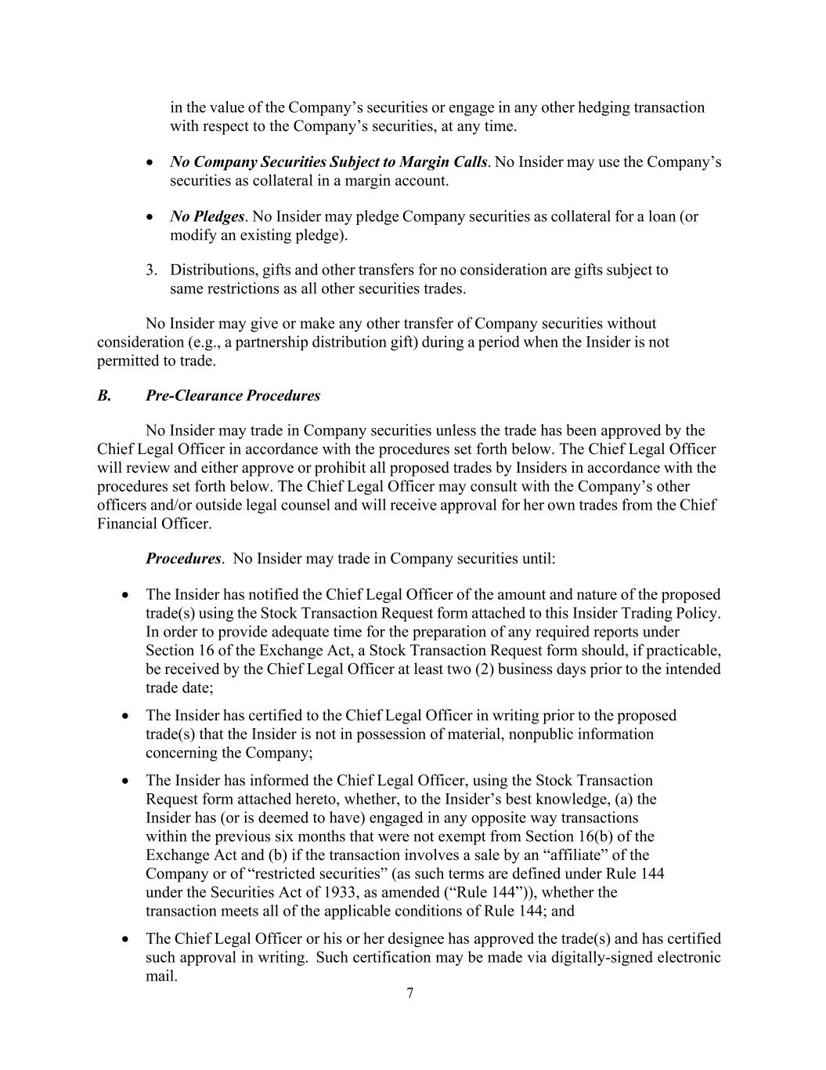
7 in the value of the Company’s securities or engage in any other hedging transaction with respect to the Company’s securities, at any time. • No Company Securities Subject to Margin Calls. No Insider may use the Company’s securities as collateral in a margin account. • No Pledges. No Insider may pledge Company securities as collateral for a loan (or modify an existing pledge). 3. Distributions, gifts and other transfers for no consideration are gifts subject to same restrictions as all other securities trades. No Insider may give or make any other transfer of Company securities without consideration (e.g., a partnership distribution gift) during a period when the Insider is not permitted to trade. B. Pre-Clearance Procedures No Insider may trade in Company securities unless the trade has been approved by the Chief Legal Officer in accordance with the procedures set forth below. The Chief Legal Officer will review and either approve or prohibit all proposed trades by Insiders in accordance with the procedures set forth below. The Chief Legal Officer may consult with the Company’s other officers and/or outside legal counsel and will receive approval for her own trades from the Chief Financial Officer. Procedures. No Insider may trade in Company securities until: • The Insider has notified the Chief Legal Officer of the amount and nature of the proposed trade(s) using the Stock Transaction Request form attached to this Insider Trading Policy. In order to provide adequate time for the preparation of any required reports under Section 16 of the Exchange Act, a Stock Transaction Request form should, if practicable, be received by the Chief Legal Officer at least two (2) business days prior to the intended trade date; • The Insider has certified to the Chief Legal Officer in writing prior to the proposed trade(s) that the Insider is not in possession of material, nonpublic information concerning the Company; • The Insider has informed the Chief Legal Officer, using the Stock Transaction Request form attached hereto, whether, to the Insider’s best knowledge, (a) the Insider has (or is deemed to have) engaged in any opposite way transactions within the previous six months that were not exempt from Section 16(b) of the Exchange Act and (b) if the transaction involves a sale by an “affiliate” of the Company or of “restricted securities” (as such terms are defined under Rule 144 under the Securities Act of 1933, as amended (“Rule 144”)), whether the transaction meets all of the applicable conditions of Rule 144; and • The Chief Legal Officer or his or her designee has approved the trade(s) and has certified such approval in writing. Such certification may be made via digitally-signed electronic mail.

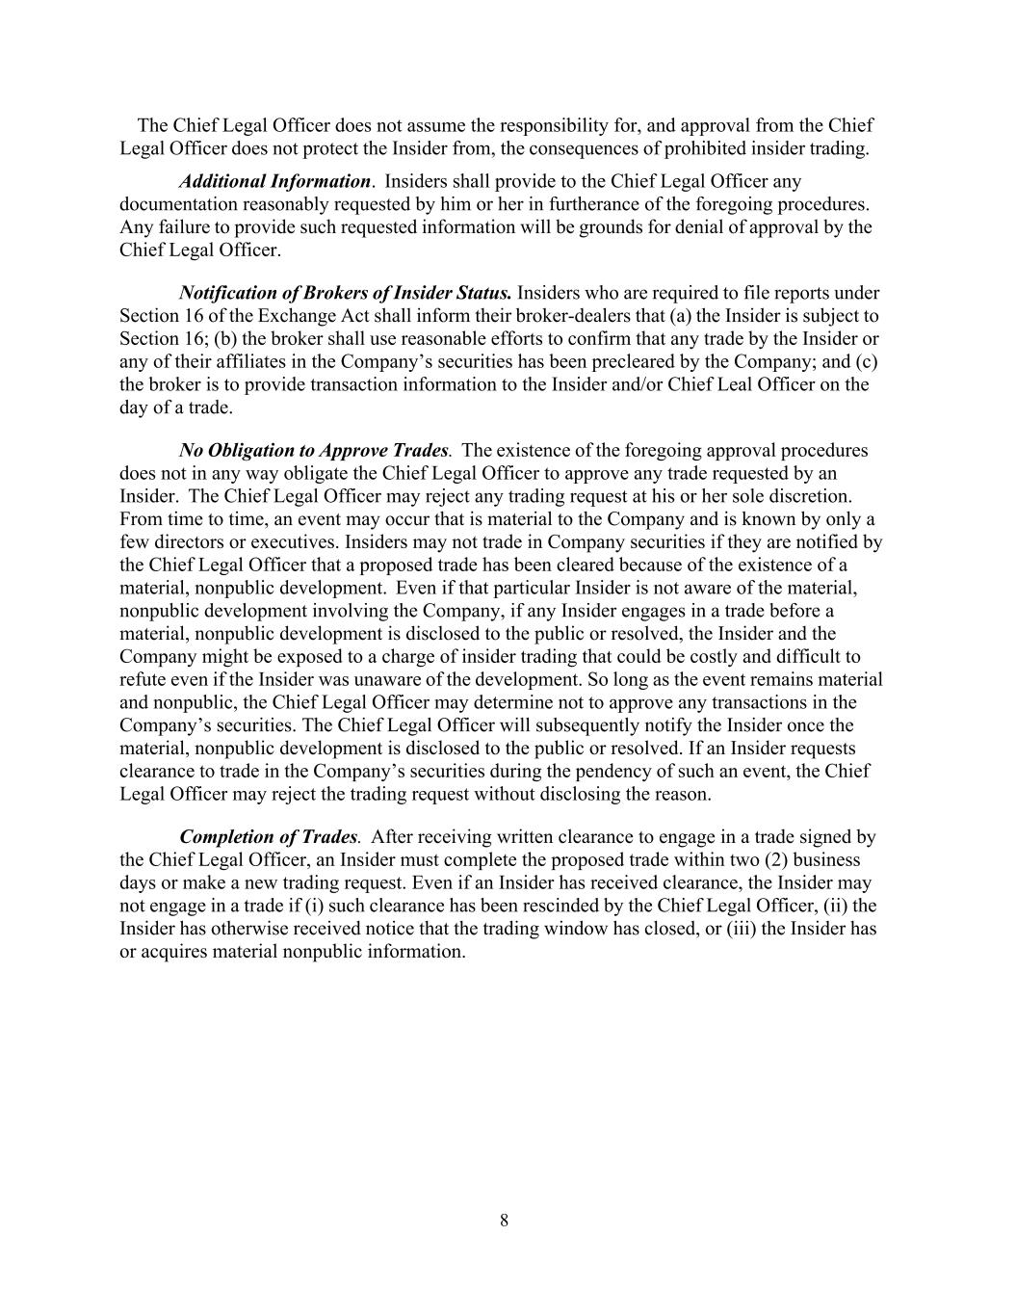
8 The Chief Legal Officer does not assume the responsibility for, and approval from the Chief Legal Officer does not protect the Insider from, the consequences of prohibited insider trading. Additional Information. Insiders shall provide to the Chief Legal Officer any documentation reasonably requested by him or her in furtherance of the foregoing procedures. Any failure to provide such requested information will be grounds for denial of approval by the Chief Legal Officer. Notification of Brokers of Insider Status. Insiders who are required to file reports under Section 16 of the Exchange Act shall inform their broker-dealers that (a) the Insider is subject to Section 16; (b) the broker shall use reasonable efforts to confirm that any trade by the Insider or any of their affiliates in the Company’s securities has been precleared by the Company; and (c) the broker is to provide transaction information to the Insider and/or Chief Leal Officer on the day of a trade. No Obligation to Approve Trades. The existence of the foregoing approval procedures does not in any way obligate the Chief Legal Officer to approve any trade requested by an Insider. The Chief Legal Officer may reject any trading request at his or her sole discretion. From time to time, an event may occur that is material to the Company and is known by only a few directors or executives. Insiders may not trade in Company securities if they are notified by the Chief Legal Officer that a proposed trade has been cleared because of the existence of a material, nonpublic development. Even if that particular Insider is not aware of the material, nonpublic development involving the Company, if any Insider engages in a trade before a material, nonpublic development is disclosed to the public or resolved, the Insider and the Company might be exposed to a charge of insider trading that could be costly and difficult to refute even if the Insider was unaware of the development. So long as the event remains material and nonpublic, the Chief Legal Officer may determine not to approve any transactions in the Company’s securities. The Chief Legal Officer will subsequently notify the Insider once the material, nonpublic development is disclosed to the public or resolved. If an Insider requests clearance to trade in the Company’s securities during the pendency of such an event, the Chief Legal Officer may reject the trading request without disclosing the reason. Completion of Trades. After receiving written clearance to engage in a trade signed by the Chief Legal Officer, an Insider must complete the proposed trade within two (2) business days or make a new trading request. Even if an Insider has received clearance, the Insider may not engage in a trade if (i) such clearance has been rescinded by the Chief Legal Officer, (ii) the Insider has otherwise received notice that the trading window has closed, or (iii) the Insider has or acquires material nonpublic information.

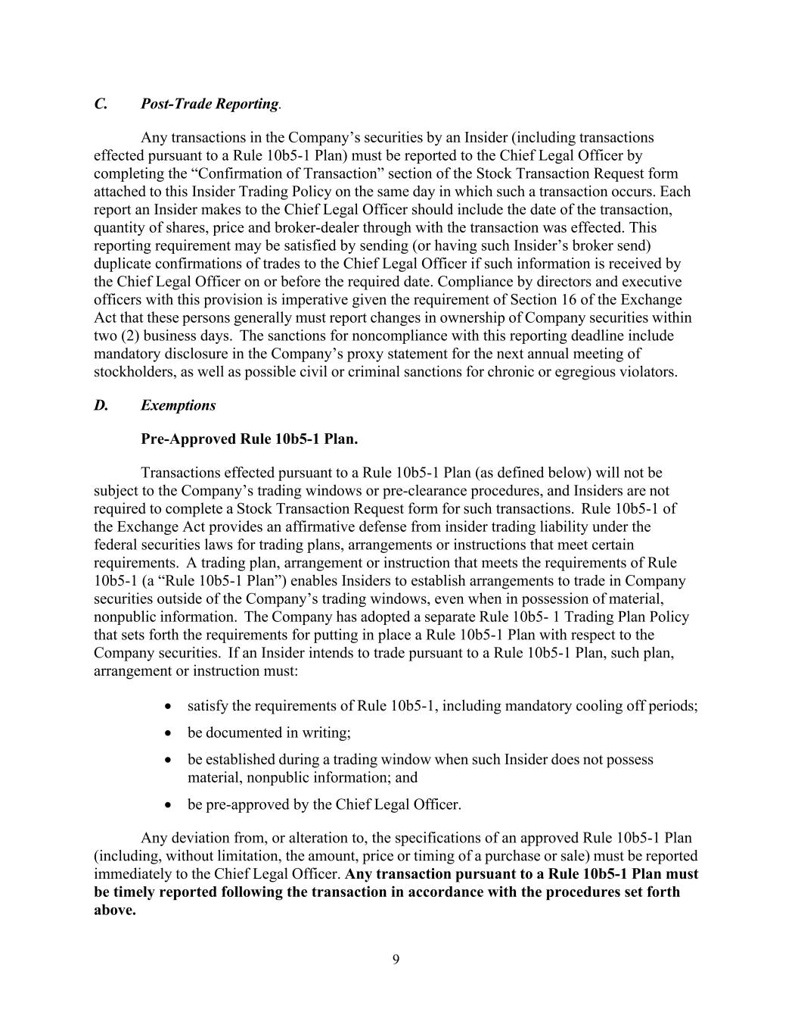
9 C. Post-Trade Reporting. Any transactions in the Company’s securities by an Insider (including transactions effected pursuant to a Rule 10b5-1 Plan) must be reported to the Chief Legal Officer by completing the “Confirmation of Transaction” section of the Stock Transaction Request form attached to this Insider Trading Policy on the same day in which such a transaction occurs. Each report an Insider makes to the Chief Legal Officer should include the date of the transaction, quantity of shares, price and broker-dealer through with the transaction was effected. This reporting requirement may be satisfied by sending (or having such Insider’s broker send) duplicate confirmations of trades to the Chief Legal Officer if such information is received by the Chief Legal Officer on or before the required date. Compliance by directors and executive officers with this provision is imperative given the requirement of Section 16 of the Exchange Act that these persons generally must report changes in ownership of Company securities within two (2) business days. The sanctions for noncompliance with this reporting deadline include mandatory disclosure in the Company’s proxy statement for the next annual meeting of stockholders, as well as possible civil or criminal sanctions for chronic or egregious violators. D. Exemptions Pre-Approved Rule 10b5-1 Plan. Transactions effected pursuant to a Rule 10b5-1 Plan (as defined below) will not be subject to the Company’s trading windows or pre-clearance procedures, and Insiders are not required to complete a Stock Transaction Request form for such transactions. Rule 10b5-1 of the Exchange Act provides an affirmative defense from insider trading liability under the federal securities laws for trading plans, arrangements or instructions that meet certain requirements. A trading plan, arrangement or instruction that meets the requirements of Rule 10b5-1 (a “Rule 10b5-1 Plan”) enables Insiders to establish arrangements to trade in Company securities outside of the Company’s trading windows, even when in possession of material, nonpublic information. The Company has adopted a separate Rule 10b5- 1 Trading Plan Policy that sets forth the requirements for putting in place a Rule 10b5-1 Plan with respect to the Company securities. If an Insider intends to trade pursuant to a Rule 10b5-1 Plan, such plan, arrangement or instruction must: • satisfy the requirements of Rule 10b5-1, including mandatory cooling off periods; • be documented in writing; • be established during a trading window when such Insider does not possess material, nonpublic information; and • be pre-approved by the Chief Legal Officer. Any deviation from, or alteration to, the specifications of an approved Rule 10b5-1 Plan (including, without limitation, the amount, price or timing of a purchase or sale) must be reported immediately to the Chief Legal Officer. Any transaction pursuant to a Rule 10b5-1 Plan must be timely reported following the transaction in accordance with the procedures set forth above.

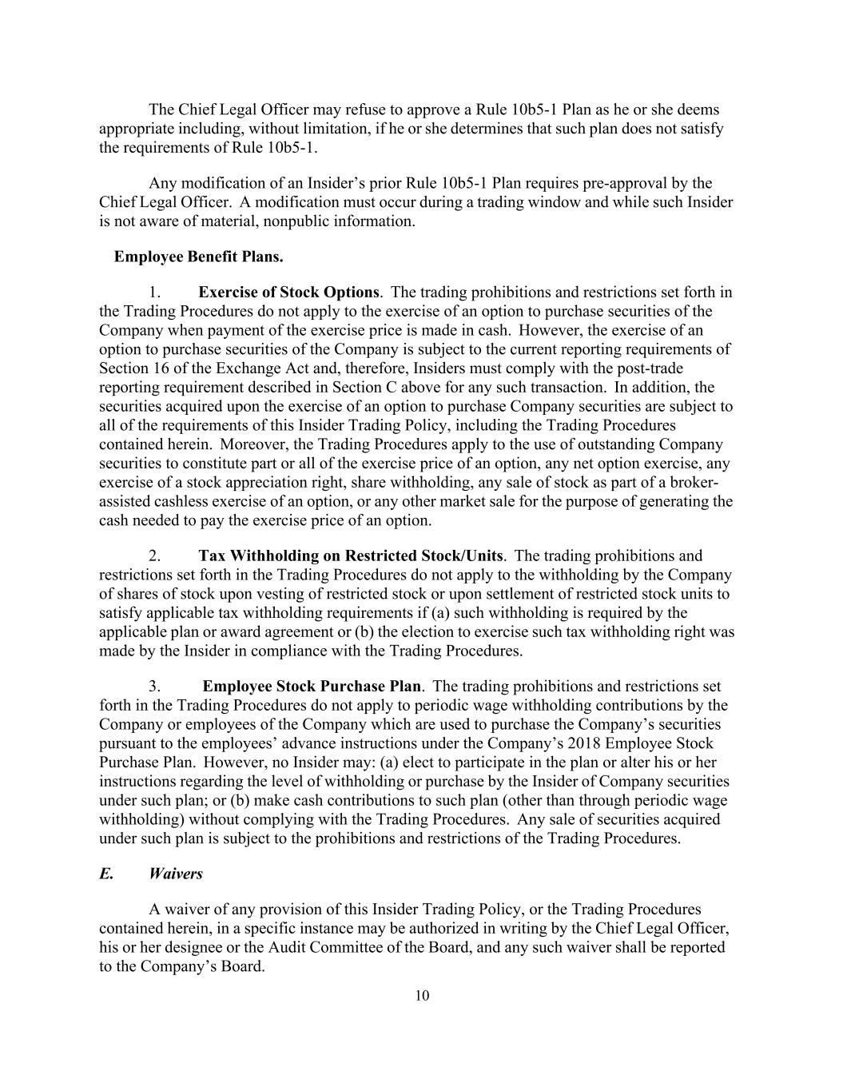
10 The Chief Legal Officer may refuse to approve a Rule 10b5-1 Plan as he or she deems appropriate including, without limitation, if he or she determines that such plan does not satisfy the requirements of Rule 10b5-1. Any modification of an Insider’s prior Rule 10b5-1 Plan requires pre-approval by the Chief Legal Officer. A modification must occur during a trading window and while such Insider is not aware of material, nonpublic information. Employee Benefit Plans. 1. Exercise of Stock Options. The trading prohibitions and restrictions set forth in the Trading Procedures do not apply to the exercise of an option to purchase securities of the Company when payment of the exercise price is made in cash. However, the exercise of an option to purchase securities of the Company is subject to the current reporting requirements of Section 16 of the Exchange Act and, therefore, Insiders must comply with the post-trade reporting requirement described in Section C above for any such transaction. In addition, the securities acquired upon the exercise of an option to purchase Company securities are subject to all of the requirements of this Insider Trading Policy, including the Trading Procedures contained herein. Moreover, the Trading Procedures apply to the use of outstanding Company securities to constitute part or all of the exercise price of an option, any net option exercise, any exercise of a stock appreciation right, share withholding, any sale of stock as part of a broker- assisted cashless exercise of an option, or any other market sale for the purpose of generating the cash needed to pay the exercise price of an option. 2. Tax Withholding on Restricted Stock/Units. The trading prohibitions and restrictions set forth in the Trading Procedures do not apply to the withholding by the Company of shares of stock upon vesting of restricted stock or upon settlement of restricted stock units to satisfy applicable tax withholding requirements if (a) such withholding is required by the applicable plan or award agreement or (b) the election to exercise such tax withholding right was made by the Insider in compliance with the Trading Procedures. 3. Employee Stock Purchase Plan. The trading prohibitions and restrictions set forth in the Trading Procedures do not apply to periodic wage withholding contributions by the Company or employees of the Company which are used to purchase the Company’s securities pursuant to the employees’ advance instructions under the Company’s 2018 Employee Stock Purchase Plan. However, no Insider may: (a) elect to participate in the plan or alter his or her instructions regarding the level of withholding or purchase by the Insider of Company securities under such plan; or (b) make cash contributions to such plan (other than through periodic wage withholding) without complying with the Trading Procedures. Any sale of securities acquired under such plan is subject to the prohibitions and restrictions of the Trading Procedures. E. Waivers A waiver of any provision of this Insider Trading Policy, or the Trading Procedures contained herein, in a specific instance may be authorized in writing by the Chief Legal Officer, his or her designee or the Audit Committee of the Board, and any such waiver shall be reported to the Company’s Board.

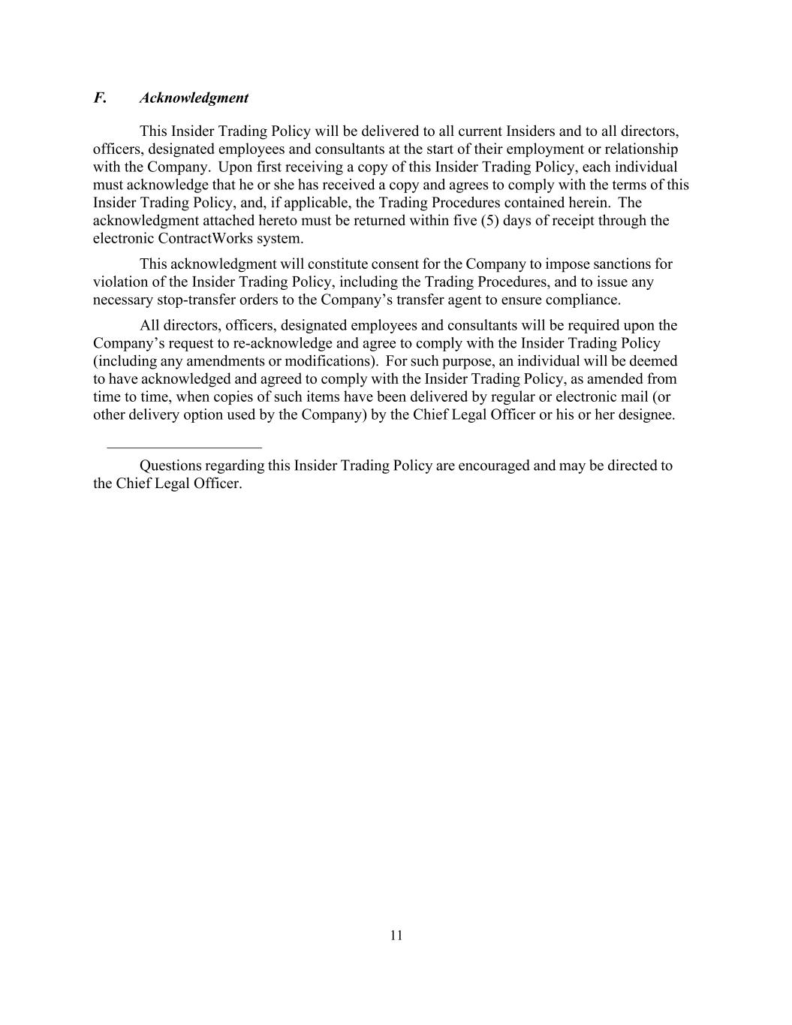
11 F. Acknowledgment This Insider Trading Policy will be delivered to all current Insiders and to all directors, officers, designated employees and consultants at the start of their employment or relationship with the Company. Upon first receiving a copy of this Insider Trading Policy, each individual must acknowledge that he or she has received a copy and agrees to comply with the terms of this Insider Trading Policy, and, if applicable, the Trading Procedures contained herein. The acknowledgment attached hereto must be returned within five (5) days of receipt through the electronic ContractWorks system. This acknowledgment will constitute consent for the Company to impose sanctions for violation of the Insider Trading Policy, including the Trading Procedures, and to issue any necessary stop-transfer orders to the Company’s transfer agent to ensure compliance. All directors, officers, designated employees and consultants will be required upon the Company’s request to re-acknowledge and agree to comply with the Insider Trading Policy (including any amendments or modifications). For such purpose, an individual will be deemed to have acknowledged and agreed to comply with the Insider Trading Policy, as amended from time to time, when copies of such items have been delivered by regular or electronic mail (or other delivery option used by the Company) by the Chief Legal Officer or his or her designee. Questions regarding this Insider Trading Policy are encouraged and may be directed to the Chief Legal Officer.

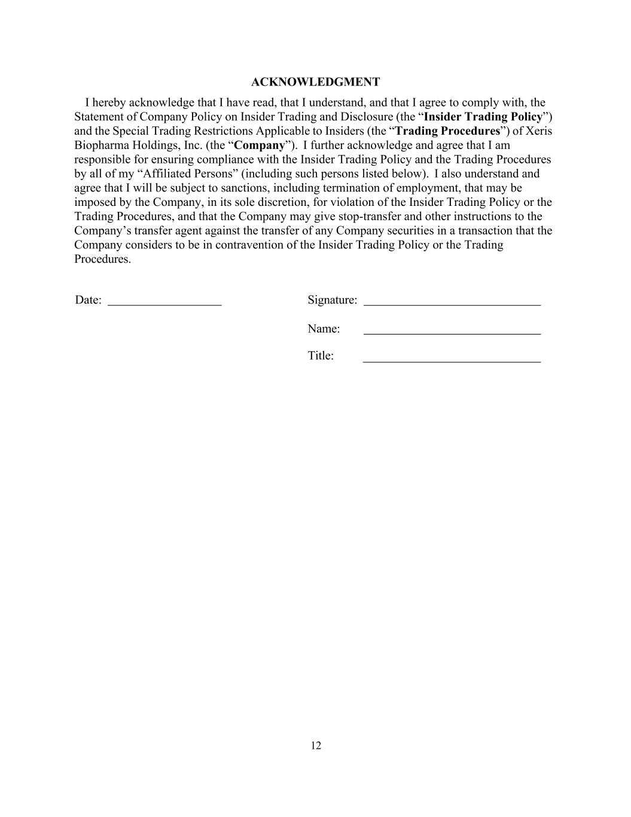
12 ACKNOWLEDGMENT I hereby acknowledge that I have read, that I understand, and that I agree to comply with, the Statement of Company Policy on Insider Trading and Disclosure (the “Insider Trading Policy”) and the Special Trading Restrictions Applicable to Insiders (the “Trading Procedures”) of Xeris Biopharma Holdings, Inc. (the “Company”). I further acknowledge and agree that I am responsible for ensuring compliance with the Insider Trading Policy and the Trading Procedures by all of my “Affiliated Persons” (including such persons listed below). I also understand and agree that I will be subject to sanctions, including termination of employment, that may be imposed by the Company, in its sole discretion, for violation of the Insider Trading Policy or the Trading Procedures, and that the Company may give stop-transfer and other instructions to the Company’s transfer agent against the transfer of any Company securities in a transaction that the Company considers to be in contravention of the Insider Trading Policy or the Trading Procedures. Date: Signature: Name: Title:

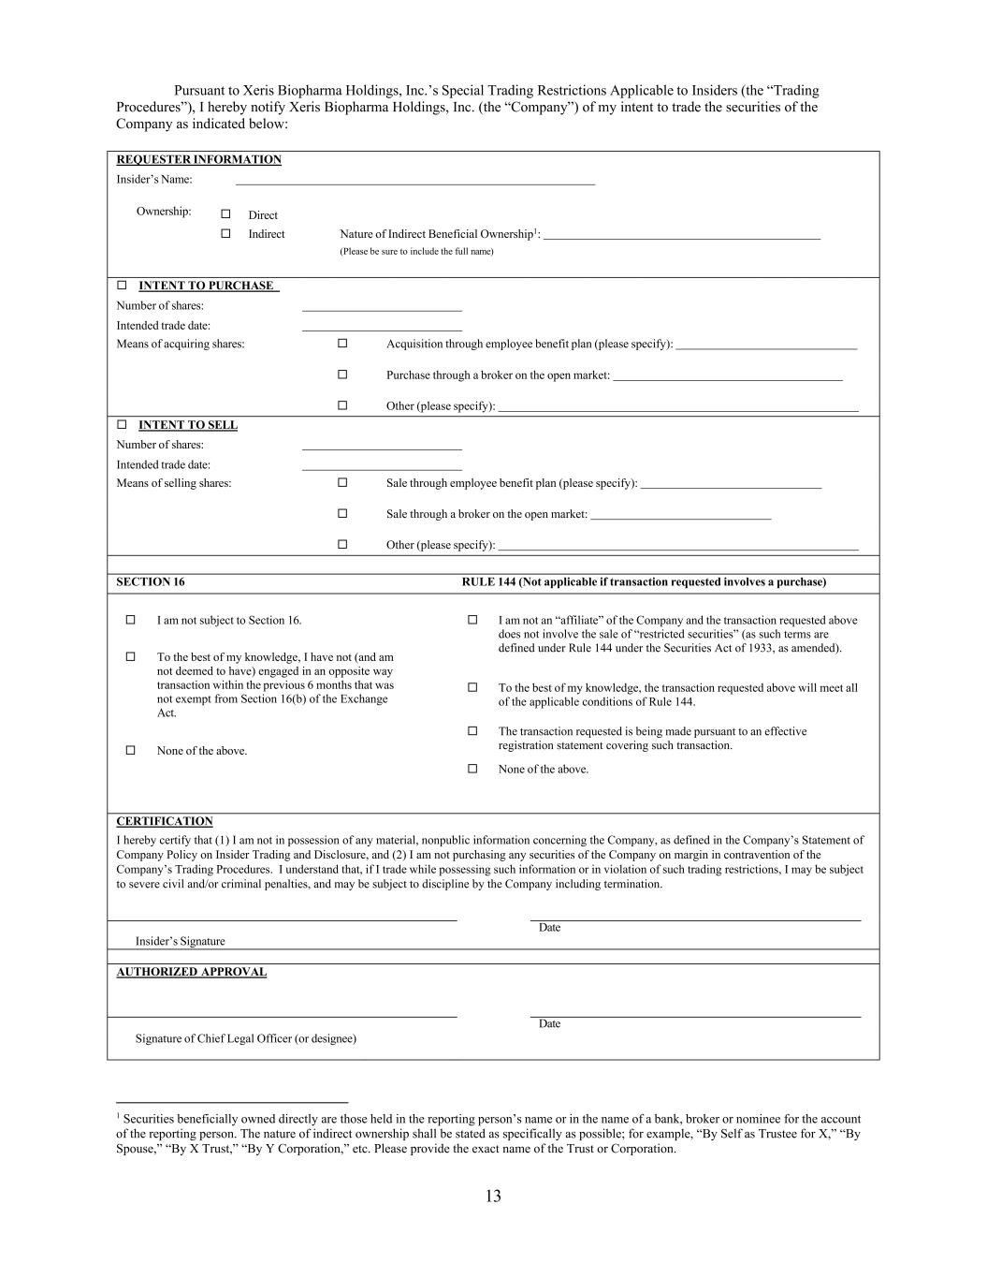
13 Pursuant to Xeris Biopharma Holdings, Inc.’s Special Trading Restrictions Applicable to Insiders (the “Trading Procedures”), I hereby notify Xeris Biopharma Holdings, Inc. (the “Company”) of my intent to trade the securities of the Company as indicated below: REQUESTER INFORMATION Insider’s Name: Ownership: ☐ Direct ☐ Indirect Nature of Indirect Beneficial Ownership1: (Please be sure to include the full name) ☐ INTENT TO PURCHASE Number of shares: Intended trade date: Means of acquiring shares: ☐  Acquisition through employee benefit plan (please specify): ☐  Purchase through a broker on the open market: ☐  Other (please specify): ☐ INTENT TO SELL Number of shares: Intended trade date: Means of selling shares: ☐  Sale through employee benefit plan (please specify): ☐  Sale through a broker on the open market: ☐  Other (please specify): SECTION 16 RULE 144 (Not applicable if transaction requested involves a purchase) ☐ I am not subject to Section 16. ☐ To the best of my knowledge, I have not (and am not deemed to have) engaged in an opposite way transaction within the previous 6 months that was not exempt from Section 16(b) of the Exchange Act. ☐ None of the above. ☐ I am not an “affiliate” of the Company and the transaction requested above does not involve the sale of “restricted securities” (as such terms are defined under Rule 144 under the Securities Act of 1933, as amended). ☐ To the best of my knowledge, the transaction requested above will meet all of the applicable conditions of Rule 144. ☐ The transaction requested is being made pursuant to an effective registration statement covering such transaction. ☐ None of the above. CERTIFICATION I hereby certify that (1) I am not in possession of any material, nonpublic information concerning the Company, as defined in the Company’s Statement of Company Policy on Insider Trading and Disclosure, and (2) I am not purchasing any securities of the Company on margin in contravention of the Company’s Trading Procedures. I understand that, if I trade while possessing such information or in violation of such trading restrictions, I may be subject to severe civil and/or criminal penalties, and may be subject to discipline by the Company including termination. Date Insider’s Signature AUTHORIZED APPROVAL Date Signature of Chief Legal Officer (or designee) 1 Securities beneficially owned directly are those held in the reporting person’s name or in the name of a bank, broker or nominee for the account of the reporting person. The nature of indirect ownership shall be stated as specifically as possible; for example, “By Self as Trustee for X,” “By Spouse,” “By X Trust,” “By Y Corporation,” etc. Please provide the exact name of the Trust or Corporation.

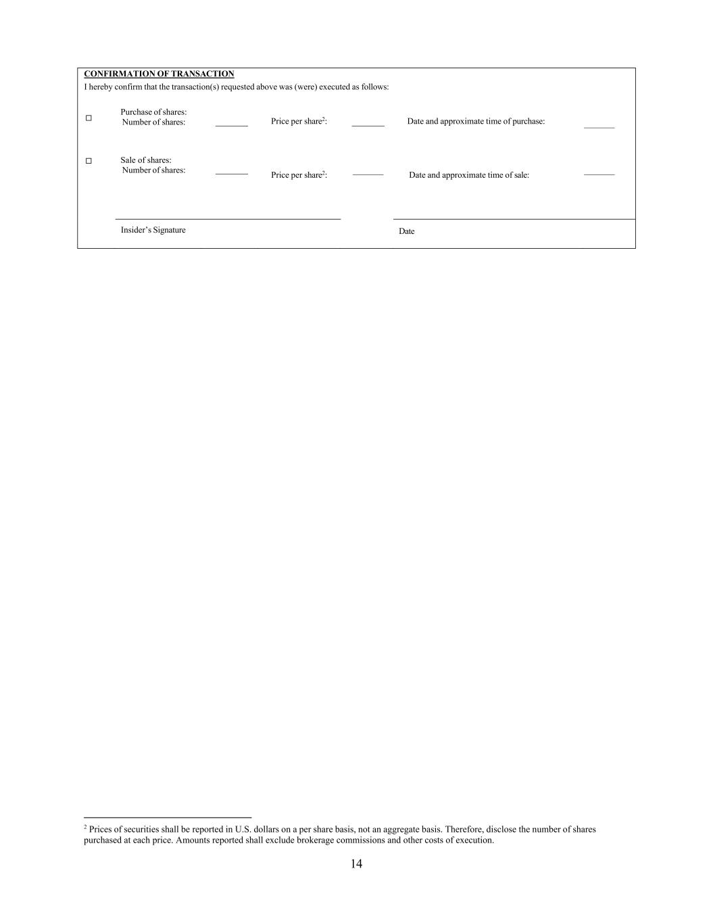
14 CONFIRMATION OF TRANSACTION I hereby confirm that the transaction(s) requested above was (were) executed as follows: ☐   Purchase of shares: Number of shares: Price per share2: Date and approximate time of purchase: ☐   Sale of shares: Number of shares: Price per share2: Date and approximate time of sale: Insider’s Signature Date 2 Prices of securities shall be reported in U.S. dollars on a per share basis, not an aggregate basis. Therefore, disclose the number of shares purchased at each price. Amounts reported shall exclude brokerage commissions and other costs of execution.

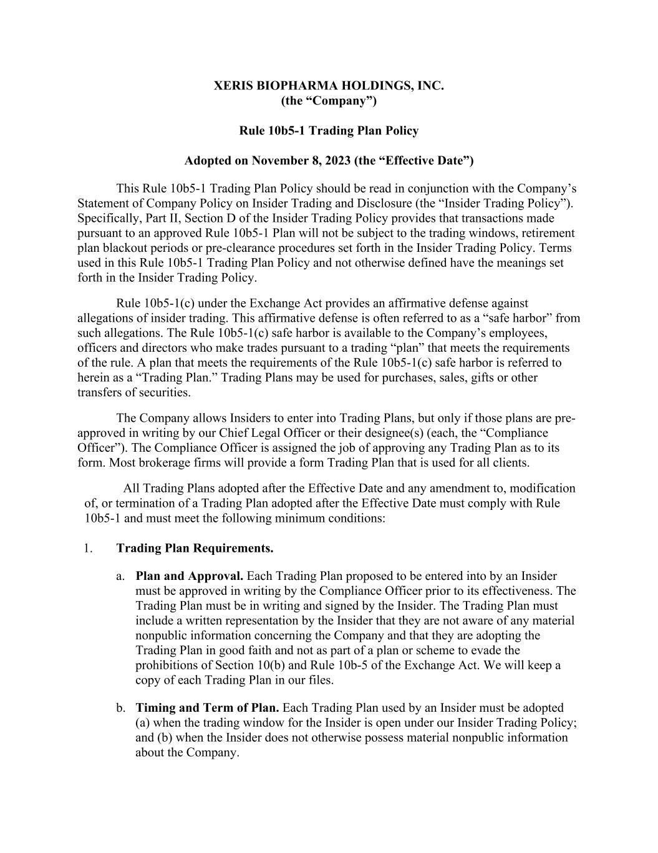
XERIS BIOPHARMA HOLDINGS, INC. (the “Company”) Rule 10b5-1 Trading Plan Policy Adopted on November 8, 2023 (the “Effective Date”) This Rule 10b5-1 Trading Plan Policy should be read in conjunction with the Company’s Statement of Company Policy on Insider Trading and Disclosure (the “Insider Trading Policy”). Specifically, Part II, Section D of the Insider Trading Policy provides that transactions made pursuant to an approved Rule 10b5-1 Plan will not be subject to the trading windows, retirement plan blackout periods or pre-clearance procedures set forth in the Insider Trading Policy. Terms used in this Rule 10b5-1 Trading Plan Policy and not otherwise defined have the meanings set forth in the Insider Trading Policy. Rule 10b5-1(c) under the Exchange Act provides an affirmative defense against allegations of insider trading. This affirmative defense is often referred to as a “safe harbor” from such allegations. The Rule 10b5-1(c) safe harbor is available to the Company’s employees, officers and directors who make trades pursuant to a trading “plan” that meets the requirements of the rule. A plan that meets the requirements of the Rule 10b5-1(c) safe harbor is referred to herein as a “Trading Plan.” Trading Plans may be used for purchases, sales, gifts or other transfers of securities. The Company allows Insiders to enter into Trading Plans, but only if those plans are pre- approved in writing by our Chief Legal Officer or their designee(s) (each, the “Compliance Officer”). The Compliance Officer is assigned the job of approving any Trading Plan as to its form. Most brokerage firms will provide a form Trading Plan that is used for all clients. All Trading Plans adopted after the Effective Date and any amendment to, modification of, or termination of a Trading Plan adopted after the Effective Date must comply with Rule 10b5-1 and must meet the following minimum conditions: 1. Trading Plan Requirements. a. Plan and Approval. Each Trading Plan proposed to be entered into by an Insider must be approved in writing by the Compliance Officer prior to its effectiveness. The Trading Plan must be in writing and signed by the Insider. The Trading Plan must include a written representation by the Insider that they are not aware of any material nonpublic information concerning the Company and that they are adopting the Trading Plan in good faith and not as part of a plan or scheme to evade the prohibitions of Section 10(b) and Rule 10b-5 of the Exchange Act. We will keep a copy of each Trading Plan in our files. b. Timing and Term of Plan. Each Trading Plan used by an Insider must be adopted (a) when the trading window for the Insider is open under our Insider Trading Policy; and (b) when the Insider does not otherwise possess material nonpublic information about the Company.

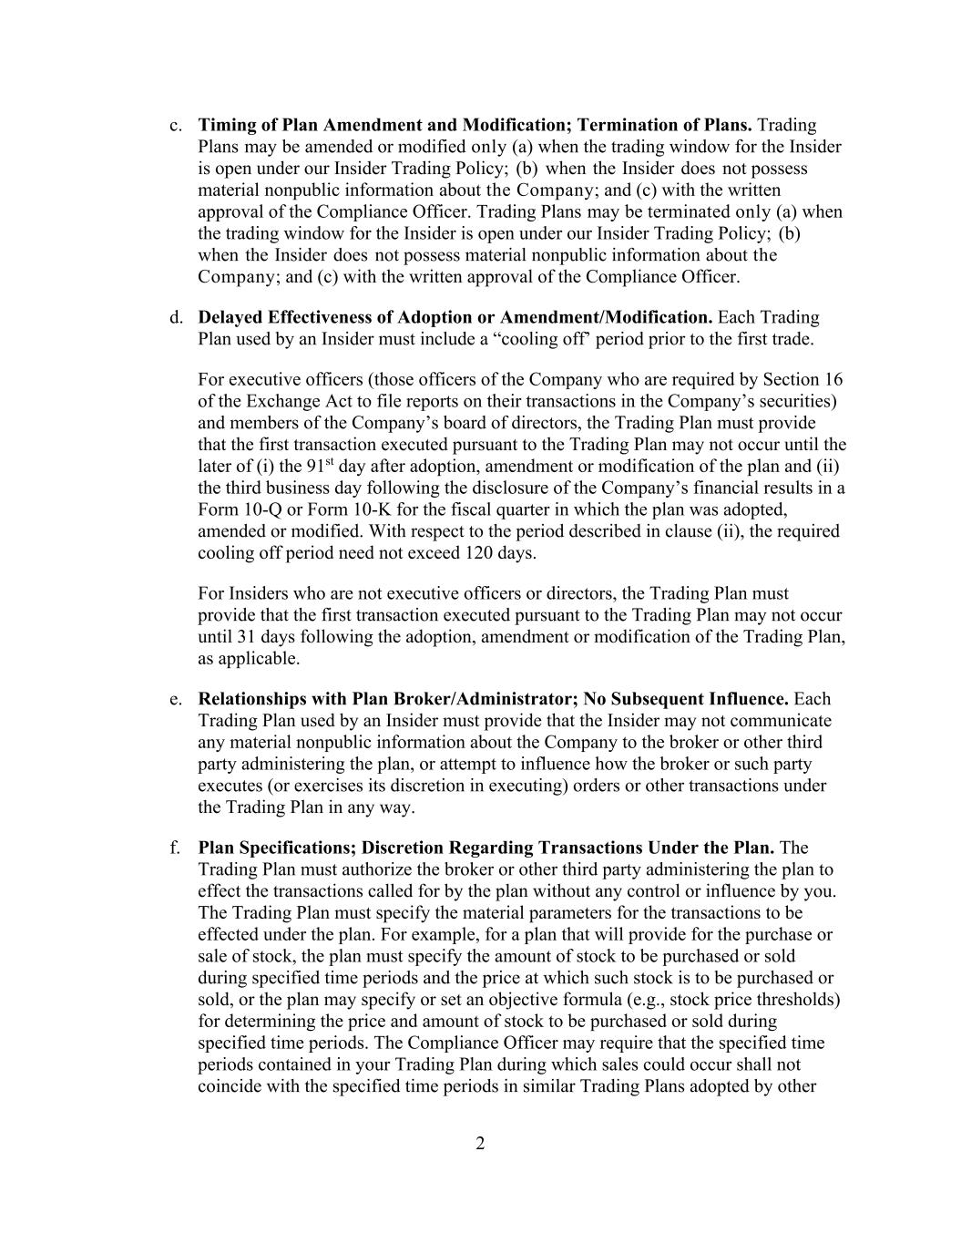
2 c. Timing of Plan Amendment and Modification; Termination of Plans. Trading Plans may be amended or modified only (a) when the trading window for the Insider is open under our Insider Trading Policy; (b) when the Insider does not possess material nonpublic information about the Company; and (c) with the written approval of the Compliance Officer. Trading Plans may be terminated only (a) when the trading window for the Insider is open under our Insider Trading Policy; (b) when the Insider does not possess material nonpublic information about the Company; and (c) with the written approval of the Compliance Officer. d. Delayed Effectiveness of Adoption or Amendment/Modification. Each Trading Plan used by an Insider must include a “cooling off’ period prior to the first trade. For executive officers (those officers of the Company who are required by Section 16 of the Exchange Act to file reports on their transactions in the Company’s securities) and members of the Company’s board of directors, the Trading Plan must provide that the first transaction executed pursuant to the Trading Plan may not occur until the later of (i) the 91st day after adoption, amendment or modification of the plan and (ii) the third business day following the disclosure of the Company’s financial results in a Form 10-Q or Form 10-K for the fiscal quarter in which the plan was adopted, amended or modified. With respect to the period described in clause (ii), the required cooling off period need not exceed 120 days. For Insiders who are not executive officers or directors, the Trading Plan must provide that the first transaction executed pursuant to the Trading Plan may not occur until 31 days following the adoption, amendment or modification of the Trading Plan, as applicable. e. Relationships with Plan Broker/Administrator; No Subsequent Influence. Each Trading Plan used by an Insider must provide that the Insider may not communicate any material nonpublic information about the Company to the broker or other third party administering the plan, or attempt to influence how the broker or such party executes (or exercises its discretion in executing) orders or other transactions under the Trading Plan in any way. f. Plan Specifications; Discretion Regarding Transactions Under the Plan. The Trading Plan must authorize the broker or other third party administering the plan to effect the transactions called for by the plan without any control or influence by you. The Trading Plan must specify the material parameters for the transactions to be effected under the plan. For example, for a plan that will provide for the purchase or sale of stock, the plan must specify the amount of stock to be purchased or sold during specified time periods and the price at which such stock is to be purchased or sold, or the plan may specify or set an objective formula (e.g., stock price thresholds) for determining the price and amount of stock to be purchased or sold during specified time periods. The Compliance Officer may require that the specified time periods contained in your Trading Plan during which sales could occur shall not coincide with the specified time periods in similar Trading Plans adopted by other

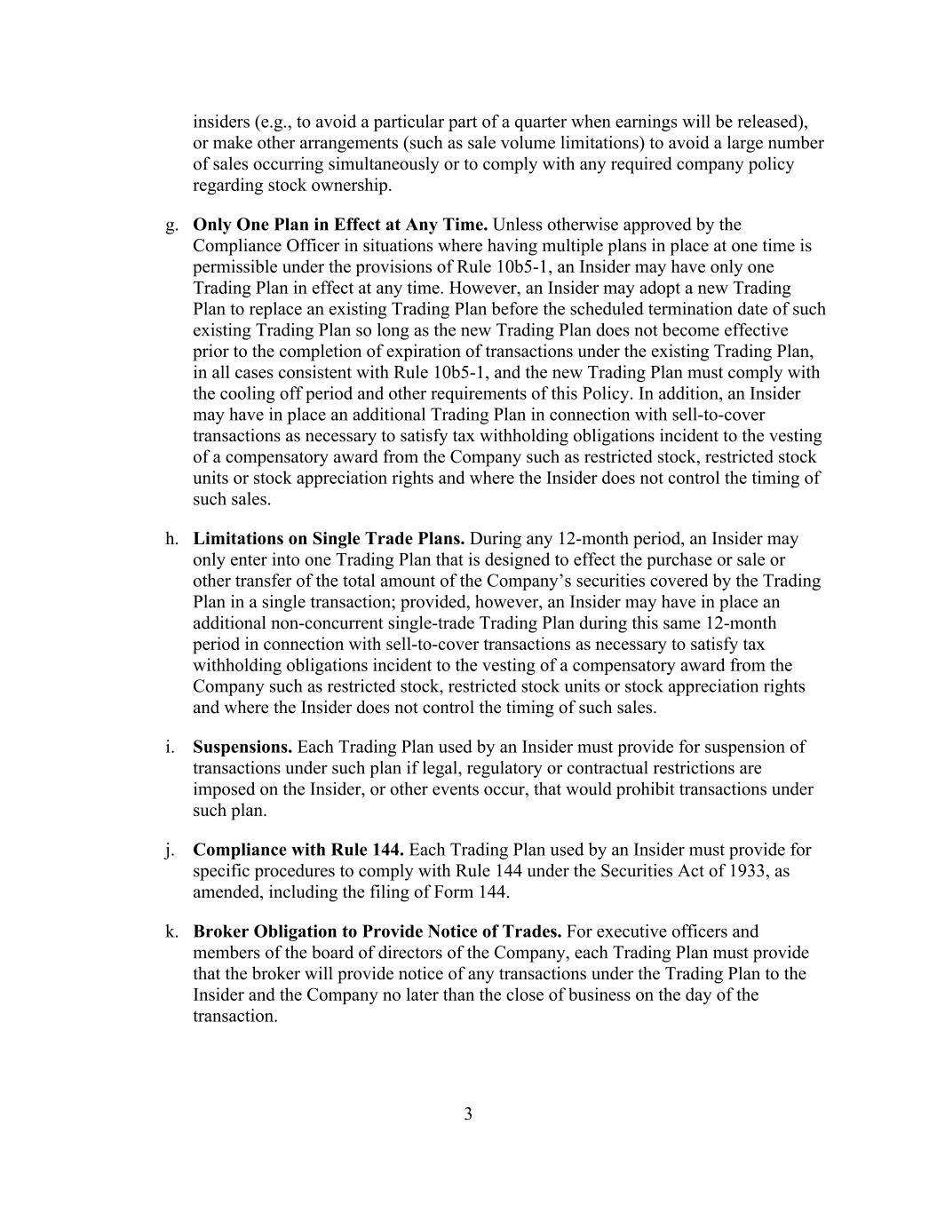
3 insiders (e.g., to avoid a particular part of a quarter when earnings will be released), or make other arrangements (such as sale volume limitations) to avoid a large number of sales occurring simultaneously or to comply with any required company policy regarding stock ownership. g. Only One Plan in Effect at Any Time. Unless otherwise approved by the Compliance Officer in situations where having multiple plans in place at one time is permissible under the provisions of Rule 10b5-1, an Insider may have only one Trading Plan in effect at any time. However, an Insider may adopt a new Trading Plan to replace an existing Trading Plan before the scheduled termination date of such existing Trading Plan so long as the new Trading Plan does not become effective prior to the completion of expiration of transactions under the existing Trading Plan, in all cases consistent with Rule 10b5-1, and the new Trading Plan must comply with the cooling off period and other requirements of this Policy. In addition, an Insider may have in place an additional Trading Plan in connection with sell-to-cover transactions as necessary to satisfy tax withholding obligations incident to the vesting of a compensatory award from the Company such as restricted stock, restricted stock units or stock appreciation rights and where the Insider does not control the timing of such sales. h. Limitations on Single Trade Plans. During any 12-month period, an Insider may only enter into one Trading Plan that is designed to effect the purchase or sale or other transfer of the total amount of the Company’s securities covered by the Trading Plan in a single transaction; provided, however, an Insider may have in place an additional non-concurrent single-trade Trading Plan during this same 12-month period in connection with sell-to-cover transactions as necessary to satisfy tax withholding obligations incident to the vesting of a compensatory award from the Company such as restricted stock, restricted stock units or stock appreciation rights and where the Insider does not control the timing of such sales. i. Suspensions. Each Trading Plan used by an Insider must provide for suspension of transactions under such plan if legal, regulatory or contractual restrictions are imposed on the Insider, or other events occur, that would prohibit transactions under such plan. j. Compliance with Rule 144. Each Trading Plan used by an Insider must provide for specific procedures to comply with Rule 144 under the Securities Act of 1933, as amended, including the filing of Form 144. k. Broker Obligation to Provide Notice of Trades. For executive officers and members of the board of directors of the Company, each Trading Plan must provide that the broker will provide notice of any transactions under the Trading Plan to the Insider and the Company no later than the close of business on the day of the transaction.

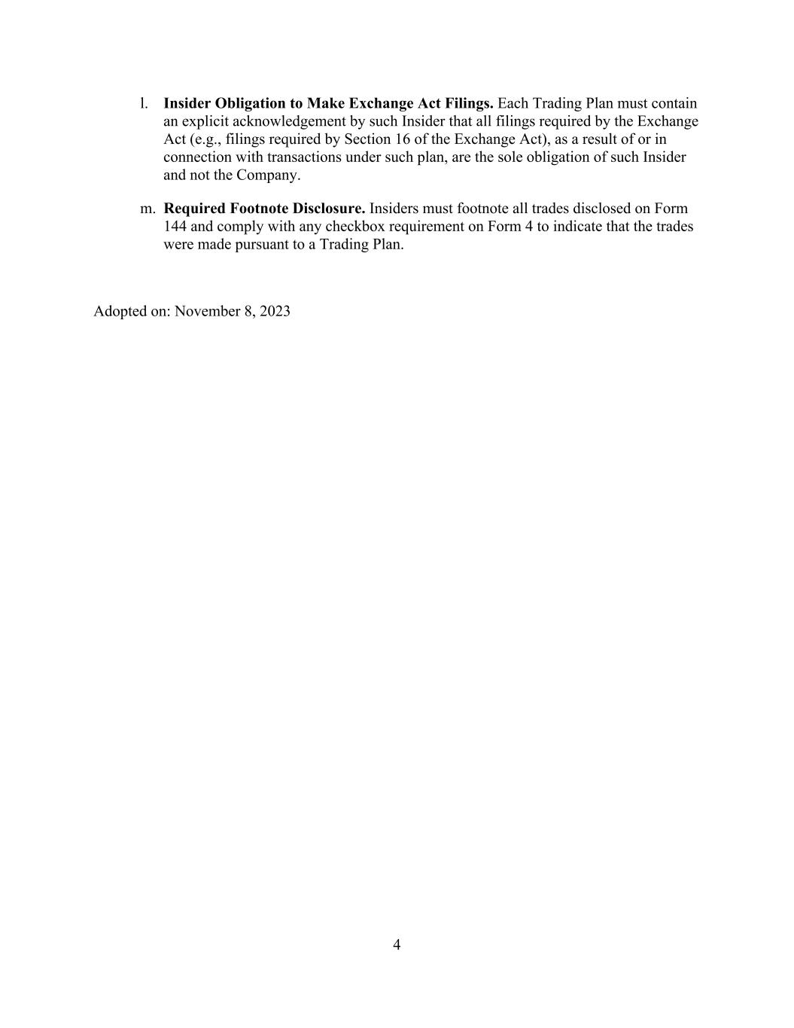
4 l. Insider Obligation to Make Exchange Act Filings. Each Trading Plan must contain an explicit acknowledgement by such Insider that all filings required by the Exchange Act (e.g., filings required by Section 16 of the Exchange Act), as a result of or in connection with transactions under such plan, are the sole obligation of such Insider and not the Company. m. Required Footnote Disclosure. Insiders must footnote all trades disclosed on Form 144 and comply with any checkbox requirement on Form 4 to indicate that the trades were made pursuant to a Trading Plan. Adopted on: November 8, 2023

Exhibit 21.1

XERIS BIOPHARMA HOLDINGS, INC.
LIST OF SUBSIDIARIES
Name |  |  | Jurisdiction of Incorporation
Xeris Pharmaceuticals, Inc. |  |  | Delaware
Xeris Pharmaceuticals Australia Pty Ltd |  |  | Australia
Strongbridge Biopharma Limited |  |  | Ireland
Strongbridge Dublin Limited |  |  | Ireland
Cortendo AB |  |  | Sweden

Exhibit 23.1

Consent of Independent Registered Public Accounting Firm

We consent to the incorporation by reference in the following Registration Statements:

1.Registration Statement (Form S-8 No. 333-285600) pertaining to the Xeris Pharmaceuticals, Inc. 2018 Stock Option and Incentive Plan,

2.Registration Statements (Form S-8 Nos. 333-270357 and 333-263466) pertaining to the Xeris Pharmaceuticals, Inc. 2018 Stock Option and Incentive Plan, and the Xeris Pharmaceuticals 2018 Employee Stock Purchase Plan,

3.Registration Statement (Form S-8 No. 333-281382) pertaining to the Xeris Pharmaceuticals, Inc. 2018 Employee Stock Purchase Plan,

4.Registration Statement (Form S-8 No. 333-277701) pertaining to the Xeris Pharmaceuticals, Inc. 2018 Stock Option and Incentive Plan, the Xeris Pharmaceuticals 2018 Employee Stock Purchase Plan, and the Xeris Pharmaceuticals, Inc. Inducement Equity Plan, as amended,

5.Registration Statement (Form S-8 No. 333-260068) pertaining to the Xeris Pharmaceuticals, Inc. 2011 Stock Option/Stock Issuance Plan, the Xeris Pharmaceuticals, Inc. 2018 Stock Option and Incentive Plan, the Xeris Pharmaceuticals, Inc. 2018 Employee Stock Purchase Plan, the Xeris Pharmaceuticals, Inc. Inducement Equity Plan, the Strongbridge Biopharma plc 2015 Equity Compensation Plan, the Strongbridge Biopharma plc Non-Employee Director Equity Compensation Plan, the Individual Stock Option Agreements, and the Strongbridge Biopharma plc 2017 Inducement Plan, and

6.Registration Statement (Form S-3 No. 333-262403) of Xeris Biopharma Holdings, Inc.

of our reports dated March 2, 2026, with respect to the consolidated financial statements of Xeris Biopharma Holdings, Inc. and the effectiveness of internal control over financial reporting of Xeris Biopharma Holdings, Inc. included in this Annual Report (Form 10-K) of Xeris Biopharma Holdings, Inc. for the year ended December 31, 2025.

/s/ Ernst & Young LLP
Grand Rapids, Michigan
March 2, 2026

Exhibit 31.1

CERTIFICATION PURSUANT TO RULE 13a-14(a) OR 15d-14(a) OF
THE SECURITIES EXCHANGE ACT OF 1934,
AS ADOPTED PURSUANT TO SECTION 302 OF
THE SARBANES-OXLEY ACT OF 2002

I, John Shannon, certify that:

1. I have reviewed this annual report on Form 10-K of Xeris Biopharma Holdings, Inc.;

2. Based on my knowledge, this report does not contain any untrue statement of a material fact or omit to state a material fact necessary to make the statements made, in light of the circumstances under which such statements were made, not misleading with respect to the period covered by this report;

3. Based on my knowledge, the financial statements, and other financial information included in this report, fairly present in all material respects the financial condition, results of operations and cash flows of the registrant as of, and for, the periods presented in this report;

4. The registrant’s other certifying officer and I are responsible for establishing and maintaining disclosure controls and procedures (as defined in Exchange Act Rules 13a-15(e) and 15d-15(e)) and internal control over financial reporting (as defined in Exchange Act Rules 13a-15(f) and 15d-15(f)) for the registrant and have:

a) Designed such disclosure controls and procedures, or caused such disclosure controls and procedures to be designed under our supervision, to ensure that material information relating to the registrant, including its consolidated subsidiaries, is made known to us by others within those entities, particularly during the period in which this report is being prepared;

b) Designed such internal control over financial reporting, or caused such internal control over financial reporting to be designed under our supervision, to provide reasonable assurance regarding the reliability of financial reporting and the preparation of financial statements for external purposes in accordance with generally accepted accounting principles;

c) Evaluated the effectiveness of the registrant’s disclosure controls and procedures and presented in this report our conclusions about the effectiveness of the disclosure controls and procedures, as of the end of the period covered by this report based on such evaluation; and

d) Disclosed in this report any change in the registrant’s internal control over financial reporting that occurred during the registrant’s most recent fiscal quarter (the registrant’s fourth fiscal quarter in the case of an annual report) that has materially affected, or is reasonably likely to materially affect, the registrant’s internal control over financial reporting; and

5. The registrant’s other certifying officer and I have disclosed, based on our most recent evaluation of internal control over financial reporting, to the registrant’s auditors and the audit committee of the registrant’s board of directors (or persons performing the equivalent functions):

a) All significant deficiencies and material weaknesses in the design or operation of internal control over financial reporting which are reasonably likely to adversely affect the registrant’s ability to record, process, summarize and report financial information; and

b) Any fraud, whether or not material, that involves management or other employees who have a significant role in the registrant’s internal control over financial reporting.

Date: March 2, 2026

By: |  |  | /s/ John Shannon
 |  |  | John Shannon
 |  |  | Chief Executive Officer and Director
 |  |  | (Principal Executive Officer)

Exhibit 31.2

CERTIFICATION PURSUANT TO RULE 13a-14(a) OR 15d-14(a) OF
THE SECURITIES EXCHANGE ACT OF 1934,
AS ADOPTED PURSUANT TO SECTION 302 OF
THE SARBANES-OXLEY ACT OF 2002

I, Steven M. Pieper, certify that:

1. I have reviewed this annual report on Form 10-K of Xeris Biopharma Holdings, Inc.;

2. Based on my knowledge, this report does not contain any untrue statement of a material fact or omit to state a material fact necessary to make the statements made, in light of the circumstances under which such statements were made, not misleading with respect to the period covered by this report;

3. Based on my knowledge, the financial statements, and other financial information included in this report, fairly present in all material respects the financial condition, results of operations and cash flows of the registrant as of, and for, the periods presented in this report;

4. The registrant’s other certifying officer and I are responsible for establishing and maintaining disclosure controls and procedures (as defined in Exchange Act Rules 13a-15(e) and 15d-15(e)) and internal control over financial reporting (as defined in Exchange Act Rules 13a-15(f) and 15d-15(f)) for the registrant and have:

a) Designed such disclosure controls and procedures, or caused such disclosure controls and procedures to be designed under our supervision, to ensure that material information relating to the registrant, including its consolidated subsidiaries, is made known to us by others within those entities, particularly during the period in which this report is being prepared;

b) Designed such internal control over financial reporting, or caused such internal control over financial reporting to be designed under our supervision, to provide reasonable assurance regarding the reliability of financial reporting and the preparation of financial statements for external purposes in accordance with generally accepted accounting principles;

c) Evaluated the effectiveness of the registrant’s disclosure controls and procedures and presented in this report our conclusions about the effectiveness of the disclosure controls and procedures, as of the end of the period covered by this report based on such evaluation; and

d) Disclosed in this report any change in the registrant’s internal control over financial reporting that occurred during the registrant’s most recent fiscal quarter (the registrant’s fourth fiscal quarter in the case of an annual report) that has materially affected, or is reasonably likely to materially affect, the registrant’s internal control over financial reporting; and

5. The registrant’s other certifying officer and I have disclosed, based on our most recent evaluation of internal control over financial reporting, to the registrant’s auditors and the audit committee of the registrant’s board of directors (or persons performing the equivalent functions):

a) All significant deficiencies and material weaknesses in the design or operation of internal control over financial reporting which are reasonably likely to adversely affect the registrant’s ability to record, process, summarize and report financial information; and

b) Any fraud, whether or not material, that involves management or other employees who have a significant role in the registrant’s internal control over financial reporting.

Date: March 2, 2026

By: |  |  | /s/ Steven M. Pieper
 |  |  | Steven M. Pieper
 |  |  | Chief Financial Officer
 |  |  | (Principal Financial Officer and Principal Accounting Officer)

Exhibit 32.1

CERTIFICATION PURSUANT TO
18 U.S.C. SECTION 1350, AS ADOPTED PURSUANT TO
SECTION 906 OF THE SARBANES-OXLEY ACT OF 2002

In connection with the Annual Report of Xeris Biopharma Holdings, Inc. (the “Company”) on Form 10-K for the year ended December 31, 2025 as filed with the Securities and Exchange Commission on the date hereof (the “Report”), I, John Shannon, certify, pursuant to 18 U.S.C. § 1350, as adopted pursuant to § 906 of the Sarbanes-Oxley Act of 2002, to the best of my knowledge, that:

1. The Report fully complies with the requirements of Section 13(a) or 15(d) of the Securities Exchange Act of 1934; and

2. The information contained in the Report fairly presents, in all material aspects, the financial condition and results of operations of the Company.

Date: March 2, 2026

By: |  |  |  |  |  | /s/ John Shannon
 |  |  |  |  |  | John Shannon
 |  |  |  |  |  | Chief Executive Officer and Director
 |  |  |  |  |  | (Principal Executive Officer)

Exhibit 32.2

CERTIFICATION PURSUANT TO
18 U.S.C. SECTION 1350, AS ADOPTED PURSUANT TO
SECTION 906 OF THE SARBANES-OXLEY ACT OF 2002

In connection with the Annual Report of Xeris Biopharma Holdings, Inc. (the “Company”) on Form 10-K for the year ended December 31, 2025 as filed with the Securities and Exchange Commission on the date hereof (the “Report”), I, Steven M. Pieper, certify, pursuant to 18 U.S.C. § 1350, as adopted pursuant to § 906 of the Sarbanes-Oxley Act of 2002, to the best of my knowledge, that:

1. The Report fully complies with the requirements of Section 13(a) or 15(d) of the Securities Exchange Act of 1934; and

2. The information contained in the Report fairly presents, in all material aspects, the financial condition and results of operations of the Company.

Date: March 2, 2026
By: |  |  | /s/ Steven M. Pieper
 |  |  | Steven M. Pieper
 |  |  | Chief Financial Officer
 |  |  | (Principal Financial Officer and Principal Accounting Officer)

